How to Use This Chapter?
__________________________________________________________________

FOR LAND DIVISIONS

DEFINITIONS.
Partition – A land division resulting in 3 or fewer lots.
Subdivision – A land division resulting in 4 or more lots.
Lot consolidation – The reduction in lots by eliminating common lot boundaries.
Replat - Reconfiguring, increasing or decreasing lots in a platted subdivision or partition.

The land division process is basically the same in all zones with differences in dimensional and infrastructure standards.

Notes:
1. Creating a separate tax lot with the Assessors Office does not constitute a new legal lot. All standards in this chapter (lot size, setbacks, and use restrictions) are based on legal lots.
2. Deeding property without local planning approval or a plat map creates an illegal lot. All new lots shall be approved by the local jurisdiction and recorded on a plat.

Process:
- Look up the dimensional standards in the dimensional standards table for the appropriate zone. Standards include:
    - Minimum lot size for residential zones
    - Public Street frontage
    - Setbacks
    - Lot coverage
- Determine if public infrastructure is necessary. (The City has a “to and through” standard for streets, water and sewer meaning these utilities are required to be constructed not only to a development property but also across the entire width of the property).
    - New streets
    - Possible additional street right-of-way if existing does not meet standard.
    - Water and sewer lines
    - Other serving utilities
- Once lots are approved a final plat is required by a licensed surveyor.
- Prior to signing the final plat for recording with the County Clerk, all infrastructure required by the decision shall be constructed or bonded for.

FOR NEW CONSTRUCTION
Process:
- Determine Zone of development site.

- Verify that intended use is allowed within that zone.

- Determine whether the application would be processed as an outright use (administrative), type I conditional use (public hearing may be required) or type II conditional use (public hearing required).

- Determine whether a design review application is required.
    - Single family homes, duplexes, minor additions (<25%), some changes of use and rehabilitation are the only exceptions to a design review application.

- Check each applicable code section for specific standards with regard to:
    - Specific types of use
    - Setbacks & lot coverage
    - Riparian or wetland setbacks
    - Slope Restrictions
    - Parking
    - Landscaping
    - etc.

- Think and ask about possible public infrastructure improvement requirements such as:
    - Streets
    - Sidewalks
    - Water and Sewer
    - Strom Water Drainage
- Draw up preliminary site plan.
- Schedule a pre-application meeting (optional but recommended).
- Submit application with appropriate review fee.

FLOW CHARTS
__________________________________________________________________

The following pages are examples of procedural flow charts for most applications.

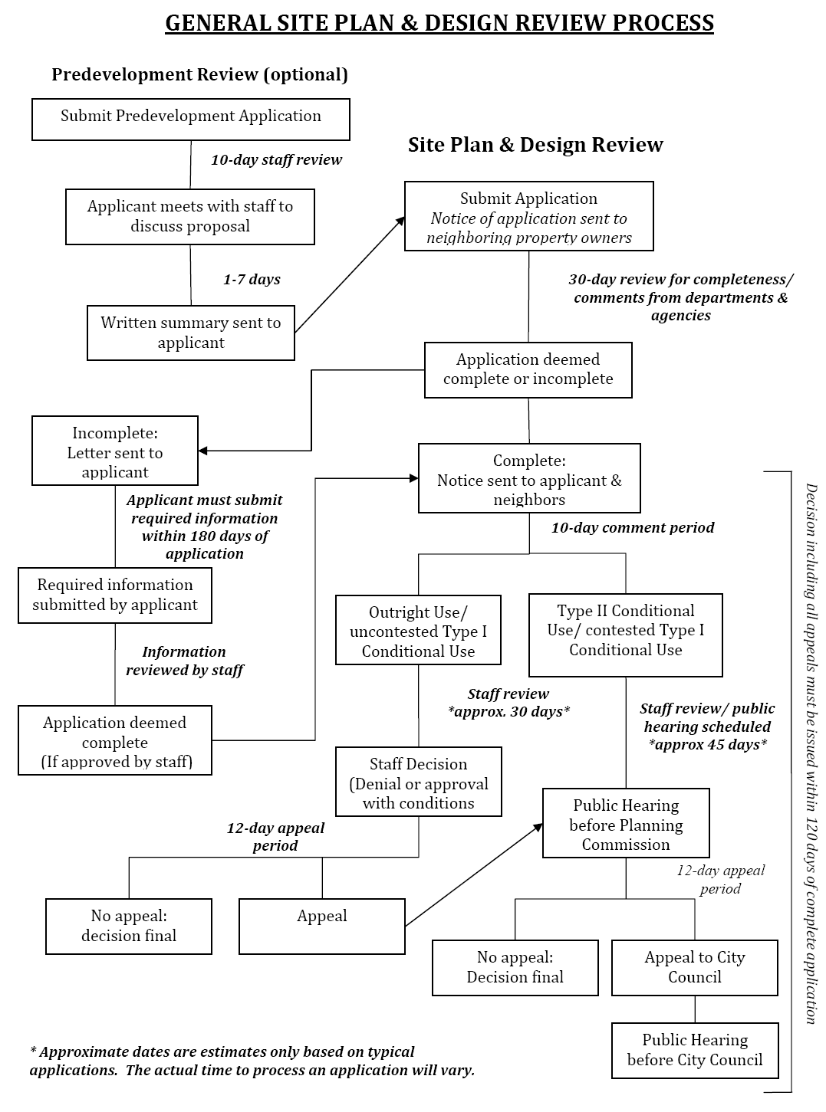

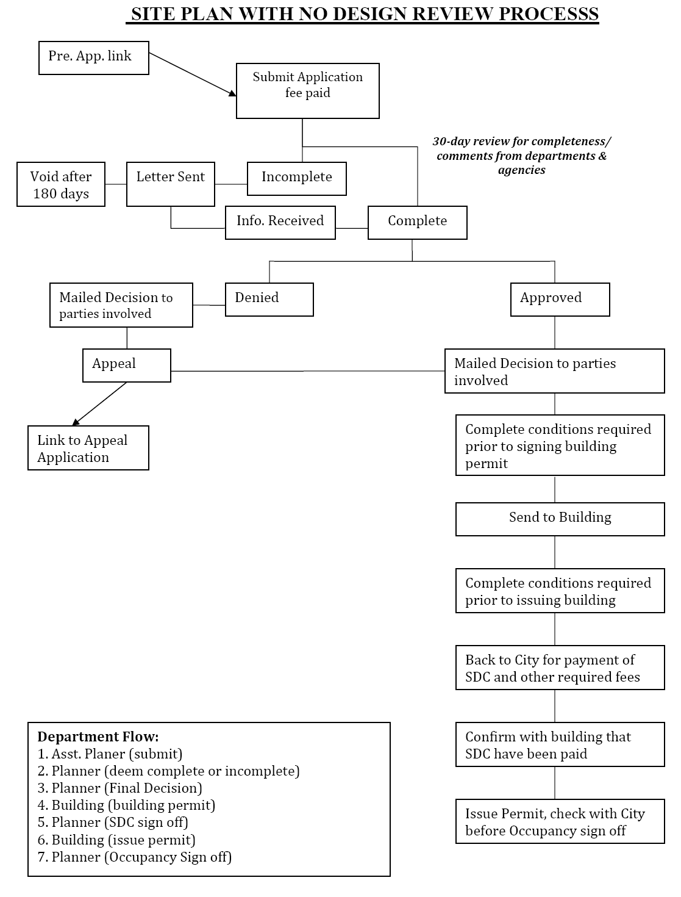

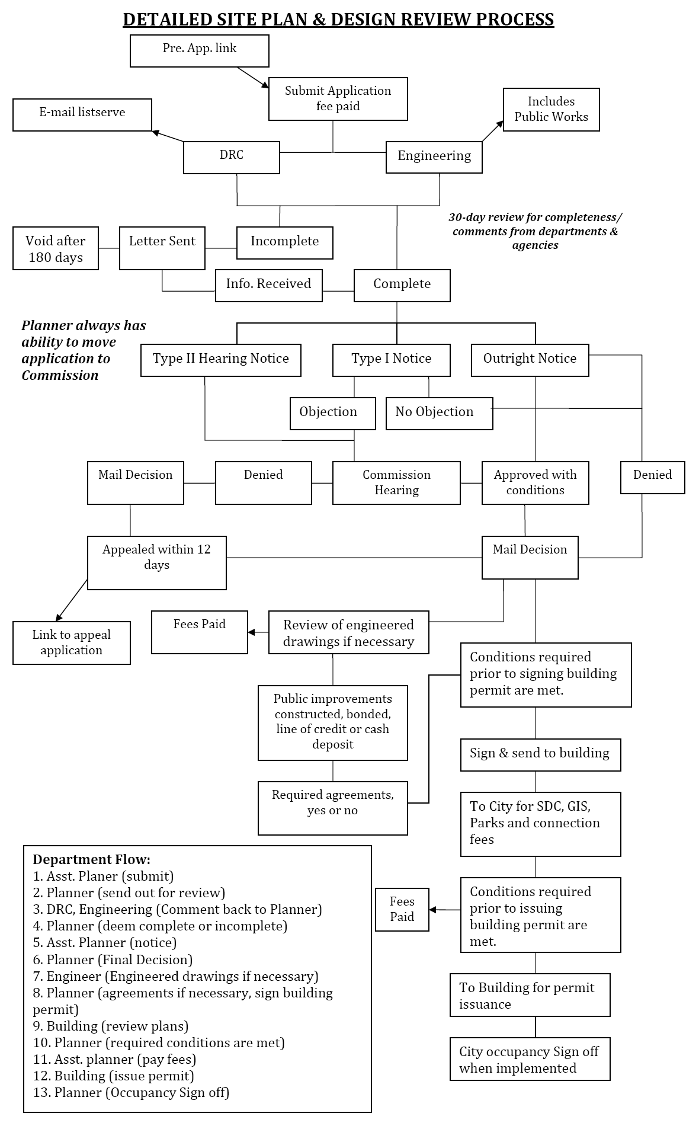

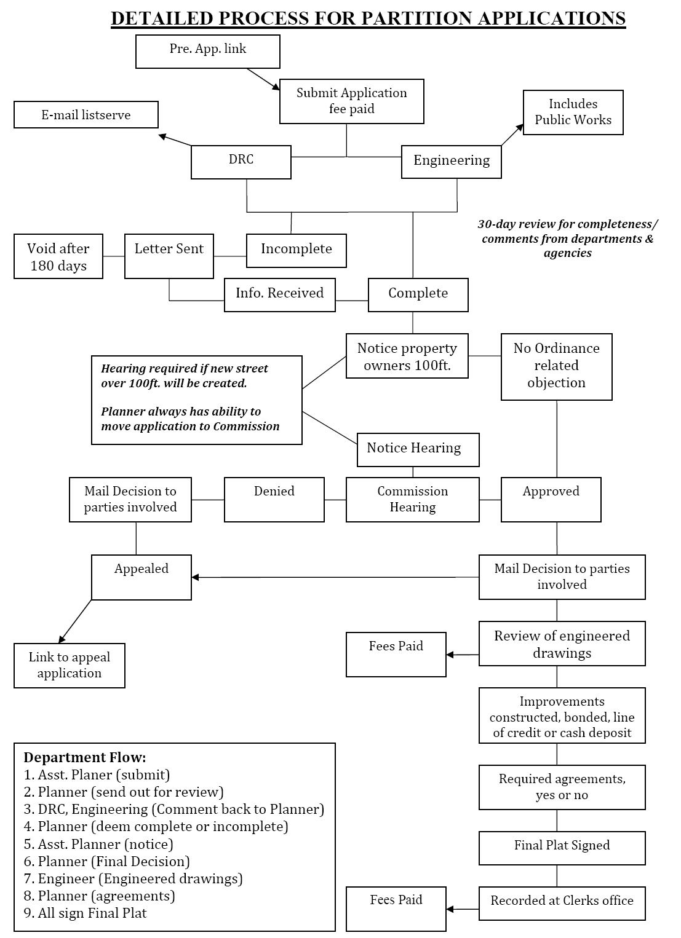

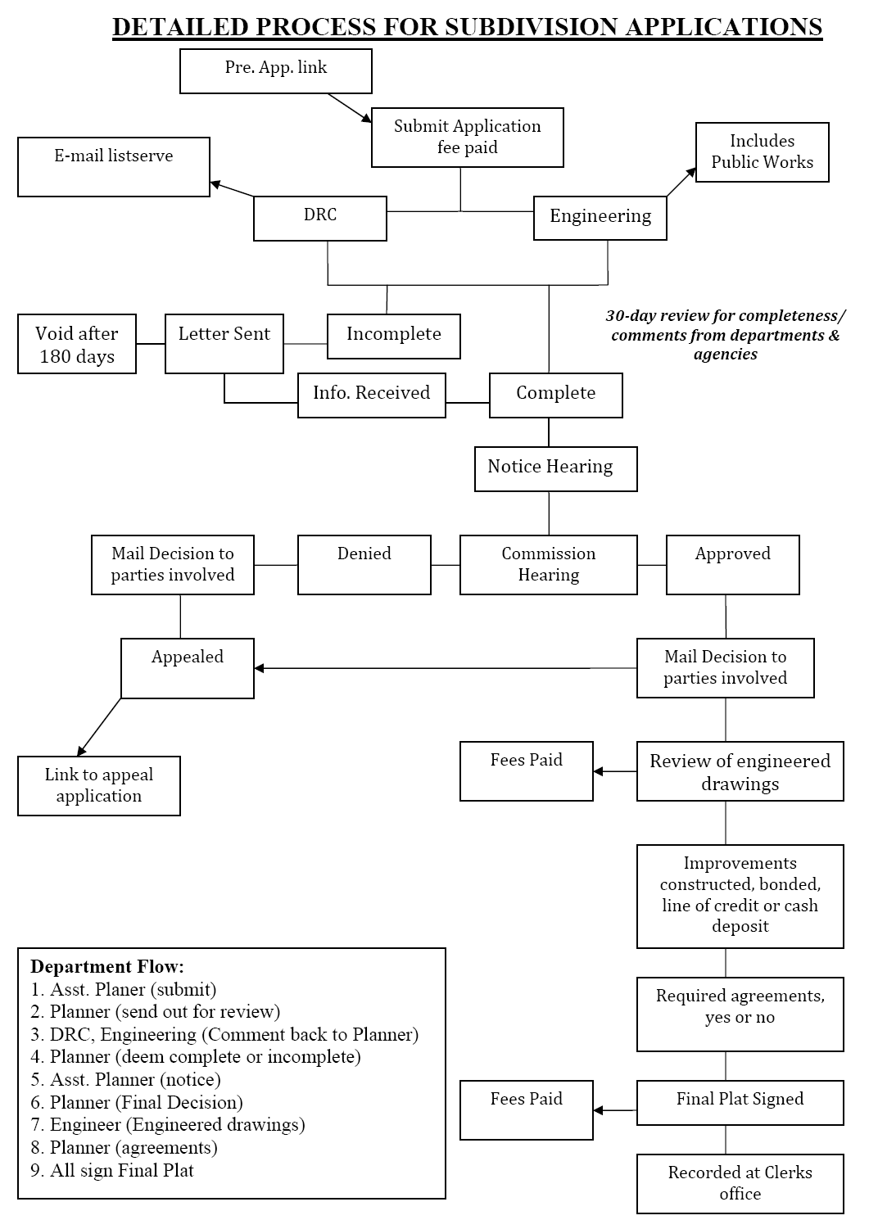

CHAPTER 153: LAND DEVELOPMENT
Last full update on 03/24/1998 (Ord. 1057), Amended 12/09/1998 (Ord. 1063) adding Industrial Park zone, Amended 11/28/2006 (Ord. 1137) procedures update, Amended 02/26/2008 (Ord. 1150) general housekeeping changes, Amended 01/27/2009 (Ord. 1156) Big Box Design Review, Amended 12/08/2009 (Ord. 1166) changes to extension procedures.
_________________________________________________________________________________________________________
General Provisions
153.001 Title
153.002 Purpose
153.003 Construction and terminology
153.004 Definitions
153.005 Compliance
153.006 Citing
153.007 Existing agreements and permits
153.008 Zoning/other development permit approval
153.009 Compliance with other regulations
153.010 Applicability of current regulations
153.011 Interpretation
153.012 Consolidated permit procedure
153.013 Administration
153.014 General Criteria
153.015 Authorization of similar uses
153.016 Municipal sewer and water required
Site and Building Design Review
153.020 Site plan and building design review provisions
153.021 Special design requirements for buildings with a footprint of over 40,000 square feet in commercial zones
Classification of Zones
153.030 Classification of zones
153.031 Location of zones
153.032 Zoning Map and amendments
153.033 Zone boundaries
153.034 Zoning of annexed areas
Zoning Tables
153.035 Residential Uses
153.036 Residential Dimensional Standards
153.037 Commercial & Industrial Uses
153.038 Commercial & Industrial Standards
153.039 Airport Uses
153.040 Airport Dimensional Standards
Specific Zone Requirements
153.045 Limited Residential R-1 Zone
153.046 General Residential R-2 Zone
153.047 Low Density Residential R-3 Zone
153.048 Residential Redevelopment R-4 Zone
153.049 High Density Residential R-5 Zone
Home
153.050 Central Commercial C-1 Zone
153.051 General Commercial C-2 Zone
153.052 Professional Commercial C-3 Zone
153.053 Neighborhood Commercial C-4 Zone
153.054 Recreation Commercial C-5 Zone
153.060 Light Industrial M-1 Zone
153.061 Heavy Industrial M-2 Zone
153.062 Industrial Park IP Zone
153.063 Mixed Use MU Zone
153.070 Airport General Criteria
153.071 Airport Specific Zones

153.075 Open Space-Park Reserve PR Zone
Replaced with NFOD.
153.076 Natural Features Overlay District (Chapter 155)
Supplementary Provisions
153.080 Accessory Dwelling Units & Guest Houses Covered in 153.191.
153.081 Clear vision areas
153.082 Onsite Lighting Covered in tables.
153.083 Standards, for Specific Uses Moved to 153.015
153.084 Attached Single Family Housing, Townhomes & Duplex Lots
Removed, covered elsewhere.
153.085 Off-street parking and loading: requirements and provisions
153.086 Off-street parking and loading: design/improvement standards
153.087 Landscaping requirements
153.088 Riparian habitat, Scenic protections, Slope hazard
153.089 Cutting and filling
153.090 Fences
153.091 Decks

153.092 Storage-unused vehicles/junk/debris
153.093 Outdoor merchandising
153.094 Cluster Developments Redundant, Combined with cluster development.
153.095 Manufactured homes; mobile homes; RV’s
153.096 Livestock
153.097 Compliance with state/federal rules
Removed, covered in 153.200
Nonconforming Uses & Exceptions
Home
153.115 Nonconforming uses
153.116 Exceptions to lot size requirements
Removed, covered in 153.116.
153.117 Exceptions to yard-setback requirements
153.118 Exceptions to building heights
153.119 Exception, zone boundaries
153.120 Exception, minor repair/rehabilitation
153.121 Exception, public street/highway improvement
153.122 Exception, public facilities improvement
Conditional Uses
153.135 Authorization to grant or deny

153.136 Specific conditions
Removed, Covered in 153.197
153.137 Application for conditional use
153.138 Permit processing: type I and II
Removed, covered in procedures section.
Removed, covered in procedures section.
Moved to 153.083
153.139 Time limit on permit
Subdivisions, Partitions, Lot consolidations & Replats
153.155 Purpose
153.156 Applicability
153.157 Subdivisions, applications
153.158 Planned Unit Development (PUD)
153.159 Subdivision and PUD review
153.160 Land Partitioning
153.161 Lot Consolidations
153.162 Replats
153.163 Boundary line adjustment & Final map recordation
153.164 Final map processing and recording procedures; subdivisions, partitions, lot consolidations & Replats
Dedication of Streets Not Part of Development
153.175 Application
153.176 Minimum design standards
153.177 Procedures
Design and Improvement Standards/Requirements
153.190 Compliance required
153.191 Lots and blocks
153.192 Easements
153.193 Land for public purposes
153.194 Streets and other public facilities
153.195 Access management
153.196 Improvement procedures
153.197 Completion or assurance of improvements
153.198 Building and occupancy permits
153.199 Maintenance surety bond
153.200 Engineering/special services for review
Variances
153.210 Authorization to grant or deny
153.211 Circumstances for granting variance
153.212 Minor variances
153.213 Application for a variance
Removed, covered in procedures.
Removed, covered in procedures.
153.216 Procedures for action on variances
153.217 Time limit for variances
Amendments
153.230 Authorization to initiate amendments
153.231 Application for amendments
153.232 Public hearings on amendments
153.233 Public notice requirements
153.234 Records of amendments
153.235 Limitations on reapplications
153.236 Adoption of an amendment
Administration and Enforcement
153.250 Introduction and definitions
153.251 General Provisions
153.252 Legislative Procedures
153.253 Development action procedures
153.254 Review of land use action applications
153.255 Land use action hearings
153.256 Land use action decisions
153.257 Reconsideration
153.258 Appeals
153.259 Limitations on approvals
153.260 Declaratory ruling
153.261 Enforcement and remedies

Cross-reference:
Property owners claim for compensation, see Chapter 41

GENERAL PROVISIONS
153.001 TITLE.
This chapter shall be known as the Zoning, Subdivision, Partitioning and Land Development Ordinance of 2011 for the City of Prineville, Oregon.
Home
153.002 PURPOSE.
The overall general purposes of this chapter are as follows: to implement applicable provisions of O.R.S. Chs. 92, 197, 215, 227 and other related statutes; to implement the applicable provisions of certain OAR's, statewide planning goals 1-14 as applicable, and applicable provisions from state agency plans, programs, policies and regulations; and to implement Prineville’s Urban Area Comprehensive Plan. Relative thereto, the intent of this chapter is as follows: to encourage the most appropriate use of land, taking into account the various characteristics of different areas of the city; to determine the suitability of various areas for certain land uses; to conserve and stabilize the value of property by establishing objective development standards; to recognize the needs for economic enterprises in order to maintain a healthy and balanced economy; to facilitate the redevelopment and rehabilitation of certain areas; to aid in the provision of urban services, facilities and utilities water, sewer, solid waste disposal, schools, parks, fire and police protection; to lessen congestion by providing adequate transportation facilities for all modes of travel; to provide for adequate light and air by establishing reasonable setback requirements; to recognize the values of certain natural resources; to provide for the protection and preservation of significant open space, and other natural resources and features; to encourage the orderly growth of the city and provide an adequate supply of buildable land areas for residential, commercial, industrial and other land uses while maintaining the quality of life environment currently evident and desired; to maintain and to provide for the coordination of land use review actions among all affected parties; and, in general, to promote the public health, safety, convenience and general welfare of the city, and the residents therein.

153.003 CONSTRUCTION AND TERMINOLOGY.
(A) Construction. Words used in the present tense include the future tense; words used in the singular include the plural, and words used in the plural include the singular; the word “may” is permissive, and the word “shall” is mandatory; and the masculine shall include the feminine and neuter.
(B) Terminology.
(1) The word “city” shall mean the City of Prineville, Oregon. The words “City Council” and “Council” shall mean the City Council of Prineville. The words “City Planning Commission” and “City Commission” shall mean the City Planning Commission for Prineville as duly appointed by the City Council. The words “City Recorder,” “City Manager,” “City Planning Official or Director,” “Fire Chief,” “City Legal Counsel, City Counsel or City Attorney” and “City Public Works or Street Superintendent” shall mean the respective positions for the City of Prineville as applicable.
(2) The word “county” shall mean the County of Crook, Oregon. The words “County Court” and “Court” shall mean the county Court of Crook County. The words “County Planning Commission” and “County Commission” shall mean the County Planning Commission for the county as duly appointed by the County Court. The words “County Clerk,” “County Assessor,” “County Planning Official or Director,” “County Legal Counsel, County Counsel or County Attorney,” “County Roadmaster or Roadmaster” and “County Survey” or shall mean the respective positions for Crook County as applicable.

Home
153.004 DEFINITIONS.
As used in this chapter, the following words and phrases, unless the context of this chapter requires or provides otherwise, shall have the meaning set forth herein. Words and phrases not defined herein shall have the meaning set forth in state statutes, state administrative rules, state planning goals, policies and other relevant local, state and/or federal regulations. Note: O.R.S.’s or O.A.R.’s set forth herein in parentheses “( )”are for reference information relative to the basis and/or source of the definition.
ABUT. Contiguous to; for example, two lots with a common property line, or two buildings with a common or immediately adjacent wall. For the purposes of this chapter, ABUT does not apply to buildings, uses, lots or parcels separated by a public right-of-way, river, stream channel or canal. It shall include the terms adjacent, adjoining and contiguous.
ACCESS. The right to cross between public and private property, allowing pedestrians, bicycles and vehicles to enter and leave property.
ACCESS EASEMENT. An easement recorded for the purpose of providing access from a public street to a lot across intervening property under separate ownership from the lot being provided access.
ACCESSORY DWELLING UNIT. See DWELLING
ACCESSORY USE OR STRUCTURE. A use or structure, or a portion of a structure, the use of which is incidental and subordinate to the main use of the property or structure and located on the same premises as the main or primary use and/or structure.
ADULT DAY CARE CENTER. See Residential Care Facility
ADULT FOSTER HOME. See Residential Care Home
AIRPORT or AIRCRAFT LANDING FACILITY. Any strip of land, landing area, runway, landing pad or other facility designed, used or intended to be used in connection with the landing or taking off of aircraft, including helicopters, and including all necessary taxiways, hangars and other necessary buildings and open spaces; also includes, but is not limited to, land used for existing commercial and recreational airport uses and activities and activities as described in O.A.R. 660-013-0100; for
example, emergency medical flight services; law enforcement and firefighting activities; search and rescue operations; flight instruction and ground training; aircraft maintenance, refueling, rental, service and sales; aeronautic skills training; aeronautic recreational and sporting activities; construction and maintenance of airport facilities; crop dusting activities; agricultural and forestry activities; and, activities, facilities and accessory structures provided and accessory to any of the foregoing uses and activities.
ALLEY. A Street or right-of-way which affords only a secondary means of access to property, primarily to the back or side of properties otherwise abutting on a street.
Home
ALTERATION. A change in construction or a change in occupancy. Where the term ALTERATION is applied to a change in construction, it is intended to apply to any change, addition or modification. Where the term is used in connection with a change in occupancy, it is intended to apply to changes in occupancy from one use to another.
ALTERATION, STRUCTURAL. A change or repair which would tend to prolong the life of the supporting members of a building or structure, such as alteration of bearing walls, foundation, columns, beams or girders. A change in the external dimensions of a building shall also be considered a structural alteration.
ARENA, Indoor/Outdoor. A facility intended to support spectator sporting events in an enclosed or open air facility.
AUTO DETAILING. A use designed for cleaning the inside and outside of autos, not including automated car wash.
AUTO REPAIR. Major automotive repairs that are not preformed at a automotive service station.
AUTOMOBILE SERVICE STATION. A retail place of business engaged primarily in the sale of motor fuels, but also supplying goods and services required in the operation and maintenance of automotive vehicles; this may include petroleum products, tires, batteries, automotive accessories and replacement parts and items, washing and lubrication services, the performance of minor automotive maintenance and repair and the supplying of other incidental customer services and products.
AUTOMOBILE WRECKING YARD. A premises used for the storage and/or sale of used automobile or truck parts, and/or for the storage, dismantling or abandonment of junk, obsolete automobiles, trailers, trucks, machinery or parts thereof.
AUTOMOBILE AND/OR TRAILER SALES AREA. An open area, other than a street, used for the display, sale or rental of new and/or used automobiles or trailers, and where no repair work is done except minor incidental repair of units to be displayed, sold or rented on the premises.
BASEMENT. A story partly underground. A basement shall be counted as a story in building height measurement when the floor level directly above is more than six feet above the average level of the adjoining ground.
BED AND BREAKFAST FACILITY. Any establishment located in a structure designed for a single family residence, where the owner of the establishment resides in the structure, which has more than two rooms for rent on a daily basis to the public; offers a breakfast meal as a part of the cost of the room; and serves one breakfast meal a day to guests, staff and owners only. BREAKFAST MEAL is the meal served to guests during the a.m. or morning hours each day (O.A.R. 333-17).
BOARDING OR ROOMING HOUSE. A building or portion thereof, other than a motel, restaurant or hotel, where meals or lodging or both are provided for compensation for more than five but not more than ten persons.
BUILDABLE AREA. The portion of a property that can be used to construct a building. Buildable area is the area excluding yard setbacks, easements, and other legal or physical prohibitions to construction.
BUILDING CODE. Current codes adopted by the State of Oregon Building Codes Division.
BUILDING FOOTPRINT. The area of a building as measured around its foundation or the perimeter of the first story exterior walls or support structures.
Home
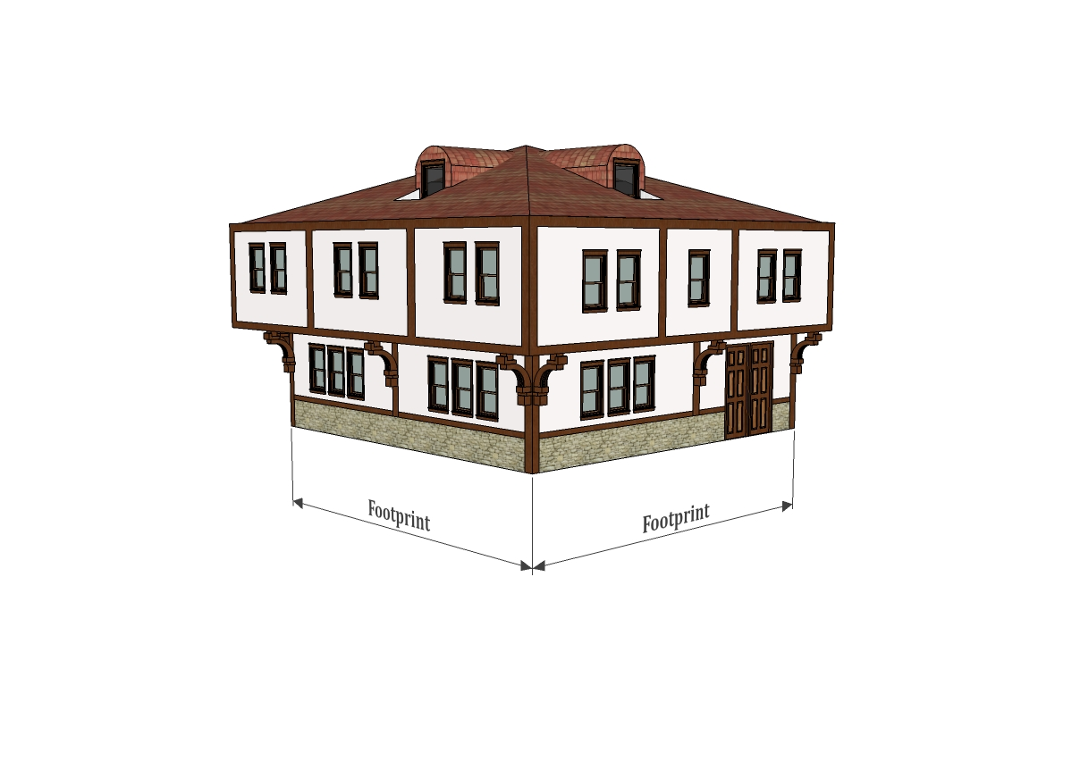
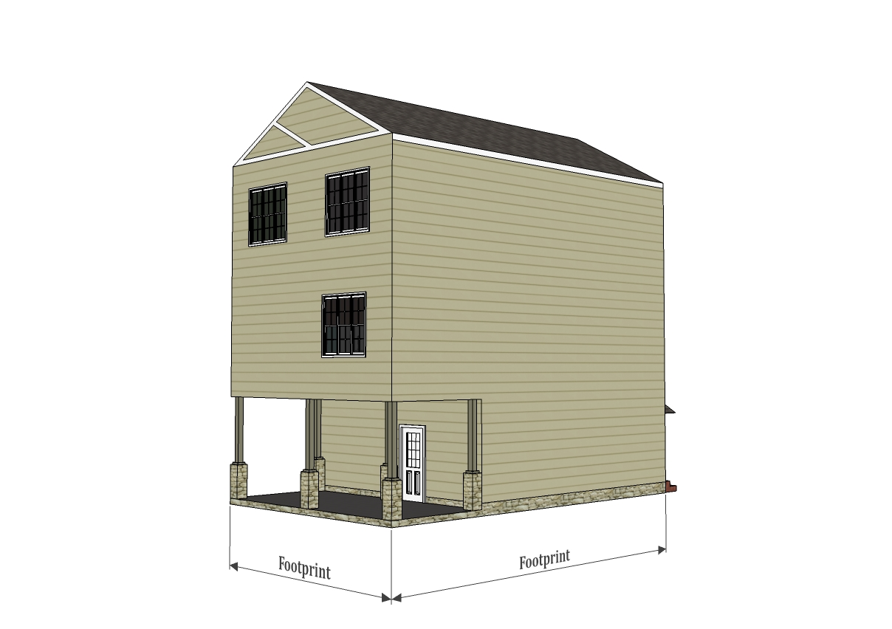

BUILDING OFFICIAL. That person or official who is responsible for the enforcement of the building codes, ordinances and regulations within the city and within the unincorporated area of the city's Urban Growth Boundary (UGB) area.
CALENDAR YEAR. A period of twelve months from January through December.
CANOPY. A permanent roofed structure which may be free standing or partially attached to a building for the purpose of providing shelter to patrons in automobiles, and patrons on foot, but shall not mean a completely enclosed structure.
CARPORT. A stationary structure consisting of a roof with its supports and not more than one wall, built to match the existing dwelling in color and architecture and used for sheltering motor vehicles, recreational vehicles or boats.
CEMETERY. Land used or intended to be used for the burial of the dead and dedicated for cemetery purposes.
CHILD CARE CENTER (commercial). Any registered child care facility which is not a child care home.
CHILD CARE HOME (residential). Any registered child care facility or certified group child care home where child care is offered in the home of the provider to fewer than 13 children, including children of the provider, regardless of full-time or part-time status. (ORS 657A)
CLINIC. A place where professional services are provided, including but not limited to, medical, dental, chiropractics, counseling, optometry and other medical and social type services, and including single and/or multiple offices.
CLINIC, ANIMAL. A business establishment in which veterinary services are rendered for domestic pets and/or livestock on an outpatient basis. The facilities may be further classified as “small animal” (those limited to domestic pets), or “large animal” (those limited to domestic livestock).
COMMERCIAL RECREATION. A private facility or structure intended for recreational purpose.
Indoor. A room or rooms within an enclosed building including uses raging from skating rinks and bowling alleys to pool halls and arcades.
Outdoor. A facility or structure not enclosed by a building including uses such as batting cages, bumper cars, mini golf, tennis courts and basketball courts.
Home
COMMUNITY WATER SYSTEM. A domestic water supply source or distribution system which serves more than three single residences or other users for the purpose of supplying water for household uses, but is neither a municipal water supply system nor a public utility water supply system, and must have legal financial provisions for long-term operation and maintenance.
COMMUNITY SEWAGE SYSTEM. A sewage disposal system, which serves more than ten single residences or other users for the purpose of disposing of household liquid wastes, but is neither a municipal nor a public utility sewage disposal system, and must be approved by the appropriate government agency and must have legal financial provisions for long-term operation and maintenance.
CONDOMINIUM. A multiple family dwelling, duplex or single unit in which the dwelling units are individually owned, with each owner having a recordable deed enabling the unit to be sold, mortgaged or exchanged independently, under the provisions of applicable O.R.S.'s.
CONTIGUOUS or CONTIGUOUS LAND. Two or more parcels or units of land under a single ownership which are not separated by an intervening parcel of land under separate ownership, including limited access right-of-way which would deny access between the two parcels under single ownership, or parcels of land under a single ownership which are not separated by a river, public road, street or other public right-of-way.
COTTAGE INDUSTRY. See Home Occupation.
CUSTOM SLAUGHTERING or SLAUGHTER HOUSE. A mobile or stationary establishment wherein meat animals, caused to be delivered by the owners thereof, are slaughtered for compensation, payment or rneration of any kind, and are thereafter returned to the owner thereof or to the order of the owner. (O.R.S. 603.010(2)).
DAY CARE See Child Care.
DENSITY, NET. The number of dwelling units per unit of land expressed as the number of square feet of land per dwelling unit. The net density for any lot is computed by dividing the net square footage of the parcel by the number of dwelling units. The net square footage is determined by subtracting from the total square footage of the parcel that which is deemed necessary for street dedication and that area used for private streets and common driveways, if any.
DEVELOPER. Any person, corporation, partnership or other legal entity that creates or proposes to create a land development, subdivision, partitioning or other development including residential, commercial or industrial developments.
DEVELOPMENT. Means all human caused change to improved or unimproved real estate including but not limited to: buildings, fences, decks, placement or replacement of manufactured or other structures, subdividing or partitioning property, parking and loading areas, landscaping, roadways, paved or graveled areas, grading, excavation or drilling operations and areas devoted to storage of equipment and materials.
Home
DIKE. A structure designed and built to prevent inundation of a parcel of land by water.
DWELLING. As follows:
Accessory Dwelling Unit. A secondary living unit or separate cottage excluding RV’s on a single family lot in a residential zone containing cooking facilities, and meets the dimensional and other requirements of the zoning district in which it is located.
Single Family Dwelling. A detached building containing one dwelling unit designed for occupancy by 1 family or one household only.
Duplex. A detached building containing two dwelling units on a single lot or duplex lot and designed for occupancy by 2 families or households living independently of each other where neither is a guest house or accessory dwelling.
Multifamily Dwelling. A detached building containing 3 or 4 dwelling units on a single lot and designed for occupancy by 3 or 4 families or households living independently of each other. Multifamily Dwellings built on adjacent lots shall be considered a Multifamily complex.
Multifamily Complex. A single lot containing five or more dwelling units.
Townhome (house). A single family dwelling with a private entrance, which is part of a structure whose dwelling units are attached horizontally in a linear arrangement with each unit on its own separate lot and having a totally exposed front and rear wall to be used for access, light and ventilation. Also referred to as single family attached housing or row homes.

DWELLING UNIT. A building, or portion thereof, consisting of one or more rooms including a bathroom, living, eating, sleeping and kitchen facilities, which are arranged, designed or used as living quarters for one family or one household.
EASEMENT. A grant of the right to use a parcel of land, or portion thereof, for specific purposes where ownership of the land or portion thereof is not transferred.
Home
FAMILY DAY CARE CENTER. See Child Care Center(Home)
FAMILY or HOUSEHOLD. An individual or two or more persons related by blood, marriage, legal adoption or guardianship, living together as one housekeeping unit in a dwelling unit using one kitchen, and providing meals, board and/or lodging to not more than three unrelated persons, living together as one housekeeping unit using one kitchen, excluding servants; or a group of not more than five persons who need not be related by blood, marriage, legal adoption or guardianship living in a dwelling unit.
FARMING or FARM USE. As defined by O.R.S. 215.203 (2)(a), to include the use of land for the purpose of raising, harvesting or selling crops, for the feeding, breeding, management and sale of, or the produce of, livestock, poultry, fur-bearing animals, honeybees or dairying and the sale of dairy products, or for any other agricultural or horticultural use, animal husbandry, timber propagation or harvest, or any combination thereof, including the preparation, processing and storage of products raised on the land, but not including the construction or use of dwellings and other buildings customarily provided in conjunction therewith.
FENCE. A protective or confining barrier constructed of wood, plastic, masonry or wire mesh. FENCE does not include hedges or other plantings.
FENCE, SIGHT-OBSCURING. A fence constructed, arranged and maintained in a manner as to obscure vision.
FRONTAGE. All property fronting on one side of a street and measured along the street line, between intersecting and intercepting streets, or between a street and a right-of-way, waterway, end of dead-end street, alley, city or district boundary.
GARAGE, PRIVATE. An accessory building or portion of a main building used for the parking or temporary storage of vehicles owned or used by occupants of the main building.
GARAGE, REPAIR. A building used for the care and repair of motor vehicles, including major and minor work such as body and fender work or engine and transmission overhaul, and incidental storage or parking of vehicles.
GRADE. The average level of the finished surfaces of the ground adjacent to the exterior of a building.
Existing Grade. The surface of the ground or infrastructure at a stated location as it exists prior to disturbance in preparation for a project or as officially established by City authority.
Finished Grade. The final elevation of the ground surface after man-made alterations, such as grading, grubbing, filling, or excavating, have been made on the ground surface.
Ground Level Grade. The average of the finished ground elevation along the perimeter walls of a building. In case walls are parallel to and within 5 feet of a sidewalk, alley or other public way, the above-ground level should be measured at the elevation of the sidewalk, alley or public way.
Natural Grade. The existing grade or elevation of the ground surface that exists or existed prior to man-made alterations, such as grading, grubbing, filling, or excavating.
Home
Engineered Grading. Any filling of land that is intended to provide support for structures and or infrastructure.
GRADING. Any leveling, stripping, cutting, filling or stockpiling of earth or land, including the land in its cut or filled condition to create new grades.
GUEST HOUSE. A structure of no more than 450 square feet used in conjunction with the main building for the temporary housing of nonpaying visitors and guests and containing no cooking facilities, unless otherwise approved by the city or other planning authority.
HABITABLE FLOOR AREA. Any floor area usable for living purposes, which includes working, sleeping, eating, cooking or recreation, or any combination thereof. A floor area used only for storage purposes is not a HABITABLE FLOOR AREA.
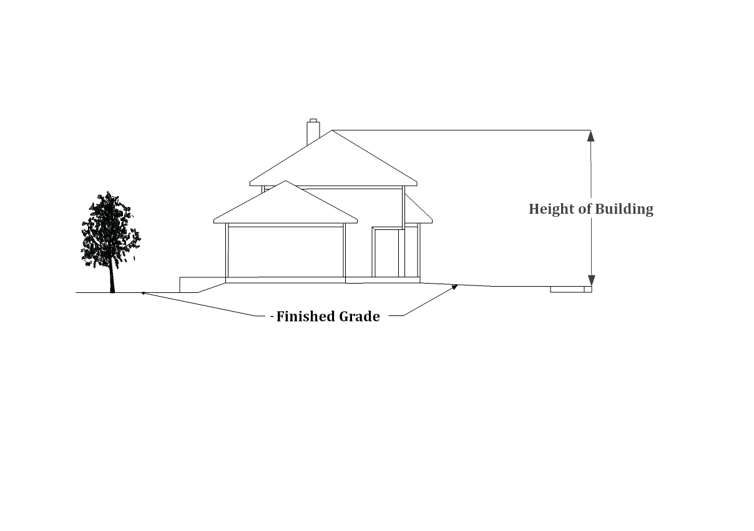
HEIGHT OF BUILDING. With natural grade of up to and including 10%, “height of building” is the vertical distance measured between the elevation of the curb or street serving the property, and the highest point of the roof. For sites having a natural grade greater than 10%, “height of building is measured from the average finished grade to the highest point of the roof. Introduced fill or excessive grading beyond that which is necessary shall not be used to circumvent this standard by artificially elevating a structure above the height limit.

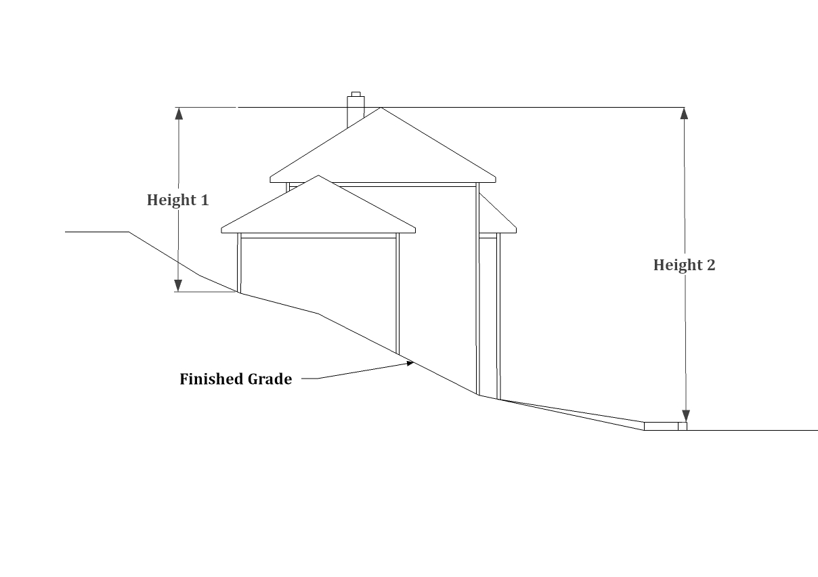

Natural Grade 10% or Less.
Height determined by measurement from the curb or street.

Home
Natural Grade greater than 10%.
Height determined by the average of heights 1 & 2.

HISTORICAL, GEOLOGICAL AND ARCHAEOLOGICAL BUILDINGS AND SITES. Land, buildings and/or other natural or manmade features which have a special historical, geological or archaeological interest, represent one or more periods of time in the history of the city and adjoining areas, and have at least local significance.
HOME OCCUPATION. A small business activity which may involve the provision of services or manufacture and sale of products, carried on by a resident or resident family living on the premises as an accessory use within the same dwelling, or in an accessory building on the same property, with limited employees outside of the immediate family, that is not detrimental to the overall character of the neighborhood.
HOSPITAL. An establishment, publicly or privately operated, which provides sleeping and eating facilities to two or more non-related persons receiving medical, obstetrical or surgical care, and other healing, curing and/or nursing services over a period exceeding 24 hours.
HOTEL or MOTEL (TRAVELERS' ACCOMMODATIONS). A building, or portion thereof, designed and/or used for occupancy of transient individuals who are lodged with or without meals. (O.R.S. 446.310)
INDOOR COMMERCIAL RECREATION. A room or rooms within an enclosed building which is designated and used for recreational purposes by the general public.
INTEREST. Includes a lot or parcel, and a share, undivided interest or membership which includes the right to occupy the land overnight, and lessee’s interest in land for more than three years or less than three years of the interest may be renewed under the terms of the lease for a total period more than three years. Does not include any interest in a condominium or any security interest under a land sales contract, trust deed or mortgage, and does not include divisions of land created by lien foreclosure or foreclosures of recorded contracts for the sale of real property.
JUNK. Means old or scrap copper, brass, rope, rags, batteries, paper, trash, rubber, debris, waste or junked, dismantled, wrecked, scrapped or ruined motor vehicles or appliances, or motor vehicle parts, iron, steel or other old or scrap ferrous, or nonferrous material, metal or nonmetal materials.
(O.R.S. 377.605(5))
JUNK OR WRECKING YARD. Any property or establishment where a person(s) is engaged in breaking up, dismantling, sorting, storing, distributing, buying or selling scrap or waste materials, or any establishment or place of business where there is accumulated on the premises eight or more motor vehicles or an equivalent volume of junk, that is maintained, operated or used for storing, keeping, buying or selling of junk, and the term includes automobile graveyards, garbage dumps and scrap metal processing facilities. (O.R.S. 377.605(6))
Home
KENNEL. A lot, building or premises in or on which four or more dogs, cats or other animals at least four months of age are kept commercially for board, propagation, training or sale.
LANDSCAPING. The total ground area of a lot not covered by permanent structures, except areas which may be covered by projections from buildings, that include a combination of any of the following materials: living plant material such as trees, shrubs, groundcover, flowers and lawn, including native vegetation; and nonliving materials such as benches, walkways and courtyards, consisting of brick, decorative rock or other decorative materials. Does not include areas surfaced solely for the purpose of off-street parking and loading.
LIVESTOCK. Domestic animals of types customarily raised or kept on farms for profit or other purposes, and include horses, mules, asses, cattle, sheep, swine, goats, llamas and poultry, including turkeys, of any age or sex. (O.R.S. 599.205) Does
not include exotic animals as defined by O.R.S. 609.305.
LIVESTOCK FEEDING YARD. An enclosure designed or used for the purpose of the concentrated feeding or fattening of livestock for marketing.
LIVESTOCK AUCTION MARKET or SALES YARD. Any place of business to which the public may consign livestock for sale by auction open to public bidding or sold on a commission basis, but, specifically does not include breed or livestock associations operating subject to and in compliance with the provisions of the Oregon Nonprofit Corporation Law (O.R.S. 61.005 to 61.215), FFA and 4H groups, auction sales conducted in conjunction with the County Fair or other fairgrounds approved events or private fairs or auctions by or for a person on the premises of the person. (O.R.S. 599.205) (6))
LOADING SPACE. An off-street space within a building or on the same lot with a building, for the temporary parking of a commercial vehicle or truck while loading or unloading merchandise or materials, and which space has direct access to a street or alley.
LOT. Means a single unit of land that is created by a subdivision of land. (O.R.S. 92.010). The term “lot” within this code and all referenced codes and regulations shall always refer to a “lot of record” based on the context of the property being discussed.
Corner Lot. A lot abutting on 2 or more streets, other than alleys, at their intersection; provided the angle of intersection of the abutting streets does not exceed 135°.
Double Frontage Lot. A lot having frontage on two parallel or approximately parallel streets other than alleys.
Duplex Lot. A lot containing 1 dwelling unit of a duplex dwelling structure.
Home
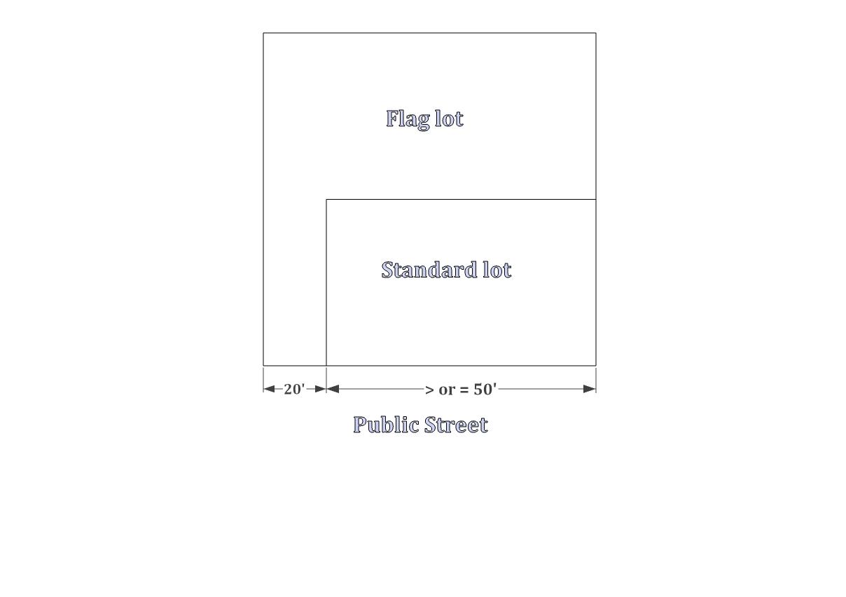
Flag Lot. A lot which fronts a public street or road and where access to the street or road is by a private driveway. A lot shall be considered a “flag lot” if the pole of the flag has a continuous width of at least 20 feet up to but not including 50 feet of street frontage.

Interior Lot. A lot other than a corner lot.
Irregular lot. A lot of such a shape or configuration that technically meets the area, frontage and width requirements of these standards but does so by incorporating unusual elongations, angles, curvilinear lines unrelated to topography or other natural land features.
Nonconforming Lot. A lot that lawfully existed prior to the enactment of the requirements of these standards, but does not meet the minimum lot size or street frontage requirements.
LOT CONSOLIDATION. The consolidation of lot lines resulting in fewer lots.

LOT AREA. The total horizontal net area within the lot lines of a lot to mean that square footage of a lot that is free from public and private road rights-of-way.
LOT COVERAGE. The percentage of the total lot area covered by the footprint of a building or buildings, including covered parking areas; but excluding covered patios, porches and decks that are not enclosed and have no living space above them. For the purposes of this definition “enclosed” shall mean anything other than typical roof supports and common railing.

Home
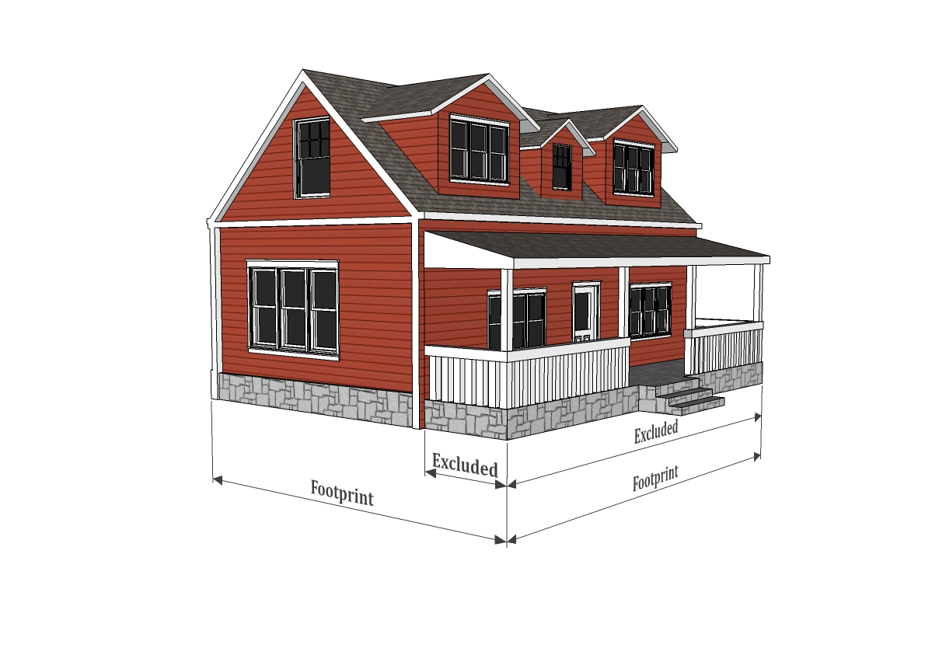

LOT DEPTH. The average horizontal distance between the front and rear lot lines.
LOT LINE. The property line bounding a lot.
Front Lot Line. The lot line separating a lot from a street other than an alley, and in the case of a corner lot, the shortest lot line along a street other than an alley.
Rear Lot Line. The lot line which is opposite and most distant from the front lot line. In the case of an irregular, triangular or other odd- shaped lot, a line ten feet in length within the lot, parallel to and at a maximum distance from the front lot line.
Side Lot Line. Any lot line other than a front or rear lot line bounding a lot.
LOT WIDTH. The average horizontal distance between the side lot lines, measured at right angles to the lot depth at a point midway between the front and rear lot lines.
LOT OF RECORD. Any unit of land created as follows:
(1) A lot in an existing, duly recorded subdivision;
(2) A parcel in an existing, duly recorded major or minor land partition; or,
(3) An existing unit of land (tract) for which a survey has been duly filed which conformed to all applicable regulations at the time of filing; or
(4) Any unit of land created by deed description or metes and bounds provided, however, contiguous units of land created by deed description or metes and bounds under the same ownership and not conforming to the minimum parcel size of these standards shall be considered 1 lot of record.
MAINTAIN. To allow to exist. (O.R.S. 377.605(7))
MANUFACTURED DWELLING. Except as may be additionally defined for the purposes of this chapter, manufactured dwelling means the following:
(1) RESIDENTIAL TRAILER. A structure constructed for movement on the public highways that has sleeping, cooking and plumbing facilities, that is intended for human occupancy, that is being used for residential purposes and that was constructed before January 1, 1962.
(2) MOBILE HOME. A structure constructed for movement on the public highways that has sleeping, cooking and plumbing facilities, that is intended for human occupancy, that is being used for residential purposes and that was constructed between January 1, 1962 and June 15, 1976, and met the construction requirements of Oregon mobile home law in effect at the time of construction.
(3) MANUFACTURED HOME. A structure constructed for movement on the public highways that has sleeping, cooking and plumbing facilities, that is intended for human occupancy, that is being used for residential purposes and that was constructed in accordance with federal manufactured housing construction and safety standards and regulations in effect at the time of construction. (O.R.S. 446.003(26)(a))
Home
(4) Does not mean any building or structure subject to structural specialty code adapted pursuant to O.R.S. 455.100 to 445.450 or any unit identified as a recreational vehicle by the manufacturer.
(5) For the purposes of this chapter, it shall be immaterial whether the units or components thereof are placed upon property for a temporary, semi-permanent or permanent residence, or that the wheels are removed and the unit or component(s) are supported upon footings or a foundation.
(6) This definition does not include travel trailers, camping trailers, motorized homes or campers, pickup coaches or other recreational type vehicles.
MANUFACTURED DWELLING OR MOBILE HOME PARK. Any place where four or more manufactured dwellings or structures are located within 500 feet of one another on a lot, tract or parcel of land under the same ownership, the primary purpose of which is to rent or lease space or keep space for rent or lease to any person for a charge or fee to be paid for rental or lease or use of facilities or to offer space free in connection with securing the trade or patronage of the person(s). Manufactured dwelling park does not include a lot or lots located within a subdivision being rented or leased for occupancy by no more than one manufactured dwelling per lot if the subdivision was approved as a subdivision permitting manufactured dwellings at the time of platting and approved by the city pursuant to provisions adopted pursuant to O.R.S. 92.010 to 91.190, or if an amendment to the approval of the subdivision for manufactured dwelling use is subsequently granted by the city.
MANUFACTURED DWELLING SUBDIVISION. A subdivision intended to be occupied primarily or exclusively by manufactured dwellings and so approved at the time of platting.
MANUFACTURING.
Commercial. Light assembly as a support use to the primary commercial use (i.e., furniture assembly, electronic repair/ assembly).
Light Industrial. Fully enclosed; manufacturing of items permitted in the respective zone; does not use chemicals or materials which may be toxic or otherwise detectable visually or by odor from neighboring properties.
Heavy Industrial. Industrially related manufacturing; typified by the use of larger machinery or chemicals; not generally associated with commercial sales other than as a secondary use to the primary industrial use.
MODULAR OR PREFABRICATED HOME. A prefabricated, sectional or factory constructed dwelling unit manufactured off-site, normally constructed in two or more sections or components for assembly on a permanent foundation as a permanent residential structure, and when completed is essentially indistinguishable from a conventionally constructed home and conforms to the current edition of the State of Oregon One and Two Family Dwelling Code.
MOTEL. A building, or group of buildings, on the same lot or parcel containing motel rental units for rental to transients and consisting of individual sleeping quarters with or without cooking facilities which are designed, intended or used primarily for the accommodation of transients and travelers, and shall include hotels and inns.
MUNICIPAL WATER SYSTEM. A domestic water supply source and distribution system owned and operated by a city or a county; or owned and operated by a special district or other public corporation which has independent tax-levying powers to support the system and which supplies water to a total of 1,000 or more households.
Home
MUSEUM. Includes any collection of archaeological specimens, artifacts, pioneer relics, articles, documents and other things of historical, scientific or artistic import that are assembled, displayed, preserved and protected for the benefit of the public, for educational and scientific purposes or
to commemorate the occupation and development of the area or the Pacific Northwest region, and the structure or structures housing the collection(s). (O.R.S. 358.310(2))
NATURAL AREA. Includes land and water that has substantially retained its natural character and land and water that, although altered in character, is important as habitats for plant, animal or marine life, for the study of its natural, historical, scientific or paleontological features, or for the appreciation of its natural features, and is so designated by the Comprehensive Plan either by Plan policy or Map designation.
NATURAL HAZARD AREA. An area that is subject to natural events that are known to result in death or endanger the works of man, such as stream flooding, ground water, flash flooding, erosion and deposition, landslides, earthquakes, weak foundation soils and other hazards unique to a local or regional area, and are so designated or identified by Plan policies or Map designations.
NATURAL RESOURCES. Air, land and water and the elements thereof which are valued for their existing and potential usefulness to man.
NEW CONSTRUCTION. Any structure for which the “start of construction” commenced on or after the effective date of this chapter.
NONCONFORMING USE OR STRUCTURE. A lawful existing use or structure at the time this chapter or any amendments hereto become effective which does not conform to the requirements of this chapter as amended or to the zone in which it is located.

NURSING OR CONVALESCENT HOME. Any home, institution or other structure maintained or operating for the nursing and care of four or more ill or infirm adults not requiring hospitalization.
OFFICE. A room, suite of rooms, or portion of a building used for the practice of a profession or for conducting the affairs of a business.
OPEN SPACE. Consists of lands used for agricultural or forest uses, and any land area that would if preserved and continued in its present use conserve and enhance natural or scenic resources; protect air or streams or water supply and promote conservation of soils, wetlands or marshes. It also consists of landscaped areas such as parks, open recreation areas, golf courses and similar areas that reduce pollution and enhance the value of abutting or neighboring property; enhance the value to the public of abutting or neighboring parks, forests, wildlife preserves, natural reservations or other open space; enhance recreation opportunities; preserve historic, geological and archeological sites; promote orderly urban development; minimize land use conflicts; and maintain quality living conditions.
Home
OUTDOOR MERCHANDISING. The sale or display for sale of merchandise outside of an enclosed building space; including sales which are transacted through an open window or door; does not include incidental, infrequent garage, patio or yard sales.
OWNER. The owner of the title to real property or the authorized agent thereof, or the contract purchaser of real property of record as shown on the last available complete county tax assessment roll, County Clerk's records and/or City Recorder's records.
PARCEL. Means a single unit of land that is created by a partition of land.
PARKING AREA, PRIVATE OR PUBLIC. Privately or publicly owned property, other than streets and alleys, on which parking spaces are defined, designated or otherwise identified; in the case of a private parking area for use by the tenants, employees or owners of the property for which the parking area is required by this chapter and not open space for use by the general public; and, in the case of a public parking area, for use by the general public, either free or for remuneration, and may include parking lots which may be required by this chapter for retail customers, patrons and clients.
PARKING SPACE. A clear, off-street area for the temporary parking or storage of one automobile, having an all-weather surface and a width of not less than eight and one half feet when within a building or structure; with an area of not less than 190 square feet in area; deviations are allowed when in compliance with applicable provisions set forth in 153.080 et seq. PARKING SPACES shall have easy access to a street or alley by a driveway having an all-weather surface.
PERSON. Every natural person, firm, partnership, association, social or fraternal organization, corporation, trust, estate, receiver, syndicate, branch of government or any group or combination acting as a unit.
PLANNED UNIT DEVELOPMENT or PLANNED COMMUNITY. The development of an area of land as a single entity for a number of dwelling units or a number of uses, according to a plan which does not necessarily correspond in lot size, bulk or type of dwelling, density, lot coverage or required open space to the standard regulations otherwise required by this chapter. A PLANNED COMMUNITY means any subdivision which results in a pattern of ownership of real property and all the buildings, improvements and rights located on or belonging to the real property in which there is a homeowners association responsible for the maintenance, operation, insurance and taxes, relating to any common property of the PLANNED COMMUNITY and/or for the exterior maintenance of any property that is individually owned; and owners of individual lots, by virtue of their ownership, automatically are members of the homeowners association and assume liability for membership fees. (O.R.S. 94.550)
PLAT. A final map, diagram, drawing, re-plat or other writing containing all the descriptions, locations, specifications, dedications, provisions and information concerning a subdivision.
PRIMARY, PRINCIPAL OR MAIN USE. The first use to which property is or may be devoted, and that use to which all other uses on the premises are derived as accessory or secondary uses. As used relative to dwelling units, the primary dwelling shall be the first dwelling unit to be located on a specific lot or parcel.
PRINTING and PUBLISHING, RETAIL. Service commercial use providing printing services available to the general public.
PRINTING, WHOLESALE. Printing intended to serve retail or other wholesale uses rather than the general public.
Home
PROJECTION ARCHITECTURAL. Features such as cornices, eaves, sunshades, gutters, chimneys, flues, steps, terraces, platforms, patios, decks and porches having no roof covering.
PUBLIC NEED. An identifiable and measurable public benefit which accrues to the community as a whole.
PUBLIC OR SEMI-PUBLIC USE. A use owned and operated by a public, governmental or nonprofit organization for the benefit of the public in general. This does not include landfill sites, solid waste disposal sites, garbage dumps, recycling facilities, quarry sites or utility facilities.
PUBLIC UTILITY WATER SYSTEM. A domestic water supply source and distribution system supplying water for household uses, owned and operated by a person subject to regulation by the Public Utility Commissioner of Oregon and supplying water to a total of 500 or more households.
PUBLIC WATER SYSTEM. A water system for the provision to the public of piped water for human consumption, if the system has at least 15 service connections or regularly serves at least 25 individuals.
RECREATION CAMP, RESORT or PARK. An area devoted to facilities and equipment for recreational purposes, including swimming pools, tennis, basketball and volleyball courts, sports fields, playgrounds, picnicking areas and other similar uses, whether the use of the area is limited to private membership or whether open to the public upon payment of a fee, or an area designated by the landowner for picnicking or overnight camping and offered to the general public, whether or not a fee or charge is made for the accommodations.
RECREATION FACILITY (public). Indoor and/or outdoor structures built for public recreation such as aquatic centers, basketball courts, tennis courts, mini-golf and skate parks.
RECREATION VEHICLE. Boats, ATVs and vacation trailers or other units with or without motive power, which are designed for human occupancy and intended to be used temporarily for recreation, vacation, seasonal or emergency purposes, but not for residential purposes includes camping trailers, camping vehicles, motor homes, park trailers, bus conversions, van conversions, tent trailers, travel trailers, truck campers and any other vehicle converted for use as a recreational vehicle. (O.R.S. 446.003(36))
RECREATION VEHICLE PARK, RECREATION PARK or CAMPGROUND. Any area designated by the person or party establishing, operating, managing or maintaining the same for picnicking or overnight camping by the general public or any segment of the public. Includes, but is not limited to, areas open to use free of charge or through payment of a tax or fee, or by virtue of rental, lease, license, membership, association or common ownership, and further includes, but is not limited to, those areas divided into two or more lots, parcels, units, spaces or other interests or designations for purposes of the use. Includes the facilities and spaces for tents, tent vehicles, camping vehicles or recreation vehicles of any type.
RESIDENTIAL CARE. Services such as supervision; protection; assistance while bathing, dressing, grooming or eating; management of money; transportation; recreation; and the providing of room and board.
Home

RESIDENTIAL CARE FACILITY. A residential care, residential training or residential treatment facility licensed or registered by or under the authority of the Department of Land Conservation and Development, as defined in O.R.S. 443.400, under O.R.S. 443.400 to 443.460 or licensed by the state Office for Services to Children and Families, under O.R.S. 418.205 to 418.327 which provides residential care alone or in conjunction with treatment or training or a combination thereof for 6 or more individuals who need not be related. Staff persons required to meet licensing requirements shall not be counted in the number of facility residents, and need not be related to each other or to any resident of the residential facility. (ORS 197.660). Does not include a residential school, state or local correctional facilities, a nursing home, a hospital, a place primarily engaged in recreational activities, a foster home, a place providing care and treatment on less than a 24-hour basis, or a child-caring agency or residential school or other organization certified or licensed by the Children's Services Division under O.R.S. 418.205 to 418.327.
RESIDENTIAL CARE HOME. A residential treatment or training or an adult foster home, licensed by or under the authority of the state Mental Health and Development Disability Services Division or the Senior and Disabled Services Division or the office of Alcohol and Drug Abuse Programs, as appropriate, under O.R.S. 443.400 to 443.825, a residential facility registered under O.R.S. 443.480 to 443.500 or an adult foster home licensed under O.R.S. 443.705 to 443.825 which provides residential care alone or in conjunction with treatment or training or a combination thereof for 5 or fewer individuals who need not be related. Staff persons required to meet licensing requirements shall not be counted in the number of facility residents, and need not be related to each other or to any resident of the residential home. (ORS 197.660).

RESIDENTIAL USE. A structure or use for occupancy as a human dwelling or lodging place such as single family, two family and multi family dwellings; duplexes; apartments; boarding, lodging or rooming houses; mobile homes and mobile home parks; and labor camps.
RESOURCE CAPABILITY OR CAPACITY. A use or activity that is consistent with the resource capabilities or capacities of the area when either the impacts of the use on wildlife species and habitats, riparian habitats, waterways, wetlands, biological productivity and water quality are not significant, or that the resources of the area are able to assimilate the use and activity and their effects and continue to function in a manner which conserves long-term renewable resources, natural biological productivity, recreation and aesthetic values.
Home
RESTAURANT. Any establishment where food or drink is prepared for consumption by the public or any establishment where the public obtains food or drink so prepared in form or quantity consumable then and there, whether or not it is consumed within the confines of the premises where prepared, and also includes establishments that prepare food or drink in consumable form for service outside the premises where prepared, but does not include railroad dining cars, bed and breakfast facilities or temporary restaurants as defined in division (2) of this definition.
(1) LIMITED SERVICE RESTAURANT. A restaurant serving only pre-wrapped sandwiches or a single dish or food product and nonperishable beverages.
(2) TEMPORARY RESTAURANT. Any establishment operating temporarily in connection with any fair, carnival, circus or similar public gathering or entertainment, food product promotion or any other event where food is prepared or served for consumption by the public. TEMPORARY RESTAURANT does not include the following:
(a) An establishment where food is prepared and served by a fraternal, social or religious organization only to its own members and guests;
(b) An approved school lunchroom where food is prepared and served for school and community activities, where the preparation and service are under the direction of the school lunchroom supervisor; and,
(c) A food product promotion where only samples of a food or foods are offered to demonstrate the characteristics of the food product (for the purposes of this subdivision a “sample” shall not include a meal, an individual hot dish or a whole sandwich).
RESTORATION. Revitalizing, returning or replacing original attributes and amenities, such as natural biological productivity, aesthetic and cultural resources, that have been diminished or lost by past alterations, activities or catastrophic events.
RETIREMENT CENTER. A building or group of buildings containing separate dwelling units designed for and occupied principally (at least one occupant of each dwelling unit) by persons over the age of 60 years; excluding convalescent and nursing care as a function of the center.
RIGHT-OF-WAY. That area between the boundary lines of a street, road or other easement.
RIPARIAN. Of, or pertaining to, or situated on the edge of the bank of a river, stream or other body of water (Webster). As defined by O.R.S. 308.792 (regarding lands eligible for special tax assessments.) DESIGNATED RIPARIAN LAND means the beds of streams, the adjacent vegetation communities and the land there under, which are predominantly influenced by their association with water, not to extend more than 100 feet landward of the line of nonaquatic vegetation, however, only the lands zoned as forest or agricultural lands outside of Urban Growth Boundaries (UGB’s) shall qualify for special tax assessment (O.R.S. 308.795(2)(a))
ROAD or STREET. A public or private way that is created to provide ingress or egress for persons to one or more lots, parcels, areas or tracts of land, excluding a private way that is created to provide ingress or egress to the land in conjunction with the use of the land for forestry, mining or agricultural purposes. (O.R.S. 92.010(13))
Home
Alley. A narrow street through a block primarily for vehicular service access to the back or side of properties abutting on another street.
Arterial. A street of considerable continuity which is primarily a traffic artery for intertransportation among large areas, and so designated by the Comprehensive Plan as may be amended.
Bicycle Route. A right-of-way for bicycle traffic.
Collector. A street supplementary to the arterial street system and a means of intertransportation between this system and small areas; used to some extent for through traffic and to some extent for access to abutting properties and so designated by the Comprehensive Plan as may be amended.
Cul-de-sac. A short street having only one end open to traffic and being terminated by a vehicle turnaround.
Half Street. A portion of the width of a street usually along the edge of a subdivision, where the remaining portion of the street could or is planned to be provided for in another subdivision adjacent thereto.
Local Street. A street intended primarily for access to abutting properties.
Marginal Access Street. A minor street parallel and adjacent to a major arterial street providing access to abutting properties, but protected from through traffic.
Stubbed Street. A street having only one outlet for vehicular traffic and which is intended to be extended or continued to serve future subdivisions or development on adjacent lands.
Roadway. That portion of a street or road right-of-way developed for vehicular traffic.
ROOF LINE. The line which marks the highest point of the vertical front of a building in the case of a false front, or the line where the roof is joined to the vertical front wall of the building in other cases.
SCALE. The relationship in size between one building or use and another.
SCENIC AREA OR RESOURCE. Land or other natural features that are valued for their scenic and aesthetic values and appearance, and are designated as a scenic resource by the Comprehensive Plan.
SCHOOL. Includes kindergarten, primary, elementary, junior or high school and college. Includes public, private or parochial schools of all grade levels, including higher and vocational education and training, but not a nursery or day nursery school.
SECOND HAND STORE. Retail use that vends second hand (used) items including clothing and furniture as the primary use. The selling of second hand items as a secondary use in the same store with no community drop off area is not considered a second hand store, see primary use.
SETBACK (YARD). An open space on a lot which is unobstructed from the ground upward except as otherwise provided in this chapter.
Front Setback. A setback between side lot lines and measured horizontally at right angles to the front lot line from the front lot line to the nearest point of a building.
Rear Setback. A yard between side lot lines and measured horizontally at right angles to the rear lot line from the rear lot line to the nearest point of a building.
Home
Side Setback. A setback between the front and rear yards measured horizontally at right angles from the side lot line to the nearest point of a building.
Street Side. A setback adjacent to a street between the front setback and rear lot line measured horizontally and at right angles from the side lot line to the nearest point of a building.
SIGN. An identification, description, illustration or device which is affixed to or represented, directly or indirectly, upon a building, structure or land, and which directs attention to a product, place, activity, person, institution, business or service, excluding house numbers. Each display surface of a sign other than two surfaces parallel and back to back on the same structure shall be considered a sign.
SIGN, ADVERTISING. A sign which directs attention to a business, product, activity or service which is not necessarily conducted, sold or offered upon the premises where the sign is located.
STABLE, PRIVATE. A detached accessory building for the keeping of horses owned only by the occupants of the premises and which are not kept for remuneration or profit.
STABLE, PRIVATE COMMERCIAL. A private stable which is maintained by the property owner, lessee or renter, and which is available for the keeping of horses not owned solely by the occupants of the premises whether or not for remuneration or profit.
STABLE, PUBLIC. A stable other than a private stable that is maintained by a public, semi-public or nonprofit organization.
START OF CONSTRUCTION. The first placement of permanent construction of a structure (other than a manufactured dwelling) on a site, such as the pouring of slabs or footings or any work beyond the initial site preparation, such as clearing, grading and filling; also does not include excavation for a basement, footings, piers or foundations, or the erection of temporary forms; also does not include the installation on the property of accessory buildings such as garages, sheds or similar buildings or structures not occupied as dwelling units or not a part of the main structure. For a structure (other than a manufactured dwelling) without a basement or poured footings, the START OF CONSTRUCTION includes the first permanent framing or assembly of the structure or any part thereof on its piling or foundation. For manufactured dwellings not within a manufactured dwelling subdivision or manufactured dwelling/mobile home park, the START OF CONSTRUCTION means the date on which construction of facilities for servicing the site on which the manufactured dwelling is to be affixed (including, at a minimum, the construction of streets, either final site grading or the pouring of concrete pads, and installation of utilities) is completed.
STORY. That portion of a building included between a floor and the ceiling above it which is 6 feet or more above the grade.
STORY, HALF. A story under a gable, hip or gambrel roof, the wall plates of which on at least 2 opposite exterior walls, are not more than 2 feet above the floor of the story.
STRUCTURE. That which is built or constructed. An edifice or building of any kind or any piece of work artificially built up or composed of parts joined together in some definite manner and which requires location on the ground or which is attached to something having a ground location.
SUBDIVIDED LAND or SUBDIVISION.
Improved or unimproved land or lands divided, or created into interests or sold under an agreement to be subsequently divided or created, immediate or future, into 11 or more undivided interests or four or more lots, parcels or other interests within a calendar year when the area or tract of land exists as a unit or contiguous units of land under a single ownership at the beginning of the year. Does not include the sale of a lot in a recorded subdivision or an approved partition even though the seller may have owned other contiguous lots or property prior to the sale; the lot or lots, however, must be sold as platted and recorded.
Home
TIMESHARE CONDOMINIUM or TIMESHARE ESTATE. A condominium and/or other development in which units are individually owned by a family or group of persons for a variable amount of time during the year, and in which part or all of the units may be available to transients or travelers for rent or on an exchange basis. For the purposes of this chapter, a TIMESHARE CONDOMINIUM OR ESTATE unit shall be considered as a motel and/or subdivision, and shall also be subject to approval in accordance with O.R.S. 94.803.
TOTALLY ENCLOSED. Surrounded by 4 solid walls and a solid roof.
TRANSFER STATION. Shall be as defined pursuant to state law.
TRANSIENT MERCHANT, BUSINESS OR COMMERCIAL ENTERPRISE. A person, business or other enterprise that travels from place to place, either carrying their goods with them, selling and delivering at the same time, or not carrying goods but taking orders for future delivery, or purchasing goods for resale or processing off-site. Includes those who occupy a temporary fixed location, selling and delivering from stock on hand, doing business in much the same manner as a permanent business does or might be expected to, with the principal difference being the temporary nature of the business location or type of activity.
TRAVELERS’ ACCOMMODATIONS. Any establishment having rooms or apartments rented or kept for rent on a daily or weekly basis to travelers or transients for a charge or fee paid or to be paid for rental or use of facilities.
UNIQUE RESOURCE. Land or buildings which have a special character or aesthetic interest, irrespective of age, including the type or method of construction or artistic value, and are so designated by the Comprehensive Plan.
URBAN SERVICES. Sanitary sewers, water, fire protection, parks, open space, recreation and streets, roads and mass transit.
USE. The purpose for which land or a structure is designed, arranged or intended, or for which it is occupied or maintained.
UTILITY FACILITY.
Major. Utility facilities owned or operated by a public, private or cooperative electric, fuel, communication, sewage or water company for the generation, transmission, distribution or processing of its products or for the disposal of cooling water, waste or byproducts, and including cellular towers, power transmission lines including their poles or towers, above ground pipelines, power substations, dams, water towers, sewage lagoons, sanitary landfills and similar facilities.
Minor. Utility facilities of a smaller scale such as well houses, booster pump stations, small communication towers within local height limit, utility equipment buildings and similar facilities.
Exempt. Utility facilities other than those listed above approved in a master plan such as streets, any utility placed underground or on existing above ground poles, site specific power generation such as solar panels ground or roof mounted and similar facilities.
UTILITY TOWERS. Facilities that cannot be defined as a minor utility facility an generally exceed the height limit of the zone, such as communication towers or power line towers.
VISIBLE. Capable of being seen without visual aid by a person of normal visual acuity.
VISION CLEARANCE AREA. A triangular area on a lot at the intersection of two streets or a street and a railroad, two sides of which are lot lines measured from the corner intersection of the lot lines to a distance specified in this chapter. The third side of the triangle is a line across the corner of the lot joining the ends of the other two sides. Where the lot lines at intersections have rounded corners, the lot lines will be extended in a straight line to a point of intersection.
WETLANDS. Those areas that are inundated or saturated by surface or ground water at a frequency and duration sufficient to support, and that under normal circumstances do support, a prevalence of vegetation typically adapted for life in saturated soil conditions. (O.R.S. 197.015.21)
WHOLESALE RETAIL. An establishment engaged in the bulk sales of goods with direct public access.
WHOLESALE DISTRIBUTION. An establishment engaged in the bulk sales or storage of goods with distribution and storage facilities without direct public access. Includes “contractor supplies”.

153.005 COMPLIANCE.
A lot or parcel may only be used and a structure, or part of a structure, may only be constructed, reconstructed, altered, occupied or used as permitted by this chapter. No lot or parcel area, yard or other open space existing on or after the effective date of this chapter shall be reduced below the minimum required by the provisions set forth in this chapter.

153.006 CITING.
This chapter may be so cited, or may be cited as “this chapter" and shall have the same force and effect as any city ordinance, resolution or other regulation.

153.007 EXISTING AGREEMENTS AND PERMITS.
This chapter does not repeal, abrogate or impair any existing easements, covenants, deed restrictions or permits such as preliminary subdivision plats and partitioning approvals, conditional use permits, nonconforming use permits, temporary use permits, special use permits, special exceptions or building permits issued or effective (and still valid) prior to the date of adoption hereof.

153.008 ZONING/OTHER DEVELOPMENT PERMIT APPROVAL.
Prior to the construction, alteration, reconstruction, expansion or change of use of any structure, lot or parcel for which a permit or other land development approval is required by this chapter, the permit or approval shall be obtained from the city or the designated official thereof prior to the construction, alteration, reconstruction, expansion or change of use.
Home

153.009 COMPLIANCE WITH OTHER REGULATIONS.
No permit or approval required or authorized by this chapter shall be issued or given final approval unless it is found that the use will be in compliance with all local, county, state and/or federal air, water, solid waste and noise pollution regulations and with other regulations such as access control, signs and the like applicable thereto.

153.010 APPLICABILITY OF CURRENT REGULATIONS.
An application for any use or activity requiring a permit or approval by any city land use document, ordinance or regulation, shall be processed and reviewed in accordance with the standards and criteria effective at the time the application was submitted providing that the initial application was complete or completion was accomplished in a timely manner.

153.011 INTERPRETATION.
Where the conditions imposed by any provision of this chapter are less restrictive than comparable conditions imposed by any other provisions of this chapter, or by any other city ordinance, resolution, regulation, policy or document, the provisions which are more restrictive shall govern.

153.012 CONSOLIDATED PERMIT PROCEDURE.
All applications or permit processes required by this chapter and other city planning ordinances, documents or regulations for a specific single land use development or use may be consolidated into a single permit processing procedure, including the public hearings, public notices and City and/or County Planning Commission(s) and/or City Council and/or County Court action requirements. For example, for a specific land use development proposal which may require a zone change (map or text amendment), a conditional use permit, a dimensional or area variance and a partitioning, all of these required permits and the respective hearing and notice requirements therefore may be consolidated into a single public hearing process, a single public notice and a single decision and order action record. Notice of the consolidated process option shall be given to the applicant, and upon request thereby, such a process shall be utilized.

Statutory reference: Application for permit or zone change, see O.R.S. 227.175

153.013 ADMINISTRATION.
The City Planning Official, City Recorder, City Manager, Assistant City Manager, City Legal Counsel or other city official as may be designated by the City Council shall have the power and the duty to enforce the provisions of this chapter. The City Council may appoint agents to issue zoning and other land development permits, and to otherwise assist the Planning Official, Zoning Administrator or other designated official in the processing of applications and other administrative functions required in the implementation of this chapter.
Home

153.014 GENERAL CRITERIA.
In determining whether or not any application shall be approved or denied, it shall be determined that the following criteria are either met or can be met through compliance with specific conditions of approval.
(A) The proposal is compatible with the City Comprehensive Plan and applicable policies set forth thereby.
(B) The proposal is in compliance with the requirements set forth by the applicable primary zone, by any applicable combining or overlay zone, and other provisions set forth by this chapter that are determined applicable to the subject use.
(C) That, for a proposal requiring approvals or permits from other local, state and/or federal agencies, evidence of the approval or permit compliance is established or can be assured prior to final approval.
(D) The proposal is in compliance with specific standards, conditions and limitations set forth for the subject use in the applicable zone, this section and this chapter.
(E) That no approval be granted for any use which is or expected to be found to exceed resource or public facility carrying capacities.
(F) For any use which is found to require compliance with air, water, land, solid waste and/or noise pollution standards, that the compliance be a condition of approval and compliance therewith shall be a continuing condition.
(G) As applicable, a city business license shall be required, and if a requirement, the continual maintenance of the license shall be a continuing condition of approval and failure to maintain the compliance shall constitute grounds for permit revocation.
(H) Boats, trailers, travel trailers, pick-up campers, recreational vehicles, motor homes and similar recreational vehicles and equipment may be stored on a lot, but shall not be used for permanent occupancy other than that permitted in 153.095 (D)(E)(F).

153.015 AUTHORIZATION OF SIMILAR USES.
(A) The city may authorize a use that is not specifically listed in a specific zone if the use is of the same general type as other uses permitted in the subject zone, unless the city finds the following.
(1) The proposed use is specifically permitted in another zone; or
(2) The proposed use is more similar to uses provided for in another zone; and
(3) That the permitting of the proposed use in the zone requested would be detrimental to the intent and purpose of the zone and this chapter in general. The City shall consider the following factors.
(a) Size, scale, configuration, bulk, and other characteristics of the requested use.
(b) Physical and operational similarity of the use to uses now allowed in the zone.
Home
(c) Potential on-site and off-site impacts of allowing the use (traffic, noise, odors, etc.) as compared to uses now allowed in the zone.
(B) The application for and processing procedure for a similar use approval shall be as required by the use it is similar too.

153.016 MUNICIPAL SEWER AND WATER REQUIRED
(A) Commercial and Industrial development within the City limits requiring water and sewer service shall connect to the municipal water and sewer systems.
(B) Existing structures within the City limits shall connect to the municipal water and sewer services when made necessary by well and/or septic failure that is not recoverable and within the distance described by the State or the City’s sewer and water ordinances. A Land division shall also require connection when the size of a lot is reduced to a point where well and septic are not feasible or allowed by law.
(C) Existing residences or single family home construction on existing lots may use existing wells and septic fields or construct new ones if services are not within the distance described by State or the City’s sewer and water ordinances.
(D) Approval of subdivisions and land partitions shall require municipal sewer and water service to each lot in accordance with the City’s Standards and Specifications unless specifically allowed by another section in this chapter.

Site and Building Design Review
153.020 SITE PLAN AND DESIGN REVIEW PROVISIONS.
(A) Purpose.
(1) The purpose of the design review provisions of this chapter is to ensure that development within the city complies with standards and limitations set forth within the applicable zoning regulations, other city standards and requirements, and with applicable county, state and federal regulations. It is also the intent of these provisions that some level of review be exercised regarding the aesthetics of developments for the goal of maintaining the desirable character and living quality of the community or of specific areas within the community. The overall community character and living quality is defined by the following: keeping buildings in scale; honoring the beauty and ecology of the city’s natural setting; and recognizing that historical and natural features are an integral part of the community's overall character.
(2) This broad purpose is furthered by the following specific purposes of design review.
(a) To implement the goals and policies of the Comprehensive Plan.
(b) To foster development that is designed, arranged and constructed in a manner that provides a safe, efficient and aesthetically pleasing community asset.
(c) To encourage originality and creativity in site design, architecture and landscape design.
Home
(d) To ensure required public and site improvements and ensure that the arrangement of all functions, uses and improvements of a development reflect the natural amenities, capabilities and limitations of its site and adjacent areas.
(e) To encourage development where the various structures, use areas and site elements are integrated in a manner that is visually harmonious within the development and the surrounding area.
(f) To encourage development and landscape design that complements the natural landscape and setting, improves the general appearance of the community and enhances specific elements of the manmade environment, both presently and historically.
(B) Applicability. The following uses and developments shall be subject to the provisions of this section:
(1) All new development and changes of use. A building permit shall not be issued prior to approval by the City. Site clearance activities such as grading, excavation or filling shall not be permitted unless specifically allowed by the City prior to approval.
(C) Exemptions. The following are exempt from the site and building design review process.
(a) Single family and two family/ duplex dwellings and their accessory structures.
(b) Outright uses existing on or before the effective date of this chapter.
(c) Exterior remodeling and/or expansion of a use up to and not exceeding 25% of the total square footage (including upper floors) of all structures on a specific lot or parcel under unit ownership, however, it shall meet the “Site design evaluation criteria”(G)(2) below.
(d) Changes of uses that occupy an existing building or site that is either similar to the previous use or of equal or lesser impact to the site with regard to water, sewer and traffic as determined by the Planning Director and City Engineer. A change of use application may be required to make this determination (converting a residence to a commercial use is always considered a greater impact). Conditional use procedures still apply for those applications that require it. As a conditional use improvements may be required that are exempted in this section.
Replaced above.
(e) Painting, replacement of roofing and siding, and other normal maintenance and upkeep requirements which are not subject to regulation under the provisions of this chapter or any other applicable city, county, state and/or federal regulations.
Home
(f) Activities that are determined to comply with section 153.121 (EXCEPTION, MINOR REPAIR/REHABILITATION).
(D) Improvements Required. Uses requiring a design review application shall be subject to public improvements and or site improvements. Improvement requirements and standards are found in section 153.194 and the City’s Standards and Specifications. Public improvements and site improvements include but are not limited to the following:
(a) Streets. Right of Way dedication, street extensions, sidewalks, access management. Double frontage lots may require improvements on both frontages.
(b) Utilities. Connection to municipal water and sewer and other utilities as necessary.
(c) Landscaping. Per standards set forth in section 153.087.
(d) Paved parking including access and maneuvering areas as set forth in section 153.085 and 153.086.
(e) Storm Water Drainage. Per the City’s Standards and Specifications.
(E) Design review authority. The authority for design review is set forth as follows.
(1) For those uses subject to design review and classified as outright or type I conditional uses, the City Planning Official and/or the City Manager, and the City Superintendents of Streets and Public Works, the City Fire Chief and the City Police Chief shall be responsible for the design review thereof. As deemed necessary, the county’s Environmental Health Officer, as well as other agency and/or organizational representatives, may be requested to participate in the design review of specific use and/or development proposals. Any outright or type I conditional use may be referred to the City Planning Commission based on neighbor concerns, in accordance with section 153.138 Conditional Use Permit Processing, or potential significant impact on the community as determined by the Planning Director.
(2) The City Planning Commission shall be responsible for the design review of all uses classified as type II conditional uses as well as any outright use or type I conditional use that is referred to the City Planning Commission by the Planning Director.

(F) Design review procedure. The following procedure shall be used in reviewing site and building design plans.
(1) Pre-application conference. Prior to applying for design review plan approval, applicants are encouraged to meet with the city Planning Official, City Engineer, and Superintendents of Streets and Public Works, or designees thereof, and present a preliminary plan which shall contain, in an approximate manner, the information required on a design review plan application.
(a) The purpose of the preliminary site plan review is to enable the applicant to obtain advice from the city as to the intent, standards, criteria and provisions of this section, this chapter, other city ordinances, standards and regulations, and state and federal rules and regulations which may be pertinent to the proposal.
Home
(b) Information presented for preliminary discussion shall be considered confidential if so requested by the applicant.
(2) Consolidation of land use actions. Where a proposed use or development requires a variance, conditional use, partitioning, subdivision or other action which requires site plan or Planning Commission approval, the design review and applicable land use action by the respective reviewing authority may be combined into a single process.
(3) Application. A property owner or authorized representative thereof may initiate a request for design review plan approval by filing an application with the city using forms prescribed by the city together with the required filing fee. In addition to the application form, the applicant shall submit the following information.
(a) Requirements for information submitted. Information provided on the design review plan shall conform to the following.
1. Drawings depicting the proposal shall be presented on sheets not larger than 24 inches by 36 inches in the number of copies directed by the city, but in no case less than 5.
2. To facilitate public reviews and notice, at least 1 copy of the proposal shall be provided on a sheet of paper not larger than 11 inches by 17 inches.
3. Drawings shall be at a scale sufficiently large enough to enable all features of the design to be clearly discerned.
4. The city may require that a digital copy of the drawing, development plan or other information be provided to the city in a format adaptable to the city’s computer systems.
(b) Site analysis diagram. If required by the reviewing authority, this element of the design review plan, which may be in schematic or free hand form to scale, shall indicate the following site characteristics.
1. Location and species of existing trees greater than 6 inches in diameter when measured 4 feet above the natural grade, and an indication of which trees are proposed to be removed.
2. On sites that contain steep slopes, potential geological hazard or unique natural features that may affect the proposed development, the city may require contours mapped at 5-foot intervals.
3. Natural drainage ways, depths of any ground water tables less than 12 feet, any areas of surface water accumulations and any other significant natural features.
4. All buildings, roads, retaining walls, curb cuts and other manmade features, both existing and proposed.
5. Natural features, including trees, riparian habitat and stream channels and structures on-site or on adjoining properties that have or may have a visual impact or other significant relationship with the site and the proposed development thereon.
(c) Site photographs. Photographs depicting the site and its relationship to adjoining sites and the general area may be required if deemed necessary by the reviewing authority.
Home
(d) Site development plan. This element of the design review plan shall indicate the following.
1. Legal description of the property.
2. Boundary dimensions and site area.
3. Location of all existing and proposed structures, including distances from the property lines.
4. Area and percent of the site to be covered by structures, existing and proposed.
5. All external dimensions of existing and proposed buildings and structures.
6. Location of building entrances and exits.
7. Parking and circulation areas, including their dimensions.
8. Service areas, for such uses as the loading and delivery of goods.
9. Locations, descriptions and dimensions of any easements.
10. Grading and plans, including spot elevations and contours at 5-foot intervals.
11. Location of areas to be landscaped, including existing trees and natural landscaping to be retained.
12. Outdoor recreation and/or play areas.
13. Pedestrian and bicycle circulation and amenities.
14. Location of mechanical equipment not enclosed within a building, garbage disposal areas, utility appurtenances and similar structures.
15. Exterior lighting.
16. Location, size and method of illumination of signs.
17. Provisions for ADA compliance.
18. Other site elements which will assist in the evaluation of site development.
19. Location, names, surface and right-of-way widths and improvement standards of all existing and proposed streets within or adjacent to the proposed development.
(e) Accompanying written summary. In addition to the foregoing site development plan requirements, a written summary of the proposal shall be required showing the following, (unless such is shown on the site development plan).
1. Commercial and nonresidential development. For commercial and nonresidential development:
a. The square footage contained in the site area to be developed.
b. The percentage of the area to be covered by structures when developed.
c. The percentage of the area to be covered by parking areas and the total number of parking spaces.
Home
d. The total square footage of all landscaped areas, including the percentage consisting of natural materials and the percentage of hard surfaced areas such as courtyards.
2. Residential development. For residential development:
a. The total square footage of the lot or parcel.
b. The total square footage of all structures in the development.
c. The number of dwelling units in the development.
d. Percentage of lot coverage by structures, parking/driveway areas, recreation areas and landscaping.
(f) Landscape plan. A landscape plan shall be submitted and shall indicate the following.
1. The size, species and locations of plant materials to be retained or placed on site.
2. The layout of irrigation facilities.
3. Location and design details of walkways, plazas, courtyards and similar areas.
4. Location, type and intensity of outdoor lighting.
5. Location and design details of proposed fencing, retaining walls and trash collection areas.
(g) Architectural drawings. This element of the design review plan, if required by the reviewing authority, shall indicate the following.
1. A plan specifying the building footprint and dimensions, including all points of access. Floor plans of interior spaces to the extent required to clarify access functions and the relationship of the spaces to decks, porches, balconies and stairs or other features shown on the building elevations. The floor plans shall be provided for all building floors and shall include appropriate dimensions.
2. Exterior elevations showing building heights, windows, doors, exterior light fixtures, stairways, balconies, decks and other architectural details. These elevations shall be provided for every exterior wall surface, including those which are completely or partially concealed from view by overlapping portions of the structure. Existing and finished grades at the center of all walls shall be shown with elevations of floors indicated and a dimension showing compliance with height limitations.
3. For any building proposed in any of the airport zones (AA, AO, AD, AC, AM and AR), exterior elevations shall include a description of the color and texture of finish materials and shall specifically identify any proposed reflective materials. Samples of the materials and color ranges of siding, roofing and trim may be required if deemed necessary by the Planning Director in order to review any potential safety hazards related to the airport operations. Any use within any airport zone shall be subject to review and approval of the Federal Aviation Administration (FAA).
4. Location and type of exterior light fixtures, including the lamp types and the levels of illumination that they provide.
5. Location, size and method of illumination of all exterior signs.
Home
(h) Property survey. A survey of the property by a licensed land surveyor shall be required and shall clearly delineate property boundaries and show the location of the corners of proposed buildings and other significant features proposed for the site. The requirement for a survey of the exterior boundaries of a site may be waived where it is found that there is a recent survey that can be used to clearly establish the applicant's property boundaries.
(4) Complete application. Upon receipt of an application for design review, the city shall review the application to ensure that it is complete. If the application is found to be incomplete, the applicant shall be provided with a description of the items required to complete it. The city shall not begin processing the application until found to be complete.
(5) Investigation and reports. As applicable, the City Planning Official, or a designee thereof, shall prepare a report to the applicable review authority on the conformance of the application with the pertinent zoning requirements. The report shall be available to the applicant at no cost and to the public, at a reasonable cost, 7 days prior to the date set for the public hearing or review authority review.

Covered in procedures section.
Home
(G) Design review criteria. To ensure that the stated purposes of the design review process are met the reviewing authority shall be governed by the following criteria as it evaluates and renders a decision on a proposal.
(1) Statement of intent.
(a) The design review criteria are intended to provide a frame of reference for the applicant in the development of a site, building and landscape plans, as well as providing the city with a means of reviewing proposed plans.
(b) These criteria are not intended to be inflexible requirements, nor are they intended to discourage creativity. The specification of one or more architectural styles is not intended by these criteria.
(c) The reviewing authority is not authorized as a part of the design review process to approve projects which exceed specific development standards set forth by the applicable zone unless the exceptions are approved in accordance with specific variance or other provisions set forth in this chapter.
(2) Site design evaluation criteria. A development shall make the most effective use possible of the site topography, existing landscaping and building placement so as to preserve existing trees and natural features, preserve vistas and other views from public ways, minimize visibility of parking, loading and storage areas from public ways and neighboring residential uses and to minimize intrusion into the character of existing developments and land uses in the immediate area. The following are additional criteria that shall be used in evaluating site development plans.
(a) The arrangement of all functions, uses and improvements has been designed so as to reflect and harmonize with the natural characteristics and limitations of the site and adjacent sites.
(b) In terms of setback from streets or sidewalks, the design creates a visually interesting and compatible relationship between the proposed structures and/or adjacent structures.
(c) The design incorporates existing features, such as streams, rocks, slopes, vegetation and the like, (for example, making use of a small stream rather than placing it in a culvert).
(d) Where appropriate, the design relates or integrates the proposed landscaping/open space to the adjoining landscape/open space in order to create a pedestrian/bike pathway and/or open system that connects several properties or uses.
(e) The arrangement of the improvements on the site does not unreasonably degrade the scenic values of the community and the surrounding area in particular.
(f) Where appropriate, the design includes a parking and circulation system that encourages a pedestrian and bicycle.
(g) The design shall screen all storage, mechanical equipment, utilities and/or waste collection facilities from view, both from within and from outside the site.
Home
(h) Any proposed building with a footprint over 40,000 square feet located in a commercial zone or a building with over 40,000 square feet of retail area in an industrial zone shall comply with the special requirements as specified in 153.021.
(3) Landscape design evaluation criteria. The following criteria shall be used in evaluating landscape plans.
(a) The overall design substantially complements the natural environment of the city and the character of the site and the surrounding area.
(b) The design acknowledges the growing conditions for this climatic zone, and the unique requirements that its specific site location makes upon plant selection.
(c) Provision has been made for the survival and continuous maintenance of the landscape and its vegetation.
(d) The design contributes to the stabilization of slopes and the protection of other natural features and resources where applicable.
(e) The design delineates and separates use areas, where it is desirable to do so.
(H) Revision of plans. Construction documents (plans, drawings and specifications, etc.) shall conform to all aspects of the approved design review plan. Where circumstances, unknown or unforeseen at the time the plans are approved, make it undesirable or unfeasible to comply with some particular aspect of the approved plan, the applicant shall request in writing that the city review proposed modifications. The reviewing authority that originally approved the plans shall review the proposed modifications to determine whether they constitute a major or minor revision of the approved plans.
(1) Major modifications.
(a) Major modifications are those which result in a significant change in the initial plans. The following are examples of major modifications: changes in the siting of a building; modification of areas to be landscaped; and modifications to a plan element that was the subject of a design reviewing authority condition of approval.
(b) If the reviewing authority determines that the proposed change is a major modification, the proposed alteration shall be reviewed and processed in the same manner as the original application and as a new application.
(c) The fee shall be in accordance with the City’s fee schedule.
(2) Minor modifications.
(a) Minor modifications are those which result in an insignificant change in the initial plans. Examples are: limited dimensional or locational changes to building elements such as windows or doors; changes in building materials where only a limited area is affected; and substitution of landscape materials which does not affect the overall landscape design.
(b) If the city determines that the proposed change is a minor modification, the reviewing authority may proceed with the review of the plans; however, if the reviewing authority is different than the original reviewing authority, the original reviewing authority shall be notified of the proposed change and given an opportunity to comment relative thereto prior to final approval of such change.
(c) The fee shall be in accordance with minor modifications on the City’s fee schedule.
Home
(I) Development in accordance with permit approval. Development, including any site grading or landscape removal activities, shall not commence until:
(1) The applicant has received all of the appropriate land use and development approvals (i.e. site development review approval), grading permits and building permits.
(2) The applicant has entered into an improvement agreement with the City (e.g. for phased developments and developments with required off-site public improvements), and required bonding or other assurances of site improvements have been submitted to the City.
(J) Phased Development. Phasing of development plans may be requested at the time of application for Site and Building Design Review, subject to the following standards and procedures:
(1) Any phased development shall be reviewed by the Planning Commission.
(2) A proposed phasing plan shall be submitted with the Site and Building Design Review application. The Planning Commission may approve a time schedule for developing a site in phases, but in no case shall the total time for all phases be greater than five years without obtaining additional Planning Commission approval. In no case may the total time for all phases be greater than ten years without submitting a new application. The first phase of the project shall begin no later than 12 months from the date of City approval for Site and Building Design Review.
(3) Approval of a phased site development proposal requires satisfaction of the following criteria:
(a) The public facilities required to serve each phase are constructed in conjunction with or before each phase, or bonded at the discretion of the City engineer.
(b) The phased development shall not result in requiring the City or other property owners to construct public facilities that are necessary to support the development proposal.
(c) An application for phasing may be approved after Site and Building Design Review approval as a modification to the approved plan, in accordance with section 153.259.030.
(d) Requests for phasing periods longer than five years shall include supportable analysis showing why such an extension is warranted.
(K) Bonding, Assurances and Occupancy. The City may require a bond or other assurance of required improvements pursuant to section 153.197. These improvements shall include all required public and private site improvements including required off site improvements. An occupancy permit shall not be issued unless improvements are completed pursuant to section 153.198 of this chapter. Exceptions to occupancy may only be granted for circumstances necessitating delay of paving or landscape installation. If such an exception is granted a bond or other assurance of improvement pursuant to 153.197 shall apply.
Home

Replaced with the above, also covered in 153.197.

153.021 SPECIAL DESIGN REQUIREMENTS FOR BUILDINGS WITH A FOOTPRINT OVER 40,000 SQUARE FEET IN COMMERCIAL ZONES

(A) Purpose. Improving the function and appearance of the community’s commercial areas is an important goal of the Prineville Comprehensive Plan. Programs, policies, and implementation strategies outlined in the Plan focus on the ways and means to improve the built environment in the key commercial areas like the downtown core, highway commercial areas and other commercial nodes throughout the city. Large buildings, defined in this section as those with footprints over 40,000 square feet, particularly have the potential to affect the character of the community. Specific goals of applying special design requirements to development of large buildings in commercial zones include the following:
(1) Implement development patterns that promote quality design, support economic development, and promote the plan of the City Council and its Comprehensive Plan policies in an efficient and effective manner.
(2) Encourage originality and creativity in site layout, architecture and landscape design.
(3) Encourage development that complements the surrounding natural and built environment, enhances the pedestrian environment, and improves the general appearance of the community.
(4) Encourage efficient use of land resources, mixed uses and human-scaled design while protecting public health, safety, and general welfare of the community.
Home
(B) Applicability. Any development of a building with a footprint of over 40,000 square feet which is located in one of the city’s commercial zones or a building with over 40,000 square feet of retail sales area in one of the city’s industrial zones shall be processed as a Type II Conditional Use and shall be subject to conditional use criteria as well as the following special design requirements.
(1) A building or buildings with abutting walls constructed at one time that cover multiple lots shall be considered a single building for the purposes of this section.
(2) Separate buildings with abutting walls constructed independently of one another at different times shall not be considered a single building as long as each building is under separate ownership, each is on its own lot and there are no internal access points between buildings.
(3) Any proposed addition to a building which is already in excess 40,000 square feet or would become so with the addition, shall be subject to these standards if it is visible from a public street. Any such addition which is visible from a public street and represents 25% or more of the original square footage of the building shall require the entire building to be improved to these standards.
(4) In the case where an addition is proposed to a building that has an abutting wall with a building on another legal lot under separate ownership, the building shall be treated as a stand-alone building for the purposes of applying Design Review standards.
(5) If it is appears that an applicant is trying to avoid the Design Review criteria in 153.021 by constructing abutting buildings under separate applications, the Planning Commission may review the proposals and determine whether the proposed buildings should be treated as separate developments or as a single development in applying the standards of 153.021
(C) Exceptions. Buildings that are listed in the Inventory of Historic Sites within the Prineville Comprehensive Plan, or buildings designated on the Historic National Landmarks register are exempt from these special design requirements. Buildings located within the Crook County Fairground site shall also be exempt from these special design requirements. The Planning Commission may waive any specific requirement of this section based on the finding that a proposal meets the intent of the criteria.
(D) Special design requirements for buildings with a footprint of over 40,000 square feet.
(1) In regard to any wall visible from a public street, buildings shall incorporate a minimum of five types of architectural features from the list below. Such architectural features shall be incorporated, at a minimum, along 80% of the horizontal façade.
(a) Recesses
(b) Projections
(c) Columns
(d) Bands
(e) Wall insets
(f) Building projections
(f) Window display areas
(g) Awnings
Home
(h) Balconies
(i) Arcades
(j) Landscape structures or planter boxes
(k) Decorative light fixtures
(l) Other features as approved by the reviewing body.

(2) In the C-2 and C-5 zones, any exterior wall with a public entrance shall be designed with windows totaling a minimum 10% of the first floor wall area, unless restricted by the current building or energy code. In the C-1, C-3 and C-5 zones, any exterior wall facing a public street shall be designed with windows totaling a minimum of 35% of the first floor wall area. In the case of a single story building, the first floor shall be considered the wall area below the lowest point of the roof line or the area below 16 feet in height, whichever is less.
(3) Buildings shall incorporate clearly defined, highly visible customer entrances using features such as bay and transom windows, canopies, porticos, arcades, arches, wing walls, integral planters, and patio/seating areas.
(4) Buildings with exterior walls and/or rooflines greater than 35 feet in horizontal length shall be constructed utilizing a combination of architectural features and variety of building materials to break up the vertical and/or horizontal span(s). See section (D)(1) above for a list of architectural features.
(5) Architectural methods shall be used to conceal flat rooftops; however a maximum of 30% of the building elevations visible from the adjacent right-of-way may include flat roof components.
(6) Building materials such as smooth-faced concrete block, undecorated tilt-up concrete panels, or pre-fabricated steel panels may only be used as accents and not dominate the building exterior of the structure unless the mass of the building is broken up into various facades with varied articulation. Metal roofs may be allowed only if compatible with the overall architectural design of the building or hidden by parapets.
(7) Fluorescent, neon, metallic and excessively bright or other high intensity paint colors shall be prohibited on any building subject to this section. Any proposed wall mural not included as approved signage is subject to review and approval by the Prineville City Council.
(8) The following landscape requirements shall be installed in accordance with the landscaping requirements set forth in 153.087:
a) A minimum of 15% of the total area shall be landscaped. Such landscaping shall consist of a mix of trees, shrubs and/or ground cover plants distributed throughout. At a minimum, 1 tree per 10 parking spaces total shall be planted within the parking areas. All landscaped areas for trees shall have minimum dimensions of 4 feet by 4 feet to ensure adequate soil, water, and space for healthy tree growth.
b) A minimum 10-foot landscaped buffer strip, not including right-of-way, shall be required along any adjacent right-of-way or adjacent residentially zoned property. The C-1 downtown zone is exempt from this buffer standard.
c) A 5-foot landscaped buffer strip shall be required along any other property line, with the exception of approved cross access points into adjacent properties.
Home
d) Buffer strips required in a) and b) above shall incorporate at least one tree for every 25 feet of street frontage as well as shrubs and plantings to achieve a minimum of 50% vegetative coverage. All plant materials shall be installed in accordance with the landscaping requirements set forth in section 153.087.
e) All loading/delivery areas shall be entirely screened from view from any adjacent public street or neighboring residentially zoned property.
(9) Pedestrian circulation shall be clearly defined by sidewalks, alternate raised materials, and/or painted crosswalks to ensure safe pedestrian circulation from all points of the parking area to the building entrance(s). Pedestrian access shall be provided from public sidewalks adjacent to the site to building entrances via the shortest, most direct route.
(10) The site shall be designed to ensure adequate visibility and lighting for safety and monitoring of the site. Access points and internal circulation shall be designed sufficiently to allow entrance onto and maneuvering within the site for emergency and delivery vehicles.
(11) All mechanical units, including those located on the roof of a structure, trash enclosures and outdoor storage areas shall be completely screened from public view. Screening materials shall be consistent with the primary architectural style of the building.
(12) All primary drive aisles for entering the site shall include designated bicycle lanes on each side of at least four feet in width. The site shall have at least one covered, securable bicycle parking facility with a minimum of one bicycle space for every 25 parking spaces.
(13) Special Amenities Required. Buildings with a footprint greater than 40,000 square feet shall provide at least three of the pedestrian amenities listed below. Additional amenities may be proposed by the applicant which may also satisfy these requirements, subject to approval of the review body.
(a) A plaza, courtyard, square, or extra-wide sidewalk with an unobstructed minimum width of eight feet (8’) next to the building entrance.
(b) Sitting space (i.e., dining area, benches or ledges) between the building entrance and sidewalk.
(c) Building canopy, awning, pergola, arcade, or similar weather protection with a minimum projection of five feet (5’) from the building over a sidewalk or other pedestrian space.
(d) Public art (e.g. fountain, sculpture, etc.) or wall decoration (e.g. wall mural, art display case/window, etc.).
(e) Other amenity as approved by the reviewing body.
(14) Signage. Monument or ground mounted signs and wall signs, including projecting signs, are permitted subject to the requirements of this section and City sign code regulations (Chapter 152), with the following restrictions:
(a) Pole signs are prohibited in all commercial zones. Existing pole signs may be utilized but may not be moved or replaced, nor may the existing sign area be increased.
(b) Flashing lights or flashing signage is not permitted unless using neutral tones of Liquid Crystal Devices (LCD’s) to express time, date and temperature. Such devices shall not exceed 20% of the allowable sign area, and in no circumstance shall they interfere with traffic control devices as determined by the City Engineer and/or Police Chief. Publicly owned community events signs and any signs erected in conjunction with an operation related to public safety are exempt from this restriction.
Home

CLASSIFICATION OF ZONES.
153.030 CLASSIFICATION OF ZONES.
For the purposes of this chapter, the city of Prineville and the applicable Urban Growth Boundary (UGB) area are divided into zones designated as follows:

Section Zone Title Abbreviated Designation
153.045 Limited Residential R-1
153.046 General Residential R-2
153.047 Low Density Residential R-3
153.048 Residential Redevelopment R-4
153.049 High Density Residential R-5
153.050 Central Commercial C-1
153.051 General Commercial C-2
153.052 Professional Commercial C-3
153.053 Neighborhood Commercial C-4
153.054 Recreation Commercial C-5
153.060 Light Industrial M-1
153.061 Heavy Industrial M-2
153.062 Industrial Park IP
153.063 Mixed Use MU
153.070 Airport General Criteria
153.071 Airport Specific Zones

153.075 Open Space-Park Reserve PR

153.076 Natural Features Overlay District (Chapter 155)

153.031 LOCATION OF ZONES.
(A) The boundaries of the zones established and classified by this chapter are as indicated and set forth on the map entitled the “Prineville City Zoning Map of 2011” dated #####, which is hereby adopted by reference as though set forth in full herein. The designations and boundaries of zones may be modified in accordance with Zoning Map amendments adopted in accordance with the provisions of this chapter which shall also be adopted by reference.
Home

(B) The City of Prineville’s first Comprehensive Plan was adopted on April 10th 2007 by Ordinance 1143. The map was based on Crook County’s 1984 Comprehensive Plan Map as amended and expanded to meet the current UGB at that time. There have been three Comprehensive Plan Map Amendments with zone changes as follows: Amendment #1 adopted May 28th 2008 by Ord. 1151, Amendment #2 adopted October 14th 2008 by Ord. 1157 and Amendment #3 adopted December 9th 2008 by Ord. 1159.

153.032 ZONING MAP AND AMENDMENTS.
A Zoning Map or Zoning Map Amendment adopted by 153.230 et seq., or by an amendment thereto, shall be prepared by authority of the City Planning Commission and the City Council, or as may otherwise be provided for by the Urban Growth Management Agreement adopted by the city and the county. The Map or Map Amendments shall be dated with the effective date of the adoption thereof by the jurisdiction designated by the UGM agreement, and shall be signed by the respective highest elected official and attested to by the respective planning official of the jurisdiction. The signed original, together with a copy thereof, shall be maintained on file in the offices of the City Planning Official, the City Recorder, the County Planning Official and the County Clerk.

153.033 ZONE BOUNDARIES.
Unless otherwise specified, zone boundaries are section lines, subdivision lines, lot lines, center lines of streets and other rights-of-way or utilities, water courses, ridges or rimrocks, contour lines or such lines extended. Whenever uncertainty exists as to the exact boundary of a zone as shown on the Zoning Map(s) or amendments thereto, the following provisions shall control:
(A) Where a boundary line is indicated as following a street, alley, canal or railroad right-of- way, it shall be construed as following the centerline of the right-of-way.
(B) Where a boundary line follows or approximately coincides with a section line or division thereof, lot or property ownership line, public utility easement, watercourse, ridge or rimrock or contour line, it shall be construed as following the line.
(C) If a zone boundary, as shown on the Zoning Map, divides a lot or parcel between two zones, the entire lot or parcel may be determined to be in the zone in which the greater area of the lot or parcel lies unless there is a specific statement set forth by this chapter or on the applicable Zoning Map as to the exact location of the boundary line, and if the adjustment is in compliance with the Comprehensive Plan use designating for the area.
(D) Where a public street, alley, canal or railroad right-of-way is officially vacated, the zoning regulations applicable to the abutting property on each side of the centerline of the right-of-way shall apply up to the centerline of the right-of-way as such existed prior to vacation on each respective side hereof . If the right-of-way is vacated in total to one property- owner, the zoning of that abutting property shall apply to the total vacated property.

Home
153.034 ZONING OF ANNEXED AREAS.
An area annexed to the city shall, upon annexation, assume the zoning classification determined by the city to be in compliance with the Comprehensive Plan and/or the City/County Urban Growth Management Agreement. The determination shall be made by the City Council upon receipt of a recommendation relative thereto from the City Planning Commission.

ZONING TABLES

153.035 RESIDENTIAL USES

153.036 RESIDENTIAL STANDRADS

153.037 COMMERCIAL & INDUSTRIAL USES (Tables Attached Separately)

153.038 COMMERCIAL & INDUSTRIAL STANDRADS

153.039 AIRPORT GENERAL CRITERIA

153.040 AIRPORT SPECIFIC ZONES

Zone criteria has been reorganized to be more consistent and refer to other applicable sections. Uses and dimensional standards have been moved to tables.

SPECIFIC ZONE REQUIREMENTS

153.045 LIMITED RESIDENTIAL R-1 ZONE.
In an R-1 Zone, the following regulations shall apply.
(A) Purpose. The purpose of the R-1 Zone is to preserve the existing characteristics of certain residential areas within the city which are predominantly single family, owner occupied, conventional type housing; for example, the Ochoco Heights and Northridge Areas.
(B) Specific Conditions. Section 153.083 contains a list of uses with specific conditions that may apply to specific types of uses.
(C) Design Review. Provisions set forth in 153.020. Except single family and two-family/duplex dwellings and their accessory structures.
(D) Off-street parking and loading. Provisions set forth in 153.085 and 153.086.
(E) Minimum landscaping requirements. When design review is required a minimum level of landscaping in accordance with 153.087 shall be required.
(F) Streets & Public Facilities. When design review is required streets and public facilities shall be required in accordance with section 153.194 and the City’s Standards and Specifications. These improvements include but are not limited to right-of-way dedication, streets, stormwater management, sidewalks, waterlines, sewer lines, access management and the like.
Home
(G) Chapter 155 Natural Features Overlay District. This chapter contains provisions for the protection of riparian areas, wetlands, rimrock, Barnes Butte and construction on steep slopes.
(H) Minimum sidewalk requirements. Whether replacing or required by design review; sidewalks shall be constructed to City Standards and Specifications. The minimum sidewalk width in an R-1 Zone is 5ft., with the exception of those streets identified in section 153.194 (V)(1).
(I) Signs. In an R-1 Zone, signs are permitted in accordance with the provisions set forth in Chapter 152 as amended.
(J) Limitations on Use. In an R-1 Zone, no structure or land shall be occupied or used for any purpose which creates or causes to be created any public nuisance, including but not limited to excessive odor, dust, noise, vibration, flashing light or any hazard to the general health, safety and welfare of the area. Domestic livestock are permitted, but only in compliance those provisions set forth in 153.096 of this chapter. No animal is permitted to run at large, animals shall be confined to an individual owner's property. Any animals permitted to run at large are hereby declared a nuisance and may be abated as such.

153.046 GENERAL RESIDENTIAL R-2 ZONE.
In an R-2 Zone, the following regulations shall apply.
(A) Purpose. It is the purpose of the R-2 Zone to provide for residential areas which permit a mixture of a variety of housing types at various densities in a more planned type of development design, including a minimum of nonresidential commercial convenience and service type uses in more accessible proximities for the purposes of providing for conveniences and services to the dominant intended residential users of the area.
(B) Specific Conditions. Section 153.083 contains a list of uses with specific conditions that may apply to specific types of uses.
(C) Design Review. Provisions set forth in 153.020. Except single family and two-family/duplex dwellings and their accessory structures.
(D) Off-street parking and loading. Provisions set forth in 153.085 and 153.086.
(E) Minimum landscaping requirements. When design review is required a minimum level of landscaping in accordance with 153.087 shall be required.
(F) Streets & Public Facilities. When design review is required streets and public facilities shall be required in accordance with section 153.194 and the City’s Standards and Specifications. These improvements include but are not limited to right-of-way dedication, streets, stormwater management, sidewalks, waterlines, sewer lines, access management and the like.
(G) Chapter 155 Natural Features Overlay District. This chapter contains provisions for the protection of riparian areas, wetlands, rimrock, Barnes Butte and construction on steep slopes.
(H) Minimum sidewalk requirements. Whether replacing or required by design review; sidewalks shall be constructed to City Standards and Specifications. The minimum sidewalk width in an R-2 Zone is 5ft., with the exception of those streets identified in section 153.194 (V)(1).
(I) Signs. In an R-2 Zone, signs are permitted in accordance with the provisions set forth in Chapter 152 as amended.
Home
(J) Limitations on Use. No structure or land shall be occupied or used for any purpose which creates or causes to be created any public nuisance, including but not limited to excessive odor, dust, noise, vibration, flashing light or any hazard to the general health, safety and welfare of the area. Domestic livestock are permitted, but only in compliance those provisions set forth in 153.096 of this chapter. No animal is permitted to run at large, animals shall be confined to an individual owner's property. Any animals permitted to run at large are hereby declared a nuisance and may be abated as such.

153.047 LOW DENSITY RESIDENTIAL R-3 ZONE.
In an R-3 Zone, the following regulations shall apply.
(A) Purpose. It is the purpose of the R-3 Zone to provide for housing areas which are or may be of a more transitional character, and in areas for which both public water and sewer may not be reasonably available primarily due to economic or physical limitations. It is also the purpose of the R-3 Zone to preserve the more rural characteristics of existing developed areas and/or to provide areas for those future residents which desire or demand a more rural type setting in close proximity to urban uses and services. It is further the intent of the R-3 Zone to provide for zoning which corresponds to the existing county Suburban-Residential S-R Zone that is currently applicable within the subject Urban Growth Boundary (UGB) area, thereby providing minimal impacts when transitioning from county to city jurisdiction.
(B) Specific Conditions. Section 153.083 contains a list of uses with specific conditions that may apply to specific types of uses.
(C) Design Review. Provisions set forth in 153.020. Except single family dwellings and their accessory structures.
(D) Off-street parking and loading. Provisions set forth in 153.085 and 153.086.
(E) Minimum landscaping requirements. When design review is required a minimum level of landscaping in accordance with 153.087 shall be required.
(F) Streets & Public Facilities. When design review is required streets and public facilities shall be required in accordance with section 153.194 and the City’s Standards and Specifications. These improvements include but are not limited to right-of-way dedication, streets, stormwater management, sidewalks, waterlines, sewer lines, access management and the like.
(G) Chapter 155 Natural Features Overlay District. This chapter contains provisions for the protection of riparian areas, wetlands, rimrock, Barnes Butte and construction on steep slopes.
(H) Minimum sidewalk requirements. Whether replacing or required by design review; sidewalks shall be constructed to City Standards and Specifications. The minimum sidewalk width in an R-3 Zone is 5ft., with the exception of those streets identified in section 153.194 (V)(1).
(I) Signs. In an R-3 Zone, signs are permitted in accordance with the provisions set forth in Chapter 152 as amended.
(J) Limitations on Use. No structure or land shall be occupied or used for any purpose which creates or causes to be created any public nuisance, including but not limited to excessive odor, dust, noise, vibration, flashing light or any hazard to the general health, safety and welfare of the area. Domestic livestock are permitted, but only in compliance those provisions set forth in 153.096 of this chapter. No animal is permitted to run at large, animals shall be confined to an individual owner's property. Any animals permitted to run at large are hereby declared a nuisance and may be abated as such.
Home

153.048 RESIDENTIAL REDEVELOPMENT R-4 ZONE.
In an R-4 Zone, the following regulations shall apply.
(A) Purpose. The purpose of the R-4 Zone is to encourage redevelopment and rehabilitation of existing housing characterized by older, deteriorating housing needing replacement by permitting higher densities, increased lot coverage’s, decreased setbacks and other incentives for redevelopment efforts.
(B) Specific Conditions. Section 153.083 contains a list of uses with specific conditions that may apply to specific types of uses.
(C) Design Review. Provisions set forth in 153.020. Except single family and two-family/duplex dwellings and their accessory structures.
(D) Off-street parking and loading. Provisions set forth in 153.085 and 153.086.
(E) Minimum landscaping requirements. When design review is required a minimum level of landscaping in accordance with 153.087 shall be required.
(F) Streets & Public Facilities. When design review is required streets and public facilities shall be required in accordance with section 153.194 and the City’s Standards and Specifications. These improvements include but are not limited to right-of-way dedication, streets, stormwater management, sidewalks, waterlines, sewer lines, access management and the like.
(G) Chapter 155 Natural Features Overlay District. This chapter contains provisions for the protection of riparian areas, wetlands, rimrock, Barnes Butte and construction on steep slopes.
(H) Minimum sidewalk requirements. Whether replacing or required by design review; sidewalks shall be constructed to City Standards and Specifications. The minimum sidewalk width in an R-4 Zone is 5ft., with the exception of those streets identified in section 153.194 (V)(1).
(I) Signs. In an R-4 Zone, signs are permitted in accordance with the provisions set forth in Chapter 152 as amended.
(J) Limitations on Use. No structure or land shall be occupied or used for any purpose which creates or causes to be created any public nuisance, including but not limited to excessive odor, dust, noise, vibration, flashing light or any hazard to the general health, safety and welfare of the area. Domestic livestock are permitted, but only in compliance those provisions set forth in 153.096 of this chapter. No animal is permitted to run at large, animals shall be confined to an individual owner's property. Any animals permitted to run at large are hereby declared a nuisance and may be abated as such.

153.049 HIGH DESITY RESIDENTIAL R-5 ZONE.
In an R-5 Zone, the following regulations shall apply.

(A) It is the purpose of the R-5 Zone to provide for residential areas which permit a high density of housing in proximity to necessary services including shopping, employment, outdoor recreation and public transit. When considering the designation of a property or properties for R-5 zoning, the following criteria shall be considered:
Home
1) The site must be adjacent to property that is zoned for commercial or mixed uses;
2) The site must have frontage along a street designated as a collector or arterial or directly access a local street that intersects with the nearest collector or arterial at a signalized intersection;
3) The site must be located within 1,320 feet (1/4 mile) of a public park of a minimum of 1 acre that includes a playground;
4) The site may be required to install a public transit stop within 1,320 feet (1/4 mile) if deemed appropriate by the local or regional transit authority.
5) The site must encompass the full length of a city block or combine with other commercial and multifamily uses to encompass the full length of the city block;
6) At least 50% of the uses on the opposite side of the adjacent street or streets must be zoned or developed with commercial and/or multifamily uses.
7) If any of the above criteria cannot be met, the applicant/owner may propose to make improvements to meet the criteria as a condition of the zone change.
(B) Specific Conditions. Section 153.083 contains a list of uses with specific conditions that may apply to specific types of uses.
(C) Design Review. All development is subject to the design review provisions set forth in 153.020 in addition to the following requirements:
1) Articulation. In order to break up both horizontal and vertical expanses of buildings, wall and rooflines shall include offsets and other architectural methods to provide variation (i.e. pillars, entryway features, awnings, etc).
2) Variation of materials. In order to break up vast expanses of single-element building elevations and to provide differentiation between adjacent attached structures and floor levels, building design shall include a combination of architectural elements, features and materials.
4) Multiple Stories. All new structures shall be at least 2 stories;
5) Upper-Floor Setbacks. Any floor above the second floor shall be set back from public right-of-way by a minimum of 15 feet. Any floor above the second floor shall be set back from the property line of an adjacent residential use (not including other uses in the R-5 zone) by a minimum of 20 feet. Uncovered porches and balconies may be allowed within this setback area;
6_ Weather Protection. Awnings and canopies are intended to protect pedestrians from the weather and to add to the architectural interest of buildings. New buildings in the R-5 zone shall provide a weather-protected area over and/or adjacent to sidewalks and plazas;
7. Mechanical Equipment and Trash Receptacles. All mechanical equipment (including equipment located on the roof) and trash receptacles shall be screened with building materials consistent with the architecture of the building;
8. Parking Structures. Any parking structures shall be designed to include commercial uses along any portion of the first floor of the structure abutting a street, open space or other public or common area. Upper floors may utilize a combination of residential and commercial uses and false fronts to mask the appearance of the parking structure in order to provide consistency with the architecture of surrounding buildings;
9. Covered Bicycle Parking. Each building shall have access to a covered bicycle parking facility within 100 feet of the doorway.
Home
(D) Off-street parking. In an R-5 Zone, off-street parking facilities shall meet the applicable requirements set forth in 153.085 & 153.086 of this chapter; however, 50% of the adjacent on-street parking spaces shall be counted to meet the parking needs as well as any off-site parking spaces owned or leased specifically for the subject development.
(E) Minimum landscaping requirements. When design review is required a minimum level of landscaping in accordance with 153.087 shall be required.
(F) Streets & Public Facilities. When design review is required streets and public facilities shall be required in accordance with section 153.194 and the City’s Standards and Specifications. These improvements include but are not limited to right-of-way dedication, streets, stormwater management, sidewalks, waterlines, sewer lines, access management and the like.
(G) Chapter 155 Natural Features Overlay District. This chapter contains provisions for the protection of riparian areas, wetlands, rimrock, Barnes Butte and construction on steep slopes.
(H) Minimum sidewalk requirements. Whether replacing or required by design review; sidewalks shall be constructed to City Standards and Specifications. The minimum sidewalk width in an R-5 Zone shall be compatible with the development design and surrounding area.
(I) Signs. In an R-5 Zone, signs are permitted in accordance with the provisions set forth in Chapter. 152 as amended.
(J) Limitations on Uses. No new single story buildings are permitted in the R-5 zone. No structure or land shall be occupied or used for any purpose which creates or causes to be created any public nuisance, including but not limited to excessive odor, dust, noise, vibration, flashing light or any hazard to the general health, safety and welfare of the area. Domestic livestock are permitted, but only in compliance those provisions set forth in 153.096 of this chapter. No animal is permitted to run at large, animals shall be confined to an individual owner's property. Any animals permitted to run at large are hereby declared a nuisance and may be abated as such.

153.050 CENTRAL COMMERCIAL ZONE C-1 ZONE.
In a C-1 Zone, the following regulations shall apply.
(A) Purpose. The purpose of the C-1 Zone is to preserve and enhance the dominant characteristics of that area of the city identified as the Downtown Core Commercial Area with emphasis on pedestrian shopper convenience and safety, the enhancement of historic features, downtown improvement needs and designs and to enhance the area’s economic importance as a commercial center of the community.
(B) Specific Conditions. Section 153.083 contains a list of uses with specific conditions that may apply to specific types of uses.
(C) Design Review. Provisions set forth in 153.020 & 153.021 as applicable.
(D) Off-street parking and loading. Provided in accordance with the provisions set forth in 153.085 and 153.086.
(E) Minimum landscaping requirements. When design review is required a minimum level of landscaping in accordance with 153.087 and the provisions set forth in the currently adopted Downtown Improvement Plan which shall be periodically updated by the City Council may be required.
Home
(F) Streets & Public Facilities. When design review is required streets and public facilities shall be required in accordance with section 153.194 and the City’s Standards and Specifications. These improvements include but are not limited to right-of-way dedication, streets, stormwater management, sidewalks, waterlines, sewer lines, access management and the like.
(G) Chapter 155 Natural Features Overlay District. This chapter contains provisions for the protection of riparian areas, wetlands, rimrock, Barnes Butte and construction on steep slopes.
(H) Minimum sidewalk requirements. Whether replacing or required by design review; sidewalks shall be required to be constructed in accordance with the currently adopted Downtown Improvement Plan which shall be periodically updated by the City Council. The minimum sidewalk width in a C-1 Zone shall be 10 ft. and comply with the City’s Standards and Specifications. Greater widths may be required; the following is guidance for certain situations:
(1) When replacing existing sidewalks greater than 10 feet they shall be replaced at the greater width. Unless approved otherwise under design review incorporating landscaping against an existing building.
(2) When replacing sidewalks less than 10 feet wide the sidewalk shall be widened.
(3) Sidewalks shall not be less than existing sidewalks to which the new or replacement sidewalk is connected. If the general pattern of the street has sidewalks greater than 10 feet then the larger shall be required.
(I) Outdoor merchandising. Outdoor merchandising shall only be permitted as set forth in 153.093, or as otherwise approved by the city.
(J) Signs. In a C-1 Zone, signs are permitted in accordance with the provisions set forth in Chapter 152 as amended.
(K) Use limitations. In a C-1 Zone, permitted uses shall be subject to the following limitations and standards.
(1) All business, service, repair, processing, storage or merchandise display shall be conducted wholly within an enclosed building, except for drive-in windows as may be approved by the Planning Commission. Display of merchandise along the outside wall of the building shall not in any case impede parking or preclude pedestrian use of walkways, sidewalks and the like; these limitations do not apply to the outside display of merchandise during a merchants or community sponsored promotional sale.
(2) All building frontages or primary entrances shall be constructed to the sidewalk of the primary or higher order street. In the case of a corner lot where a building has no entrances on the side street, landscaping shall be provided as a buffer to the sidewalk. Exemptions to this rule include extensions to the streetscape that include out door seating for restaurants, cafés, bakeries etc. or plazas open to the public.
(3) All nonresidential uses permitted in t his zone shall be screened from abutting properties in a residential zone by a sight-obscuring fence except as otherwise approved by the city.
(4) Nuisance. No structure or land shall be occupied or used for any purpose which creates or causes to be created any public nuisance, including but not limited to excessive odor, dust, noise, vibration, flashing light or any hazard to the general health, safety and welfare of the area.
Home
153.051 GENERAL COMMERCIAL C-2 ZONE.
In a C-2 Zone, the following regulations shall apply.
(A) Purpose. The purpose of the C-2 Zone is to provide for those commercial uses which are considered more desirable to be located in an area outside of the downtown commercial core area, that are more dependent upon and create the highest volumes of vehicular traffic, are considered the heaviest or most intensive type of commercial uses, which actually involve a combination of heavy commercial and light industrial type uses, which commonly involve expansive areas of outside storage and displays of products and are more traveler oriented.
(B) Specific Conditions. Section 153.083 contains a list of uses with specific conditions that may apply to specific types of uses.
(C) Design Review. Provisions set forth in 153.020 & 153.021 as applicable.
(D) Off-street parking and loading. Provided in accordance with the provisions set forth in 153.085 and 153.086.
(E) Minimum landscaping requirements. When design review is required a minimum level of landscaping in accordance with 153.087 shall be required.
(F) Streets & Public Facilities. When design review is required streets and public facilities shall be required in accordance with section 153.194 and the City’s Standards and Specifications. These improvements include but are not limited to right-of-way dedication, streets, stormwater management, sidewalks, waterlines, sewer lines, access management and the like.
(G) Chapter 155 Natural Features Overlay District. This chapter contains provisions for the protection of riparian areas, wetlands, rimrock, Barnes Butte and construction on steep slopes.
(H) Minimum sidewalk requirements. Whether replacing or required by design review; sidewalks shall be constructed to City Standards and Specifications. The minimum sidewalk width in a C-2 Zone is 8ft. Greater widths may be required; the following is guidance for certain situations:
(1) When replacing existing sidewalks greater than 8 feet they shall be replaced at the greater width. Unless approved otherwise under design review incorporating landscaping against an existing building.
(2) When replacing sidewalks less than 8 feet wide the sidewalk shall be widened.
(3) Sidewalks shall not be less than existing sidewalks to which the new or replacement sidewalk is connected. If the general pattern of the street has sidewalks greater than 8 feet then the larger shall be required.
(I) Outdoor merchandising. Outdoor merchandising is permitted only as set forth in this section and in 153.093.
(J) Signs. In a C-2 Zone, signs are permitted in accordance with the provisions set forth in Chapter 152 as amended.
(K) Use limitations. In a C-2 zone, permitted uses shall be subject to the following limitations and standards:
(1) Except for drive-in service windows and/or as approved otherwise by the city, all business, service, repair, processing, storage or merchandise display shall be conducted wholly within an enclosed building. Display of merchandise along the outside wall of the building shall only be permitted on private property, and shall not in any case preclude pedestrian use of walkways, sidewalks or other pedestrian facilities; these limitations do not apply to the outside display of merchandise during a merchants or community sponsored promotional sale, or to the outside display of merchandise confined to an area or facility designed for such purpose and approved by the city.
Home
(2) All nonresidential uses permitted in this zone shall be screened from abutting residential uses by a sight-obscuring fence except as otherwise approved by the city.
(3) Nuisance. No structure or land shall be occupied or used for any purpose which creates or causes to be created any public nuisance, including but not limited to excessive odor, dust, noise, vibration, flashing light or any hazard to the general health, safety and welfare of the area.

153.052 PROFESSIONAL COMMERCIAL C-3 ZONE.
In a C-3 zone, the following regulations shall apply.
(A) Purpose. It is the purpose of the C-3 Zone to provide for a transitional area between the dominate commercial areas of the city that occur along major transportation routes and dominate residential areas by providing for a commercial area that is limited to uses which are most compatible with residential uses and which also complement the commercial uses to which the zone is adjacent.
(B) Specific Conditions. Section 153.083 contains a list of uses with specific conditions that may apply to specific types of uses.
(C) Design Review. Provisions set forth in 153.020 & 153.021 as applicable.
(D) Off-street parking and loading. Provided in accordance with the provisions set forth in 153.085 and 153.086.
(E) Minimum landscaping requirements. When design review is required a minimum level of landscaping in accordance with 153.087 shall be required.
(F) Streets & Public Facilities. When design review is required streets and public facilities shall be required in accordance with section 153.194 and the City’s Standards and Specifications. These improvements include but are not limited to right-of-way dedication, streets, stormwater management, sidewalks, waterlines, sewer lines, access management and the like.
(G) Chapter 155 Natural Features Overlay District. This chapter contains provisions for the protection of riparian areas, wetlands, rimrock, Barnes Butte and construction on steep slopes.
(H) Minimum sidewalk requirements. Whether replacing or required by design review; sidewalks shall be constructed to City Standards and Specifications. The minimum sidewalk width in a C-3 Zone is 8ft.
(I) Outdoor merchandising. Permitted only as set forth in this section and in 153.093.
(J) Signs. In a C-3 Zone, signs are permitted in accordance with the provisions set forth in Chapter 152 as amended.
(K) Use limitations. In a C-3 Zone, the following use limitations shall apply to all uses permitted under this section.
(1) Nonresidential uses permitted by this section shall be screened from abutting residential uses by densely planted trees and shrubs or a sight-obscuring fence unless otherwise approved by the city.
Home
(2) Nuisance. No structure or land shall be occupied or used for any purpose which creates or causes to be created any public nuisance, including but not limited to excessive odor, dust, noise, vibration, flashing light or any hazard to the general health, safety and welfare of the area.
(L) Additional standards and requirements. In approving a multi family residential or nonresidential use in a C-3 Zone, the city may require additional standards and requirements considered necessary to protect the best interests of the surrounding and adjacent area. Such may include, but is not limited to the following.
(1) Additional lot size or setback requirements.
(2) Limitations on the placement of structures and the heights thereof.
(3) Limitations on vehicular parking areas and ingress and egress.
(4) Limitations on the placement and type of signs.
(5) Require additional landscaping and screening.

153.053 NEIGHBORHOOD COMMERCIAL C-4 ZONE.
In a C-4 Zone, the following regulations shall apply.
(A) Purpose. The purpose of a Neighborhood Commercial C-4 Zone is to provide for limited commercial services in areas that are in close proximity to or within neighborhood residential areas. The purpose relative thereto is to provide opportunities for basic residential household needs without excessive vehicular travel.
(B) Specific Conditions. Section 153.083 contains a list of uses with specific conditions that may apply to specific types of uses.
(C) Design Review. Provisions set forth in 153.020 & 153.021 as applicable.
(D) Off-street parking and loading. Provided in accordance with the provisions set forth in 153.085 and 153.086.
(E) Minimum landscaping requirements. When design review is required a minimum level of landscaping in accordance with 153.087 shall be required.
(F) Streets & Public Facilities. When design review is required streets and public facilities shall be required in accordance with section 153.194 and the City’s Standards and Specifications. These improvements include but are not limited to right-of-way dedication, streets, stormwater management, sidewalks, waterlines, sewer lines, access management and the like.
(G) Chapter 155 Natural Features Overlay District. This chapter contains provisions for the protection of riparian areas, wetlands, rimrock, Barnes Butte and construction on steep slopes.
(H) Minimum sidewalk requirements. Whether replacing or required by design review; sidewalks shall be constructed to City Standards and Specifications. The minimum sidewalk width in a C-4 Zone is 8ft.
(I) Outdoor merchandising. Permitted only as set forth in this section and in 153.093.
(J) Signs. In a C-4 Zone, signs are permitted in accordance with the provisions set forth in Chapter 152 as amended.
(K) Use limitations. In a C-4 Zone, the following use limitations shall apply to all uses permitted under this section.
(1) Nuisance. No structure or land shall be occupied or used for any purpose which creates or causes to be created any public nuisance, including but not limited to excessive odor, dust, noise, vibration, flashing light or any hazard to the general health, safety and welfare of the area.
Home
(L) Additional standards and requirements. In approving a nonresidential use in a C-4 Zone, the city may require additional standards and requirements considered necessary to protect the best interests of the surrounding and adjacent area. Such may include, but is not limited to the following.
(1) Additional lot size or setback requirements.
(2) Limitations on the placement of structures and the heights thereof.
(3) Limitations on vehicular parking areas and ingress and egress.
(4) Limitations on the placement and type of signs.
(5) Require additional landscaping and screening.

153.054 RECREATION COMMERCIAL C-5 ZONE.
In a C-5 Zone, the following regulations shall apply.
(A) Purpose. The purpose of the Recreation Commercial C-5 Zone is to provide for those commercial uses which are most closely related to the recreation tourism resources of the area in which the zone is located. The recreation tourism resources of the one area to which this zone is initially designated include the County Fairgrounds, the Crooked River, the Crooked River-Les Schwab Fields complex and Highway 27 providing access to the Prineville Reservoir and the Crooked River Back Country Area which includes significant geological features such as Chimney Rock and the Palisades. Uses permitted in this zone are to be limited in retail floor space in order to minimize the competitive level with the Downtown Core Commercial area of the city.
(B) Specific Conditions. Section 153.083 contains a list of uses with specific conditions that may apply to specific types of uses.
(C) Design Review. Provisions set forth in 153.020 & 153.021 as applicable.
(D) Off-street parking and loading. Provided in accordance with the provisions set forth in 153.085 and 153.086.
(E) Minimum landscaping requirements. When design review is required a minimum level of landscaping in accordance with 153.087 shall be required.
(F) Streets & Public Facilities. When design review is required streets and public facilities shall be required in accordance with section 153.194 and the City’s Standards and Specifications. These improvements include but are not limited to right-of-way dedication, streets, stormwater management, sidewalks, waterlines, sewer lines, access management and the like.
(G) Chapter 155 Natural Features Overlay District. This chapter contains provisions for the protection of riparian areas, wetlands, rimrock, Barnes Butte and construction on steep slopes.
(H) Minimum sidewalk requirements. Whether replacing or required by design review; sidewalks shall be constructed to City Standards and Specifications. The minimum sidewalk width in a C-5 Zone is 8ft.
(I) Outdoor merchandising. Outdoor merchandising is permitted only as set forth in this section and in 153.093.
(J) Signs. In a C-5 Zone, signs are permitted in accordance with the provisions set forth in Chapter 152 as amended.
Home
(K) Use limitations. In a C-5 Zone, permitted uses shall be subject to the following limitations and standards.
(1) Except as approved otherwise by the city, particularly as such is common to a specific use type, all business, service, repair, processing, storage or merchandise display shall be conducted wholly within an enclosed building or other approved enclosure, except for drive-in windows. Display of merchandise along the outside wall of the building shall not extend more than 3 feet from the wall, and be on private property only, except during a city approved merchants, community, fairgrounds, parks or other nonprofit organizational sponsored promotional sale or event; the sales and/or events occurring on a regular annual basis need not be approved annually, but may be approved by the city on an ongoing basis as annual events.
(2) All nonresidential uses permitted in this zone shall be screened from abutting properties in a residential zone by a sight-obscuring fence except as otherwise approved by the city.
(3) Nuisance. No structure or land shall be occupied or used for any purpose which creates or causes to be created any public nuisance, including but not limited to excessive odor, dust, noise, vibration, flashing light or any hazard to the general health, safety and welfare of the area.
(L) Use criteria. In addition to the standards and regulations set forth by this section relative to a permitted use under this section, and in addition to standards and regulations that may be set forth by 153.135 et seq. or other sections of this chapter relative to a specific use, the following criteria shall be considered by the city in approving or denying an application for a use permitted under this section.
(1) An application for a use permitted by this section may be denied if, in the findings of the city, the proposed use is not related to or beneficial to the recreation-tourism resources or industry, or the overall economic and social amenities of the community, the city and the county.
(2) An application for a use permitted by this section may be denied if the applicant fails to demonstrate that the proposed location is beneficial relative to the recreation-tourism sector and/or the overall economics and social amenities to be served, and to the benefit of the general public relative to the full development of the recreation-tourism resources of the community, the city and the county.
(M) Additional standards and requirements. In approving a nonresidential use in a C-5 Zone, the city may require additional standards and requirements considered necessary to protect the best interests of the surrounding and adjacent area. Such may include, but is not limited to the following.
(1) Additional lot size or setback requirements.
(2) Limitations on the placement of structures and the heights thereof.
(3) Limitations on vehicular parking areas and ingress and egress.
(4) Limitations on the placement and type of signs.
(5) Require additional landscaping and screening.

153.060 LIGHT INDUSTRIAL M-1 ZONE.
In an M-1 Zone, the following regulations shall apply.
(A) Purpose. The purpose of the Light Industrial M-1 Zone is to provide for a wide range of industrial uses, but limiting or excluding those industrial uses which are generally not considered compatible with adjoining commercial or residential areas and which, in many cases, involve industrial uses which involve hazardous or nuisance creating conditions.
Home
(B) Specific Conditions. Section 153.083 contains a list of uses with specific conditions that may apply to specific types of uses.
(C) Design Review. Provisions set forth in 153.020 & 153.021 as applicable.
(D) Off-street parking and loading. Provided in accordance with the provisions set forth in 153.085 and 153.086.
(E) Minimum landscaping requirements. When design review is required a minimum level of landscaping in accordance with 153.087 shall be required.
(F) Streets & Public Facilities. When design review is required streets and public facilities shall be required in accordance with section 153.194 and the City’s Standards and Specifications. These improvements include but are not limited to right-of-way dedication, streets, stormwater management, sidewalks, waterlines, sewer lines, access management and the like.
(G) Chapter 155 Natural Features Overlay District. This chapter contains provisions for the protection of riparian areas, wetlands, rimrock, Barnes Butte and construction on steep slopes.
(H) Minimum sidewalk requirements. Whether replacing or required by design review; sidewalks shall be constructed to City Standards and Specifications. The minimum sidewalk width in an M-1 Zone is 5ft., with the exception of those streets identified in section 153.194 (V)(1).
(I) Outdoor merchandising. Outdoor merchandising is permitted only as set forth in this section and in 153.093.
(J) Signs. In an M-2 Zone, signs are permitted in accordance with the provisions set forth in Chapter 152 as amended.
(K) Use limitations. In an M-1 Zone, permitted uses shall be subject to the following limitations and standards.
(1) No use shall be permitted which has been declared a nuisance by action of the City, County, State, or Federal, or by a court of competent jurisdiction.
(2) No use is permitted which is reasonably expected to create a nuisance because of noise, smoke, odor, dust or gas.
(3) For uses requiring pollution or contaminant discharge permits by an agency other than the city, final approval for the use shall not be issued by the city prior to review and approval by the applicable permit reviewing authority(ies).
(4) Materials shall be stored and grounds maintained in a manner as to prevent the attraction of or aid in the propagation of insects or rodents, or in a manner as to not otherwise create a public health hazard or attractive nuisance hazard.
(5) Points of access from a public right-of-way to properties and uses in this zone shall be so located, constructed, maintained and controlled as to minimize traffic congestion, noise and dust pollution, and shall avoid directing traffic onto residential streets or onto streets passing directly through residential, school, hospital or other noise sensitive use areas and safety zones.
(6) All uses permitted in this zone may be required to be screened from abutting residential zones.
Home
(7) Building entrances or other openings adjacent to or across the street from a residential zone shall be prohibited if they cause glare, excessive noise or otherwise adversely affect land uses in the affected residential zone.
(8) Except as approved otherwise by the city in accordance with applicable access management provisions, there shall not be more than 1 ingress and 1 egress from properties accommodating uses permitted by this section. To minimize the number of the accesses within any given street section, permitted uses may be required to provide for shared ingress and egress or provide frontage roads.
(L) Use criteria. In the consideration of an application for a proposed use in an M-1 Zone, the city shall take into account the impact of the proposed use on nearby residential and commercial uses, on resource carrying capacities, on the capacity of transportation and other public facilities and services and on the appearance of the proposal. In the approval of an application, the city shall find that any identified measurable adverse social, economic, physical or environmental impacts are minimized or reasonably mitigated.
(M) Additional requirements. As a condition of approval of any use proposed within an M-1 Zone, the city may require the following.
(1) An increase in required setbacks.
(2) Additional off-street parking and loading facilities.
(3) Limitations on signs or lighting, time of operations and points of ingress and egress.
(4) Additional landscaping, screening and other improvements.
(5) Any other conditions considered necessary to achieve compliance with the intent and purposes of this chapter and policies of the Comprehensive Plan.

153.061 HEAVY INDUSTRIAL M-2 ZONE.
In an M-2 Zone, the following provisions shall apply.
(A) Purpose. The purpose of the Heavy Industrial M-2 Zone is to provide for a wide range of industrial uses, which are generally not considered compatible with adjoining commercial or residential areas and which, in many cases, involve industrial uses which involve hazardous or nuisance creating conditions.
(B) Specific Conditions. Section 153.083 contains a list of uses with specific conditions that may apply to specific types of uses.
(C) Design Review. Provisions set forth in 153.020 & 153.021 as applicable.
(D) Off-street parking and loading. Provided in accordance with the provisions set forth in 153.085 and 153.086.
(E) Minimum landscaping requirements. When design review is required a minimum level of landscaping in accordance with 153.087 shall be required.
(F) Streets & Public Facilities. When design review is required streets and public facilities shall be required in accordance with section 153.194 and the City’s Standards and Specifications. These improvements include but are not limited to right-of-way dedication, streets, stormwater management, sidewalks, waterlines, sewer lines, access management and the like.
(G) Chapter 155 Natural Features Overlay District. This chapter contains provisions for the protection of riparian areas, wetlands, rimrock, Barnes Butte and construction on steep slopes.
Home
(h) Minimum sidewalk requirements. Whether replacing or required by design review; sidewalks shall be constructed to City Standards and Specifications. The minimum sidewalk width in an M-2 Zone is 5ft., with the exception of those streets identified in section 153.194 (V)(1).
(I) Outdoor merchandising. Outdoor merchandising is permitted only as set forth in this section and in 153.093.
(J) Signs. In an M-2 Zone, signs are permitted in accordance with the provisions set forth in Chapter 152 as amended.
(K) Use limitations. In an M-2 Zone, permitted uses shall be subject to the following limitations and standards.
(1) No use shall be permitted which has been declared a nuisance by action of the City, County, State, or Federal or by a court of competent jurisdiction.
(2) No use is permitted which is expected to create a nuisance because of noise, smoke, odor, dust or gas.
(3) For uses requiring pollution or contaminant discharge permits by an agency other than the city, final approval for the use shall not be issued by the city prior to review and approval by the applicable permit reviewing authority(ies).
(4) Materials shall be stored and grounds maintained in a manner as to prevent the attraction of or aid in the propagation of insects or rodents, or in a manner as to not otherwise create a public health hazard or attractive nuisance hazard.
(5) Points of access from a public right-of-way to properties and uses in this zone shall be so located, constructed, maintained and controlled as to minimize traffic congestion, noise and dust pollution, and shall avoid directing traffic onto residential streets or onto streets passing directly through residential, school, hospital or other noise sensitive use areas and safety zones.
(6) All uses permitted in this zone shall be screened from abutting residential zones by a sight-obscuring fence., except for those uses permitted outright existing on or before the effective date of this chapter or as otherwise approved by the City.
(7) Building entrances or other openings adjacent to or across the street from a residential zone shall be prohibited if they cause glare, excessive noise or otherwise adversely affect land uses in the affected residential zone.
(8) Except as otherwise approved or required by the city or the Oregon Department of Transportation in accordance with applicable access management provisions, there shall not be more than 1 ingress and 1 egress from properties accommodating uses permitted by this section. To minimize the number of the accesses within any given street section, permitted uses may be required to provide for shared ingress and egress, or provide frontage roads.
(L) Use criteria. In the consideration of an application for a proposed use in an M-2 Zone, the city shall take into account the impact of the proposed use on nearby residential and commercial uses, on resource carrying capacities, on the capacity of transportation and other public facilities and services and on the appearance of the proposal. In the approval of an application, the city shall find that any identified measurable adverse social, economic, physical or environmental impacts are minimized or reasonably mitigated.
(M) Additional requirements. As a condition of approval of any use proposed within an M-2 Zone, the city may require the following.
Home
(1) An increase in required setbacks.
(2) Additional off-street parking and loading facilities.
(3) Limitations on signs or lighting, time of operations and points of ingress and egress.
(4) Additional landscaping, screening and other improvements.
(5) Any other conditions considered necessary to achieve compliance with the intent and purposes of this chapter and the applicable policies of the Comprehensive Plan.

153.062 INDUSTRIAL PARK IP ZONE. (Formerly M-3 zone)
In an M-3 Zone, the following regulations shall apply.
(A) Purpose. The purpose of the Industrial Park IP Zone is to provide for a variety of commercial, wholesale, trade and distribution, bulk retailing and industrial uses in a park or planned unit development type setting where visual appearance is a prime consideration. Uses permitted in this zone should require little or no outdoor storage of products, materials or equipment except as may otherwise be permitted in approved landscaped display areas. In many cases, such will require the limiting or exclusion of those commercial and industrial uses which commonly involve open, outside storage and outside operations that are not aesthetically attractive, that are commonly found in more intensive type industrial settings and/or involve hazardous or nuisance creating conditions, real or potential. Relative thereto, the provisions of this section are intended to do as follows.
(1) Provide a mix of clean and attractive industries and commercial uses which have no on-site or off-site impacts in terms of noise, odor, glare, lights, smoke, dust or visual types of impacts.
(2) Provide for combining building materials and appearances, parking, landscaping and other design features which physically enhance the overall attractiveness of the area.
(3) Establish and maintain high aesthetic standards and preserve and enhance the natural features of the area.
(4) Encourage originality, flexibility and innovation in site planning and development, including architecture, landscaping and graphic design.
(B) Specific Conditions. Section 153.083 contains a list of uses with specific conditions that may apply to specific types of uses.
(C) Design Review. Provisions set forth in 153.020 & 153.021 as applicable.
(D) Off-street parking and loading. Provided in accordance with the provisions set forth in 153.085 and 153.086.
(E) Minimum landscaping requirements. When design review is required a minimum level of landscaping in accordance with 153.087 and division (E) below shall be required.
(F) Streets & Public Facilities. When design review is required streets and public facilities shall be required in accordance with section 153.194 and the City’s Standards and Specifications. These improvements include but are not limited to right-of-way dedication, streets, stormwater management, sidewalks, waterlines, sewer lines, access management and the like.
Home
(G) Chapter 155 Natural Features Overlay District. This chapter contains provisions for the protection of riparian areas, wetlands, rimrock, Barnes Butte and construction on steep slopes.
(H) Minimum sidewalk requirements. Whether replacing or required by design review; sidewalks shall be constructed to City Standards and Specifications. The minimum sidewalk width in an M-3 Zone is 5ft., with the exception of those streets identified in section 153.194 (V)(1).
(I) Performance design standards. In an IP Zone, structures, circulation, parking, loading and landscaping shall be designed to do the following.
(1) Avoid undue disturbance of significant vegetation, slopes, drainage ways and other natural features.
(2) Incorporate and use significant natural features to enhance the quality of the development and preserve the visual character of the site and the area.
(3) Project a positive image as viewed from both inside and outside the site.
(4) Minimize the impact of truck loading and maneuvering, and outside display areas.
(5) Minimize hazards and conflicts with airport operations.
(J) Building types and designs. Building types and designs permitted in the IP Zone shall be designed and constructed to comply with the following provisions.
(1) Are designed for the specific site to accomplish the objectives set forth in division (E) (1) through (4) above.
(2) Buildings that provide for natural light penetrations into work areas using windows, skylights, atriums, courtyards and the like are preferred.
(3) Should have distinctive public entrances into the building.
(4) Use color, materials and architectural design to visually reduce the scale and impact of large buildings.
(5) Use high image and durable exterior materials and finishes, such as masonry, architecturally treated tilt-up concrete, glass, wood or stucco or combinations thereof; metal siding materials are permitted provided that not less than 15% of the exterior surfaces are accented by the use of the foregoing materials in combination therewith.
(6) To the extent possible, screen or mask roof mounted mechanical equipment, except solar collection apparatus, from view.
(7) Buildings shall be oriented so that major service activity areas (for example, loading, delivery, garbage collection and the like) are away from major streets and thoroughfares, especially arterials and collectors.
(K) Landscaping.
(a) A minimum of 15% of the developed site shall be landscaped, except for sites located adjacent to an arterial or collector, 25% of the area within 100 feet of the street shall be landscaped and shall, at a minimum, include a minimum five foot landscaped buffer along the street.
(b) Landscaping should consist of a variety of lawn, trees, shrubbery and ground cover, and may include preserved natural vegetation.
(c) Street trees must be provided along street frontages and within off-street parking lots except where significant trees already exist; the trees are required to help delineate entrances, to provide shade and to provide permeable areas for storm water drainage.
Home
(d) In addition to the requirements set forth in this section, a landscaping zone shall be provided and maintained in compliance with the provisions of 153.087, particularly as related to parking lots, buffering and screening and maintenance.
(e) A bond or other financial guarantee may be required to insure landscape completion.
(L) Outdoor merchandising. Outdoor merchandising is permitted only as set forth in this section and in 153.093.
(M) Outdoor storage/process areas.
(1) Outdoor storage of materials or products is limited and may only be permitted if fully enclosed and screened from an adjoining street, especially an arterial or collector.
(2) No outdoor processes shall be permitted in the operation of the business except for the loading, unloading, delivery and shipping of materials and projects.
(3) Loading, unloading, delivery and/or shipping areas shall be located to the side or rear of buildings relative to adjoining streets or roads unless topography, natural features or other requirements of this section dictate front yard loading bays.
(4) Loading/unloading docks may be required to be recessed, screened or otherwise designed to be buffered from adjacent properties, streets and roads.
(5) Waste and recycle receptacles shall be maintained within enclosed structures in all cases.
(N) Display areas. All display areas shall be located within a building except when the display is common to a permitted use, and shall then be limited to a specific area designated for that purpose and appropriately designed and landscaped; the areas shall be subject to a continuing review and are subject to additional requirements, improvements and/or limitations at any time.
(O) Signs. In an IP Zone, signs are permitted in accordance with the provisions set forth in Chapter 152 as amended.
(K) Use limitations. In an IP Zone, all permitted uses shall be subject to the following limitations and standards.
(1) No use is permitted in the IP Zone which will or is expected to produce noise, fumes, gases or vibrations which exceed the standards of the State Department of Environmental Quality (DEQ).
(2) No use shall be permitted which has been declared a nuisance by action of the City, County, State or Federal or by a court of competent jurisdiction.
(3) No use is permitted which is reasonably expected to create a nuisance because of noise, smoke, odor, dust or gas.
(4) No use is permitted in the IP Zone which will or is expected to generate, release, store or deposit hazardous materials or substances except as specifically approved by the DEQ and/or any other appropriate state and/or federal agency.
(5) For uses requiring pollution or contaminant discharge permits by an agency other than the city, final approval for the use shall not be issued by the city prior to review and approval by the applicable permit reviewing authority(ies)
(6) No use is permitted in the IP Zone if determined to be hazardous to aircraft operations by the FAA or State Aeronautics.
Home
(7) Materials shall be stored and grounds maintained in a manner as to prevent the attraction of or aid in the propagation of insects or rodents, or in a manner as to not otherwise create a public health hazard or attractive nuisance hazard or a hazard to airport operations.
(8) Except as approved otherwise by the city in accordance with applicable access management provisions, there shall not be more than 1 access for ingress and 1 egress from properties accommodating uses permitted by this section.
(P) On-site equipment and utilities. Except as approved otherwise by the city, all on-site utility lines shall be placed underground. All roof-mounted fixtures, utility cabinets or similar equipment installed above ground shall be visually screened from public view from arterial and collector streets.
(Q) Additional requirements. As a condition of approval of any use proposed within an IP Zone, the city may require the following.
(1) An increase in required setbacks.
(2) Additional off-street parking and loading facilities.
(3) Limitations on signs or lighting, time of operations and points of ingress and egress.
(4) Additional landscaping, screening and other improvements.
(5) Any other conditions considered necessary to achieve compliance with the intent and purposes of this section, this chapter and policies of the Comprehensive Plan.

153.063 MIXED USE (MU) ZONE.
In an MU Zone, the following regulations shall apply.
(A) Purpose. Mixed Use (MU) districts allow the emergence of complete neighborhoods with a mix of residential, retail, service, office and employment activities. These districts de-emphasize land-use regulations, and instead permit a broader range of uses subject to design standards established in this section. Urban design standards are required in order to maintain a neighborhood commercial scale, to promote bicycle and pedestrian activity, and to maintain the unique character of the center. There are a number of benefits that could result from appropriately sited mixed use zones, including:
(1) Provides a transition from one single-use zone to another (i.e. residential to commercial);
(2) Reduces dependence on automobile travel;
(3) Increases the vitality and convenience of formerly single-use zones by adding complimentary uses (for example, restaurants or dry cleaners to a residential area or high density housing in proximity to a commercial center);
(4) Offers residents, including seniors and youth the opportunity to meet some of their daily needs by walking or biking;
(5) Enhances the nighttime and weekend security of commercial areas through the presence of residents;
(6) Efficiently utilizes public investments of streets, parking, infrastructure and services through a higher intensity and mix of uses;
(7) Increases the amount of land available for housing in areas with high housing demand, lessening development pressure on nearby open space and agricultural land;
Home
(8) Provides for more efficient transit operations by providing a higher density and greater variety of uses within a reasonable distance of a transit stop.
(B) Designation of Mixed Use Zone. Properties may be designated with the MU zone in accordance with the procedures set forth for a quasi-judicial zone change in section 153.250. Application for the MU zone on a specific property or conglomeration of properties may be made by either the property owner or the Planning Commission on its own initiative. If the application is made by a property owner, a Regulating Master Plan for the site shall be submitted and reviewed in conjunction with the zone change.
(C) Mixed Use Zone Classifications. The following shall be the mixed use zone classifications. A zone change proposal may include any mix of these mixed use zones as well as traditional zones or may include a single mixed use zone. While there are no specific standards attached to each zone, the following purpose statements are intended to serve as a guideline for developers in preparing Regulating Master Plans and for the Planning Commission in reviewing zone change proposals. Add open space or Public Square to the description of each zone.
(1) Commercial Mixed-Use District (CMU). The CMU District is established where a mix of commercial with residential uses is intended and compatible with existing nearby zoning and uses. Development within the CMU District shall have a significant commercial element, along with medium to high density residential uses. Single family uses are also allowed but should be constructed as high-density attached homes (i.e. townhomes) or used to buffer the development from adjacent single-family neighborhoods. The layout of development within the CMU District should have a central focus around the commercial and public areas (public buildings, community facilities, parks, etc), providing clear access to these elements from the residential uses. While uniformity is not required throughout a development in and CMU District, there should be recognizable themes either throughout the development or within sub-areas of the development. Such themes should include architectural and landscape design, street layout, open space patterns and other elements that reflect the visual character of a neighborhood. The primary development objectives of the CMU District are to expand housing opportunities; allow businesses to locate in a variety of settings; provide options for living, working and shopping environments in close proximity; facilitate more intensive use of land while minimizing potentially adverse impacts; and to provide options for pedestrian-oriented lifestyles.
(2) Employment Mixed Use District (EMU). The EMU District is established where a mix of industrial uses with commercial or medium to high density residential uses is intended and compatible with existing nearby zoning and uses. Development within the EMU District shall have an employment (industrial) emphasis, but may include supporting commercial, public and/or high density residential uses. The scale of commercial uses should be designed primarily to serve employees of other commercial and industrial uses within the development and on nearby properties; commercial uses within the EMU are not intended to serve the greater Prineville area. Likewise, residential uses in an EMU District should be designed and scaled specifically to provide housing for the employees of the commercial and industrial uses within the development. Such residential uses should be carefully located to avoid conflicts with industrial uses in the development and on adjacent properties and, when possible, should be used to as a transition area between industrial/commercial in the development and residential uses on adjacent properties. EMU Districts above the grade in the southwest portion of the City shall not include permanent housing due to the proximity to the airport; however, hotels and housing directly associated with an industrial development (i.e. caretaker housing, penthouse for visiting executives, etc) may be included as part of a development proposal. Centralized public space (parks, plazas, community buildings, etc) are a key feature of development in the EMU zone in order to provide amenities for the employment base. The primary development objectives of the EMU District are to expand employment opportunities by allowing businesses to locate in a variety of locations, provide services for employees in close proximity to their work place, to increase options for workforce housing near employment centers; facilitate more intensive use of land while minimizing potentially adverse impacts; and to provide greater options and flexibility in the development of land for industrial and supporting commercial purposes.
Home
Home
(D) Mandatory Inter-Agency Pre-Application Meeting. Any applicant requesting a zone change shall be required to attend a pre-application meeting which will be facilitated by the City. At a minimum, the applicant shall submit a draft Regulating Master Plan as described in subsection (G) below. Any additional information that is required as part of the zone change and Regulating Master Plan approval may also be submitted by the applicant in order to obtain preliminary comments. The applicant shall submit the required form and information to the City a minimum of 10 days prior to the pre-application meeting.
(E) Optional Pre-Application Commission Meeting. At the request of the applicant, the City will conduct a pre-application meeting with the Planning Commission. The purpose of this meeting would be for the applicant to obtain a general sense of the Commission’s receptiveness to a zone change on a specific property and to identify primary issues prior to investing significant resources into preparation of a full quasi-judicial zone change application. Any such pre-application meeting with the Planning Commission will be held as a public hearing in accordance with Section 153.250.
(F) Consideration of Mixed Use Zone by Planning Commission Initiative. The Planning Commission, on its own initiative, may recommend to City Council that a specific property or conglomeration of properties be changed to a mixed use zone based on the following criteria and conditions:
(1) The property must be identified as a future mixed use site in the City’s Comprehensive Plan or other adopted plan, such as a framework plan or area plan;
(2) The City must obtain written consent from all owners of property under consideration for the zone change;
(3) Once the zone is changed to mixed use, no development shall take place on the subject site(s) until a Regulating Master Plan has been reviewed and approved in accordance with this section. All infrastructure impacts (water, sewer, traffic, stormwater, etc) shall be considered at the time of review of the Regulating Master Plan; therefore no vesting of rights to infrastructure capacity shall be allowed, nor shall any exactions for these purposes be required, prior to the approval of a Regulating Master Plan.
(4) Review of a zone change proposal shall be conducted in accordance with the land use action procedures in section 153.250.
(G) Application for Mixed Use Zone by Property Owner/Developer Property owners or developers may apply for a change to the mixed use zone by submitting the following to the City:
(1) A quasi-judicial zone change application and fee;
Home
(2) A written burden of proof addressing the following:
(a) Consistency of the proposed rezone with the City’s Comprehensive Plan;
(b) Compliance of the proposed zone change and associated Regulating Master Plan with the criteria in this section;
(c) Statement regarding the compatibility of proposed uses with existing uses or zoning on adjacent properties;
(d) Economic report/analysis demonstrating both the need for additional acreage for proposed uses as well as the abundance of acreage for uses that would be reduced (if applicable).
(3) A Regulating Master Plan meeting the criteria of subsection (I) below;
(4) Traffic Impact Analysis in accordance with the City’s Transportation Systems Plan detailing current traffic conditions, anticipated traffic impacts if property was developed under existing zoning and anticipated traffic impacts under the proposed mixed use zone(s);
(5) Water and sewer analysis application and fee;
(6) Any other documents, forms or reports required by state or federal law;
(7) Review of a zone change proposal shall be conducted in accordance with the land use action procedures in section 153.250.
(H) Regulating Master Plan. Prior to any development on property designated for mixed uses, a Regulating Master Plan shall be required and shall include the following:
(1) Master Plan Map and accompanying written description detailing the following:
(a) Location and area of zones if multiple zones are proposed;
(b) Location and area of specifically defined (i.e. high-density residential, commercial-residential mixed, etc.);
(c) Identification of specific uses proposed within each defined area of the plan;
(d) Description of each of the proposed use categories;
(e) Minimum and maximum residential densities in each defined area;
(f) Any existing uses and structures located on the site and whether they will be retained, removed or modified;
(g) Building envelopes and/or setbacks, orientation and maximum lot coverage for each defined area and/or building type;
(h) Proposed perimeter setbacks and buffer zones;
(i) Street network including proposed street cross-sections;
(j) Location of all existing and proposed parking facilities and street access points;
(k) Location and area of all public or common space, including parks, plazas, community buildings, open space, etc.
(2) Landscape Plan depicting the following:
(a) Recreational, park and open space;
(b) Planter strips and vegetative screening;
Home
(c) Street trees and other vegetation, including species;
(d) Areas designated for drainage and retention
(e) Existing trees and other significant vegetation and whether they will be retained or removed with development of the site
(3) Bicycle and Pedestrian circulating plan depicting the following:
(a) All sidewalks, bike lanes and other pedestrian/multi-use pathways;
(b) Bike/pedestrian amenities such as extra-wide sidewalks, planter strips, benches, covered walkways, bike parking facilities and areas where no curb cuts will be allowed (i.e. parking in rear of buildings);
(c) Any other elements of the site design that enhance the pedestrian experience or promote walking and cycling within and through the site.
(4) Conceptual Building Elevations
(a) Required for all multi-family, attached single-family and commercial uses;
(b) Recommended for detached single-family uses (may be required by Planning Commission);
(c) Shall include visual depiction of all visible sides of buildings;
(d) Shall include height, area and general footprint of each building type:
(e) May be conceptual in nature but must be detailed enough to provide an overall understanding of the visual nature of the development.
(5) Engineered Grading and Drainage Plan; including retention;
(6) Architectural renderings, detailed conceptual designs and streetscape profiles and other such visual aids are encouraged and may be required by the Planning Commission if necessary to understand and evaluate a mixed use development proposal;
(7) In the case where a property is designated with an MU Zone as a result of Planning Commission initiative, items (2) through (5) in section (F) above shall be required to be submitted with the Regulating Master Plan.
(I) Evaluation Criteria. The following criteria detail a series of design standards that seek to achieve attractive, pedestrian friendly development where mixed-use zoning is applied. Developers may choose to meet these standards as prescribed, or they may propose other design ideas which are equal to or superior in meeting the objective of a particular standard. When a developer requests an exemption from a required standard, it is their responsibility to propose an alternative that fulfills the intent of the standard to the satisfaction of the Planning Commission. The Planning Commission has sole authority to authorize the exceptions and to determine the acceptability of the alternative the developer proposes.
1) Building Design Standards. Intent: New structures and improvements to existing facades requiring building permits shall provide architectural relief and interest, with emphasis at building entrances and along sidewalks, to promote and enhance a comfortable pedestrian scale and orientation. Blank walls shall be avoided to the maximum extent practicable by complying with the following minimum requirements. The following standards are intended to be specific and quantifiable while allowing for flexibility in design.
Home
c) Articulation. In order to break up both horizontal and vertical expanses of buildings, wall and rooflines shall include offsets and other architectural methods to provide variation (i.e. pillars, entryway features, awnings, etc).
e) Variation of materials. In order to break up vast expanses of single-element building elevations and to provide differentiation between adjacent attached structures and floor levels, building design shall include a combination of architectural elements, features and materials.
f) Multiple Stories. All multifamily and single-family attached structures shall be constructed with at least two stories. At a minimum, 50% of all commercial and civic buildings shall be at least two stories.
g) Weather Protection. Awnings and canopies are intended to protect pedestrians from the weather and add to the architectural interest of buildings. New commercial, industrial and multifamily structures shall provide a weather-protected area over the primary entrances to buildings. Weather protection is encouraged along sidewalks and plazas where appropriate to abate sun exposure or icing of walkways.
h) Mechanical Equipment and Trash Receptacles. All mechanical equipment (including equipment located on the roof) and trash receptacles for commercial, industrial and multifamily residential buildings shall be screened with building materials consistent with the architecture of the building;
i) Parking Structures. Any parking structures shall be designed to include commercial uses along any portion of the first floor of the structure abutting a street, open space or other public or common area. Upper floors may utilize a combination of residential and commercial uses and false fronts to mask the appearance of the parking structure in order to provide consistency with architecture of surrounding buildings.
j) Sidewalks. Sidewalks on blocks with commercial buildings shall be a minimum of 12 feet in width for the entire length of the block, regardless of other uses on the block. Sidewalks located on blocks without commercial buildings but which have buildings located at the front property line shall have a minimum width of 10 feet. All other sidewalks shall be a minimum of 6 feet in width.
k) Large Buildings. Commercial buildings with a footprint over 40,000 square feet shall be subject to special design standards in Section 153.021.
(2) Building Orientation and Setbacks. Intent: To the greatest extent practicable, all new buildings in a mixed-use development shall be oriented toward streets, open space or other public or common areas in a manner that accommodates pedestrian comfort, convenience and safety.
a) Any commercial, industrial or multifamily or attached single-family (i.e. townhomes) shall be located at the front property line along a street. On corner lots such buildings shall be located along both property lines. This requirement may be waived by the Planning Commission when the building design incorporates public seating, plazas, landscaped open space (including stormwater drainage facilities when designed to enhance pedestrian scale, orientation and interest) or other usable public space into the area between the property line and the building;
b) Public Entrances. Public entrances to all new buildings shall be visible from the street and oriented so that pedestrians have a direct and convenient route from the sidewalk to building entrances. An exception to this standard would be buildings that are oriented to an internal plaza or pedestrian walkway;
Home
c) Minimum Setbacks. Setbacks within the Mixed Use Zoning Districts shall be determined by an approved Regulating Master Plan and shall not be based on distance to property line but distance between buildings or building envelopes (depending on specificity of Plan). Minimum required distance between buildings or building envelopes, excluding structures that share a common wall, is as follows:
1) 10’ between one- and two-story buildings;
2) Additional 5’ for each additional story. When adjacent buildings are of a different number of stories, the average of the two buildings shall be used for calculating setbacks. Example: two 4-story buildings would require 20 feet whereas a 3-story and 4-story building would require 17 ½ feet.
3) Any garage facing a public street shall be set back a minimum of 20 feet from the public right-of-way.
4) Any residential accessory structures shall be located at least 5 feet from a property line or any other structure.
d) Special Setbacks for Buildings Over Two stories. Any building over two stories shall have a setback from any adjacent residentially zoned property (not including residentially zoned property within the development site) equal to twice the height of the structure at the point of setback measurement.. This requirement may be waived or reduced by the Planning Commission if the adjacent residentially zoned property has been developed with buildings over two-stories in height.
e) Clear Vision Areas. All clear vision areas shall be free from vision-impairing development in accordance with Section 153.081;
(3) Building Height & Special Setbacks.
a) Buildings may be built to a maximum height of 45 feet, subject to the restrictions in (2)(e) above; solar access should be a consideration of design.
(4) Neighborhood Compatibility. Intent: To achieve a compatible transition between mixed-use and other zones of differing height, bulk and scale requirements, consideration shall be given to the scale and design of surrounding buildings to promote compatibility and complement or enhance the character of existing single-family neighborhoods.
a) Lot sizes, building mass and density and land use patterns around the perimeter of the development shall be similar to that which is allowed in the zone of adjacent properties and, as much as is practicable, be consistent with the actual uses on adjacent developed properties;
b) Site obscuring landscaping shall be required around the perimeter of the property, not including open space areas and access ways.
c) As much as is practicable, land use types within a mixed use development shall transition at adjoining rear property lines instead of at the street in order to maintain consistent use patterns on both sides of streets.
(5) Parking Bonus. Parking shall be provided in accordance with Sections 153.085 and 153.086. However, due to the pedestrian friendly requirement in Mixed Use Zoning Districts, 50% of on-street parking spaces may be used in determining parking requirements. This bonus does not apply to any building with parking between the building and the street (i.e. detached single family homes with garages in front). Shared parking areas may also be used as long as they are within 400 feet of the building(s) to which the parking spaces are assigned.
Home
(6) Open Space, Landscaping and Screening. Intent: Open space is intended to provide visual relief and interest in a development as well as to provide recreational opportunities for the residents, employees and customers of the development. Landscaping is intended to compliment built forms within a development area, softening and providing visual relief and contrast to buildings, sidewalks, parking lots and other built features of a development. The installation of landscaping shall be accomplished in a manner that assures the planted stock receives adequate irrigation – drought resistant plantings and xeriscape is strongly encouraged where practical. Screening is intended to compliment a development area by shielding trash receptacles, storage areas and other unsightly facilities from public view within the development area.
a) Open Space - General. A minimum of 20% of the entire mixed use site shall be dedicated to public open space including parks, plazas, gardens, parking lot screening, landscaped stormwater drainage areas, paths and trails (not including sidewalks) and other common open areas;?
b) Open Space – Central Park. Half (50%) of the required general open space shall be dedicated either to a single, centralized park or to a series of parks interconnected by a pedestrian greenway and/or off-street walking trails;
c) Screening. All parking lots, loading areas, storage areas and the like shall be screened with a combination of fencing and/or densely planted trees and shrubs to minimize the visual impact;
d) Street Trees. A landscape plan shall include a street tree plan describing the type and species of all existing and new trees in the development. At a minimum, street trees shall be planted at an average of one tree per every 25 feet of street frontage throughout the development. Street trees located in the sidewalk shall be planted in grated tree wells with minimum dimensions of 4’ by 4’. No street trees may be placed in sidewalks less than 10 feet in width.
e) Preservation of Existing Trees. Whenever feasible, mature, existing trees should be preserved and incorporated into the design of the development;
(7) Street Connectivity and Internal Circulation. Intent: To make mixed-use developments part of a connected street system that serves vehicles, pedestrians and bicycles. Public streets shall connect the development to adjacent neighborhoods and zoning districts. When street connections are not practicable, pedestrian ways shall be made to and through the development in lieu of planned street connections.
a) Streets and access ways of any one development or sites shall interconnect with those of adjacent developments or sites. Internal street or circulation patterns that isolate a development from all adjacent developments, and only allow access to fronting arterial or collector streets, shall be prohibited. Exception – the Planning Commission may determine that topography and/or existence of natural features or street patterns on adjacent properties would be better accommodated with an alternative circulation pattern;
b) Streets shall be constructed in accordance with the City’s Standards and Specifications; however, the Planning Commission may make the determination that an alternate design is appropriate for serving the development. Any such alternative should be contingent on the City’s Public Works Director accepting the street as a public street or approving it as a private street;
Home
c) Mid-block curb cuts (i.e. driveways) shall be minimized as much as possible to create a safe, pedestrian-friendly environment. Access alleys are encouraged and may be required.
d) Whenever feasible, the bicycle and pedestrian system in a mixed-use development shall tie in to and extend trail systems on adjacent properties. Trail connections identified on the Crook County Parks and Recreation District Trails Master Plan shall be constructed and dedicated to the public in accordance with this plan.
e) Pedestrian paths and sidewalks shall connect all building entrances with each other and with public rights-of-way in a manner that is direct and convenient for the pedestrian. Pedestrian crossings, both in the public right-of-way and in parking areas, shall be clearly marked with paint and/or alternative, raised materials.
(8) Public Transit. Mixed Use sites may be required to include a public transit stop in accordance with a regional or local transit plan. This may include a pull-out designed for inter-city buses, a bicycle parking facility and a covered passenger waiting area. The public transit stop shall be located along a higher order street within or adjacent to the development, or as otherwise recommended by the regional transit provider, and shall be located to maximize the accessibility of all residents, employees and customers of the development.
(J) Exceptions. Any of the evaluation criteria listed above may be waived by the Planning Commission based on any of the following:
(1) Site specific conditions such as topography or character of neighboring developments which make an alternative design more ideal;
(2) ADA requirements that make it impractical to construct buildings to the prescribed criteria;
(3) At the sole discretion of the Planning Commission, alternative designs may be approved based on the finding that they meet the intent of this Section and are equal to or exceed the quality of development that would be created under the prescribed criteria.
(K) Conflicts.
(1) In cases where the development standards of this Section conflict with standards found in other Sections of this Code, the standards of this section shall prevail;
(2) Development standards found in adopted refinement plans, specific area plans and specific development plans shall prevail over those in this Section;
(3) The intent of this Section is not to create non-conforming uses due to necessary zoning map amendments to Mixed Use; however, if a non-conforming situation is created, existing buildings, structures and uses may continue until abandoned or vacated for at least 12 months. No expansion of a non-conforming use shall be allowed.

Airport sections have been reorganized and no refer to the ORS regulation instead of listing them. Uses and dimensional standards have been moved to tables. The AR zone has been eliminated. All other changes are shown.

153.070 AIRPORT ZONES GENERAL CRITERIA
(A) Special definitions. For the purposes of this zone as set forth by this section, and other related airport zones set forth in this chapter, the following definitions shall apply:

LIST OF ACRONYMS:
AA Zone – Airport Approach Overlay Zone
AC Zone – Airport Commercial Zone
AD Zone – Airport Development Zone
AM Zone – Airport Business-Industrial Zone
AO Zone – Airport Operations Zone
AR Zone – Airport Residential Zone
BRL – Building Restriction Line
DNL – Decibel Noise Level
FAA – Federal Aviation Administration
GPS – Global Positioning Satellite System
ILS – Instrument Landing System
MLS – Microwave Landing System
OAR – Oregon Administrative Rule
OFA – Object Free Area
PAR – Precision Approach Radar System
RPZ – Runway Protection Zone
RSA – Runway Safety Area

AIRPORT. The strip of land used for taking off and landing aircraft, together with all adjacent land used in connection with the aircraft landing and taking off from the strip of land, including but not limited to land used for existing commercial and recreational airport uses and activities as described in O.A.R. 660-013-0100, for example:
(1) EMERGENCY MEDICAL FLIGHT SERVICES. Includes activities, aircraft accessory structures and other facilities necessary to support emergency transportation for medical purposes; does not include hospitals, medical offices or labs, or medical equipment sales and similar uses.
(2) LAW ENFORCEMENT AND FIREFIGHTING ACTIVITIES. Includes aircraft and ground based activities, facilities and accessory structures necessary to support federal, state or local law enforcement and land management agencies engaged in law enforcement and firefighting activities. Such activities include transport of personnel, aerial observation and transport of equipment, water, fire retardant and supplies.
(3) SEARCH AND RESCUE OPERATIONS. Includes aircraft and ground based activities, facilities and accessory structures located at airport sites that promote the orderly and efficient conduct of search and rescue related activities.
(4) FLIGHT INSTRUCTION AND GROUND TRAINING. Includes activities, facilities and accessory structures located at airport sites that provide education and training directly related to aeronautical activities; does not include schools for flight attendants, ticket agents or similar personnel.
(5) AIRCRAFT MAINTENANCE. Includes activities, facilities and accessory structures provided to maintain, service and repair aircraft and aircraft components, but not including activities, structures and facilities for the manufacturing of aircraft for sale to the public or the manufacturing of aircraft related products for sale to the public. Does include the construction of aircraft and aircraft components for personal use and the assembly of aircraft and aircraft components is allowed as part of servicing, maintaining or repairing aircraft and aircraft components.
Home
Home
(6) AIRCRAFT REFUELING. Includes activities, facilities and accessory structures for dispensing aviation fuel to aircraft.
(7) AIRCRAFT RENTAL. Includes activities, facilities and accessory structures that support the provision of aircraft for rent or lease to the public.
(8) AIRCRAFT SERVICE AND SALES. Includes activities, facilities and accessory structures for the storage, dis play, demonstration and sale of aircraft to the public.
(9) AERONAUTIC SKILLS TRAINING. Includes activities, facilities and accessory structures used to teach aviation-related skills and subjects, or promote proficiency in the operation of aircraft.
(10) AERONAUTIC RECREATIONAL AND SPORTING ACTIVITIES. Includes activities, facilities and accessory structures at airports that support recreational use of aircraft and sporting activities that require the use of aircraft or other devices used and intended for use in flight. Includes, but are not limited to, fly-ins; glider flights; hot air ballooning; ultralight aircraft flights; displays of aircraft; aeronautic flight skills contests; gyrocopter flights; flights carrying parachutists; and parachute drops onto an airport.
(11) CONSTRUCTION AND MAINTENANCE OF AIRPORT FACILITIES. Includes activities, facilities and accessory structures necessary for the construction and maintenance of runways, taxiways, parking aprons, hangars, approach facilities, airport operational areas, aeronautical aids, lighting, residence for an airport caretaker or security officer, fixed base operator facilities and other uses necessary and accessory to airport operations. Does not include activities, facilities and structures that support residential, commercial or industrial uses that are not necessary and accessory to airport operations.
(12) CROP DUSTING ACTIVITIES.
Includes activities, facilities and accessory structures provided for and accessory to crop dusting operations, including, but not limited to, aerial application of chemicals, seed, fertilizer, pesticide, defoliant and other activities and chemicals used in a commercial agricultural, forestry or rangeland management setting.
AIRPORT APPROACH SAFETY ZONE. The land that underlies the approach surface, excluding the RPZ.
AIRPORT DEPENDENT USE OR ACTIVITY: A use or activity directly servicing the airport, employees working on the airport property or air service patrons. Direct service businesses and uses include such uses as aircraft fueling stations; aircraft repair facilities, hangars, air charter services, taxiways, heliports and other similar uses.
AIRPORT RELATED USE OR ACTIVITY: A use that is determined to be a use requiring a location at or adjacent to an airport to be economically viable. Economic viability can be measured by finding that the use would suffer an identifiable and measurable economic disadvantage if not so located. Measurements may include consideration of the following: percentage of business done with aircraft or air-cargo; and dependence of staff, management, sales personnel, vendors or clientele on air transportation.
Home
AIRPORT HAZARD. Any structure, vegetation or use of land which exceeds height limits established by the Airport Imaginary Surfaces.
AIRPORT IMAGINARY SURFACES. The restricted three-dimensional land and air space which is defined by the approach surface, transitional surface, horizontal surface and conical surface and in which any object extending above or within these spaces is an obstruction. See OAR 660 Division 13 Exhibits for dimensions and graphics specifically defining these surfaces.
APPROACH SURFACE. A surface longitudinally centered on the extended runway centerline and extending outward and upward from each end of the primary surface. See OAR 660 Division 13 Exhibits for graphics specifically defining this surface. The inner edge of the approach surface is the same width as the primary surface and extends to a width of 1,250 feet for utility runway having only visual approaches; 1,500 feet for a runway other than a utility runway having only visual approaches; 2,000 feet for a utility runway having a non precision instrument approach; 3,500 feet for a non precision instrument runway other than utility, having visibility minimums greater than three-fourths of a statute mile; 4,000 feet for a non precision instrument runway having visibility minimums as low as three-fourths of a statute mile; and 16,000 feet for precision instrument runways. The approach surface extends for a horizontal distance of 5,000 feet at a slope of 20 feet outward to each foot upward (20:1) for all utility and visual runways; 10,000 feet at a slope of 34 feet outward for each foot upward (34:1) for all non precision instrument runways other than utility; and for all precision instrument runways extends for a horizontal distance of 10,000 feet at a slope of 50 feet outward for each foot upward (50:1); thence slopes upward 40 feet outward for each foot upward (40:1) an additional distance of 40,000 feet.
BUILDING RESTRICTION LINE (BRL). This area is intended to protect the runway from building encroachment.
CONICAL SURFACE. A surface extending outward and upward from the periphery of the horizontal surface at a slope of 20 to 1 for a horizontal distance of 4,000 feet. See OAR 660 Division 13 Exhibits for dimensions and graphics specifically defining this surface. Extends 20 feet outward for each foot upward (20:1) for 4,000 feet beginning at the end of the horizontal surface (5,000 feet from the center of each end of the primary surface of each visual and utility runway or 10,000 feet for all non precision instrument runways other than utility at 150 feet above the airport elevation) and upward extending to a height of 350 feet above the airport elevation.
FREIGHT. Services and facilities at public use airports.
HORIZONTAL SURFACE. A horizontal plane 150 feet above the established airport elevation, the perimeter of which is constructed by swinging arcs of specified radii 5,000 feet from the center of each end of the primary surface of each visual or utility runway and 10,000 feet from the center of each end of the primary surface of all runways and connecting the adjacent arcs by lines tangent to those arcs. See OAR 660 Division 13 Exhibits for dimensions and graphics specifically defining this surface.
NOISE SENSITIVE AREAS. Within 1,500 feet of an airport, or within established noise contour boundaries exceeding 55 DNL.
NONPRECISION INSTRUMENT RUNWAY. A runway having an existing instrument approach procedure utilizing air navigation facilities with only horizontal guidance, or area type navigation equipment, for which a straight-in non precision instrument approach procedure has been approved, or planned, or indicated on an FAA or state planning document or military service airport planning document.
Home
OBJECT FREE AREA (OFA). Two dimensional surface intended to be free of ground objects.
PLACE OF PUBLIC ASSEMBLY. Structure or place which the public may enter for such purposes as deliberation, education, worship, shopping, entertainment, amusement, awaiting transportation or similar activity.
PRECISION INSTRUMENT RUNWAY. A runway having an existing instrument approach procedure utilizing an Instrument Landing System (ILS), Microwave Landing System (MLS), Global Positioning System (GPS) or a Precision Approach Radar System (PAR). It also means a runway for which a precision approach system is planned and is not indicated by an FAA approved airport layout plan; any other FAA or state planning document, or military service airport planning document.
PRIMARY SURFACE. A surface longitudinally centered on a runway. See OAR 660 Division 13 Exhibits for dimensions and graphics specifically defining this surface. When the runway has a specially prepared hard surface, the primary surface extends 200 feet beyond each end of the runway. The width of the primary surface is 250 feet for utility runways having only visual approaches, 500 feet for utility runways having non precision instrument approaches, 500 feet for other than utility runways
having only visual approaches or non precision instrument approaches with visibility minimums greater than three-fourths of a mile and 1,000 feet for non precision instrument runways with visibility minimums of three-fourths of a mile or less and for precision instrument runways.
RUNWAY SAFETY AREA (RSA). A defined surface surrounding the runway prepared or suitable for reducing the risk of damage to airplanes in the event of an undershoot, overshoot, or excursion from the runway.
RUNWAY PROTECTION ZONE (RPZ). An area off the runway end (formerly the clear zone) used to enhance the protection of people and property on the ground. The RPZ is trapezoidal in shape and centered above the extended runway centerline. It begins 200 feet beyond the end of the arcs usable for takeoff or landing. The RPZ dimensions are functions of the type of aircraft and operations to be conducted on the runway.
TRANSITIONAL SURFACE. Those surfaces which extend upward and outward at 90 degree angles to the runway centerline and the runway centerline. See OAR 660 Division 13 Exhibits for dimensions and graphics specifically defining this surface. Extends seven feet outward for each foot upward (7:1) beginning on each side of the primary surface which point is the same elevation as the runway surface, and form the sides of the approach surfaces thence extending upward to a height of 150 feet above the airport elevation (horizontal surface).
UTILITY RUNWAY. A runway that is constructed for and intended to be used by propeller driven aircraft of 12,500 pounds maximum gross weight or less.
VISUAL RUNWAY. A runway that is intended solely for the operation of aircraft using visual approach procedures where no instrument approach procedures have been approved or planned or indicated on an FAA or state planning document or military service airport planning document.
(B) Application. Information accompanying an application for a permit within an Airport Zone shall include the following:
Home
(1) Property boundary lines as they relate to Airport Imaginary Surfaces or to the boundary lines of the RPZ, BRL, OFA and/or RSA Areas, and to the airport layout plan as may be amended.
(2) Location and height of all existing and proposed buildings, structures, utility lines and roads.
(3) In accordance with O.A.R. Ch. 738, Division 100, the reviewing planning authority shall notify the airport managing authority and State Aeronautics of land use permits of zone changes within 5,000 feet of a visual and 10,000 feet of an instrument airport in a manner as to provide the parties an opportunity to review and comment.
(C) Design and use criteria. In the consideration of an application for a proposed use in an Airport Zone, the reviewing authority shall take into account the impact of the proposed use on the airport and on nearby commercial and industrial uses, on resource carrying capacities, on the capacity of transportation and other public facilities and services and on the appearance of the proposal. In approving a proposed use, the reviewing authority shall find the following.
(1) The proposal is in compliance with the Comprehensive Plan, and more specifically with the Airport Layout Plan.
(2) The proposal is in compliance with Site and design review section 153.020 and/or 153.021. Site Design of any permitted use shall protect the future use and development of the airport. Within the AR zone special design considerations shall be given and may be required to protect scenic views from State Highway 126 and from the airport, and special design considerations shall be given to requirements that maximize the compatibility with and continuing use and development of the airport.
(3) The proposal is in compliance with the intent and provisions of this chapter and more particularly with this section.
(4) That any identifiable social, economic, physical or environmental impacts are minimized or effectively mitigated.
(5) The proposal is in compliance with applicable State Aeronautics and FAA regulations.
(D) Off-street parking and loading and access requirements and limitations. In an Airport Zone, limitations and requirements for off-street parking, loading and access shall be provided in accordance with the provisions of this subsection and 153.085 & 153.086.
(1) Unless approved otherwise by the reviewing authority, all parking demand created by any use permitted by this section shall be accommodated on the subject premises entirely off- street or off the serving taxiway, including parking for employees, patrons, customers, clientele, visitors and the like.
(2) No use permitted by this section shall require the backing of auto vehicular traffic onto a public or private street or road right-of-way, or onto a taxiway to accommodate ingress or egress to any use of the premises thereof.
(3) It is the intent of this section that no use approved pursuant hereto shall access directly onto the serving state highway (that is, an arterial). Ingress and egress for uses permitted under this section shall utilize existing or future lower order roads in the area, and if necessary to meet this requirement, permitted uses shall provide for shared ingress and egress, and/or the construction of marginal access roads.
Home
(E) Minimum landscaping requirements. A minimum level of landscaping in accordance with the provisions set forth in 153.087 may be required for all new development in an Airport Zone, and it shall be the intent of this zone to approve development which is as environmentally attractive as possible for employees, patrons and visitors to the area. The type of landscaping used shall not impede or endanger airport operations such as fruiting or flowering trees that attract birds.
(F) Use limitations. In addition to those limitations that may be applicable as set forth in an airport approach overlay zone (AA Zone), the following limitations and standards shall apply to all permitted uses in an Airport Zone.
(1) No use may result in the following:
(a) Electrical interference with navigational signals or radio communication between the airport and aircraft.
(b) Make it difficult for pilots to distinguish between airport lights and lighting, from nearby land uses.
(c) Impairs visibility.
(d) Creates or is expected to increase bird strike hazards.
(e) Endangers or interferes with the landing, taking off or maneuvering of aircraft intending to use the airport.
(2) Any use shall meet the standards established in FAA Regulations, Part 77 and O.A.R. Ch. 738, Division 70; no structure shall penetrate into the Airport Imaginary Surfaces as defined in 153.061(A)
(2) Whenever there is a conflict on height limitations prescribed by this zone and any applicable overlay or combining zone, the lowest height limitation shall govern.
(3) As may be applicable, no place of public assembly shall be permitted in the Airport Approach Safety Zone or Runway Protection Zone (RPZ), and no structure or building shall be allowed within the RPZ.
(4) Except as may otherwise be approved by the city, county, State Aeronautics and FAA, no use shall be approved under the provisions of this section that proposes or would require any overhead power or other utility lines to be located in clear or approach zones, or in the RPZ.
(5) No development shall be permitted that attracts or sustains hazardous bird movements from feeding, watering or roosting across the runways and/or approach and departure patterns of aircraft, nor shall any use be permitted under the provisions of this section if the use will allow or cause ponding which is likely to attract birds, or which otherwise is likely to attract birds which are normally considered high flight.
(6) No use shall be approved under the provisions of this section that does not utilize glare resistant materials in construction and landscaping that will minimize hazards to airport operations.
(7) It is the intent of this section, and the reviewing authority may require, that all structures permitted pursuant hereto be surfaced primary with earth tone colors, although limited surface areas of not more than 15% may be approved with accent colors if such a requirement are set forth.
Home
(8) All structures and uses approved under the provisions of this section shall be maintained in a good and attractive appearance, and such may be set forth as a condition of approval by the reviewing authority.
(9) No on-site lighting shall be permitted which is determined to be hazardous to airport operations.
(10) Any use permitted under the provisions of this section that is determined to be incompatible with an existing or planned use adjacent thereto or across the street from it, shall be screened from the incompatible uses by densely planted trees and shrubs or sight-obscuring fencing.
(11) In noise sensitive areas (within 1,500 feet of an airport or within established noise contour boundaries of 55 DNL and above) where noise levels are a concern, a declaration of anticipated noise levels shall be attached to any building permit, land use or division permit, deed and mortgage records. In areas where the noise level is anticipated to be 55 DNL and above prior to issuance of a building permit for construction of a noise sensitive land use (real property normally used for sleeping or normally used as schools, churches, hospitals or public libraries) the permit applicant shall be required to demonstrate that a noise abatement strategy will be incorporated into the building design which will achieve an indoor noise level equal to or less than 55 DNL.
(12) No use shall be permitted which has been declared a nuisance or a hazard to airport operations by statute or action of the city, the county, State Aeronautics, FAA or by a court of competent jurisdiction.
(13) For any use permitted under this section that requires a contaminant or other environmentally related permit from an agency other than the city or the county, final approval shall not be granted until such time as the approval of the agency is evident, and continuing compliance with the conditions of the permit shall be a condition of approval for the use.
(G) Additional requirements. As a condition of approval of any use proposed within an Airport Zone, the reviewing authority may require the following.
(1) Increases in required setbacks and/or reduced height limitations.
(2) The use of special noise insulation, glare resistant exteriors and other special construction requirements.
(3) Limitations on signs or lighting, time of operations and points of ingress and egress.
(4) Additional landscaping, screening fencing and other improvements; sight-obscuring fence shall be considered and may be required along property lines bordering serving arterials or collectors.
(5) Any other conditions considered necessary to protect the future use and development of the airport and the adjoining areas.

153.071 AIRPORT SPECIFIC ZONES.
(A) AIRPORT APPROACH OVERLAY (AA) ZONE.
In an AA Zone, the following regulations shall apply in addition to those of the underlying primary zone as applicable.
(1) Purpose.
(a) This overlay zone is intended to prevent the establishment of airspace obstructions in airport approaches and areas through height restrictions and other land use controls as deemed essential to the future development of the airport, and to protect the health, safety and welfare of the people of the city and county and airport users.
Home

(b) In order to carry out the provisions of this overlay zone, there are hereby created and established certain zones which include certain lands lying beneath the Airport Imaginary Surfaces as they apply to Airport located in the Prineville Urban Area within Crook County. The zones are shown on the current Airport Layout Plans and may be amended.
(2) Internal Zones. Zones BRL, OFA, RSA and RPZ are within the AA zone. Uses in this area are limited to the following:
(a) Operations involving the alteration, removal, maintenance and other nonstructural activities associated with native vegetative cover.
(b) Uses of a public works, public service or public utility nature, including the maintenance or improvement of such, and including runway, taxiway, street or road construction or maintenance activities.
(c) Other uses and activities specifically identified on the 1995 Airport Layout Plan within the areas as approved by the city, the county, State Aeronautics and FAA; and as such may be amended and subsequently approved by the city, county, State Aeronautics and FAA.
(3) Uses Allowed. See airport zone use tables in section 153.039

(B) AIRPORT OPERATIONS AO ZONE.
In an AO Zone, the following regulations shall apply.
(1) Purpose. The purpose of this zone is to provide designated areas for development of facilities designed to support and facilitate airport operations and other airport dependent uses or activities; protect airport facilities from incompatible uses; to provide for future airport development and expansion; and to minimize hazards to airport use and operations.
(2) Special definitions. For the purposes of this zone as set forth by this section, the following definition shall apply.
(3) Uses Allowed. See airport zone use tables in section 153.039

(C) AIRPORT DEVELOPMENT AD ZONE.
In an AD Zone, the following regulations shall apply.
(1) Purpose. The purpose of this zone is to provide designated areas for development of airport dependent and airport related uses and activities which support or facilitate airport operations; to protect airport facilities from incompatible uses; to provide for future airport development and expansion; and to minimize hazards to airport use and operations.
(2) Special definitions. For the purposes of this zone as set forth by this section, the following definitions shall apply.
(3) Uses Allowed. See airport zone use tables in section 153.039.

(D) AIRPORT COMMERCIAL AC ZONE.
In an AC Zone, the following regulations shall apply.
Home
(1) Purpose. The AC zone is to provide for those business and commercial activities that are supporting, related to and/or dependent upon aircraft or air transportation when such activities, in order to function, require or desire a location adjacent to, or in close proximity to, the airport with or without immediate aircraft access to a taxiway. Business and commercial activities designed to serve users of the airport facilities (i.e. cafes, restaurants, coffee stands, mini-marts, overnight lodging, etc) are also permitted in this zone provided they are determined to be of appropriate scale, location and orientation so as to focus primarily on airport users and not the general public.
(2) Uses Allowed. See airport zone use tables in section 153.039

(E) AIRPORT BUSINESS-INDUSTRIAL AM ZONE.
In an AM Zone, the following regulations shall apply.
(1) Purpose. The AM Zone is intended to provide for those business and industrial uses that are considered compatible with each other, airport operations, the long range development plans of the airport and the future economic needs of the community. It is further the purpose of this zone to provide areas for those business and industrial activities that are supporting, related to and/or dependent upon aircraft or air transportation when such activities, in order to function, require or desire a location adjacent to, or in close proximity to, the airport with or without immediate aircraft access to a taxiway.
(2) Use criteria. In the determination of the need or desirability for a use to be located within this zone, and in the determination of compatibility with the stated purpose of the AM Zone, the following use criteria shall be considered.
(a) The use is determined to be a use requiring a location in this zone to be economically viable. Economic viability can be measured by finding that the use would suffer an identifiable and measurable economic disadvantage if not so located. Measurement may include consideration of the following: percentage of business done with aircraft or air-cargo; and dependence of staff, management, sales personnel, vendors or clientele on air transportation.
(b) An application for a use permitted by this section may be denied if the applicant fails to demonstrate that the proposed location is essential to the business and industrial sector to be served or an overall benefit of the economic future of the community.

153.075 OPEN SPACE-PARK RESERVE PR ZONE.
In a PR Zone, the following regulations shall apply.
(A) Purpose. The purpose of the PR Zone is to protect and provide natural resources within the city and the surrounding urban area considered important for recreation, open space and quality of living amenities and to limit development in those areas considered environmentally sensitive that have been designated by the Urban Area Comprehensive Plan to have open space qualities.
(B) Definition. For the purpose of this zone, as set forth in Statewide Planning Goal 5; OPEN SPACE consists of lands that would, if preserved and continued in its present use, do the following.
(1) Conserve and enhance natural or scenic resources (SCENIC AREAS are defined as lands that are valued for their aesthetic appearance).
Home
(2) Protect air or streams or water supply.
(3) Promote conservation of soils or wetlands.
(4) Conserve landscaped areas, such as public or private golf courses, that reduce air pollution and enhance the value of abutting or neighboring property.
(5) Enhance the value to the public of abutting or neighboring parks or other open space.
(6) Enhance recreation opportunities.
(7) Preserve historic sites.
(8) Promote orderly urban development.
(C) Uses permitted outright. In a PR Zone, the following uses and their accessory uses are permitted outright.
(1) Public park or other passive recreation area including a day use picnic area, playground, open grass covered play area and similar uses.
(2) Nature, hiking, jogging and bicycling trails, including exercise fitness courses in conjunction therewith.
(3) Normal maintenance, replacement and improvement activities for existing parks, recreation, streets and roads and other public works facilities.
(4) The development of parks, recreation areas and facilities, streets, roads and other public works facilities that were adopted as part of a Plan element and/or a separate Plan document directly related thereto prior to the effective date of this chapter, or the development approved as part of an overall development plan in compliance with this chapter.
(5) Utility lines necessary for public service, limited to those underground except in the case of the replacement, maintenance and/or upgrading of existing overhead facilities.
(6) Farming and farm use, excluding structures.
(D) Conditional uses permitted. In a PR Zone, the following uses and their accessory uses are permitted when authorized in accordance with the provisions of this section and 153.135 et seq.
(1) Type I conditional uses.
(a) Removal, fill and riprap activities directly related to a stream bank restoration project, and subject to applicable state and/or federal requirements.
(b) Temporary dike and other structural work for emergency flood protection, limited to 90 days and subject to all applicable state and federal requirements.
(c) Vegetative shoreline restoration and stabilization projects subject to applicable state and federal requirements.
(d) Projects involving active restoration of fish and wildlife habitat or water quality subject to applicable state and federal requirements.
(e) Tree and other riparian habitat alteration and removal subject to applicable state and federal requirements.
(f) The expansion of an existing use permitted by this zone by not more than 10%, either in terms of land and/or facility area.
(g) Farm structures.
(2) Type II conditional uses.
(a) Public parks or recreation areas and facilities that include structures associated with active recreation activities.
Home
(b) Public or private museums or other historical display or exhibit areas and/or facilities.
(c) Organizational and/or educational camps, public, private or semi-public.
(d) Permanent dike and other structural work for flood and/or stream bank protection purposes.
(e) Public or private golf courses, including “Pitch 'n' Putt” and driving ranges.
(f) Submerged cable, sewer line, water line or other pipeline.
(g) Bridge crossings and support structures therefore.
(h) Dredging, fill, alteration or piling installations or slope/soil stabilization structures necessary for the installation of either a type I or type II conditional use listed in this section.
(i) Overhead or above ground public utility lines and facilities.
(j) Public or private utility or public works facilities, including, but not limited to, water systems, sewer systems, streets, roads, substations, pumping stations, sewer lift stations and the like.
(E) Dimensional standards. In a PR Zone, the following dimensional standards shall apply.
(1) The minimum lot area shall be determined in accordance with the provisions of this section and this chapter relative to yard and other setback requirements, off-street parking and loading requirements, and any additional area as deemed necessary to maintain air, water, vegetation and other natural resource quality and adjoining and area land uses.
(2) The minimum building setback between a structure and the right-of-way line of an arterial or collector road or street shall be 50 feet except as otherwise approved by the reviewing authority.
(3) The minimum building setback from a front property line shall be 25 feet.
(4) A yard abutting a residential zone shall be a minimum of 20 feet, except as approved otherwise by the reviewing authority.
(5) A side or rear yard shall be a minimum of 10 feet, except as approved otherwise by the Commission.
(6) No building shall exceed a height of 25 feet except as approved otherwise by the reviewing authority.

(F) Design Review. Provisions set forth in 153.020 as applicable. In the consideration of an application for a proposed use, the reviewing authority shall take into account the impact of the proposed use on the open space and natural resource qualities of the area, on nearby uses, on resource carrying capacities, on the capacity of transportation and other public facilities and services, and on the appearance of the proposal.
Home
(G) Off-street parking and loading. Provided in accordance with the provisions set forth in 153.085 and 153.086.
(h) Minimum landscaping requirements. When design review is required a minimum level of landscaping in accordance with 153.087 shall be required. It shall also be the intent of this zone to require development to be as environmentally attractive as possible for residents and visitors to the area.
(I) Streets & Public Facilities. When design review is required streets and public facilities shall be required in accordance with section 153.194 and the City’s Standards and Specifications. These improvements include but are not limited to right-of-way dedication, streets, stormwater management, sidewalks, waterlines, sewer lines, access management and the like.
(J) Chapter 155 Natural Features Overlay District. This chapter contains provisions for the protection of riparian areas, wetlands, rimrock, Barnes Butte and construction on steep slopes.
(K) Minimum sidewalk requirements. Whether replacing or required by design review; sidewalks shall be constructed to City Standards and Specifications. The minimum sidewalk width in a PR Zone is 5ft.
(L) Signs. In a PR Zone, signs are permitted in accordance with the provisions set forth by Ch. 152 as amended, or as approved otherwise based on section (N) below.
(M) Use limitations. In a PR Zone, permitted uses shall be subject to the following limitations and standards.
(1) Uses which are found to exceed resource carrying capacities based on qualified technical resource data and information shall not be permitted.
(2) Special project designs may be required to insure or otherwise maximize the preservation and/or protection of riparian habitats and other wildlife, public recreation or open space values.
(3) Points of access from a public street or way to a use permitted in this zone shall be so located, constructed, maintained and controlled as to minimize traffic congestion, noise and dust pollution and to protect scenic views and vistas.
(4) All parking demand created by any use permitted in this zone shall be accommodated entirely on-premises or off-street on another area or adjoining area. In no case shall the location of the off-premises area require pedestrian crossing of an arterial or collector street or highway to obtain access to the subject use except as otherwise approved by the city.

(5) All uses permitted in this zone may be required to be screened and/or fenced from abutting residential zones and uses.

Home

(N) Additional requirements. As a condition of approval of any use proposed within this zone, the reviewing authority may require the following.
(1) Increases in required setbacks and/or reduced height limitations.
(2) The preservation and/or enhancement of existing vegetative, scenic views and vistas and other natural resources, and may even consider requirements relative to building colors, placement and maintenance.
(3) Limitations on signs or lighting, time of operations and points of ingress and egress.
(4) Additional landscaping, screening, fencing and other improvements.
(5) Any other conditions considered necessary to protect existing and future open space and other natural resource values and qualities of the area.

153.076 NATURAL FEATURES OVERLAY DISTRICT (Chapter 155).
For regulations on riparian habitat, scenic views and slope hazards see Chapter 155 - Natural Features Overlay District (NFOD)
(Ord. 1165, passed 11-10-2009).

(SR zone replaced in 2009 by Chapter 155 above)

SUPPLEMENTARY PROVISIONS
153.080 ACCESSORY DWELLING UNITS & GUEST HOUSES
(A) An accessory dwelling, including a guest house, is a small, secondary housing unit on a single family lot, usually the size of a studio apartment. The additional unit can be a detached cottage, a unit attached to a garage, or in a portion of an existing house. The lot size standards of the residential zones do not apply to accessory dwellings, due to the small size and low occupancy level of the use. An accessory dwelling unit shall not constitute grounds for future partitioning. The following standards are intended to control the size and number of accessory dwellings on individual lots, so as to promote compatibility with adjacent land uses. Accessory dwellings shall comply with all of the following standards:
(1) An accessory dwelling is allowed only if specified in the underlying zone use table.
(2) One Unit. A maximum of 1 accessory dwelling unit is allowed per lot.
(3) Floor Area. The maximum floor area of the accessory dwelling shall not exceed 700 square feet.
(4) Dimensional standards. An accessory dwelling shall not cause a lot to exceed the dimensional standards of the underlying zone.
Home
(5) Parking. In addition to the requirements of the primary residence an accessory dwelling shall provide at least 1 additional off street parking space to city standards.
(6) Building Height. The building height of any detached accessory dwellings (i.e., separate cottages or above garages) shall not exceed 28 feet.
(7) Building Materials. Accessory dwellings shall be constructed with materials and detailing that generally match those used on the primary dwelling, except where the approval body requires different materials and/or detailing to promote compatibility with single family dwellings on abutting lots.
(8) Buffering. A minimum 6-foot hedge or fence and/or trees may be required to buffer a detached accessory dwelling from dwellings on adjacent lots when buffering is necessary for the privacy and enjoyment of yard areas by either the occupants or adjacent residents.
(9) Utilities. Accessory dwelling units shall have independent connections to the City’s water and sewer systems and a discount on system development charges shall apply according to the City’s current fee schedule.
(10) Building Code. The structure shall comply with the current Building Code.

(Covered in section 153.191 lots and blocks).

153.081 CLEAR VISION AREAS.
In all zones, a clear-vision area shall be maintained at the intersection of two streets, a street and a bike or pedestrian way and a street and an alley. A clear- vision area shall contain no plantings, sight-obscuring fences, walls, structures or temporary or permanent obstructions exceeding 2 ½’ feet in height measured from the grade of the street centerline, except that trees exceeding this height may be located in this area, provided all branches and foliage are removed to a height of 8 feet above the grade, and trunk diameter does not exceed 18 inches.
(A) Measurement of clear vision areas. A clear vision area shall consist of a triangular area, two sides of which are measured from the corner intersection of the street curb or location where street curb would be located if the right-of-way were developed to full City standards (ignoring any corner radius) for a distance of 25 feet. The third side is a line across the corner of the lot adjoining the non-intersecting ends of the other two sides. The vertical clear vision area is the area above the triangle, between 2 ½’ and 8’ in height. In the case of an intersection of a street with an alley or bike/pedestrian way, the measurement shall be made along the nearest edge of the alley or bike/pedestrian way to the intersection for a distance of 15 feet.
Home
Home

(B) Exceptions to clear vision standards. Buildings constructed in the C-1 zone shall be exempt from clear vision requirements.
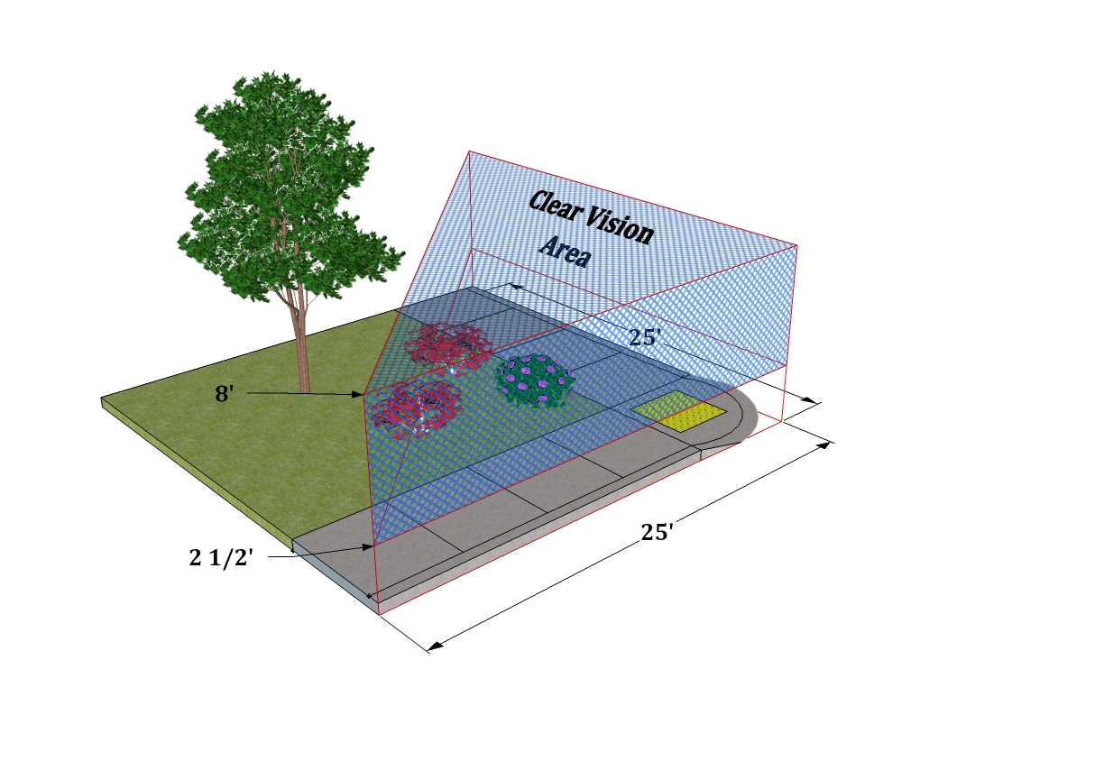

153.082 ONSITE LIGHTING.
(A) As part of any application for a development or any use within the City, all on-site lighting shall be designed, located, shielded or deflected, so as not to shine directly onto adjoining properties, impair the vision of a driver of any vehicle or be a hazard to aircraft operations within the area.
Home
(Covered in tables).

153.083 STANDARDS FOR SPECIFIC USES.
A use shall comply with the standards of the zone in which it is located, with the specific standards that may be applicable thereto as set forth by this section, with any additional standards and conditions that may be set forth by the reviewing authority and with any other applicable local, state and/or federal regulations.
(A) Residential care facility or residential care home. When permitted as a conditional use, the facilities shall be subject to the following conditions and limitations:
(1) A provider must live in the home that is to be used for the purpose and must be certified for the intended care, or must hire a certified resident care manager whom shall reside in the subject home.
(2) There shall be adequate sleeping accommodations for all occupants and resident staff.
(3) The resident structure shall be inspected by the City Fire Chief and a certified Building Official and determined to be reasonably safe from fire and other safety hazards. The cost of the inspection(s), as applicable, shall be borne by the applicant.
(4) As may be recommended by the officials in the foregoing inspection, appropriate fire alarms shall be installed and an approved fire exit plan established. Not less than two exits from the structure shall be readily available to all occupants.
(5) Appropriate handicapped facilities and access shall be provided and/or installed as recommended by the appropriate local, county or state officials.
(6) Off-street parking shall be provided for all needs generated by the proposed use unless approved otherwise by the city.
(7) Annual inspections of the facilities shall be made by the appropriate state agency, and a report of the inspections shall be provided to the city within 10 days of the receipt thereof by the applicant.
(8) As applicable, state licensing requirements shall be complied with on a continuing basis; failure of the compliance shall be a violation of this chapter and constitute sufficient grounds for permit revocation.
(B) Automobile wrecking yard or junk yard. In considering an application for an automobile wrecking yard or junk yard, the following factors, conditions and limitations shall be applicable:
(1) No such facility shall be permitted within 500 feet of the right-of-way of a state highway or other arterial or major collector unless hidden or adequately screened by terrain or other natural objects, or by plantings, fences or other appropriate means so as not to be visible from the main traveled way of the right-of-way.
(2) As applicable, applicant has been issued a wrecker certificate from the Department of Motor Vehicles or that the certificate of issuance be a condition of final approval, and that continued possession and compliance therewith be a condition of approval.
Home
(3) A building and/or enclosure or other barrier at least 6 feet in height shall be constructed and maintained, and that the subject use shall be contained totally within the building and/or enclosure.
(4) Premises on the outside of the establishment shall be maintained in a clear and clean condition at all times.
(5) No activity involving any wrecking, dismantling or altering of vehicles shall be permitted outside the building, enclosure or barrier at any time.
(6) In an industrial or commercial zone, the display and offer for sale of vehicle parts or vehicles outside the building, enclosure or barrier may be permitted, but shall be limited to a single defined area comprising not more than 5% of the total area of the business and to not more than eight vehicles at any one time.
(7) In any zone except an industrial or commercial zone, the outside display shall be limited to 5% of the total area and not more than 4 vehicles.
(8) Special consideration shall be given to the following factors, and additional setbacks, screening and other conditions and limitations may be established relative thereto.
(a) Extent of development of surrounding property as a residential area.
(b) Proximity of churches, schools, hospitals, public buildings or other places of public assembly or gatherings, particularly recreational facilities.
(c) The health, safety and general welfare of the city and the public.
(C) Bed and breakfast facility. In the review and approval of such a facility, the following conditions and limitations shall apply. (O.A.R. 333-170)
(1) Compliance with applicable state regulations shall be established or assured, and continued compliance therewith shall be a condition of approval.
(2) Subject facility shall be inspected by the City Fire Chief and a certified Building Official relative to structural and fire safety conditions and hazards. A report and recommendation therefore shall be received and considered prior to final action on a proposed facility. The costs of the inspection, as applicable, shall be borne by the applicant.

(3) The owner and/or manager of the facility shall reside on the premises.
(4) All parking demands shall be accommodated totally off-street on the premises, except as approved otherwise by the reviewing authority.
(5) Total occupancy load shall be limited to the number of available private bedroom facilities, but in no case shall the number of rental units exceed 6.
(6) As may be applicable, annual inspection shall be made of the subject facility by the appropriate local, county or state official(s) and a copy of the annual inspection report shall be provided to the city within 10 days of the receipt thereof; the costs of the inspection shall be borne by the applicant/owner if applicable.
(7) As applicable, state licensing requirements shall be complied with on a continuing basis, and failure to comply therewith shall constitute grounds for permit revocation.
(8) As applicable, a city business license shall be required.
Home
(D) Dog pounds or kennels. The reviewing authority may authorize dog pounds or kennels as permitted by the primary zone, and upon a finding that the use would not be detrimental to the adjoining properties and surrounding area because of noise, odor and other associated nuisances.
(1) Building and site design shall be adequate to minimize noise and odor.
(2) A sight-obscuring and sound-reducing fence or hedge or vegetative screening may be required.
(3) Holding cages and facilities may be restricted to being totally located within a building, and sound-insulating construction may be required.
(4) Vehicular access and loading/unloading facilities may be restricted as to number, location and improvement requirements.
(5) The types and numbers of animals permitted may be specified.
(6) Receipt of a valid complaint concerning odor, sanitary conditions and/or noise shall constitute sufficient grounds for immediate permit review and possible revocation.
(7) No on-site disposal of animals shall be permitted.
(E) Home occupations. When permitted as a conditional use and conducted as an accessory use to the primary use, a home occupation or a cottage industry may be permitted subject to the following standards and limitations.
(1) It will be operated by a resident of the property on which the business is located.
(2) It shall be limited to either an existing accessory structure, or to not more than 25% of the floor area of the main floor of the primary dwelling.
(3) The use is secondary to the main use of the property as a residence.
(4) In no case shall alterations or additions detract from the outward appearance of the property as a residential use.
(5) Except as approved otherwise by the city, total employment shall not exceed 4 persons, including the owner/operator(s) and members of the immediate family.
(6) No use shall be permitted that is found to be detrimental to the residential use of the subject property or adjoining or area properties because of noise, vibration, dust, smoke, odor, traffic, or interferences with radio or television reception or other factors.
(7) Retail sales shall be limited to those commodities and/or materials used in conjunction with the use, shall not be the primary basis for the proposed use and off-street parking and access shall be designed and provided for at such levels that the customer traffic does not create the appearance of a commercial business parking lot.
(8) No materials or commodities shall be delivered to and from the premises at a time, or of such bulk or quantity, as to create undesirable traffic, noise, congestion or hazards.
(9) Hours of operation and associated activities shall be within normal daylight business hours for the type of business involved, and in no case infringe upon the rights of neighboring residents to enjoy the residential occupancy of their homes. Uses involving nonresident employees, the delivery of goods or materials or customer visits shall limit their hours of operation to between 8:00 a.m. and 6:00 p.m. unless otherwise approved by the city.
Home
(10) The existence of a home occupation or a cottage industry shall not be used as justification for a zone change.
(11) All parking shall be entirely accommodated by a combination of off-street and on-street parking limited to the subject premises and the frontage of the subject property.
(12) Sight-obscuring fencing and/or landscaping of at least 6 feet in height may be required between the use and adjacent properties or public streets.
(13) Signs associated with the proposed use shall not exceed 8 square feet in area.
(14) The disposal of all wastes associated with the subject use shall be provided for as required by the city and in accordance with applicable city, county and/or DEQ standards.
(15) The use shall only be operated by residents of the property. As applicable, a city business license shall be required.

(16) The Planning Commission shall review the permit for a home occupation or cottage industry upon the receipt of 2 or more written complaints of violations of these or applicable state standards or regulations from 2 or more households within 250 feet of the boundaries of the affected property.
(a) A public hearing shall be held to review the complaints and the subject permit.
(b) The Commission, after reviewing the permit and the complaints relative thereto, and after hearing the evidence presented at the hearing, may, with adequate findings, do any of the following.
1. Approve the continuance of the use as it exists.
2. Require that it be terminated.
3. Impose new and additional restrictions for the continuance. New complaints which are substantially the same as those previously reviewed and acted upon will only be heard by the Commission after a period of 6 months has elapsed from the date of the earlier decision, unless the Commission believes or finds that any restrictions or conditions imposed on the use have not been followed or complied with.
(17) Home occupations of a minor nature that do not advertise on site, change the outward appearance of the home or produce a significant amount of additional traffic are allowed outright without review. Examples would include: musical lessons, photo studio, attorney, or accountant. Should a home occupation reach a level that is not considered minor the above criteria shall apply.
Home
(F) Mobile home or manufactured dwelling park. In addition to the standards and conditions set forth herein, the development shall be in compliance with applicable state regulations, and with any additional conditions set forth in the approval thereof, and such compliance may be required prior to the occupancy of the development. (O.R.S. 446 and O.A.R. 814-28).
(1) Each access road intersecting a public street shall have a surface width of not less than 30 feet, and driveways within the park shall be at least 20 feet in width, or if parking is permitted thereon shall be at least 36 feet in width.
(2) All public roads and driveways shall be well-drained and hard-surfaced as approved by the City Superintendents of Streets and Public Works and/or the City Engineer in accordance with city standards and/or with the “durable and dustless surface” definition set forth in 153.086.
(3) Walkways, bicycle paths or other pedestrian ways may be required, and if required, shall not be less than 5 feet in width and hard- surfaced in accordance with the foregoing referenced, “durable and dustless surface” definition.
(4) Each space within the park shall be serviced with public water and sewer facilities and electrical power receptacles for solid wastes shall be provided, and fire hydrants shall be installed as deemed necessary by the City Fire Department.
(5) Facilities for incoming and outgoing mail shall be installed in accordance with the requirements of the U.S. Postal Service.
(6) There shall be constructed on each unit space, adjacent and parallel thereto, 1 or more wooden decks or slabs or patios of concrete, asphalt, flagstone or the equivalent, which singularly or in combination total at least 120 square feet

(7) In no case shall an individual unit space be permitted that is less than 30 feet in width or less than 40 feet in length.
(8) Except as provided otherwise herein, in no case shall the overall density exceed 12 units per acre. An increase in density may be approved by the city in accordance with the following standards.
(a) An increase of 10% in the maximum allowable density for dedicated and improved open space equaling 30% or more of the total land area of the development.
(b) An increase of 5% in the maximum allowable density for the development and maintenance of an approved recreation and/or common use building or other indoor facility.
(c) An increase of 5% for a developed playground area. (d) An increase of 10% for a developed recreation area including a covered picnic area, basketball and/or tennis court facilities and the like.
Home

(e) In no case, however, shall the total of density increases provided for herein exceed 25%.
(10) All parks shall provide recreational space of at least 2,500 square feet plus 50 square feet for each unit within the park. The recreational space shall be improved with landscaping to provide open recreation and shall be secured from driveways and parking areas. Facilities such as picnic tables, barbecues and playground equipment are recommended.
(11) No dwelling unit in the park shall be located closer than 15 feet from another unit or from a general use building in the park. No dwelling unit, other building or structure shall be located within 25 feet of a public street right-of-way line, or within ten feet of any other property boundary line.
(12) No unit shall be permitted in a park as a residence that does not meet the definition set forth by 153.004.
(13) No recreation vehicle shall be permitted to be located within a park and occupied as a residence, and no such vehicle shall be permitted within a park unless on spaces for such RV use are designated therefore in the park design and approval.
(14) A unit permitted in a park shall be provided with continuous skirting within 30 days of placement.
(15) The total land area used for park purposes shall be required to be surrounded, except at entry and exit places, by a sight-obscuring fence or hedge not less than 6 feet in height.
(16) If a park provides spaces for 20 or more units, each vehicular way in the park shall be named and marked with signs which are similar in appearance and location to those used to identify public streets in the city. A map of the entire development showing named vehicular ways shall be provided to the City Fire Department, other service agencies, the City Police Department and the City Planning Official.
(17) An updated listing of the names and addresses of the occupants of each space in the park shall be maintained at all times and a copy thereof provided to the city upon request.
(G) Temporary mobile home park. With the exception of standards concerning access and driveway improvements, mail service, telephone, playground areas, patios and overall density set forth by division (F) of this section, the city may approve a temporary mobile home park for the establishment of the facility for a construction company, timber company or farm or by exclusive use by such companies by a party independent thereof. The approval may only be granted if the following conditions are met. (O.R.S. 446.105)
Home
(1) There is no available space or inadequate space available in existing or planned mobile home parks for which construction has commenced within a reasonable distance.
(2) A mobile or manufactured home park is necessary for the proper housing of the subject company's employees until the construction; farm or logging project is finished.
(3) The subject facility will not be occupied by any parties not employed by the subject company or subcontractors thereto.
(4) There is an identified housing shortage in the area, due to the size of the subject project to be served.
(5) The facility shall not be permitted for a period to exceed the time required to provide temporary housing for the special use or project to be served thereby, or for a period of 12 months, whichever is less.
(6) If the facility is converted or proposed to be converted to a permanent facility at the end of the period, full compliance with the standards and set forth by division (F) of this section shall be required.
(H) Multi family dwelling complex. A multi family dwelling complex permitted as a conditional use shall comply with the following standards and conditions, and the compliance shall be evident prior to occupancy except as may otherwise be approved by the city.
(1) All such complexes with more than 20 dwelling units shall be so located as to have direct access onto an improved arterial or collector street unless approved otherwise by the city.
(2) All such complexes shall provide both an improved ingress and egress.
(3) Each access road permitting two-way traffic and intersecting a public street shall have a minimum surface width of not less than 30 feet, and not less than 16 feet in width for single-lane, one-way traffic. Interior complex driveways shall not be less than 24 feet in width for two-way traffic, and not less than 12 feet in width for single-lane traffic. For interior driveways providing on-street parking, an additional eight feet of width shall be added for each parking lane or area. All access roads, driveways and parking facilities shall be improved and maintained with “durable and dustless surfaces” as defined in 153.086, and as approved by the City Superintendent of Streets.
(4) Sidewalks, walkways, bicycle paths and other pedestrian ways may be required. The walks, paths and ways shall not be less than four feet in width and shall be surfaced with concrete, asphalt, asphaltic concrete or paving bricks as approved by the City Superintendent of Streets.
(5) The complexes may be required to provide storage facilities and/or extra parking spaces as deemed necessary to provide for tenant storage of household goods, equipment, extra furnishings and/or recreation vehicles.
(6) Each complex, and each individual unit contained therein, shall be serviced with public water and sewer, electrical power, receptacles for garbage disposal and collection service, and fire hydrants shall be installed as deemed necessary by the City Fire Department.
Home
(7) Facilities for incoming and outgoing mail shall be installed in accordance with the requirements of the U.S. Postal Service.

(9) The overall density of the complex shall not exceed the dimensional standards set forth by the applicable zone, except as approved otherwise by the city in accordance with the following factors.
(a) An increase of 5% in the maximum allowable density for dedicated and improved open space equaling 25% or more of the total land area of the development.
(b) An increase of 5% in the maximum allowable density for the development and maintenance of an approved recreation and/or common use building or other indoor facility.
(c) An increase of 5% for a developed playground area
(d) An increase of 5% for a developed recreation area including a covered picnic area, basketball and/or tennis court facilities and the like.
(e) As an incentive for development excellent, a total increase of 25% may be permitted if three or more of the foregoing are provided.
(10) A complex shall provide recreational space of at least 2,500 square feet plus 50 square feet for each unit in the complex The recreational space shall be improved with landscaping to provide open recreation and shall be secured from driveways and parking areas. Facilities such as picnic tables, barbecues and playground equipment are recommended.
(11) For any complex permitting tenants to have recreation vehicles, camp trailers, boats and similar recreational equipment, there shall be provided a separate, designated parking area for such uses at a ratio of one space per each three units in the complex.
(12) If each unit in the complex is not provided with clothes washing and drying facilities, and there is not a private commercial coin-operated laundry facility within a reasonable walking distance, then there shall be provided within the complex a separate laundry facility providing not less than one washer and one dryer for each six units in the complex.
(13) The total land area of the complex may be required to be surrounded, except at entry and exit locations, by a sight-obscuring fence or hedge not less than six feet in height.
153.158 only.
Home

Moved to cluster development 153.094.

(I) Radio, telephone or television transmitter tower, utility station or substation. When authorized within the applicable zoning, the following standards and limitations shall apply to radio, telephone or television transmitter towers, or utility stations and substations.
(1) In a residential zone, all equipment storage on the site shall be enclosed within a building.
(2) The use may be required to be fenced, including sight-obscuring, and provided with landscaping.
(3) Coloring of structures, buildings and other permanent installations shall be of neutral colors or colors that otherwise blend with the surrounding natural features unless otherwise required by the Commission.
(4) The reviewing authority may set standards or limitations regarding height, shape, location or factors necessary to minimize the impact of the facilities on the area in which they are proposed to be located.
(5) The reviewing authority may set any standards or limitations deemed necessary to insure that the proposed facilities are aesthetically pleasing and compatible with the area.
(J) Recreation Vehicle Parks. A recreation vehicle park shall be constructed, maintained and operated in accordance with applicable state standards and regulations, and shall also comply with the standards and conditions set forth herein. (O.R.S. 446 and O.A.R. 333-31).
(1) Water supply service to each camping space is not required, but at least 1 water supply service shall be provided on-site.
Home
(2) In lieu of individual sewer connections, at least 1 sewage disposal station shall be provided on-site for the park.
(3) All solid waste shall be stored in individual garbage containers, storage bins or storage vehicles. All such containers shall have tight-fitting lids, covers or closable tops, and shall be durable, rust-resistant, watertight, rodent-proof and be readily washable. All solid waste shall be collected for disposal at regular intervals not to exceed seven days.
(4) Liquefied petroleum gas storage tanks on-site shall be approved by the City Fire Chief and/or the State Fire Marshall as applicable.
(5) Toilet, hand washing and bathing facilities shall be maintained to meet the requirements set forth by the Building Official and the County and/or State Health Division.
(6) Eating and drinking establishments, commissaries, mobile units and vending machines operated in conjunction with the park shall be approved in accordance with applicable provisions of this chapter and in accordance with applicable regulations administered by the County and/or State Health Division.
(7) All swimming pools, spa pools and wading pools in a recreation park shall comply with the applicable rules of the County and/or State Health Division.
(8) The owner and/or management of a recreation park shall maintain all buildings, grounds, rental units, spaces and furnishings in good repair and appearance, and in clean condition at all times.
(9) Either the owner, an operator, resident manager or other supervisor shall be available on the premises of a recreation park at all times while it is open for use, except as otherwise approved by the city.
(10) Each camping space shall be identified by number, letter or name.
(11) Each camping space shall be large enough to accommodate the parked camping vehicle, tent vehicle or tent as the case may be and for which the space was intended or designed, and to maintain at least ten feet separation from any other camping vehicle or tent, ten feet from any building, 20 feet from a boundary line abutting a public street or highway and ten feet from any other boundary line. Only 1 camping vehicle, tent vehicle or tent is permitted per space.
(12) Each recreation park shall have direct access to either an arterial or collector street. Each access road intersecting a public street or highway shall have a surface width of not less than 30 feet, and driveways within the park shall be at 20 feet in width or if parking is permitted thereon, 36 feet in width. All roads and driveways shall be well-drained and hard-surfaced as approved by the city and the City Superintendent of Streets.
(13) Each space in the park shall have direct access to a park driveway or road.
(14) Except as approved otherwise in those parks providing independent sewer and water services to individual spaces, toilet facilities shall be provided in recreation vehicle parks in the following ratios.

Home
Number of Spaces Number of Toilets
1-15 2
16- 30 3
31- 60 5
61-100 7

(15) The density of RV parks shall not exceed 20 campsites per acre except as otherwise approved by the Commission; the Commission may adjust the density downward in the case of limitations necessary by steep slopes, geologic or natural features or impacts on adjacent areas.
(16) Each recreation vehicle space shall be a minimum of 200 square feet.
(17) Each RV space shall contain no more than 33% paving or concrete.
(18) Landscaped or open space areas shall be a minimum of 20% of the project site, and may include nature trails, buffers, landscaping, common picnic or recreation areas, wetlands or streams.
(19) Accessory uses may include an owner's/manager's office/residence, restroom and bathing facilities, laundry, mini market with limited gasoline and propane gas services, swimming pool and other small-scale recreational facilities such as tennis courts, miniature golf and playgrounds for the use of park customers only.
(20) 1 additional parking space for each 4 campsites shall be provided in convenient locations throughout the park, except that this requirement may be reduced where individual RV spaces are of such dimensions to permit at least 1 additional parking space on site.
(21) The reviewing authority may exempt certain temporary recreation vehicle facilities from the on-site improvement requirements, requirements for toilets, water supply, sewage disposal and spacing if such temporary facilities are for the purpose of accommodating a camping vehicle rally or other groups of camping vehicles assembled for the purpose of traveling together or for special events such as fairs, rodeos, races, derbies, community event celebrations and the like and the reviewing authority finds that the public health will not be endangered. The period of operation shall be designated by the reviewing authority as shall other conditions such as solid waste collection and disposal found necessary to protect the public health and general welfare. In no case shall the temporary facilities be approved in conjunction with private commercial activities, except as temporary RV locations for highway or building construction or forestry projects, and in no case shall a temporary facility for the projects be approved if other alternatives for housing the employees associated with such projects are found to be available.
(22) Recreational Vehicle (RV) Parks within the General Residential (R-2) zone shall comply with the above requirements as well as the following:
(a) RV parks within the R-2 zone shall only be allowed on properties with direct frontage on an arterial street as identified by the City of Prineville transportation systems plan (TSP). In no case shall a local street be used for ingress or egress from the site. If a site has access to both a collector and an arterial, access shall be determined by the City Engineer.
(b) Arterial streets provide the entrances into our community. Therefore an applicant shall take careful consideration to the appearance of the entrance to the park. In review of any RV park proposal the Planning Commission shall be responsible for the design review of the entrance.
Home
(c) As part of the 20% landscaping and open space, screening from neighboring properties and public streets shall take priority.
(K) Camping vehicle building, boat building, cabinet, carpentry or other contractors' shops, machine shops, vehicle repair or storage or similar uses.
(1) Materials, vehicles or parts shall be stored in an enclosed structure, or where impractical in a structure, behind fences or vegetative buffers.
(2) Odors, fumes, sawdust or other emissions shall be controlled so as not to affect adjacent properties.
(3) Noise and other pollution or contaminant discharge standards of the Department of Environmental Quality shall be adhered to.
(L) Public or private facilities, utilities and services.
(1) Public facilities including, but not limited to, utility substations, sewage treatment plants, storm water and water lines, water storage tanks, radio and television transmitters, cell towers, electrical generation and transmission devices, fire stations and other public facilities shall be located so as to best serve the community or area with a minimum impact on neighborhoods, and with consideration for natural aesthetic values.
(2) Structures shall be designed to be as unobtrusive as possible.
(3) Wherever feasible, all utility components shall be placed underground.
(4) Public facilities and services proposed within a wetland or riparian area shall provide findings of the following.
(a) The location is required and a public need exists.
(b) Dredging, fill and other adverse impacts are avoided, minimized or mitigated to the maximum extent reasonable.
(5) Co-locating on existing utility poles or cellular towers is required unless demonstrated that it is not feasible.
(M) Airports, aircraft landing fields, aircraft charter, rental, service and maintenance facilities not located in an Airport (A- ) Zone. In the review and approval of the facilities, the Planning Commission shall find the following.
(1) That the location and site design of the proposed facility will not be hazardous to the safety and general welfare of surrounding properties.
(2) That the location will not unnecessarily restrict existing and future development of surrounding lands as designated by the Comprehensive Plan.
(3) That the location will not unnecessarily restrict, be in conflict with or be hazardous to the existing and future development of the City-County Airport.
(4) As applicable, the subject facility has been reviewed and approved by the State Department of Aeronautics and/or the Federal Aviation Administration; or, as applicable, the review and approval is a condition of approval.
(N) Cemeteries. The reviewing authority shall require evidence and shall find that the terrain and soil types of a proposed location are suitable for interment, and that the nature of the subsoil and drainage will not have a detrimental effect of ground water sources or domestic water supplies in the area of the proposed use.
Home
(O) Church, hospital, nursing home, convalescent home, retirement home, and elderly assisted housing complex. Such uses may be approved only after consideration of the following factors.
(1) Sufficient areas provided for the building, required yards, and off-street parking (related structures and uses such as a manse, parochial school or parish house are considered separate principal uses and additional lot areas shall be required therefore.
(2) Location of the site relative to the service area.
(3) Probable growth and needs therefore.
(4) Site location relative to land uses in the vicinity.
(5) Adequacy of accesses to and from principal streets together with the probable effect on the traffic volumes and patterns of abutting and nearby streets.
(6) Such uses or related buildings shall be at least 10 feet from a side or rear lot line abutting an existing residential use in a commercial or industrial zone, and 20 feet from a side or rear lot line abutting a residential zone.
(7) Such uses may be required to provide sound-insulating screening and/or construction methods if found to be within an area of influence of an existing commercial or industrial use which is considered incompatible with a noise sensitive use.
(8) Such uses may be built to exceed the height limitations of the zone in which it is located to a maximum height of 50 feet if the total floor area of the building does not exceed the area of the site and if the yard dimensions in each case are equal to at least two-thirds of the height of the principal structure.
(9) Such uses should provide for, and may be required to provide, outside sitting and/or exercise areas in sufficient areas to accommodate patient or resident loads.
(P) Solid waste collection, disposal and/or transfer station. The reviewing authority may authorize a solid waste collection and/or disposal site or transfer station as a conditional use, subject to the following standards.
(1) The proposed site shall not create a fire hazard, litter, insect or rodent nuisance or air or water pollution in the area.
(2) The proposed site shall be located in or as near as possible to the area being served.
(3) The proposed site shall be located at least 1/4 mile from any existing dwelling, home or public road (except the access road), unless approved otherwise with adequate screening and buffering.
(4) The proposed site shall be provided with a maintained access road (all-weather).
(5) The proposed site and facility shall be enclosed in such a manner that materials that may be carried by the wind or animals are totally contained within the site.
(6) Any other condition that the reviewing authority deems necessary to minimize the potential adverse impacts on the surrounding area, while taking into account the public need for solid waste disposal alternatives.
(Q) Mining, quarrying or other aggregate extraction or processing activities. Plans and specifications submitted to the reviewing authority for approval must contain sufficient information to allow the authority to consider and set standards pertaining to the following.
(1) The most appropriate use of the land.
Home
(2) Setbacks from the property lines and surrounding uses.
(3) The protection of pedestrians and vehicles through the use of fencing and screening.
(4) The protection of fish and wildlife habitat and ecological systems through control of potential air and water pollutants.
(5) The prevention of the collection and the stagnation of water at all stages of the operation.
(6) Surface mining equipment and necessary access roads shall be constructed, maintained and operated in such a manner as to eliminate, as far as is practicable, noise, vibration or dust which may be injurious or annoying to persons or other uses in the vicinity.
(7) The comments and recommendations of all appropriate natural resource agencies of the state and federal government shall be sought.
(8) A rock crusher, washer or sorter shall not be located closer than 500 feet from a residential or commercial zone.
(9) A sight-obscuring fence or other screening may be required by the reviewing authority, when, in its judgment, the fence or other screening is necessary to preserve the values of nearby properties or to protect the aesthetic character of the neighborhood or vicinity.
(R) Motel, hotel, convention center, multi use pavilion, sports arena or other similar uses. Such uses may be approved only after consideration of the following factors.
(1) Sufficient areas provided for the main buildings, required yards, off-street parking and related or accessory or support structures and uses.
(2) Location of the site relative to the service area or to other related facilities and uses.
(3) Probable growth and needs therefore.
(4) Site location relative to land uses in the vicinity.
(5) Adequacy of accesses to and from principal streets; relative thereto, access must be to either a designated collector or arterial street.
(6) Such uses or related buildings shall be at least 20 feet from a side or rear lot line abutting a residential use or a residential zone.
(7) Such uses may be required to provide sound-insulating screening and/or construction methods if found to be within an area of influence of an existing commercial or industrial use which is considered incompatible with a noise sensitive use.

(S) Professional commercial uses. Professional commercial uses such as offices for accountants, bookkeepers, attorneys, engineers, architects, doctors, dentists, real estate and insurance and medical or dental clinics in an R-2, R-3 or R-4 Zone subject to the following conditions and limitations.
(1) Uses shall be located within a preexisting residential structure. An applicant may rebuild a structure if it is determine that the existing structure is in such a condition as not to be economically viable to restore. Any new structure shall be residential in design and will be subject to design review by the reviewing authority.
Home
(2) Have frontage on an existing designated or future planned arterial and/or collector street.
(3) Access to and from the proposed use is not required solely to pass through a residentially zoned and developed area on a local or lower classified street.
(4) Traffic and parking generated and/or required by the proposed use will adversely affect the overall residential character of the area.
(5) The proposed use is found to result in a general improvement of the physical appearance and aesthetics of the subject property and the general area.
(6) In reviewing and approving such a use, the reviewing authority may consider the following factors.
(a) The need for screening, landscaping and other factors that will minimize the impact of the proposed use on adjoining residential uses.
(b) The need for, and availability of, off-street parking.
(c) Limitations on hours and days of operations, signing and other factors deemed necessary to preserve and protect the residential character of the neighborhood.

(T) Residential dwellings in a commercial zone. Residential uses from single family dwelling to fourplexes shall consider the following limitations when placed in a commercial zone.
(1) Structures shall not be located on a collector or arterial streets unless;
(2) The property is determined not to be commercially viable based on size, location and surrounding uses.
(3) Provisions for the future conversion to a commercial business should be considered when placing a residence on a lot.

(Moved to section 153.015).

153.084 Attached Single Family Housing , Townhomes & Duplex lots
(A) Attached Single Family Housing. Any 2 adjacent legal lots zoned for single family homes may build 2 single family homes attached at the lot line (see Dwelling townhome definition) in accordance with the Building code. All owner signatures are required.
Home
(B) Townhomes (as part of a cluster development or PUD). Shall comply with the standards in 1-4, below. The standards are intended to control development scale; avoid or minimize impacts associated with traffic, parking, and design compatibility; and ensure management and maintenance of common areas. Cluster Development standards can be found in section 153.094.
(1) Building Mass Supplemental Standard. Within the residential zones, the maximum number and width of consecutively attached townhomes (i.e., with attached walls at property line) shall not exceed 6 units, or 150 feet (from end-wall to end-wall), whichever is less.
(2) Each townhouse shall have some architectural articulation by either staggering the buildings or including unique features within the façade to produce the same effect (ie: no long continuous flat wall).
(3) Alley Access. Subdivisions (4 or more lots) containing townhomes shall receive vehicle access only from a rear alley. Alley(s) shall be created at the time of subdivision approval. Alleys are not required when existing development patterns or topography make construction of an alley impracticable (See “3” for standards). Alley access shall also be required on existing lots if available. As necessary, the City shall require dedication of right-of-way or easements and construction of pathways between townhome lots (e.g., between building breaks) for access and circulation.
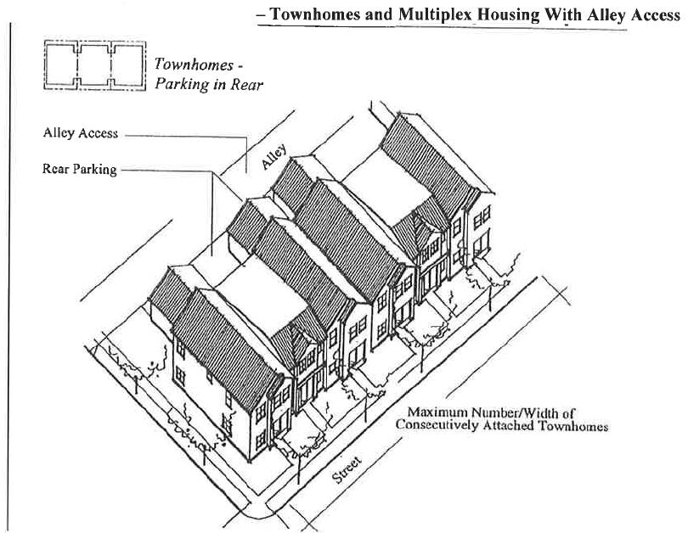

Home
(4) Street Access Developments. Townhomes receiving access directly from a public or private street shall comply with all of the following standards in order to minimize interruption of adjacent sidewalks by driveway entrances, slow traffic, improve appearance of the streets, and minimize paved surfaces for better storm water management.
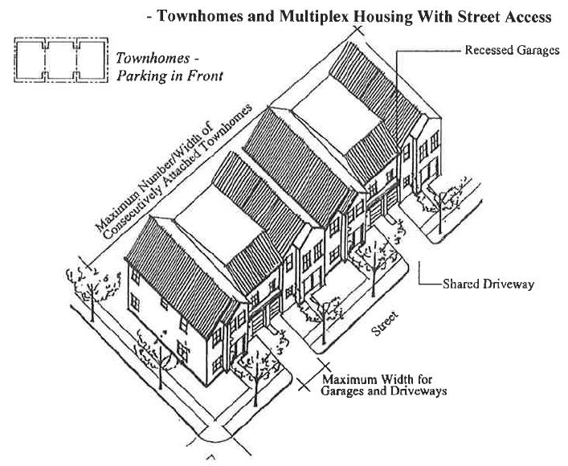

(a) When garages face the street, they shall be recessed behind the front elevation (i.e., living area or covered front porch) by a minimum of 4 feet.
(b) The maximum allowable driveway width facing the street is 20 feet per dwelling unit for double car garages and 12 feet for single car garages.
(c) Two adjacent garages shall share one driveway when individual driveways would otherwise be separated by less than 20 feet (i.e., the width of 1 on-street parking space). When a driveway/curb cut serves more than 1 lot, the developer shall record an access and maintenance easement/agreement to benefit each lot, prior to building permit issuance.
(5) Common Areas. “Common areas” (e.g., landscaping in private tracts, shared driveways, private alleys, and similar uses) shall be maintained by a homeowners association or other legal entity. A homeowners association may also be responsible for exterior building maintenance. A copy of any applicable covenants, restrictions and conditions shall be recorded and provided to the city prior to building permit approval.
(5) Utilities. Each lot shall have separate public and private utilities.
(C) Duplex lots. Duplex lots essentially allow for 2 unit townhomes outside of the cluster development standards (section 153.094). A duplex lot is intended to look, feel and act like a duplex but allow for separate unit ownership of not only the building but the land as well. The following criteria shall be met for the approval of a duplex lot.
(1) Minor Partition. The process for creating a duplex lot shall follow the process and platting procedures for a minor partition located in section 153.160.
(2) Lots shall be restricted to attached homes only. A deed restriction shall be recorded with the partition plat.
Home
(3) Original lot size. The original lot shall meet at least the current minimum lot size standard of the applicable zone and street frontage requirements including cul-de-sac standards.
(4) Duplex lot size. Each duplex lot shall be at least half the size of the original lot and at least half the size of the current required street frontage.
(5) Structure. The structure itself shall meet all the dimensional standards of the required zone including parking.
(6) Utilities. All utilities public and private shall be separate.
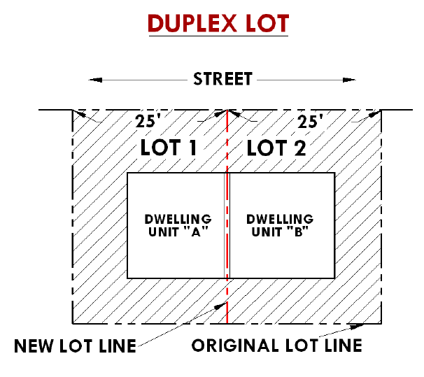

Removed, unecessary.

Moved to 153.080.

Removed, not desirable.
Home
Moved to tables and 153.014 General Criteria.

153.085 OFF-STREET PARKING AND LOADING: PROVISIONS AND REQUIREMENTS.
(A) The provision and maintenance of off-street parking and loading facilities are continuing obligations of the property owner. No building permit shall be issued until plans are submitted and approved by the city that show property that is and will remain available for exclusive use as off-street parking and loading facilities as required by this section and this chapter. The subsequent use of property for which the building permit is issued shall be conditional upon the unqualified continuance and availability of the required parking and loading facilities set forth by this section and this chapter. It is not, however, the intent of these provisions to require off-street parking and loading facilities in a manner as to unreasonably limit improvements to existing structures and uses, particularly in that area identified as the downtown core commercial area.
(B) Applicability. Unless exempted by this section, all construction, reconstruction, enlargement of a structure or at the time a use is changed in any zone off-street parking facilities shall be provided in accordance with the requirements set forth by this section and section 153.086
(C) Exemptions. The following are exemptions in all zones.
(1) Outright uses existing on or before the effective date of this chapter on a lot or parcel of land that has no remaining room for off-street parking and loading facilities;.
(2) Exterior remodeling and/or expansion of a use up to and not exceeding 25% of the total square footage of all structures on a specific lot or parcel under unit ownership, however, any existing parking displaced by the remodeling and/or expansion shall be replaced.
(3) Changes of uses that are permitted outright in a zone and occupy an existing building or site that is either similar to the previous use or of equal or lesser impact to the site with regard to traffic impacts as determined by the reviewing authority and City Engineer. A change of use application may be required to make this determination.

(D) Specific Parking Requirements by Zone.
(1) R-1, R-2, R-3 and R-4 Zones.
(a) No specific requirements; the number of spaces required are listed in the table below; spaces shall meet City standards.
Home
(2) C-1 Zone. More specifically, the provisions of this section shall be exempted for uses permitted outright in a C-1 Zone, which occupy an existing building on a parcel of land which contains no room for parking. For those parcels of land which do have room for parking, the standards of this section shall apply.
(a) Except as may be approved otherwise by the City, all employee parking demand created by any use permitted under the provisions of this section shall be provided entirely off-street on an area or facility, public or private, designated for such use; no on-street parking shall be considered in meeting the requirement for employee parking. In the event that the City has established a process for a parking in lieu of fee, this fee may be used to reduce required parking in accordance with the policy. This fee would then be used for future public parking facilities.
(c) Redevelopment of existing second and third floor uses, including residential uses shall also be exempt from the parking requirements.
(d) Required parking for new construction shall utilize alleys to the greatest extent possible primarily placing required parking at the rear of the structure and not along the primary or higher order street.
(e) Bicycle parking shall be provided with all new construction at a minimum of 2 spaces per use. Consolidation of Bicycle racks per block is allowed.
(3) C-2, C-3, C-4 and C-5 Zones. All parking demand created by any use permitted in this zone shall be accommodated entirely on-site or off-street on another area or adjoining site within a reasonable walking distance of not more than 1,200 feet that is available for the subject use in compliance with the standards set forth herein. The location of any off-site parking area that requires pedestrians to cross an arterial or collector street or highway to obtain access to the subject use is prohibited.
(a) No use permitted in this zone shall require the backing of traffic onto a public street right-of-way to accommodate ingress or egress to any use or the premises thereof unless approved otherwise by the City.
(b) Bicycle parking shall be provided at a rate of 1 space per 12 vehicle parking spaces.
(4) M-1, M-2 and M-3 Zones. All parking demand created by any use permitted in this zone shall be accommodated entirely on-site or off-street on another area or adjoining site shared by one or more uses permitted in this zone. The location of any off-site parking area that requires pedestrians to cross an arterial or collector street or highway to obtain access to the subject use is prohibited.

(E) Parking Table.Where the square feet of the structure or use are specified as the basis for the requirements, the area measured shall be the gross floor area primary to the functioning of the particular use of the structure and property. When the requirements are based on the number of employees and/or the number of occupants, customers or users, the number counted shall be the number of employees working on the premises during the largest shift at peak season, and the number of occupants, customers or users shall be counted as the maximum rated capacity. Fractional requirements shall be counted as a whole space and parking spaces in a public street, including an alley, shall not be eligible as fulfilling any part of the parking requirement.
Home

Use Description | Minimum Requirements
Residential
Single Family Dwelling & Duplex  (includes townhomes) | 2 spaces per unit, including driveways and garage approaches.
Multi Family Dwelling (3 to 4 attached units)  (includes townhomes) | 2 spaces per unit, including driveways and garage approaches.
Multi family complex | 1.5 spaces per unit from 5 to 8 units; 1.25 spaces per each unit thereafter, plus 2 spaces for owner/manager.
Res. use other than ground floor | 1 space per Dwelling unit.
Res. use ground floor | 1 space per Dwelling unit.
Res. 2nd and 3rd story in C-1 zone | 1 space per Dwelling unit (new), none for existing Dwelling units or converted structures.
Residential Care Facility | 1 space per each two rooms plus 1 space for each manager and employee at peak use.
Residential Care Home | 2 spaces.
Accessory dwelling | 1 space per dwelling unit.
Guest house | No spaces required.
Homeless Shelter | As determined by reviewing authority.
Caretaker, Watchmen living on site | 1 space per Dwelling unit.
Home
Commercial Residential
Bed and breakfast | 1 space per guest room plus 2 spaces for owner/ manager.
Boarding, lodging or rooming house | 1 space per unit plus 2 spaces for owner/manager.
Hotels and motels | 1 space per guest room plus 2 spaces for owner/ manager.
Institutional
Club, lodge or convention center | 1 space per 4 seats.
Convalescent hospital, nursing home, sanitarium, rest home, home for the aged, elderly assisted living complex | 1 space per each 4 beds or lodging units for patients or residents, plus 1 space per employee.
Hospital | 1 space per each 4 beds, plus 1 space per employee on the largest work shift.
Public or Semi-Public Uses
Public recreational facility/Community Center. | 1 space per 300 s.f. of net square footage.
Park (public or private) | 5 spaces per acre.
Public Transportation Station | 1 space per 1000 s.f. enclosed.
RV Park (Public or Private) | 1 auto + RV space for each designated place and 5 guest spaces.
Utility Facility | 1 space, no full time employees.
Church | 1 space per each 4 seats.
Library, reading room | One space per each 400 sq. ft. of floor area plus 1 space per each employee.
Nursery, kindergarten | 1 space per employee and adequate off-street parking and loading areas for the delivery/pickup of patrons.
Elementary or junior high | 2 spaces per classroom plus 1 space per administrative Employee.
High school  Home | 8 spaces per classroom .
College | 1 space per employee plus 1 space per each 2 students.
Trade School or Adult Training | 1 space per employee plus 1 space per each student.
Other auditorium or meeting facility | 1 space per each 4 seats., or 1 space for each 75 sq. ft. of assembly room floor area.
Commercial Amusement
Amusement Park | 20 spaces per acre.
General Recreation, Outdoor | 20 spaces per acre.
General Recreation, indoor | 1 space per 4 seats.
Stadium, arena, theater | 1 space per each 4 seats.
Bowling alley | 4 spaces per alley plus 1 for each employee.
Golf Course | 50 spaces per each 9 holes.
Driving Range | 1 space per driving cage, plus 1 per employee.
Gymnasium, Fitness Center, Spa | 1 space per 300 s.f. of net square footage.
Dance hall, skating rink | 1 space per each 100 s.f. floor area plus 1 space per each employee.
Commercial
Retail store except those handling exclusively bulk materials | 1 space per 200 s.f. of retail floor area , plus 1 space per employee.
Retail store handling exclusively bulk merchandise; (includes RVs, Furniture) | 1 space per 1,000 s.f. of retail floor area, plus 1 space for each employee in peak employment shifts.
Shopping Center/Department stores | 1 space per 250 s.f. of floor area.
Telemarketing/Call Center | 1 space per employee, plus 5 guest spaces.
Service and Repair | 1 space per 600 s.f. retail floor area.
Auto Service | 1 space per service bay.
Auto Sales (new and used) | 1 space per sales office or cubicle.
Bank, offices (except medical and dental) | 1 space per 600 s.f. of customer service area, plus 1 space per employee during peak employment shifts.
Medical/dental clinic | 1 space per 300 s.f. of customer service area, plus 1 space per employee.
Veterinarian  Home | 2 spaces per DVM
Eating and/or drinking establishment | 1 space per 100 s.f. of customer service area, plus 1 space per employee.
Espresso Stand or drive through | 1 space per employee
Mortuaries, funeral home | 1 space per 4 seats, plus 1 space per employee.
Mini Storage | 1 space per employee..
Kennel | 1 space per employee , plus 2 spaces per customer service area.
Industrial
Equipment Rental, Sales and Service | 1 space per 600 s.f. of retail floor area.
Industrial, General | 1 space per 800 s.f.
Storage warehouse, manufacturing, transport facility. | 1 space per employee.
Truck Stop | As determined by reviewing authority.
Wholesale establishment | 1 space per 600 s.f. of customer service area, plus 1 space per employee.
Other Structures and Uses
To be determined by the reviewing authority on the basis of comparable use requirements.

153.086 OFF-STREET PARKING AND LOADING: DESIGN/IMPROVEMENT STANDARDS.
(A) In the event that several uses occupy a single lot or building, the total requirements for off-street parking shall be the sum of the requirements of the several uses computed separately.
(B) Owners of two or more uses, structures or parcels of land may agree to jointly utilize the same parking, loading and access facilities when the hours of operation do not overlap; provided however that satisfactory legal evidence is submitted to and approved by the reviewing authority in the form of deeds, leases or contracts to establish the joint use and provide for improvements and maintenance thereof.
(C) Off-street parking spaces for dwellings shall be located on the same lot with the dwelling. Other required parking spaces shall not be located farther than 600 feet from the building or use they are required to serve, measured horizontally in a straight line from the building or use, or not more than 1,200 feet from the building or use they are required to serve, measured along the route of the shortest and most direct walking distance, whichever is greater.
(D) Required parking spaces shall be available for the parking of operable passenger automobiles of residents, customers, patrons and employees only, and shall not be used for storage of inoperable or other non-passenger vehicles, materials or the parking of trucks used in conducting the business or use.
(E) When required by section 153.085 all areas used for parking and maneuvering of vehicles shall have durable and dustless surfaces maintained adequately for all weather use as herein defined. DURABLE AND DUSTLESS SURFACES shall mean to be surfaced with asphaltic concrete, concrete or equivalent material. Exceptions include the following when the use is determined not to cause a nuisance and are approved by the reviewing authority:
Home
(1) Parking in conjunction with single and two family dwellings
(2) Parking and maneuvering of heavy equipment (ex. Saw mills, lumber yards, heavy equipment yards, shipping yards and warehousing)
(3) Storage of bulky merchandise (ex. building materials, ranching and farming materials, contractor yards)
(F) The following off-street parking development standards shall apply.
(1) Parking areas, aisles and turnarounds shall be paved with concrete, asphaltic or comparable durable and dustless surfaces as defined in division (E) of this section, or as otherwise approved by an authorized official of the City.
(2) Approaches to driveways providing ingress and egress to parking areas shall be paved with asphalt, asphaltic concrete or concrete surfacing and inspected by the City Street Superintendent. In the event that a serving street is not paved, the approach may be maintained to the same standard as the street until the street is paved.
(3) Parking areas, aisles and turnarounds shall have provisions made for the onsite collection of drainage waters to filter contaminates and eliminate sheet flow of the waters onto or across sidewalks and other pedestrian ways, bike paths, public rights-of-ways and abutting private property.
(4) In areas that are duly designated for parking, parking spaces shall be permanently and clearly marked except as otherwise approved by the city.
(5) Wheel stops and bumper guards shall be provided where appropriate for parking spaces abutting a property line or building and no vehicle shall overhang a public right-of-way or other property line. Unless otherwise approved, parking spaces along the outer boundaries of a parking lot shall be contained by a curb which is at least 4 inches high and set back a minimum of 4.5 feet from the property line or by a bumper rail.
(6) Artificial lighting for parking areas which may be provided or required shall be shielded or deflected so as not to shine directly into adjoining properties, dwellings or businesses and so as not to create a hazard to the public use of a street.
(G) Unless otherwise provided for, required parking spaces and other nonstructural parking facilities may be located in required yards and other setbacks.
(H) Except for parking to serve residential uses not including multi family dwelling complexes, parking and loading areas adjacent to residential uses shall be designed to minimize disturbance of residents by the erection of a sight-obscuring fence of not less than 4 nor more than 6 feet in height, except where vision clearance is required.
(I) Except as may be approved or required otherwise the standards set forth in the table that follows shall be the minimum for parking lots approved under this section and this chapter (all figures are in feet except as noted).

Home

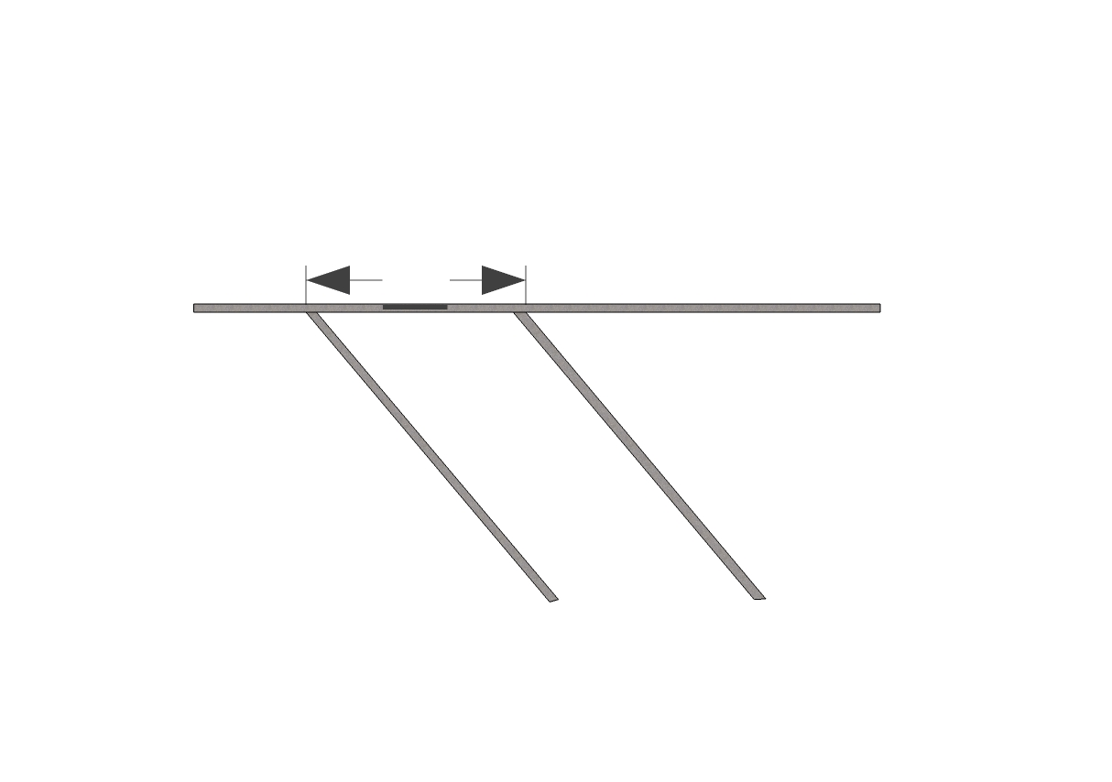
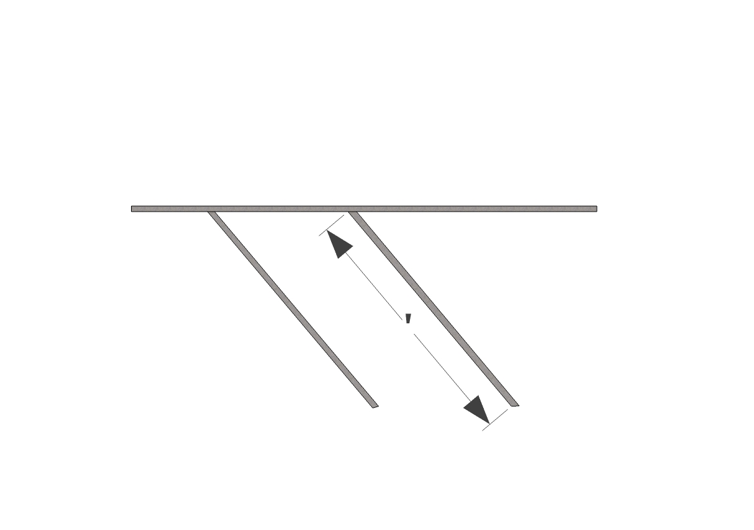
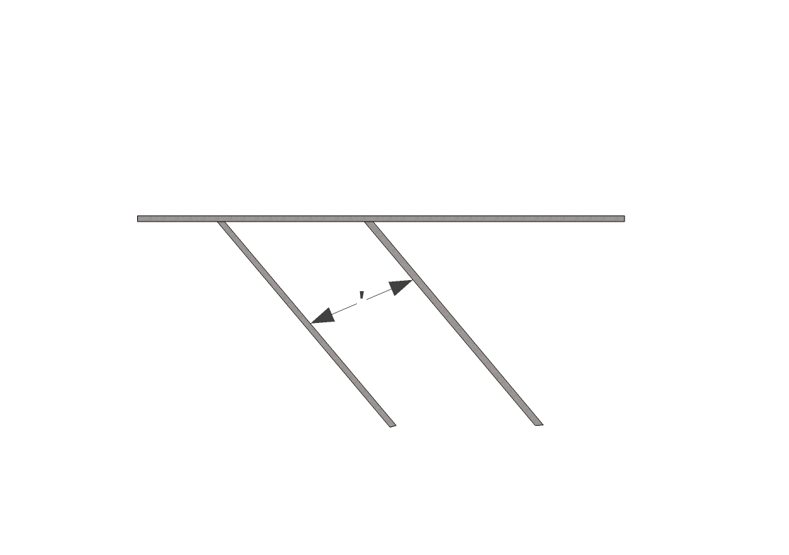
Parking Angle | Stall Width ft. | Stall depth ft. | Curb Length ft. | Drive Aisle Width ft.
0° | 8.5 | 8.5 | 23.0 | 12.0
20° | 8.5 | 14.5 | 24.9 | 11.0
30° | 8.5 | 16.9 | 17.0 | 11.0
40° | 8.5 | 18.7 | 13.2 | 12.0
45° | 8.5 | 19.4 | 12.0 | 13.5
50° | 8.5 | 20.0 | 11.1 | 12.5
60° | 8.5 | 20.7 | 9.8 | 18.5
70° | 8.5 | 20.8 | 9.0 | 19.5
80° | 8.5 | 20.2 | 8.6 | 24.0*
90° | 8.5 | 19.0 | 8.5 | 25.0*
*Two-way circulation

(J) Except as otherwise provided for in this division (J), or as may otherwise be approved by the reviewing authority, required parking lots, areas and facilities shall be improved and available for use by the time the use; to be served by the parking, is ready for occupancy.
(1) An extension of time may be granted by the city or other jurisdictional authority providing a performance bond, or its equivalent, as approved by the city and the other jurisdictional authority, is posted equaling the cost to complete the improvements as established by actual contractor's bid or by a licensed engineer approved and/or selected by the city.
(2) The extension of time may not exceed 1 year and, in the event the improvements are not completed within the 1 year time period, and an additional time period is not granted by the city, the bond or its equivalent shall be forfeited and the improvements thenceforth constructed under the direction of the city.
(3) In no case shall the total time period of all extensions granted exceed a period of more than 3 years. In the case that costs to complete the construction are in excess of the bond or its equivalent, including the costs incurred by the city for engineering, bid preparation and advertisement, and construction inspection, the applicant and/or property owner shall be liable for the extra costs.
(K) (1) Passengers. A driveway designed for continuous forward flow of passenger vehicles for the purpose of loading and unloading children shall be located on the site of any school having a capacity greater than 25 students.
(2) Merchandise, materials or supplies. Buildings or structures to be built or substantially altered which receive and distribute material or merchandise by truck or other motor vehicle shall provide and maintain off-street loading berths in sufficient numbers and size to adequately handle the needs of the particular use.
Home
(a) If loading space has been provided in connection with an existing use or is added to an existing use, the loading space shall not be eliminated if elimination would result in less space than is required to adequately handle the needs of the particular use.
(b) Off-street parking areas used to fulfill the requirements of this section and this chapter shall not be used for loading and unloading operations except during periods of the day when not required to take care of parking needs of the subject use.
(L) (1) Access aisles shall be surfaced and of sufficient width for all vehicle turning and maneuvering, and in no case shall access aisles be approved which are less than 12 feet in width.
(2) All residential off-street parking areas commencing from a public street or highway shall have at least 1 service drive, surfaced with a durable and dustless surface as defined in division (E) of this section, and all service drives shall likewise be so surfaced.
(3) Service drives to off-street parking areas shall be designed and constructed to facilitate the flow of traffic, provided maximum safety of traffic ingress and egress, and maximum safety of pedestrians and vehicular traffic on-site.
(4) Groups of more than 4 parking spaces shall be served by a driveway so that no backing movements or other maneuvering within a street other than an alley will be required to accommodate ingress and egress. Driveways serving the areas shall be designed and constructed to facilitate the flow of traffic on and off the site, with due regard to pedestrian and vehicle safety, and shall be clearly and permanently marked and defined. In no case shall two-way and one-way driveways be less than 24 feet and 12 feet in width respectively.
(5) The number of required service drives shall be determined by the City Superintendent of Public Works, City Council or other jurisdictional authority.
(6) All commercial service drives shall be clearly and permanently marked and defined through use of rails, fences, walls or other barriers or markers on frontage not occupied by service drives.
(7) Service drives shall have a minimum vision clearance area formed by the intersection of the driveway centerline, the street right-of-way line and a straight line joining the lines through points 20 feet from their intersection or as otherwise required in 153.081.
(M) For those uses which require off-street parking, a plan drawn to scale indicating how the off-street parking and loading requirements are to be fulfilled shall accompany the application for site plan review or conditional use permit. The plan shall show all those elements necessary to indicate that these requirements are being fulfilled and shall include, but not be limited to the following.
(1) Delineation of individual parking spaces.
(2) Circulation area necessary to serve spaces.
(3) Access to streets, alleys and properties to be served.
(4) Proposed curb cuts, locations and widths.
(5) Dimensions, continuity and substance of screening.
Home
(6) Landscape, lighting and signage plans.
(7) Grading, drainage, surfacing and sub-grading details.
(8) Delineations of all structures or other obstacles to parking and circulation on the site.

153.087 LANDSCAPING REQUIREMENTS.
The following minimum landscape requirements are established for all developments subject to design review plan approval, unless approved otherwise by the reviewing authority.
(A) Landscaping defined. Required landscaping may include, but is not limited to, a combination of any of the following materials: living plant material such as trees, shrubs, groundcover, flowers and lawn (including native vegetation); and nonliving materials such as benches, walkways and courtyards, consisting of brick, decorative rock or other decorative materials.

(B) Existing vegetation. Existing site vegetation may be utilized to the maximum extent possible consistent with building placement and the applicable proposed landscape plan.
(C) Area required. Minimum area requirements may include requirements for landscaping around buildings, along fence lines, in parking and loading areas, outdoor recreational use areas and screening and buffering areas. Except as approved otherwise by the reviewing authority, the area required for landscaping is expressed as a percentage within the zone dimensional tables and/or the following:

(1) Multifamily dwellings & complexes: 20%.
(2) Downtown Enhancement Plan C-1 Zone.

() Moved to (C) above.
Moved to (A) above.
Home
Moved to (B) above.
(3) Parking lots. Parking areas shall be required to be landscaped in accordance with the following minimum requirements.
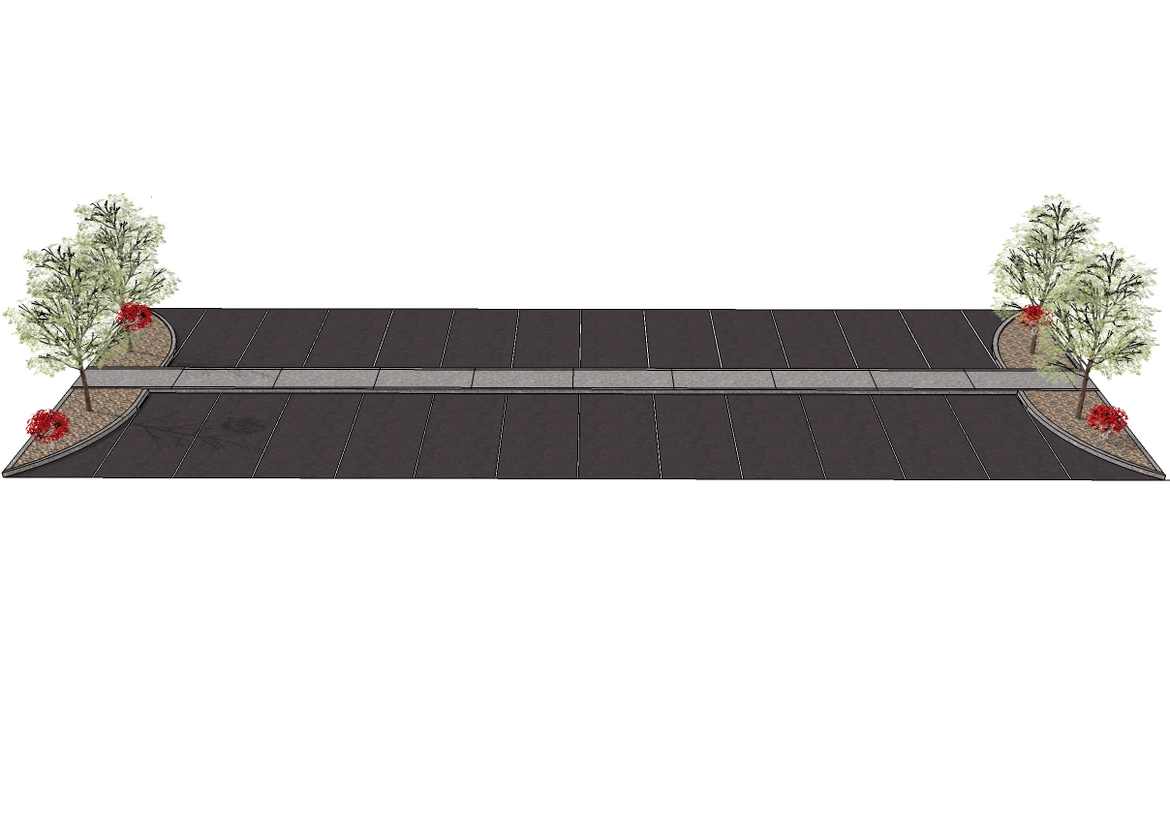
(a) In commercial and residential developments, parking areas shall be divided into bays of 12 spaces and between or at the end of each parking bay a curbed planter containing at least 16 square feet shall be required. Parking areas less than 12 spaces may require curbed planters as part of the landscape standard.
(b) Each planter should contain at least 1 tree and ground cover. An applicant may submit alternate plans for review and approval.

(c) The areas shall be designed to be protected from being damaged by vehicles using the parking area.
(d) Clear vision at the intersection within a parking area shall be maintained to provide adequate vision of vehicles and pedestrians.
(e) Unless sidewalks are provided adjacent to a structure, customer or resident parking areas should be separated from the exterior wall of a commercial or residential structure by a minimum 4 foot strip of landscaping.
(f) Where a parking, loading or driveway area serving a multi family, commercial, industrial or government use abuts a public right-of-way of a collector or arterial street or a local street across from a residential zone, or abuts a residential zone, a screen planting or other approved landscaped planter strip may be required between the parking area and the right-of-way without encroaching into a clear vision area or sidewalk.
(4) Buffering and screening. Requirements for buffering and screening may exceed the area requirement listed above. When required, buffering and screening areas shall conform to the following minimum requirements.
(a) Purpose. The purposes of buffering and screening requirements are to reduce the impacts of a proposed use on adjacent uses and zones which provide for different types of uses. The reviewing authority may waive or reduce the requirements where existing topography or vegetation is appropriate or otherwise negates the effectiveness or intended purpose or benefits of the buffering and screening.
(b) An aesthetic and/or noise reducing landscaped buffer may be required between land uses as follows.
(1) Commercial uses abutting a residential zone, public recreation area or use, institutional use, scenic resource, noise sensitive use or public right-of-way.
Home
(2) Industrial uses abutting residential or commercial zones, public recreation area or use, institutional use, scenic resource, noise sensitive use or public right-of-way.
(3) Multifamily complexes containing 4 or more units abutting a residentially zoned parcel that is limited to single family residential use, public recreation area, scenic resource, institutional use or public right-of-way.
(4) Manufactured or mobile dwelling subdivision or park abutting a residentially zoned parcel that is limited to single family residential use, public recreation area, scenic resource, institutional use or public right-of-way.
(5) Public or private recreation area or facility abutting a residential or commercial use, institutional use, scenic resource, noise sensitive use or public right-of-way.
(c) A buffer or screening area may only be occupied by screening utilities and landscaping materials, but the same may be located within the required yard or setback requirements provided vision clearance requirements are complied with.
(d) In lieu of the foregoing requirements, an applicant may provide for landscaping and screening, including plantings, fences, walls, walks and other features designed to afford the same degree of buffering as the standards above. A plan and specifications for an alternative shall be reviewed and approved by the reviewing authority with jurisdiction over the approval of the applicable use.
(D) Plant material installation standards. Except as otherwise approved by the city, the following standards shall apply to plant materials and the installation thereof as provided in accordance with the provisions of this section.
(1) Landscape plant materials shall be properly guyed and staked, and shall not interfere with vehicular or pedestrian traffic or parking and loading.
(2) Trees shall be a minimum size of 8 feet in height and be fully branched at the time of planting.
(3) Shrubs shall be supplied in 1 gallon containers or 6 inch burlap balls with a minimum spread of 12 inches.
(4) Rows of plants should be staggered to provide for more effective coverage.
(E) Maintenance and plant survival. All landscaping approved or required as a part of a development plan shall be continuously maintained, including necessary watering, weeding, pruning and replacement of plant materials. Except where the applicant proposes landscaping consisting of drought-resistant plantings and materials that can be maintained and can survive without irrigation, landscaped areas shall be irrigated. If plantings fail to survive, it is the responsibility of the property owner to replace them.

153.088 RIPARIAN HABITAT, SCENIC PROTECTIONS, SLOPE HAZARD
For regulations on riparian habitat, scenic views and slope hazards see Chapter 155 - Natural Features Overlay District (NFOD)
(Ord. 1165, passed 11-10-2009).

Home
153.089 CUTTING AND FILLING.

(A) Grading, cutting and filling of building lots or sites. Grading, cutting and filling of building lots or sites shall conform to the following standards unless physical conditions warrant other standards as demonstrated by a licensed engineer; in such a case, the documentation justifying such other standards shall be set forth in writing thereby.
(1) The City may require a grading plan by a licensed engineer for any new construction or proposed alteration of a site.
(2) Alterations greater than 3 feet from the natural pre-existing grade or any alteration greater than 1 foot within 10 feet of a property line shall require a grading permit from the City Engineer; at the discretion of the City Engineer the applicant may be required to submit a plan prepared by a licensed engineer and public notice of neighboring properties.
(3) A grading plan, if required, shall demonstrate construction feasibility, and the engineer shall attest to such feasibility and shall certify an opinion that construction on the cut or fill will not be hazardous to the development of the property or to surrounding properties.
(4) The City Engineer’s decision on the proposal shall be based on the following considerations.
Home
(a) That based on the engineer's report, that construction on the cut or fill will not be hazardous or detrimental to development of the property or to surrounding properties.
(b) That construction on such a cut or fill will not adversely affect the views or privacy of any adjacent property beyond that which could reasonably be expected without the cut or fill based on the provisions of the underlying zone; or that modifications to the design and/or placement of the proposed structure would be sufficient to minimize such adverse impact.
(c) That the proposed grading and/or filling will not have an adverse impact on the drainage on adjacent properties, or other properties down slope.
(d) That the characteristics of soil to be used for fill, and the characteristics of lots made usable by fill shall be suitable for the use intended.
(e) Cut slopes shall not exceed 1 foot vertically to 1 ½ feet horizontally.
(f) Fill slopes shall not exceed 1 foot vertically to 2 feet horizontally.
(5) Filling of wetlands shall only be permitted outside of the Natural Features Overlay District (Chapter 155) and after a permit has been issued by the Division of State Lands (DSL) and U.S. Army Corps of Engineers (if applicable). The City Planning Official, the Building Official, and City Public Works Superintendent shall find that the filling will not cause flooding of adjacent properties or public streets or drainage systems, and that drainage systems are adequate to handle actual or projected storm run-off.
(B) Filling within the designated floodway of Ochoco Creek and Crooked River is prohibited. Filling within the floodplain is prohibited unless necessary to elevate a structure to meet the standards of Chapter 151 (Flood Damage Prevention). Filling for any reason is discouraged within the floodplain while a no-net-fill approach or structural solutions such as raised stem walls with pass through vents is preferred.

153.090 FENCES.
Fences, except of barbed wire and of similar hazardous materials, are permitted in any zone and do not require a zoning permit for construction. The fences shall, however, be in compliance with the following provisions.
(A) Fences within the setback areas of yards shall not exceed 6 feet in height except as otherwise approved as a type I conditional use and constructed to meet Building code requirements.
(B) Fences which may be located in front yards shall not exceed 4 feet in height with the exception of decretive fencing such as wrought iron that can be easily seen through.
(C) Fences which may be located within clear-vision areas shall not exceed 2 ½ feet in height.
(D) Fences shall not be located within a surface water or wetland setback. (see Chapter 155 Natural Features Overlay District).
(E) Fences shall be maintained in good condition at all times and shall not create any unsightly or hazardous condition.
Home
(F) All fences, or portions thereof, shall be located or constructed in a way as to not prevent reasonable access to abutting properties for building maintenance or fire protection purposes.
(G) Fences, or portions thereof, shall be located or constructed in a manner as to not unreasonably obstruct significant scenic views of the valley, mountains or natural features of the area from adjacent buildings.
(H) The height of a fence shall be measured from the ground level where located.
(I) As applicable, the construction or reconstruction of fences shall comply with the Building Code as administered by the City or County Building Department.
(J) No owner or person in charge of property shall create a hazard by being the owner or otherwise having possession of property where there is a fence that is not structurally stable.
(K) No owner or persons in charge of property shall construct or maintain a barbed-wire fence along a sidewalk or public way; except the wire may be placed above the top of fencing that is not less than 6 feet high.
(L) No owner or person in charge of property shall construct, maintain or operate an electric fence along a sidewalk or public way or along the adjoining property of another person.

153.091 DECKS.
Except as otherwise required for compliance with the Uniform Building Code as administered by the City-County Building Department, the following provisions are applicable to decks.
(A) Decks may be constructed within setback areas up to 3 feet from the property line, provided they shall not exceed 3 feet in height and are not covered, or have fixed attachments that rise above 6 feet. Height of the deck and any attachments shall be measured from the ground level where located.
(B) Decks abutting a stream channel or riparian habitat shall adhere to Chapter 155 Natural features overlay district.
(C) Decks shall be constructed in a manner as not to be detrimental to abutting properties or obstruct scenic views from adjacent buildings.

Home

(Removed, unnecessary).

153.092 STORAGE-UNUSED VEHICLES/JUNK/DEBRIS.
It shall be unlawful to keep inoperative vehicles or vehicle parts within view of persons on a public street or adjacent properties, or to keep unsightly or potentially hazardous accumulations of debris within view of persons on the Public Street or adjacent properties.

153.093 OUTDOOR MERCHANDISING.
(A) Purpose. The purpose of this section is to ensure that certain commercial activities are carried out in a manner that is aesthetically compatible with adjacent and area uses, minimizes congestion, minimizes impacts on pedestrian circulation, maintains open space areas designed for pedestrian use and maintains the residential characteristics of residential areas.
(B) Prohibition. Except as otherwise approved by the city, all uses in the commercial zones shall be conducted entirely within a completely enclosed building, except that the outdoor storage display, sale or rental of merchandise or services may be permitted where the standards of division (D) of this section are met.
(C) The following uses and activities, subject to applicable conditions, are exempt from the prohibition set forth in division (B) of this section.
(1) The sale of living plants and plant materials.
(2) Outdoor seating in conjunction with a restaurant.
(3) Christmas tree sales lot.
(4) The dispensing of gasoline and other automotive supplies at a service station.
(5) Newspaper vending machines subject to division (E) of this section.
(6) Sales of food items, arts and handicrafts by a nonprofit organization subject to division (E)(2).
(7) Automatic teller machines, subject to the design review requirements set forth in this subchapter.
(8) Telephone booths, subject to the design review requirements set forth in this subchapter.
(9) Outdoor displays of merchandise common to a use permitted within the applicable zone such as automobile sales, boat sales, building materials, farm and other heavy equipment, hardware and the like, when such is approved as an integral component of an approved use within the applicable zone.
Home
(10) Outdoor sales of goods and materials as a part of a business community sidewalk, patio or other promotional sales event.
(11) Community outdoor sales events and activities in association with a community event such as a 4th of July celebration, fair, rodeo, centennial and the like.
(12) Garage, patio and yard sales on an individual or group basis, including community sponsored flea or farmers markets.
(13) Outdoor sales or goods and materials authorized pursuant to Ch. 110.
(D) The outdoor storage, display, sale or rental of merchandise or services may be permitted where any the following conditions are met.
(1) The outdoor storage, display, sale or rental of merchandise or services is permitted, approved or commonly identified as a accessory use or common component of a use permitted within a specific zoning designation.
(2) The outdoor area in which the merchandise or service is stored, displayed, sold or rented is accessible only through a building entrance or other entrance to a business in a secured area of the business.
(3) The outdoor area is screened from a public street or adjacent property in a manner approved by the design review plan reviewing authority.

(E) The following additional requirements are applicable to certain types of outdoor merchandising.
(1) Newspaper vending machines. Newspaper vending machines, placed on a public sidewalk, shall be located so that the use of the sidewalk by handicapped persons is not impeded. This standard shall be met by maintaining a minimum, unobstructed sidewalk width of 4 feet.
(2) Nonprofit organization sales. The sale is authorized by the City Planning Official, Manager or other city official after finding all of the following.
(a) The sale has the approval of the owner or lessee of the property on which it is to take place.
(b) The sale will be located in a manner that will not interfere with pedestrian or vehicular traffic.
(c) The sale will not interfere with the operation of adjacent businesses.
(d) The sale is an annual or semi-annual event, or is planned as such, or is being held for a special fund raising purpose.
(e) The sale shall be for a specified period of time, and the duration of the sale shall not exceed three days.

153.094 CLUSTER DEVELOPMENT
Cluster Development. In any zone, a cluster development may be permitted when authorized in accordance with the procedures for the type of development and in accordance with the applicable subdivision standards set forth in this chapter.
(A) A cluster development is a development technique wherein structures or lots are grouped together around access courts or cul-de-sacs, or where lot sizes surrounding structures are reduced while maintaining the density permitted by the applicable zoning designation. Duplex lots are exempt from the cluster development criteria.
Home
(1) A cluster development may be permitted to maintain open space, reduce street and utility construction and to increase the attractiveness of a development and the surrounding area.
(2) Clustering may be carried out within the context of a subdivision, partitioning, PUD, re-platting of existing lots or other reviews provided for by this ordinance.
(3) Attached Single Family dwellings may be permitted by the Planning Commission (pursuant to section 153.084) so long as the density of the applicable zone is not exceeded, provided that the overall design is considered to be in the best public interest and in the interest of the city.
(4) The Planning Commission may permit reduction in the minimum lot size or dimensional standards, setbacks or other standards of the applicable zone so long as the density requirements of the zone are maintained, and provided the overall design is considered to be beneficial to the residents of the development and to the city as a whole.
(5) The establishment of a Home Owners Association (HOA) shall be required to maintain common openspace and amenities not otherwise maintained by the public.

(B) For example, for a development in an R-2 Zone, the reviewing authority may waive the minimum lot size standard of 5,000 square feet for single family dwelling units for an equivalent overall net density factor calculated after deducting all areas required for streets, public utilities and other public or semi-public uses.
(C) Factors to consider in the approval of a Cluster Development include, but are not limited to the following.
(1) Excellence in design and site utilization.
(2) Provision of a variety of housing or other use types.
(3) Maximization of cost-benefit ratios for purchasers and providers of public services and facilities.
(4) Preservation of significant natural, vegetative or other significant public benefitting features or resources.
(5) Inclusion of publicly available recreation, social, educational or other publicly beneficial uses and developments.
(6) Donation of land area for public purposes identified as a need in the area or in the community.
(7) Other factors beneficial to the general public, residents of the proposed development and the city as a whole.

Home
153.095 MANUFACTURED HOMES; MOBILE HOMES; RV'S.
(A) Manufactured home placement. The provisions set forth by this subsection govern the placement of manufactured homes in the city and the urban area thereof.
(1) Purpose. This subsection (A) is designed to comply with the provisions of O.R.S. Ch. 197.307 governing the placement of manufactured homes, as herein defined, within the city and the urban area thereof.
(2) Manufactured Home Classes. For the purposes of these regulations, manufactured homes are divided into the following classes.
(a) A Class “A” manufactured home shall be a double or multi-sectional, and enclose a living space of not less than 1,000 square feet.
(b) A Class “B” manufactured home shall have more than 750 square feet of living space in a double or multi-sectional unit.
(3) General provisions.
(a) For the purposes of this subsection (A), R zones are intended to be those Residential Zones set forth in this chapter designated as R-1, R-2, R-3 and R-4.
(b) Class A: Permitted as an outright use on individual lots as a single family dwelling in all R Zones, in manufactured home parks and subdivisions and as replacements to existing nonconforming manufactured or mobile homes.
(c) Class B: Permitted in R-2, R-3 and R-4 Zones; also permitted as replacements to existing nonconforming manufactured homes provided the unit is found to be an improvement over current housing of or for the applicant.
(d) Manufactured home parks are permitted within the R Zones set forth in this chapter..
(e) In addition, manufactured home parks and subdivisions may be planned under the provisions of a planned unit development, which may be used to provide for individual ownership of manufactured homes and sites and common ownership and maintenance of other lands and facilities.
(f) Manufactured home subdivisions for Class A manufactured homes as herein defined are permitted as any other subdivision is permitted in the R-Zones when approved in compliance with the applicable provisions of this chapter.
(g) Manufactured home subdivisions for Class B manufactured homes as defined herein are only permitted as a type II conditional use in the R-2, R-3 and R-4 Zones in accordance with the applicable provisions of this chapter.
(h) Nothing in these provisions shall be interpreted as abrogating or superseding any recorded deed restriction or protective covenants.
(i) Except as specified otherwise by this subsection (A), the standards for subdividing and developing land for and within manufactured home parks and subdivisions shall be the same as for all other developments in accordance with the provisions of this chapter.
(j) Where standards for manufactured homes and developments therefore are established by state law or administrative rule, the requirements shall be in addition to the provisions of this subsection (A).
(k) The Oregon manufactured dwelling installation specialty code effective April 1st, 2010; previously known as “The Manufactured Housing Construction and Safety Standards Code” (also referred to as the HUD Code), Title VI of the 1974 Housing and Community Development Act (42 USC 5401 et seq.) as amended (previously known as the Federal Mobile Home Construction and Safety Act), rules and regulations adopted there under (including information supplied by the manufacturer, which has been stamped and approved by a Design Approval Primary Inspection Agency, and agent of the U.S. Department of Housing and Urban Development pursuant to HUD rules), and regulations and interpretations of the code by the Oregon Department of Commerce, all of which became effective for mobile and manufactured home construction on June 15, 1976, shall be utilized as the minimum construction standard of the city to which all manufactured home placements shall comply except as may be exempted or otherwise provided for by this subsection (A).
Home
(4) Definitions. For the purposes of this subsection (A) only, the definitions of terms used herein and not defined in this chapter shall be as defined in O.R.S. Ch. 446 or O.A.R. Ch. 814, Division 23 as such may be amended.
(B) MANUFACTURED HOME PLACEMENT REQUIREMENTS. Class “A” and “B” manufactured homes shall meet the following requirements.

(1) Shall comply with the placement requirements of the building code.
(2) Have wheels, axles and hitch mechanisms removed.
(3) Have utilities, public sewer and water connected in accordance with Oregon Department of Commerce requirements, manufacturer’s specifications, and city standards.
(4) Bear an insignia of compliance with the Manufactured Housing Construction and Safety Standards Code.
(5) Have a pitched roof with a minimum slope of 3/12 with eaves and trim on all sides.
(6) Have exterior siding, trim and roofing materials that are similar in appearance and complementary to other homes in the same general area including the type, color and horizontal or vertical placement of materials.
(7) Have a garage or carport constructed of like materials and color to the dwelling unit.

Home

1.

(8)Foundations/skirting
(a)All manufactured homes outside of a manufactured home park shall be placed on a foundation in accordance with building code.
(b) All manufactured homes within a manufactured home park may be either placed on a foundation or be installed with an approved foundation siding/skirting enclosing the entire perimeter of the home.

Home

(9) Additions or accessory structures.
(a) Except for a structure which conforms to the state definition of a mobile or manufactured home accessory structure, no other extension shall be attached to a manufactured home, except a garage or carport constructed to the Oregon State Structural Specialty Code.

(b) Roofing and siding materials shall be of similar material and color, and complementary to the original unit, and roofs shall have eaves and trim on all sides.
(c) In no case shall any structures or additions to the units be constructed in a manner as to fully enclose the original unit, nor may any such unit be fully enclosed by additional walls or roof structures.
(10) Other standards or limitations.
(a) Except for factory constructed components intended to be joined together to form a single manufactured home unit, no 2 or more manufactured home units may be joined together to form a single dwelling unit, nor may a manufactured home unit be joined together with a conventional constructed dwelling unit to form a single dwelling unit.
(b) Manufactured home units shall not be joined or interconnected in any manner for utilization as multi family dwelling units.
(c) All manufactured home lots and spaces shall be provided with sanitary sewer, electric and potable water with easements dedicated where necessary to provide the services. All such utilities shall be located underground.
(d) All pre-owned and pre-occupied units shall be inspected by a certified Building Official prior to installation and occupancy to insure that the units are in a condition as to not be detrimental to the public health, safety and general welfare of the occupants or to the adjoining properties. The costs of the inspection shall be borne by the applicant. In lieu of an actual inspection of the units which are not readily available for the inspection, the applicant may submit current color photographs of the unit, both exterior and interior, and a certification by the current owner as to the condition of the unit.
(e) No manufactured home shall be occupied for living purposes unless connected to local water, sewer and electrical systems.
Home
(f) No manufactured home shall be sited adjacent to any structure listed on the Register of Historic Landmarks except within a duly approved manufactured home park.
(C) Placement permits required.
(1) Requirements. Prior to the location, relocation or establishment of any manufactured home, the homeowner or authorized representative shall secure from the Building Official a placement permit and from the city a site plan permit which, in combination, state that the building and its location conform with this chapter. Each application for a placement permit and a site plan permit shall be accompanied by the following.
(a) A plot plan as required for all dwelling units, but which at a minimum requires elevations or photographs of all sides of the manufactured home, exterior dimensions, roof materials, foundation support system and enclosure design.

(b) Any other information as may be required by the Building Official, City Planning Director or other reviewing authority, for proper enforcement of this chapter.

(c) For a manufactured home park, these requirements may be consolidated with concurrence of the Building Official and the Planning Director for multiple placements in accordance with the approved park plan.

(2) Additional action necessary. If, after receipt of the information required for either a placement or a site plan permit, the Building Official or the Planning Director finds that the applicant has not fully met the standards set forth in this subsection, and the changes or additional actions needed are deemed by the Building Official or Planning Director to be relatively minor and/or required to meet applicable codes, a conditional approval may be issued with the stated conditions which must be met prior to occupancy set forth and the reasons for change clearly stated in writing. An appeal of the decision may be submitted and processed in accordance with the applicable provisions relevant thereto.
(3) Suspension or revocation of permit. The Building Official or Planning Director may, in writing, suspend or revoke a placement or site plan permit issued under the provisions of this subsection whenever it is found that the permit has been issued in error or on the basis of incorrect information or upon the failure of the applicant to comply with minimum standards or conditions upon which the respective permit approval was issued.
Home
(D) Mobile homes and RV's as temporary residences. A single-wide residential trailer or mobile house, or recreation vehicle may be authorized as a temporary residence on an individual lot if found to comply with the following conditions.
(1) The unit shall only be occupied by the owner of the lot on which the unit is located.
(2) The unit shall only be placed upon a lot and occupied by the owner for which a building permit for a conventional housing unit or a placement permit for a manufactured home meeting the standards of the applicable zone has been obtained.
(3) The unit shall only be occupied during a period in which satisfactory progress is being made towards the completion of the conventional housing unit or placement of the manufactured home for which a permit has been obtained, and in no case shall the time period exceed 18 months involving a conventional dwelling or 6 months involving a manufactured home.
(4) The owner of the lot agrees in writing to remove the unit from the lot no later than the applicable time period set forth in division (3) of this subsection (D), or not later than one month following the completion of the unit or placement of the manufactured home, whichever occurs first.
(5) Electric, public sewer and water connections shall be made to mobile home units.
(6) The City Planning Official may review permits issued under this subsection (D) at any time and revoke the permits when found to not be in compliance, including evidence of unsatisfactory progress on construction or placement of the intended permanent housing unit. (D)
(E) RVs: residential use. Recreational vehicles may not be occupied for residential purposes or other purposes on any lot in the city except as follows.
(1) As permitted as a temporary residence by 153.095(D) above or section (F) below.
(2) In an approved recreational vehicle park or in an approved mobile or manufactured home park on spaces specifically approved for RV vehicle use.
(3) As a temporary residence by guests of the owner for a period not to exceed 7 days out of any 30-day period, particularly during major local events such as rodeos, fairs, races, school and community events, adult and youth athletic events and similar events.
(F) Recreational vehicles, Mobile homes and Manufactured homes: temporary residence for care of relative.
(1) It is the intent of this temporary use permit to provide for the temporary placement and use of certain structures which, because of personal hardship and special needs, require and warrant special consideration for the special temporary use.
(2) No such use shall be approved unless there is a finding by the reviewing authority that there will not be any adverse impact on the welfare of adjacent properties and the community as a whole, nor a detriment to the overall intent of this chapter and the applicable zone designation.
(3) No temporary permit shall be granted which would have the effect of creating a permanent rezoning, nonconforming use or variance or when the use is not permitted to continue at the expiration of the permit period.
Home
(4) As a temporary special use permit in every zone in which residential uses are permitted, the City Planning Official, as a type I conditional use permit, may approve 1 accessory mobile home or RV in conjunction with a primary dwelling unit with the following findings and limitations.
(a) That the unit is necessary to give care for or provide custody of an elderly, handicapped or infirm relative who a medical doctor certifies is in need of this special kind of care or custody.
(b) The applicant and permit holder is the owner and resident of the primary dwelling and is the care provider for the infirm relative for which the special use permit is granted.
(c) That no additions to the mobile home unit shall be permitted, nor shall the unit be connected in any way, except for a covered walkway to the main dwelling unit.
(d) That all residential utilities and facilities deemed necessary can be and are provided.
(e) That all setback requirements of the applicable zone designation can be met.
(f) That the subject mobile home unit is not of a condition as to constitute a visual nuisance or be a safety hazard to the occupant thereof.
(5) A temporary special use permit granted under this subsection shall be null and void when the elderly, handicapped or infirm relative who is the subject of the permit moves to another residence or is absent from the residence for more than 120 days, or leaves the residence with no likelihood of returning. Exception to the 120-day limit may be approved because of extraordinary circumstances such as extended hospitalization, but in any case, the subject unit shall not be occupied by any other person(s) other than originally intended and approved for.
(6) Within 30 days of the permit becoming void or revoked, the unit shall be removed by the owner of the real property unless otherwise approved by the city.
(7) The city may review permits issued under this subsection at any time, and revocation thereof shall be effective upon a finding of noncompliance with the provisions of this subsection or with any other conditions set forth at the time of issuance of the permit.
(8) The permits shall be issued on a 1 year basis and renewable on an annual basis without reapplication or additional fees provided compliance with the conditions applicable to the permit are maintained.
(9) A unit placed under a permit authorized by this subsection shall be located as close as possible to the primary dwelling.
(G) Manufactured homes and mobile houses limited to parks. All single-wide manufactured homes, mobile houses and residential trailers shall be limited to location within a duly approved mobile house or manufactured home park or as a temporary use authorized by this chapter or unless approved otherwise as a conditional use pursuant to the provisions of this chapter.

Home
153.096 LIVESTOCK.
Domestic livestock shall be permitted as provided for by the respective zoning designations set forth in this chapter, but shall be subject to the following limitations.
(A) Except as provided otherwise in this section, The total number of all animals (other than their young under the age of 6 months) allowed on a lot shall be limited to the square footages listed below for each adult animal or similar type of animal listed These areas shall be exclusively for the animals.

(1) Horses: 20,000 square feet.
Cows: 20,000 square feet
Llamas: 10,000 square feet
Ostriches/emus: 10,000 square feet
Sheep: 5,000 square feet
Goats: 5,000 square feet

(2) The number of adult chickens, fowl or other poultry or rabbits over the age of 6 months shall not exceed 1 for each 1000 square feet of total lot area. The number of young (under the age of 6 months) allowed on the property at any time shall not exceed 3 times the allowable number of adults.
(3) The number of colonies of bees allowed on a lot shall be limited to one colony for each 5,000, square feet of lot area. Colonies shall be setback a minimum of 25 feet of any property line. In any instance in which a colony exhibits aggressive or swarming behavior, the beekeeper must ensure that the colony is re-queened. Every beekeeper shall maintain an adequate supply of water for the bees located close to each hive.
(B) Animal runs or barns, chicken or fowl pens and colonies of bees shall be located on the rear half of the property but no closer than 50 feet from the front property line nor closer than 50 feet from any residence not owned by the owner of the subject livestock.
(C) Animals, chickens and/or fowl shall be properly caged or housed, and proper sanitation shall be maintained at all times. All animal or poultry food shall be stored in metal or other rodent-proof receptacles.
(D) No other livestock except for domestic dogs and cats are permitted, and stud horses, bulls and rosters are specifically prohibited.
(E) Domestic livestock kept solely for the purpose of a youth livestock project such as 4-H or FFA may be exempted from the square footage requirements of this section provided that the following conditions are complied with.
(1) Evidence is provided to the City Planning Official that the youth is duly enrolled in a 4-H or FFA livestock project and an outline of the planned project, including animal types and numbers, is also provided.
(2) An acknowledgment of the project and an agreement or statement of no objections to permit the same is provided from all adjoining property owners.
Home
(3) Failure to comply with the sanitation control and other requirements of this section may result in the cancellation of the exemption.

153.097 COMPLIANCE WITH STATE/FEDERAL RULES.
(A) Approval of any use or development proposal pursuant to the provisions of this chapter shall require compliance with and consideration of all applicable state and federal agency rules and regulations.
(B) The compliance shall be evident prior to the final approval of any affected land use or development proposal; for example, the compliance may be set forth as a condition of final approval.
(C) Specific state and federal rules and regulations that may affect a specific land use or development for which compliance therewith is required if applicable include, but are not necessarily limited to the following.
(1) Air quality standards administered by the State Department of Environmental Quality (DEQ) and/or the Federal Environmental Protection Agency (EPA).
(2) Noise pollution standards administered by DEQ and/or EPA.
(3) Water quality standards administered by DEQ, state Water Resources Department (WRD) and/or EPA.
(4) Sewage disposal regulations administered by DEQ, County Environmental Health and/or EPA.
(5) Solid waste disposal regulations administered by DEQ and/or EPA, including those applicable to hazardous wastes.
(6) Uniform Building Code administered by the City-County Building Department and State Building Codes Agency.
(7) Surface and ground water withdrawals regulated by WRD.
(8) Scenic area rules administered by the State Highway Division (OSHD), state parks and/or other state or federal agencies.
(9) Access control and management regulations administered by OSHD and/or the County Road Department.
(10) Surface mining regulations administered by the State Department of Geology and Mineral Industries (DOGAMI), DEQ and other state or federal agencies.
(11) Wild and scenic river regulations administered by the State Parks and Recreation Department (OPRD), the U.S. Bureau of Land Management (BLM) or other state and federal agencies.
(12) Cut and fill, and wetland regulations administered by the Division of State Lands (DSL).
(13) Fish and wildlife habitat protection rules administered by the State Department of Fish and Wildlife (ODFW) and/or the U.S. Fish and Wildlife Department (USFW).

(removed, redundant with 153.200).
Home

EXCEPTIONS AND NONCONFORMING USES
153.115 NONCONFORMING USES.
(A) Purpose. It is the intent of this code to facilitate new development that is consistent with the goals and policies of the City of Prineville while making reasonable accommodations for existing uses and structures. Over time increased consistency with this code is the desired result.

It is not the intent of this code to remove existing structures and uses. This code aims to see that new development is consistent with goals and policies while allowing existing development to remain as long as existing structures continue to be viable. Those who invest in this area would like a reasonable expectation that new development, consistent with this code, will compliment and reinforce their investment.

(B) For the purpose of this subchapter, the following definition shall apply unless the context clearly indicates or requires a different meaning.
NON CONFORMING USE. A lawful existing use or structure at the time this chapter or any amendments hereto become effective which does not conform to the requirements of the zone in which it is located or to any other specific requirements of this chapter applicable thereto.
(C) The lawful use of any building, structure or land in existence at the time of enactment or amendment of this chapter may continue in the same use and form until substantial modification occurs or is requested. A change of ownership or occupancy shall be permitted.
(D) The modification of existing buildings is permitted through administrative review if such changes result in greater conformance with the specifications of this Chapter. This also includes expansion necessary to comply with any lawful requirement mandated by local, state or federal regulation for continuation of the subject use.
(E) A structure conforming as to use but nonconforming as to height, setback, or coverage may be altered or extended, through a type 1 conditional use provided the alteration or extension does not deviate further from the standards of this Ordinance or have a negative impact on neighboring properties.
(F) An expansion of any nonconforming use may be approved by the Planning Commission if found to be reasonably necessary to continue the use and if found to be no more detrimental than the present use.

Moved to (C), (D) & (F) above.
(G) The extension of a nonconforming use to a portion of a lot or structure which was arranged or designed for the nonconforming use at the time of the effective date of this chapter, such as an addition to a single family home, is not an expansion of a nonconforming use provided it complies with section (E) above.
Home
(H) Restoration or replacement of a nonconforming use may be permitted when the restoration or replacement is made necessary by fire, other casualty or natural disaster, or to meet health and building standards. Such restoration or replacement shall be commenced within 1 year from the occurrence of fire, casualty or natural disaster, and shall be completed within not more than 18 months from the date of commencement. In the case of the restoration or replacement because of health or building standard deficiencies, such shall be completed within not more than 12 months from the date of notification of the deficiencies.
(I) If a nonconforming use is destroyed by any such cause to an extent exceeding 80% of its fair market value as indicated by the records of the County Assessor, and is not returned to use and in actual operating condition within 18 months from the date of destruction, a future structure or use shall conform to this chapter. An extension to such time period may only be granted where circumstances beyond the owner’s control, such as an insurance claim settlement, have effectively prohibited reconstruction within the 18-month period. An application for the time extension shall be processed in the same manner as the application for reconstruction, and the filing fee shall be one-half of the fee for such an application.
(J) A nonconforming use may not be resumed after a period of interruption or abandonment of more than 1 year unless the resumed use conforms with the requirements of this chapter or is granted additional time by the Planning Commission based on circumstances beyond the owner’s control and/or a circumstance unique to the particular use. In no case, however, shall the period of inactivity exceed 2 years in any 3 year period. The resumption of a nonconforming residential use shall also be allowed where a structure still retains the original character of its nonconforming use; such as a single family home in a commercial zone.
(K) Nothing contained in this chapter shall require any change in the plans, construction, alteration or designated use of a structure for which a building permit has been issued and construction has commenced prior to the adoption of this chapter provided the structure, if nonconforming or intended for a nonconforming use, is completed and in use within 2 years from the time the permit was issued.
(L) Nothing contained in this chapter shall require any change in the plans for any use or development for which a land use permit had been granted prior to the effective date of this chapter, provided the building permit(s) therefore are obtained within the assigned time limits of the permit approval and construction is commenced within 6 months of the issuance of the building permit(s).
(M) If a nonconforming use is replaced by another use, the new use shall conform to the applicable provisions of this chapter.

Replaced with language in (J) above.
Home
153.116 EXCEPTIONS TO LOT SIZE REQUIREMENTS.
(A) The following exceptions to minimum lot size requirements shall apply.
(1) If a lot or the aggregate of contiguous lots or parcels platted prior to the effective date of these standards has an area or dimension which does not meet the requirements of these standards, the lot or aggregate holdings may be put to use(s) permitted subject to the other requirements of the zone in which the property is located. Lots that are pre-existing in residential zones that are below the minimum size for a single family dwelling shall be limited to 1 single family dwelling per lot. City Sewer and Water services shall be approved and provided.
(2) Any parcel of land or portion thereof which is to be dedicated to a public, semi-public or public utility for a park, school, road, canal, railroad, utility or other public use shall be exempt from the minimum lot size requirements of this chapter and the applicable zone.
(B) In any zone, the Planning Commission may grant an exception to the stated minimum lot size for residential purposes in accordance with section 153.094 Cluster Developments

Covered in 153.116.

153.117 EXCEPTIONS TO YARD-SETBACK REQUIREMENTS.
The following exceptions to yard or setback requirements are authorized for a lot or use in any zone.
(A) The reviewing authority may increase the yard requirement when a yard abuts a street which the City has designated for future widening. The reviewing authority may permit a lesser front yard requirement if structures on abutting lots do not meet the front yard requirements of the zone in which it is located.
(B) Any parcel of land or portion thereof which is taken by or is dedicated to a public or semi-public entity for a road, canal, railroad, utility or other public use shall be exempt from the building setback requirements set forth by the Prineville Development Code standards when such dedication of land reduces a setback for an existing building or structure. Such setback shall be treated as a non-conforming setback by the City and shall be subject to those Code regulations and provisions that regulate non-conforming uses.
Home
Replaced with above.
Replaced with above.
Moved to table, and definition.
Removed.

153.118 EXCEPTIONS TO BUILDING HEIGHTS.
(A) The following types of structures or structural parts are not subject to the building height limitations of this chapter: chimneys, cupolas, tanks, church spires, belfries, domes, derricks, monuments, fire and hose towers, observation towers, transmission towers, smokestacks, flagpoles, radio, cellular and television towers, masts, aerials, cooling towers, water towers, elevator shafts, windmills, conveyors, mill related apparatus and other similar projections.
(B) The exceptions to building height limitations set forth herein are not applicable to any such structures or structural parts that are located within an Airport Approach (AA) Overlay Zone.

153.119 EXCEPTION, ZONE BOUNDARIES.
If a zone boundary as shown on the Zoning Map splits a lot between two zones (a split zoned property), the entire lot shall be deemed to be in the zone in which the greater area of the lot lies. This does not include properties separated by a jurisdiction line such as the Urban Growth Boundary or County zoning.

153.120 EXCEPTION, MINOR REPAIR/REHABILITATION.
Except for nonconforming uses, activities involving rehabilitation, replacement, minor betterment, repairs and maintenance, improvements and other similar construction activities involving a lawful use permitted within a specific zone are exempt from the permit requirements of this chapter unless specifically regulated herein and provided the activities do not change the use or expand the capacity of use level.
Home
153.121 EXCEPTION, PUBLIC STREET/HIGHWAY IMPROVEMENT.
Excepting for those activities specifically regulated by this chapter the following public streets and highway improvement activities are permitted outright in all zones and are exempt from the permit requirements of this chapter.
(A) Installation of additional and/or passing lanes, including pedestrian and/or bikeways, within a street or highway right-of-way existing as of the effective date of this chapter, unless such adversely impacts on-street parking capacities and patterns.
(B) Reconstruction or modification of public roads and highways, not including the addition of travel lanes, where no removal or displacement of buildings would occur, and/or no new land parcels result.
(C) Temporary public road and highway detours that will be abandoned and restored to original condition or use at such time as no longer needed.
(D) Minor betterment of existing public roads and highway related facilities such as maintenance yards, weight stations and rest areas within a right-of-way existing as of the effective date of this chapter and contiguous public-owned property utilized to support the operation and maintenance of public roads and highways.
(E) The construction, reconstruction or modification of a public street or highway that is identified as a priority project in a transportation system plan (TSP) or the State Transportation Improvement Plan (STIP) that was duly adopted on or before the effective date of this chapter.

153.122 EXCEPTION, PUBLIC FACILITIES IMPROVEMENT.
Minor betterment, improvements, replacement or reconstruction of existing public facilities such as sewer and water lines, storm water drainage facilities, sidewalks and other pedestrian ways or facilities, bikeways and similar public facilities within rights-of-ways and easements for the purposes existing on or before the effective date of this chapter, or on contiguous publicly-owned property designated, intended or utilized to support the facilities, or the facilities that are set forth within an adopted public facilities plan or other capital improvement plan duly adopted on or before the effective date of this chapter, are exempt from the permit requirements of this chapter unless specifically set forth otherwise.

CONDITIONAL USES
153.135 AUTHORIZATION TO GRANT OR DENY.
Uses designated in this chapter as conditional uses may be permitted, enlarged or otherwise altered when authorized in accordance with the standards and procedures set forth in this chapter. In the case of a use existing prior to the effective date of this chapter, a change in use, enlargement or alteration of such use shall conform with the provisions of a conditional use if so classified. An application for a conditional use may be approved, modified, approved with conditions or denied by the designated reviewing authority.
(A) A conditional use that is utilizing an existing building may be transferred to a new owner or user for the same type of use. Conditions of the approval shall still apply.
Home
(B) A conditional use that is utilizing an existing building may be transferred to a new owner or user for a similar type of impact as determined by the Planning Director. A change of use application shall be required and may be referred to the Planning Commission if one or more concerns are received or if 3 or more Commissioners believe the application warrants a Commission review.

Moved to 153.014.

153.136 SPECIFIC CONDITIONS.
In addition to the standards and conditions set forth in a specific zone, this subchapter, this chapter and other applicable local, county, state and/or federal regulations, additional conditions may be imposed which are found to be necessary to avoid a detrimental impact on adjoining properties, the general area or the city as a whole, and to otherwise protect the general welfare and interests of the surrounding area, the city as a whole and the general public. No condition may be imposed which violates federal or state law with regard to needed housing. The conditions may include, but are not limited to, the following.
(A) Limiting the manner in which the use is conducted, including restricting the time an activity may take place, and restrictions to minimize environmental impacts such as noise, vibration, air or water pollution, glare and odor.
(B) Establishing a special setback or other open space requirements, and increasing the required lot size or other dimensional standards.
(C) Limiting the height, size or location of a building or other structure or use.
(D) Increasing street width and/or requiring improvements to public streets and other public facilities serving the proposed use, even including those off-site but necessary to serve the subject proposal.
(E) Designating the size, number, improvements, location and nature of vehicle access points and routes, and requiring pedestrian and/or bicycle ways.
(F) Limiting or otherwise designating the number, size, location, height and lighting of signs and outdoor or security lighting, and the intensity and/or direction thereof.
(G) Requiring diking, screening, fencing or other improvements or facilities deemed necessary to protect adjacent or nearby properties, and establishing requirements or standards for the installation and maintenance thereof.
(H) Protecting and preserving existing trees, other vegetation and water, scenic, historic, archaeological, unique, landmark or other natural or manmade significant resources.

Covered in 153.197.

Home
153.137 APPLICATION FOR CONDITIONAL USE.
A property owner or duly authorized agent may initiate a request for conditional use or the modification of an existing conditional use by filing an application with the city using forms prescribed therefore by the city. The standard application form shall be completed in its entirety and shall be accompanied by a site plan, drawn to scale, and showing the dimensions, arrangement and intended use of the proposed development. The application shall also be accompanied by a vicinity map showing the subject property, all properties within 100 feet and the names and addresses of all property owners within 100 feet as reported by the current County Assessor’s records. If an application is submitted by any person or persons other than the property owner or authorized agent thereof, the application shall be jointly signed by the owner or agent, or there shall be submitted an accompanying certified statement from the owner or agent attesting to the knowledge and approval of the submittal. An application shall not be deemed complete unless accompanied by the required filing fee established by the City Council by ordinance or resolution.

153.138 PERMIT PROCESSING: TYPE I AND II.
Conditional uses set forth by this chapter may be classified as either a type I or II conditional use. If the classification is not set forth, all such uses shall be processed in accordance with the type II processing requirements set forth hereinafter.
(A) Type I conditional use. The City Planning Official shall, within five working days of the receipt of a completed application for a type I conditional use provide individual written notice of the application to the owners of property within 100 feet of the exterior boundaries of the subject property, excluding public streets and ways, other identifiable potentially affected persons or parties including agencies, special districts, City and/or County Planning Commission and any persons or parties specifically requesting the notice. The notice shall provide for a minimum of 10 days for all such persons, parties, agencies, districts and owners to respond relative to the subject proposal. If no objection is received within the response period the Planning Official may take action on the subject proposal for approval, approval with amendments, modifications and/or conditions for denial or may refer the subject application to the Planning Commission for public hearing. If one or more objections are received within the response period, the subject application shall be referred to the Commission for public hearing. The applicant shall be required to pay any additional hearing fees prior to scheduling the public hearing.
(B) Type II conditional use. An application for a type II conditional use shall be subject to review by the Planning Commission in accordance with the public hearing requirements of 153.255.

Statutory reference: Application for permit or zone change, see O.R.S. 227.175

Covered section 153.255.

Home

Covered section 153.256.

Entire section moved to 153.083.

153.139 TIME LIMIT ON A CONDITIONAL USE PERMIT.
(A) Authorization of a conditional use permit shall be null and void after one year or such other time as may be specified in the approval thereof unless substantial development, compliance and/or investment is clearly evident.
(B) Issuance of a conditional use permit shall confer no right to the applicant beyond the time period for which it was issued.
(C) If the conditions applicable to a conditional use permit are not fulfilled within a reasonable time, the Commission may revoke the permit after giving notice to the applicant, affected property owners and other affected persons or parties, and upon holding a public hearing to make the determination.

SUBDIVISIONS, PARTITIONINGS, LOT CONSOLIDATIONS & REPLATS
153.155 PURPOSE.
It is the purpose of this subchapter, in accordance with the provisions of O.R.S. Chs. 92 and 227, to provide for minimum standards governing the approval of land divisions, including subdivisions, replats, land partitioning and lot consolidations as necessary to carry out the needs and policies for adequate traffic movement, water supply, sewage disposal, drainage and other community facilities, to improve land records and boundary monumentation and to ensure equitable processing of subdivision, replats, partitioning, lot consolidation and other land division activities within the city and the surrounding urban area.

153.156 APPLICABILITY.
No person may subdivide, replat, partition, consolidate or otherwise divide land, or create a planned unit or cluster development, or create a street for the purpose of developing land except in accordance with the provisions of this chapter, this chapter and O.R.S. Ch. 92. (O.R.S. 92.012 and 277.100).

153.157 SUBDIVISIONS-APPLICATIONS.
(A) Application. Any person proposing a subdivision, or the authorized agent or representative thereof, shall submit an application for a subdivision to the City Planning Department. The application shall be accompanied with ten copies of either an outline development plan as provided for in division (B) of this section, or a tentative plan as set forth in division (C) of this section, together with improvement plans and other supplementary material as may be required, and the appropriate filing fee as established by the City Council. The date of filing shall be construed to be the date on which all of the foregoing materials are received and accepted by the appropriate city official.
Home
(B) Outline development plan. The submittal of an outline development plan in the subdivision application process is at the option of the applicant and/or developer. If an outline development plan is prepared and submitted with the application for a subdivision, it shall include both maps and written statements as set forth in this division (B).
(1) The maps which are part of an outline development plan may be in schematic form, but shall be to scale and shall contain the following information.
(a) The existing topographic character of the land.
(b) Existing and proposed land uses, and the approximate location of buildings and other structures on the project site and adjoining lands, existing and proposed.
(c) The character and approximate density of the proposed development.
(d) Public uses including schools, parks, playgrounds and other public spaces or facilities proposed.
(e) Common open spaces and recreation facilities and a description of the proposed uses thereof.
(f) Landscaping, irrigation and drainage plans.
(g) Road, street and other transportation facility schematic plans and proposals.
(2) Written statements which shall be part of the outline development plan submittal shall contain the following information.
(a) A statement and description of all proposed on-site and off-site improvements.
(b) A general schedule of development and improvements.
(c) A statement setting forth proposed types of housing and other uses to be accommodated, and a projection of traffic generation and population.
(d) A statement relative to the impact on the carrying capacities of public facilities and services, including water and sewer systems, schools, serving utilities, streets and the like.
(e) A statement relative to compatibility with adjoining land uses, present and future, environmental protection and/or preservation measures and impacts on natural resource carrying capacities of the site and surrounding/adjacent areas.
(3) Commission approval of an outline development plan for a subdivision shall constitute only a conceptual approval of the proposed development for general compliance with the city's Urban Area Comprehensive Plan, applicable zoning and this chapter.
(4) Commission review and action on an outline development plan shall follow the requirements for review of land use action procedures, hearings and decisions in sections 153.254, 153.255 and 153.256.
(C) Tentative plan required. Following submittal and approval of an outline development plan and subdivision application, or as an initial subdivision application, any person proposing a subdivision shall submit a tentative plan together with the required application form, accompanying information and supplemental data and required filing fee, prepared and submitted in accordance with the provisions of this division (C). (O.R.S. 92.040) Note: Applicants should review the design standards set forth in 153.190 et seq. of this chapter prior to preparing a tentative plan for a development.
Home
(1) Scale of tentative plan. The tentative plan of a proposed subdivision shall be drawn on a sheet 18 by 24 inches in size or multiples thereof at a scale of 1 inch equals 100 feet or multiples thereof as approved by the City Planning Official. (O.R.S. 92.080). In addition, at least 1 copy of the plan on a sheet of paper measuring 11 inches by 17 inches shall be provided for public notice requirements.
(2) Information requirements. Along with showing compliance with the Comprehensive Plan and applicable land use standards and policies, the following information shall be shown on the tentative plan or provided in accompanying materials. No tentative plan submittal shall be considered complete, unless all such information is provided unless approved otherwise by the Planning Official.
(a) General information required.
1. Proposed name of the subdivision.
2. Names, addresses and phone numbers of the owner of record and subdivider, authorized agents or representatives, and surveyor and any assumed business names filed or to be filed by the owner or subdivider in connection with the development.
3. Date of preparation, north point, scale and gross area of the development.
4. Identification of the drawing as a tentative plan for a subdivision. Location and tract designation sufficient to define its location and boundaries, and a legal description of the tract boundaries in relation to existing plats and streets.
5. Title report issued in the last 90 days and supporting documents of all easements identified on the property.
(b) Information concerning existing conditions.
1. Location, names and widths of existing improved and unimproved streets and roads within and adjacent to the proposed development.
2. Location of any existing features such as section lines, section corners, city and special district boundaries and survey monuments.
3. Location of existing structures, fences, irrigation canals and ditches, pipelines, waterways, railroads and natural features, such as rock outcroppings, marshes, wetlands, geological features and natural hazards.
4. Location and direction of water courses, and the location of areas subject to erosion, high water tables, stormwater runoff and flooding.
5. Location, width and use or purpose of any existing easements or right-of-ways within and adjacent to the proposed development.
6. Existing and proposed sewer lines or septic tanks, water mains, wells, fire hydrants, culverts and underground or overhead utilities within and adjacent to the proposed development, together with pipe sizes, grades and locations.
7. Contour lines related to some established bench mark or other engineering acceptable datum and having minimum intervals of 2 feet for slopes < 5%, 5 feet for slopes < 15%, 10 feet for slopes < 20% and 20 feet for slopes > 20%.
Home
8. Address numbers of adjoining properties.
9. Existing covenants, codes and restrictions.
10. Distance to nearest park or recreational area.
(c) Information concerning proposed subdivision.
1. Location and size of all required and proposed public infrastructure and connections to existing infrastructure. This includes but is not limited to names, width, typical improvements, cross-sections, approximate grades, curve radii and length of streets. Connections to future infrastructure associated with an Outline Development Plan, Master Plan or the City Master Plans for Water, Sewer Transportation and Stormwater shall also be shown.
2. Location, width and purpose of all proposed easements or right-of-ways, and the relationship to all existing easements or rights-of-way.
3. Location of at least 1 temporary bench mark within the proposed subdivision boundary.
4. Location, approximate area and dimensions of each lot and proposed lot and block numbers.
5. Location, approximate area and dimensions of any lot or area proposed for public, community or common use, including park or other recreation areas, and the use proposed and plans for improvements or development thereof.
6. Proposed use, location, area and dimensions of any lot which is intended for nonresidential use and the use designated thereof.
7. An outline of the area proposed for partial recording on a final plat if phased development and recording is contemplated or proposed.
8. Source, method and preliminary plans for domestic water supply, sewage disposal, solid waste collection and disposal and all utilities.
9. Storm water, drainage facility and grading plans.
10. Statement from each utility company proposed to serve the subdivision stating their willingness to serve the subdivision as set forth in the tentative plan.
11. Proposed fire protection or fire hydrant system and written approval thereof by the appropriate fire protection agency.
12. Solar Access. Demonstrate that this proposal will not unduly affect the solar access of existing homes.
13. Location and type of street trees.
14. Availability of open space, parks and recreational areas meets the requirements of section 153.193 (Land for Public Purposes).
(D) Master development plan required. An overall master development plan shall be submitted for all developments planning to utilize phase or unit development. In addition to the tentative plan requirements of section (C) above the plan shall include, but not be limited to, the following elements.
(1) Overall development plan, including phase or unit sequences and the planned development schedule thereof.
Home
(2) Show compliance with the Comprehensive Plan and applicable land use standards and policies.
(3) Schedule of improvements initiation and completion.
(4) Development plans of any common elements or facilities.
(5) Financing plan for all improvements.
(E) Supplemental information required. The following supplemental information shall be submitted with the tentative plan for a subdivision.
(1) Proposed deed restrictions or protective covenants, if such is proposed to be utilized for the proposed development.
(2) Reasons and justifications for any variances or exceptions proposed or requested to the provisions of this subchapter, the applicable zoning regulations or any other applicable local, state or federal ordinance, rule or regulation.
(F) Tentative plan review procedures.
(1) Tentative plan review shall follow the requirements for review of land use action procedures, hearings and decisions in sections 153.254 through 153.256 et seq.
(2) The decision on a tentative plat shall be set forth in a written decision, and in the case of approval shall be noted on not less than 2 copies of the tentative plan, including references to any attached documents setting forth specific conditions.
(G) Tentative approval relative to final plat. Approval of the tentative plan shall not constitute final acceptance of the final plat of the proposed subdivision for recording. However, approval of the tentative plan shall be binding upon the city for preparation of the final plat and the city may require only such changes as are deemed necessary for compliance with the terms of its approval of the tentative plan. (O.R.S. 92.040)
(H) Resubmission of denied tentative plan. If the tentative plan for a subdivision is denied, resubmittal of an application for a subdivision of the subject property thereof shall not be accepted by the city for a period of 6 months after the date of the final action denying the plan. Resubmittal shall be considered a new filing, but shall require the applicant to consider all items for which the prior denial was based, in addition to the other filing requirements set forth by this chapter.
(I) Requirements for approval. The Commission shall not approve an outline development plan or a tentative plan for a subdivision unless the Commission finds, in addition to other requirements and standards set forth by this chapter and other applicable city ordinances, standards and regulation, the following:
(1) The proposal is in compliance with ORS Chapter 92, applicable goals, objectives and policies set forth by the city's Comprehensive Plan, Master Plans, Standards and Specifications and applicable zoning. (O.R.S. 197.175(2)(b) and 227.175 (4)) (O.R.S. 92.090(2)(C)
(2) Each lot is suited for the use intended or to be offered, including but not limited to sewage disposal, water supply, guaranteed public street access and utilities.
(3) The proposal is in compliance with the design and improvement standards and requirements set forth in 153.190 et seq. and the City’s Standards and Specifications or as otherwise approved by the city, or that such compliance can be assured by conditions of approval.
Home
(4) The subdivision will not create an excessive demand on public facilities and services required to serve the proposed development, or that the developer has proposed adequate and equitable improvements and expansions to the facilities with corresponding approved financing therefore to bring the facilities and services up to an acceptable capacity level (Goal 11).
(5) The development provides for the preservation of significant scenic, archaeological, natural, historic and unique resources in accordance with applicable provisions of this chapter and the Comprehensive Plan (Goal 5).
(6) The proposed name of the subdivision is not the same as, similar to or pronounced the same as the name of any other subdivision in the city or within a 6 mile radius thereof, unless the land platted is contiguous to and platted as an extension of an existing subdivision. (O.R.S. 92.090)
(7) The streets and roads are laid out so as to conform to an adopted transportation system plan for the area, and to the plats of subdivisions and maps of major partitions already approved for adjoining property as to width, general direction and in all other respects unless the city determines it is in the public interest to modify the street or road pattern. (O.R.S. 92.090(2)(a))
(8) Streets and roads for public use are to be dedicated to the public without any reservation or restriction; and streets and roads for private use are approved by the city as a variance to public access requirements. (O.R.S. 92.090(2)(b))
(8) Adequate mitigation measures are provided for any identified and measurable adverse impacts on or by neighboring properties or the uses thereof or on the natural environment.
(10) Provisions are made for access to abutting properties that will likely need such access in the future, including access for vehicular and pedestrian traffic, public facilities and services and utilities.
(9) Provisions of the proposed development to provide for a range of housing needs, particularly those types identified as needed or being in demand. (Goal 10 and O.R.S. 197.303-307)
(10) Provisions for openspace, parks and recreational areas shall be provided for in accordance with Section 153.193 (Land for Public Purpose).
(J) Improvement Requirements.
(1) In the approval of any subdivision, the need for a survey, and the need for street and other public facility improvements shall be required as a condition of approval. Streets and roads for public use are to be dedicated to the public without any reservation or restriction consistent with the City’s Standards and Specifications and streets and roads for private use are approved by the city as a variance to public access requirements. (O.R.S. 92.090(2)(b))
(2) Provisions are made for access to abutting properties that will likely need such access in the future, including access for vehicular and pedestrian traffic, public facilities and services and utilities.
(3) All required agreements shall be recorded at the Crook County Clerk’s Office at the same time of recording of the final subdivision plat.
(4) All public utilities are available to each lot line.
Home
(5) Public infrastructure including right of way, water, sewer, streets and sidewalks shall be extended and constructed to and through each lot created by the subdivision; unless otherwise approved by the City due to the following:
(a) Phased development
(b) Clearly defined project area where the remainder lot is of such a large size that future development or division is likely and the infrastructure will be brought through at that time.
(c) The City determines certain aspects of the “to and through” standard can be deffered. For example, right of way may be extended to and through but street, water and sewer infrastructure are differed until new development or Division of property.
(6) Paved access is guaranteed to each lot.
(7) Future development is to be connected to the City’s sewer and water systems.
(K) Final Plat Approval. The submission of a final plat shall follow the requirements set forth in section 153.164.
Criteria has been removed and covered in 153.164.

153.158 PLANNED UNIT DEVELOPMENT (PUD).
(A) Authorization. When a planned unit development is authorized pursuant to the provisions of the applicable zoning or by other provisions of this chapter, the development may be approved by the city in accordance with the provisions of this section and this chapter. A PLANNED UNIT DEVELOPMENT (PUD) is a development technique where the development of an area of land is developed as a single entity for a number and/or mixture of housing types, or a mixture of other types of uses, or a combination thereof, according to a specific development plan which does not necessarily correspond relative to lot sizes, bulk or types of dwelling units, density, lot coverage’s or required open space as required by the standard provisions set forth by this chapter and the specific applicable zoning designation.
(B) Applicability of regulations. The requirements for a planned unit development set forth in this section are in addition to the requirements set forth for a standard subdivision by 153.157 of this chapter, and in addition to those requirements set forth in 153.094.
(C) Purpose. The purpose of the planned unit development provisions is to permit the application of innovative designs and to allow greater freedom in land development that is not possible under the strict application of the applicable zoning provisions and this chapter. In permitting such design and development freedom, the intent is to encourage more efficient uses of land and public facilities and services, to maximize community needs for a variety of housing, commercial and recreational needs and to maintain as high of a quality living environment.
(D) Principal and accessory uses.
(1) The principal uses permitted within a planned unit development may include any use permitted, outright or conditional in the zone in which the subject proposed development is located.
(2) Except for open land uses such as golf courses, parks, natural areas or natural resources and the like, accessory uses shall not occupy more than 25% of the total area of the development, must be approved as a part of the initial development approval and may include the following uses.
Home

(a) Commercial uses such as a grocery store, convenience store, café, bakery, book store, salon, and professional offices.

(b) Tourist accommodations including convention or destination resort facilities.
(c) Recreation areas, buildings, clubhouse or other facilities of a similar use or type.
(d) Other uses which the city finds are designed to serve primarily the residents of the proposed development or are open to and of benefit to the general public, and are compatible to the overall design of the proposed development and with the city’s Comprehensive Plan.
(E) Dimensional standards.
(1) The minimum lot area, width, depth, frontage and yard (setback) requirements otherwise applying to individual lots in the applicable zone may be altered for a planned unit development provided that the overall density factor calculated for the applicable zone is not exceeded by more than 25%.
(2) Building heights exceeding those prescribed for by the applicable zone may only be approved if surrounding open space and building setbacks and other design features are used to avoid any adverse impacts due to the greater height. As a guideline, setback requirements should be required to be at least two-thirds of the height of a building.
(3) The building coverage for any PUD shall not exceed 40% of the total land area of the proposed development.
(4) Common open space and other community amenities such as community buildings, recreation buildings and school playgrounds, exclusive of streets, shall constitute at least 30% of the total land area of the development. Landscaped planter strips and medians within the street right-of-way may be approved by the Planning Commission as part of the open space requirement provided they are maintained by a Home Owners Association.
(a) At least half of the required open space shall be open to the general public.
(5) No PUD in a residential zone may be approved on a site with a total land area less than 5 acres, and in a commercial zone on a site less than 2 acres.
(F) Project density approval. If the Planning Commission finds that any of the following conditions would be created by an increase in density permitted by this section for a PUD, it may either prohibit any increase or may limit the increase as deemed necessary to avoid the creation of any of the following conditions.
(1) Inconvenient or unsafe access to the proposed development or adjoining developments or properties.
Home
(2) Generation of traffic loads in excess of the capacity of streets which adjoin or will serve the proposed development and in the overall street system in the area of the development.
(3) Creation of an excessive burden on sewage, water supply, parks, recreational facilities, areas or programs, schools and other public facilities which serve or are proposed to serve the proposed development.
(G) Common open space. No open area may be accepted as common open space within a PUD unless it meets the following requirements.
(1) The common open space is for an identified and designated amenity or recreational purpose(s), and the uses proposed or authorized therefore are appropriate to the scale and character of the proposed development.
(2) The common open space will be suitably improved for its intended use, except that the open space containing significant natural features worthy of preservation in the natural state may be left unimproved, but there shall be approved plans and/or provisions for the continued preservation thereof.
(3) The buildings, structures and improvements to be permitted in the open space are determined to be appropriate and accessory to the uses which are authorized for the open space.
(4) No common open space may be put to a use not authorized and approved in the final development plan of the subject development unless an amendment thereto is duly approved by the city.
(H) Application and procedures. The application for a PUD, and the procedures for the processing of the applications, shall be the same as set forth for a standard subdivision in 153.157 and for a conditional use as set forth in 153.135 et seq.

153.159 SUBDIVISION AND PUD REVIEW.
Review of a subdivision or planned unit development shall follow the procedures and policies for land use applications, hearings and decisions set forth in sections 153.254 through 153.256 et seq.
(A) Public hearing and notice required. Neither an outline development plan nor a tentative plan for a proposed subdivision or PUD may be approved unless the Planning Commission first advertises and holds a public hearing thereon. Notice of the hearing shall, at a minimum, be provided as required by this chapter for a conditional use type II.

153.160 LAND PARTITIONING.
(A) Applicability of regulations. As defined in this section and this chapter, all land partitionings within the city, except as set forth in division (B) of this section, must be approved by the city as provided for in this section; however the Planning Director or designee may refer any partition to the hearings body for a hearing and decision.
(B) Definitions. For the purposes of this section and this chapter, the words and phrases shall have the meaning set forth herein.
PARTITIONING. To divide a lot, parcel or tract of land into 2 or 3 lots or parcels but does not include the following.
(a) A division of land resulting from a lien foreclosure, foreclosure of a recorded contract for the sale of real property, or the creation of a cemetery lot.
Home
(b) An adjustment of a property line by the relocation of a common boundary where an additional unit of land is not created, and where the existing unit of land reduced in size by the adjustment complies with the applicable zoning.
(c) The division of land resulting from the recording of a subdivision or condominium plat.
(d) The sale of a lot in a recorded subdivision or town plat, even though the developer, owner or seller of the lot may have owned other contiguous lots or property prior to the sale; the lot, however, must be sold as platted and recorded.
MINOR PARTITIONING. A partitioning where each lot or parcel created has access to an existing public road, street, highway or way; that is, a partitioning that does not include the creation of a new road or street for access to one or more of the lots or parcels being created. For the purposes of this definition and this definition only, an easement or public street for access of more than 100 feet in length shall be considered a street or road.
MAJOR PARTITIONING. A partitioning where a new street or road is created for access to one or more of the parcels created by the partitioning.
SERIES PARTITIONING. A series of partitions, major or minor, of a tract of land resulting in the creation of four or more parcels over a period of more than one calendar year.
(C) Flag Lots and Duplex lots. The creation of a flag lot or duplex lot not part of a subdivision shall be considered a minor partition. For criteria regarding flag lots refer to section 153.191 (F). For criteria regarding Duplex lots refer to section 153.084 (B).
(D) Exemption. Partitions resulting in the following are not subject to the land partitioning requirements or applicable zoning regulations set forth by this chapter. However a final plat map shall be required.
(1) The partitioning of a tract of land in which not more than 1 parcel is created and the parcel is being transferred to a public or semi-public agency for the purpose of a public road, street, railroad, electric substation, canal, utility right-of-way, public park, school, recreation facility, trail, bikeway, natural area or other similar public purpose.
Removed, this is a BLA no need to make exemption.
(E) Filing procedures and requirements. Any person proposing a land partitioning, or the authorized agent or representative thereof, shall prepare and submit 10 copies of the tentative plan for a major partitioning requiring a hearing and 3 copies for a minor partitioning, together with a digital copy and the prescribed application form and required filing fee, to the City Planning Official.
(1) Minor partitioning. The Planning Official shall take action to either approve the application as submitted, approve with modifications or conditions, or deny the application; or, the Planning Official may refer the subject application to the Planning Commission for review and action thereon. Review of a minor partition shall follow the procedures and policies for land use applications, hearings and decisions set forth in sections 153.254 through 153.256 et seq.
Home
(2) Major partitioning. With an application and tentative plan for a major partitioning, the application shall be referred to the Planning Commission for the initial hearing for review and action if 1 or more objections are received in writing during the required10 day notice period. The Planning Commission may approve the application as submitted, approve with modifications or conditions or deny the application.
(3) Series partitioning. Any division of land resulting in a series partitioning shall be subject to review and approval by the Planning Commission. Applications for any series partitionings shall be made and processed in the same manner as a major partitioning. Approval requirements shall be the same as for any partitioning, however, the Commission shall deny any such series partitioning when it is determined that the partitionings are done for the purpose of circumventing applicable subdivision regulations.
(4) Proposed partitioning shall be drawn. The tentative plan of a proposed partitioning shall be drawn on a sheet 18 by 24 inches in size or multiples thereof at a scale of 1 inch equals 50 feet or multiples thereof. A copy of the proposed partitioning shall also be provided on a sheet measuring 11inches by 17 inches for public review and notice requirements.
(5) Requirements for the plan.
(a) A vicinity map locating the proposed partitioning in relation to adjacent subdivisions, roadways, properties and land use patterns.
(b) A plan of the proposed partitioning showing overall boundaries and dimensions, the area of each lot or parcel and the names, right-of-way widths and improvement standards of existing and proposed streets.
(c) Names and addresses of the land owner, the partitioner, the mortgagee if applicable, and the land surveyor employed (or to be employed) to make necessary surveys and prepare the final partitioning map.
(d) A statement regarding provisions for water supply, sewage disposal, solid waste disposal, fire protection, access, utilities and the like.
(e) North point, scale and date of map and the property identification by tax lot, map number, section, township and range, subdivision lot and block or other legal description.
(f) Statement regarding past, present and proposed use of the parcel(s) to be created, or the use for which the parcel(s) is to be created.
(g) A plan showing the layout of public infrastructure, as well as future connections to surrounding properties and existing infrastructure.
(h) Location of all existing buildings, canals, ditches, septic tanks, drain fields, wells and utility poles.
(i) Location of any topographical features which could impact the partition, such as canyons, drainages, rock outcroppings, wetlands, and floodplains.
Home
(F) Requirements for Tentative Partition Approval..
(1) The proposal is in compliance with ORS Chapter 92, the City's Comprehensive Plan, Master Plans, Standards and Specifications and applicable zoning regulations.
(2) Each parcel is suited for the use intended or to be offered, including but not limited to sewage disposal, water supply, guaranteed public street access and utilities.
(3) The proposal is in compliance with section 153.016 (water and sewer required) the design and improvement standards and requirements set forth in 153.190 et seq. and the City’s Standards and Specifications or as otherwise approved by the city, or that such compliance can be assured by conditions of approval.

(4) Proposal will not have identifiable adverse impacts on adjoining or area land uses, public services and facilities, resource carrying capacities or on any significant resources.
(5) Adequate mitigation measures are provided for any identified and measurable adverse impacts on or by neighboring properties or the uses thereof or on the natural environment.
(G) Improvement Requirements.
(1) The approval of any land partitioning, the need for a survey, and the need for street and other public facility improvements shall be considered and such may be required as a condition of approval. Any survey and/or improvement requirements that may be required for a subdivision or other land development may be required for a partitioning, including infrastructure, bonding or other assurance of compliance.
(2) Provisions are made for access to abutting properties that will likely need such access in the future, including access for vehicular and pedestrian traffic, public facilities and services and utilities.
(3) All required agreements shall be recorded at the Crook County Clerk’s Office at the same time of recording of the final partition plat.
(4) Street right of way shall be dedicated in compliance with the City’s Standards and Specifications and frontage requirements. If the existing street right-of-way is not consistent with City standards or new right of way is required through a City master plan or to and through standard.
(5) All public utilities are available to each lot line.
(6) Public infrastructure including right of way, water, sewer, streets and sidewalks shall be extended and constructed to and through each lot created by the partition; unless otherwise approved by the City due to the following:
(a) Clearly defined project area where the remainder lot is of such a large size that future development or division is likely and the infrastructure will be brought through at that time.
(b) The City determines certain aspects of the to and through standard can be deferred. For example, right of way may be extended to and through but street, water and sewer infrastructure are deferred until new development or Division of property.
Home
(7) Paved access is guaranteed to each lot.
(8) Future development is to be connected to the City’s sewer and water systems.
(H) Final map requirements. Within 1 year of the approval of a partitioning, the partitioner shall have prepared and submitted to the City Planning Official a final partitioning map prepared by a licensed surveyor and any other materials or documents required by the approval.
Removed, unnecessary.

Removed, unnecessary.
(1) A final partitioning map prepared for this purpose shall comply with the recording requirements applicable to a final plat for a subdivision.
(I) Partitioning for financial purposes.
(1) Upon application to the City Planning Director, the person may grant a special permit authorizing creation of a security interest or leasehold in a parcel of land. A filing fee as may be established by the City Council shall be required.
(2) Permits issued under the authority of this division (H) shall be subject to the following limitations and restrictions.
(a) A parcel possessed by a person under the terms of a lease or a security interest, and the remaining parcels, must remain in the legal use(s) that the parcels were at the time the interest become possessory; except as may be the basis of the security interest, no additional structure or improvement may be added to any parcel by the authority of the permit authorized pursuant to this division (H).
(b) A permit authorized by this division (H) shall only be valid for the time of the lease or the life of the security interest; except when there is a default and foreclosure upon a security interest.
(c) At the end of the life of the security interest, if there is no default or foreclosure, or in the case of leaseholds at the end of the lease, the parcels shall be rejoined into a contiguous unit of land under one ownership and, if possible, shall be reunited or combined into a single tax lot. The owner of the property shall be in violation of this chapter if he has not, within 30 days of the permit becoming void, made written application to the County Assessor for the combination of the parcels into a single tax lot.
(3) A permit issued pursuant to the provisions of this division (H) shall be immediately void if the owner of the property attempts any transfer of the subject parcels, except as provided by the terms of the permit.
Home
153.161 LOT CONSOLIDATIONS
All lot consolidations shall follow the same process and final map requirements as with a partition or subdivision as applicable.
(A) Lot consolidations resulting in a single lot.
(1) May be performed on contiguous lots resulting in a single lot.
(2) A lot consolidation is the actual removal of a lot line or lines not just the consolidation of tax lots.
(3) Lot consolidations shall not be used to avoid public improvements that would otherwise be required or have been required by a land partition or subdivision such as the re-platting of a subdivision that has not yet been constructed.
(4) Each non-contiguous consolidation shall be a separate application.
(B) Lot consolidations resulting in the same or fewer lots.
(1) The purpose of the section is to allow for the reconfiguration of lots without having to go through a full subdivision or partition process. The applicant shall meet the following criteria:
(a) All lots shall meet the minimum dimensional standards of the zone, to include public street frontage.
(b) In the case of a commercial development an applicant may reconfigure lots to meet the development needs and division of ownership.
(C) Final map requirements. Lot consolidations require a recorded plat and shall follow the same map requirements as with a partition or subdivision.
(1) In the case of multiple lot consolidations in the same area an applicant may combine all consolidations on a single map. If that map results in more than 3 lots the signatures required for a subdivision shall be required.
(2) The type of plat required (replat, partition, or subdivision) shall be determined by the County Surveyor.

153.162 REPLATS
(A) Per (ORS 92.010) A Replat is the act of platting the lots, parcels and easements in a recorded subdivision or partition plat to achieve a reconfiguration of the existing subdivision or partition plat or to increase or decrease the number of lots in the subdivision.
(B) In practice the City of Prineville will process a re-plat the same as a partition or subdivision depending on the amount of lots being created or the type of plat being replatted. The County surveyor shall make the final determination on whether a plat is titled as a re-plat, partition or subdivision.
(C) The replat of a portion of a recorded plat shall not act to vacate any recorded covenants or restrictions.

153.163 BOUNDARY LINE ADJUSTMENT & FINAL MAP RECORDATION.
(A) Boundary Line Adjustment Regulations. Boundary line adjustments are the modification of the boundaries of a lot of record. New lots are not created by a boundary line adjustment.
(B) Submission Requirements. All applications shall include a preliminary boundary line map identifying all existing and proposed boundary lines and dimensions; footprints and dimensions of driveways and public and private streets within or abutting the subject lots of record; existing fences and walls; and any other information deemed necessary by the City of Prineville for ensuring compliance with the Prineville Development Code.
Home
(C) Approval Process.
(1) Boundary line adjustments shall be reviewed administratively without prior notice consistent with section 153.254 using the criteria contained in section (D) below.
(2) Boundary line adjustment approvals shall be effective for 1 year from the date of approval, during which time it shall be recorded.
(3) The boundary line adjustment approval shall lapse if:
(a) The boundary adjustment is not recorded within the time limit in subsection (C)(2) herein.
(b) The boundary line adjustment has been improperly recorded with Crook County without satisfactory completion of all conditions attached to the approval; or
(c) The final recording is a departure from the approved plat.
(D) Approval Criteria. The City shall approve or deny a request for a lot line adjustment in writing based on findings that all of the following criteria are satisfied:
(1) No additional lot or parcel is created by the adjustment.
(2) All properties adjusted comply with the applicable zone requirements and Design and Improvement requirements of this chapter.
(E) Recording of Final Map. A final map shall be recorded in the same manner as a partition or subdivision and comply with the survey requirements of O.R.S Chs. 92 and 209.
Replaced above.
(1) The original plat and an exact copy shall be submitted to and approved by the City Planning Director. The approval shall be evidenced by signature on both the original and exact copy.
(2) The original plat and exact copy shall be submitted along with the appropriate recording fee to the County Surveyor for recording into the county survey records.
(3) The original plat and exact copy shall then be submitted along with the appropriate recording fee to the County Clerk for recording into the County Clerk's records.
(4) After recording information is placed on the exact copy by the County Clerk, the exact copy and the required number of points, a minimum of 6 copies, unless otherwise specified by the County Surveyor at the time of survey recording, shall then be submitted to the County Surveyor to complete the recording process.
(5) After recording information is placed on the exact copy, a minimum of 3 copies shall then be submitted to the City Planning Director, together with the digital data in a format approved by the City and the Crook County GIS Department.
Home

153.164 FINAL PLAT FOR SUBDIVISIONS, PARTITIONS, LOT CONSOLIDATIONS & REPLATS. .

(A) Time requirement. Except as otherwise approved in accordance with the approval the subdivider or partitioner shall, within 1 year after the date of approval (including the appeal period), prepare and submit with the appropriate filing fee the final plat for a subdivision or partition that is in conformance with the tentative plan as approved and with all conditions applicable thereto.
(a) The filing shall be to the City Planning Official. If the subdivider fails to file the final plat before the expiration of the 1 year period, the tentative plan approval shall be declared null and void and a new submittal required if the subdivider wishes to proceed with the development.
(2) Master development plan. In the case of a subdivision for which a master development plan has been approved, the tentative plans for each unit or phase thereof shall be submitted in accordance with the schedule approved as a part of the master plan.
(3) Extension. For extension criteria see 153.259 Limitations on Approvals.
(4) Form of final plat. The final plat shall be prepared in conformance with the applicable standards of O.R.S. Ch. 92 and the requirements of the Crook County Surveyor and Crook County Clerk.
(B) Technical review of final plat. Upon receipt by the City, the plat and other data shall be reviewed by City Planning Official and City Engineer to determine that the subdivision or partition as shown is substantially the same as it appears on the approved tentative plat or as otherwise approved through conditions and complies with the provisions of this chapter and other applicable laws.
(1) Field Check. The City may make such checks in the field to verify that the plat is sufficiently correct. A representative of the City may enter the property for this purpose.
(C) Conditions of Final Plat Approval. The conditions for final plat approval are essentially the same for a subdivision or partition. A partition plat may require fewer signatures based on the type of review and dedications.
(1) The City Planning Official and City Engineer shall again determine whether the final plat conforms to the approved plan and other provisions of this chapter and applicable laws. If the City Planning official and City Engineer do not approve the plat, the applicant shall be advised of the changes or additions that must be made and shall afford a reasonable opportunity (not to exceed 30 days) to make the changes or additions. If the plat does conform and supplemental documents and provisions for required improvements are satisfactory, the City Planning official will sign and recommend signatures by the Public Works Director, Planning Commission Chair and Mayor.
(2) No final plat for a proposed subdivision shall be approved unless it is found to comply with the following minimum standards. (O.R.S. 92.090 (3))
Home
(a) The final plat is found to be in compliance with the tentative plan approval and all conditions set forth thereby.
(b) Streets and roads for public use are dedicated without any reservations or restrictions.
(c) Streets and roads held for private use are clearly indicated.
(d) The plat contains a dedication to the public of all common improvements and public uses proposed or required as a condition of approval of the tentative plan, including but not limited to streets, roads, parks, sewage disposal, and water supply.
(e) Explanations of restrictions required as a condition of approval shall be recorded and referenced on the final plat.
(f) All proposed or required improvements have either been completed or approved by the city and a maintenance surety bond has been executed under section 153.199 or a bond, contract or other assurance of improvements has been executed per section 153.197.
(D) Recording of final plat. The subdivider shall, without delay, submit the final plat for the approval and signatures of other public officials required by law. Approval of the final plat shall be null and void if the plat is not recorded within 45 days after the date of approval by the City Mayor.
(a) After obtaining all required approvals and signatures, the subdivider shall submit an exact copy of the final plats to the County Surveyor for recording into the survey records.
(b) The County Surveyor recording fee shall be submitted with the final plat along with any required post-monumentation bond or letter executed by the City Attorney that the bonding requirements are met.
(c) The plat shall then be submitted to the County Clerk along with the required recording fee. After recording information is placed on the exact copy by the County Clerk, the exact copy and the required number of prints showing the recording information shall be submitted to the County Surveyor to complete the process. The number of prints required shall be 12 for a subdivision plat and 6 prints for a partition unless a greater number is requested by the County Surveyor at initial review.
(c) An exact copy of all final plats showing the recording information shall also be submitted to the City Planning Department, Assessor and Crook County GIS Department. A copy of the digital data of the plat in an approved format shall also be submitted to the City Planning Department and the Crook County GIS Department.

Home

Replaced above.

DEDICATION OF STREETS NOT PART OF DEVELOPMENT
153.175 APPLICATION.
Any person desiring to create a street or road not part of a subdivision, PUD, partitioning or other land development shall make written application to the City Planning Department. The application shall be made on prescribed forms and shall be accompanied by the required information and applicable filing fee.

153.176 MINIMUM DESIGN STANDARDS.
The minimum standards of design and improvement for the dedication of a street or road not part of a land development shall be the same as set forth in the City’s Standards and Specifications unless approved otherwise by the city. The street or road shall also be in compliance with other applicable street standard regulations of the city, county or state.

153.177 PROCEDURES.
(A) Upon receipt of a written application, together with other required information and the appropriate filing fee, the Planning Director shall refer the proposal to the City Street Superintendent for review and recommendation. A copy of the application shall also be referred to the Planning Commission for review and recommendation at the first regularly scheduled meeting following receipt of the application; referral to the Commission shall be accomplished at least 5 working days prior to a meeting.
Home
(B) Where the proposed road or street provides access to a county road and/or a state highway, the necessary permits for such access from the appropriate agency (ies) shall be obtained prior to city approval of the road or street.
(C) The Planning Commission and City Street Superintendent shall report their findings to the Planning Director, and shall give their recommendations concerning the proposed dedication and the improvements. The Commission shall also recommend a functional classification for the proposed street or road.
(D) Upon receipt of written findings and recommendations from the Commission and Street Superintendent, the Planning Director shall submit the proposal to the City Council for review and decision. The submission shall be made at least 5 working days prior to a regularly scheduled Council meeting.
(E) Upon preliminary approval by the City Council, the engineering and improvements design of the street or roadway shall be prepared and submitted to the City Street Superintendent for review and approval. The engineering and improvements design shall be prepared and signed by a licensed engineer or surveyor, and shall be in compliance with applicable city standards and specifications.
(F) Following approval of the roadway engineering and design, the applicant shall prepare a warranty deed dedicating the street or road to the public and an improvement guarantee. The documents shall be submitted to the City Attorney for review and approval.
(G) Following receipt of the approvals set forth in divisions (E) and (F) of this section, the deed and improvements guarantee shall be submitted to the City Council for final approval.

DESIGN AND IMPROVEMENT STANDARDS/REQUIREMENTS
153.190 COMPLIANCE REQUIRED.
Any land division or development and the improvements required therefore, whether by subdivision, PUD, partitioning, creation of a street or other right-of-way, zoning approval or other land development requiring approval pursuant to the provisions of this chapter, shall be in compliance with the design and improvement standards and requirements set forth in this subchapter, in any other applicable provisions of this chapter, in any other provisions of any other applicable city ordinance, in any applicable provisions of county ordinances or regulations or in any applicable state statutes or administrative rules.

153.191 LOTS AND BLOCKS.
(A) Blocks. The resulting or proposed length, width and shape of blocks shall take into account the requirements for adequate building lot sizes, street widths, access needs and topographical limitations.
(1) No block shall be more than 1,000 feet in length between street corner lines unless it is adjacent to an arterial street, or unless topography or the location of adjoining streets justifies an exception, and is so approved by the reviewing authority.
(2) The recommended minimum length of a block along an arterial street is 1,800 feet.
Home
(3) A block shall have sufficient width to provide for 2 tiers of building sites unless topography or the location of adjoining streets justifies an exception; a standard exception is a block in which the building lots have rear yards fronting on an arterial or collector street.
(B) Lots. The resulting or proposed size, width shape and orientation of building lots shall be appropriate for the type of development, and consistent with the applicable zoning and topographical conditions.
(C) Access. Each resulting or proposed lot shall have legal access and abut or front upon a public street, other than an alley, for a width of at least 50 feet or 35 feet in the case of a cul-de-sac. The following are situations where the reviewing authority may allow exceptions to the frontage rule.
(1) Cluster Developments or PUD.
(2) R-5 Residential high density zone.
(3) C-1 zone.
(4) Other commercial and industrial zones that can demonstrate proper traffic function with regard to parking, ingress and egress.
(5) Mixed Use zone.
(6) An area of steep slopes or other natural barriers where a full public street is not practical and will not be a part of the street grid system; as determined by the City. In this case an easement for access may be allowed for a limited number of newly created lots as determined by a ratio of 1 unit per acre. Emergency access and turn around shall be required and approved by the Fire Department.
(D) Side lot lines. The side lines of lots and parcels, as far as practicable, shall be perpendicular to the street upon which they front; or radial to the curve as applicable.
(E) Division by boundary, ROW and drainage ways. No lot or parcel shall be divided by the boundary line of the city, county or other taxing or service district, or by the right-of-way of a street, utility line or drainage way or by an easement for utilities or other services, except as approved otherwise.
(F) Flag Lots. The intent of a flag lot or lots is to promote infill in residential areas but not disrupt the existing nature of the neighborhood. It is also to provide dedicated public street access for these infill lots while avoiding the need for joint access easements that lead to neighbor disputes. Flag lots may be created by a boundary line adjustment, partition or subdivision with the following limitations:
(1) R-1 & R-3 zone. Flag lots are not permitted in the R-1 or R-3 zones.
(2) Lot size. The pole of the flag shall not be counted when calculating the minimum lot size within each zone.
(3) The front most lot adjacent to the street shall maintain 50ft. of frontage, with the exception of those items listed in Section 153.191(C).
(4) Flag lots for multifamily including duplexes shall require a 2 way access width of at least 30ft.
(5) Pole size. As defined the pole of a flag lot shall be a continuous width of at least 20 feet up to but not including 50 feet.
Home
(6) Multiple flags. A maximum of 2 flag lots may be permitted per original lot; however if the poles of each flag are adjacent to one another only a single shared access will be permitted and a reciprocal access easement shall be recorded.
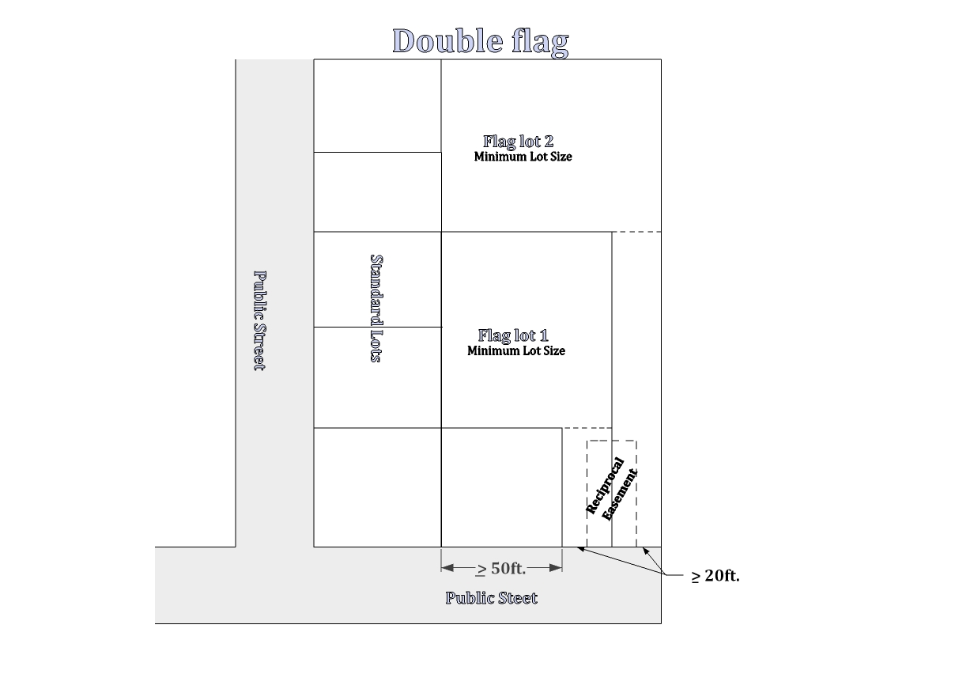
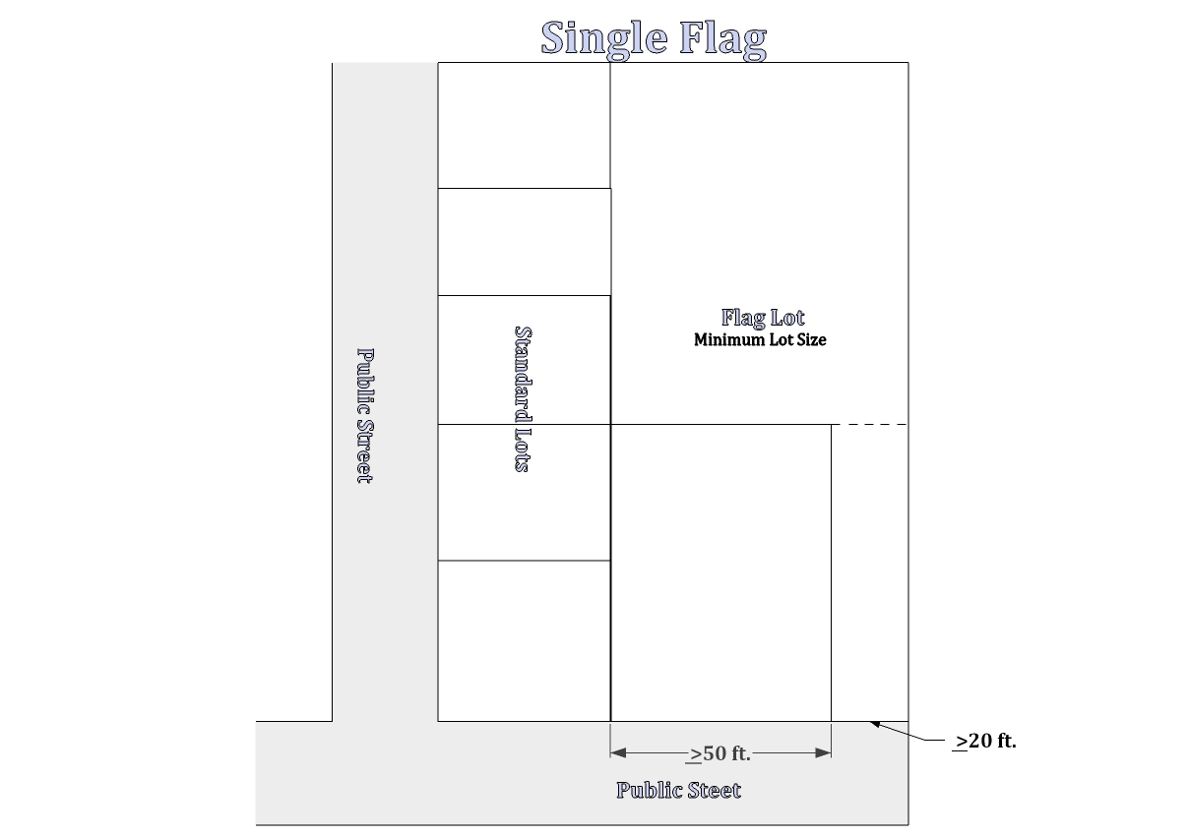
(7) Subdivisions. Flag lots within newly proposed subdivisions shall only be allowed on cul-de-sacs or where irregular lot lines warrant such a technique.

Redundant with section 153.089.

(G) Through or double-frontage lots and parcels. Through or double-frontage lots and parcels are to be avoided whenever possible, except where they are essential to provide separation of residential development from major traffic arterials or collectors and from adjacent nonresidential activities, or to overcome specific disadvantages of topography and orientation. When through or double-frontage lots or parcels are desirable or deemed necessary, a planting screen easement of at least four to six feet in width, and across which there shall be no right of vehicular access, may be required along the line of building sites abutting such a traffic way or other incompatible uses.
(H) Special building setback lines. If special building setback lines, in addition to those required by the applicable zoning, are to be established in a development, they shall be shown on the final plat of the development and included in the deed restrictions.
(I) Large building lots; redivision. In the case where lots or parcels are of a size and shape that future redivision is likely or possible, the Commission may require that the blocks be of a size and shape so that they may be redivided into building sites, and the development approval and site restrictions may require provisions for the extension and opening of streets at intervals which will permit a subsequent redivision of any tract of land into lots or parcels of smaller sizes than originally platted.

Home
153.192 EASEMENTS.
(A) Utility lines. Easements for sewer lines, water mains, electric lines or other public utilities shall be as required by the serving entity, but in no case be less than 12 feet wide and centered on a rear and/or side lot line unless approved otherwise by the city. Utility pole anchor or guy wire easements may be reduced to 6 feet in width.
(B) Water courses. If a lot is traversed by a water course, such as a drainage way, channel or stream, there shall be provided a storm water easement or drainage right-of-way conforming substantially to the lines of the water course, and such further widths as deemed necessary.
(C) Pedestrian and bicycle ways. When desirable for public convenience, a pedestrian and/or bicycle way of not less than 5 feet in width may be required to connect to a cul-de-sac or to pass through an unusually long or oddly shaped block, or to otherwise provide appropriate circulation and to facilitate pedestrian and bicycle traffic as an alternative mode of transportation.
(D) Sewer and water lines. Easements may also be required for sewer and water lines, and if so required, shall be provided for as stipulated to by the City Department of Public Works.

153.193 LAND FOR PUBLIC PURPOSES.
(A) If the city has an interest in acquiring a portion of a proposed development for a public purpose, or if the city has been advised of the interest by a school district or other public agency, and there is reasonable assurance that steps will be taken to acquire the land, then the city may require that portion of the development be reserved for public acquisition for a period not to exceed 1 year.
(B) Subdivisions containing 20 or more residential lots may be required (based on size and potential density) to develop and dedicated to the public a parcel of land at least 5% of the gross area of the development for parks and recreation purposes. The parcel of land shall be determined to be suitable for the park and/or recreation purpose(s) intended. This land may be within the development or adjacent to the development on continuous property owned by the developer. Parks approved as part of a subdivision may not be used to satisfy obligations of adjacent subdivisions. Replaced above.
(C) In the event no such area is available that is found to be suitable for parks and/or recreation uses, the developer may be required, in lieu of setting aside land to pay to the appropriate parks and recreation agency a sum of money equal to the market value of the area required for dedication, plus the additional funds necessary for the development thereof if so required; if such is required, the money may only be utilized for capital improvements by the appropriate parks and recreation agency. Replaced above.
(D) The foregoing land and development or a monetary contribution may be provided for in lieu of an equal value of systems development charge assessment if so approved by the collecting agency (Crook County Parks and Recreation) in accordance with the applicable provisions of the SDC ordinance. If the collecting agency will not accept the land or monetary contribution in lieu of an applicable systems development charge, the land and development of a park may still be required by the City. Such a park would need to be managed with a Home Owners Association unless an alternate arrangement can be reached with Crook County Parks and Recreation.
Home
(E) If the nature and design, or approval, of a development is such that over 30% of the tract of land to be developed is dedicated to the public such as parks, rights-of-way, water or sewer system facilities and the like, then the requirements shall be reduced so that the total obligation of the developer to the public does not exceed 35%.

153.194 STREETS AND OTHER PUBLIC FACILITIES.
(A) Duties of developer. It shall be the responsibility of the developer to construct all streets, curbs, sidewalks, sanitary sewers, storm sewers, water mains, electric, gas, telephone cable, and other utilities necessary to serve the use or development in accordance with the Standards and Specifications of the city and/or the serving entity.
(B) Underground installation of utility lines. All electrical, telephone or other utility lines shall be underground unless otherwise approved by the city.
(C) Location, width, and grade of streets. The location, width and grade of streets shall be considered in their relationship to existing and planned streets, to topographical conditions, to public convenience and safety and to the proposed use or development to be served thereby.
(D) Traffic circulation system. The overall street system shall assure an adequate traffic circulation system with intersection angles, grades, tangents and curves appropriate for the traffic to be carried considering the terrain of the development and the area, per the City’s Standards and Specifications.
(E) Street location and pattern. The proposed street location and pattern shall be shown on the development plan, and the arrangement of streets shall:
(1) Provide for the continuation or appropriate projection of existing principal streets to surrounding areas; or adjacent lots.
(2) Conform to a plan for the general area of the development approved by the Planning Commission to meet a particular situation where topographical or other conditions make continuance or conformance to existing streets impractical; and
(3) Conform to the adopted urban area transportation system plan as may be amended.
(F) Minimum right-of-way and roadway widths. Unless otherwise approved in the tentative development plan, street, sidewalk and bike rights-of-way and surfacing widths shall not be less than the minimum widths set forth in the City’s Standards and Specifications. Whenever existing rights-of-way adjacent to or within a tract are of less than standard width, additional rights-of-way shall be dedicated at the time of land division or development."
Home

Refer to Standards and Specifications.
(G) Alignment. All streets, as far as practicable, shall be in alignment with existing streets by continuations of the center lines thereof. Necessary staggered street alignment resulting in intersections shall, wherever possible, leave a minimum distance of 200 feet between the center lines of streets of approximately the same direction, and in no case shall the off-set be less than 100 feet.
(H) Future street extensions. Where necessary to give access to or permit future subdivision or development of adjoining land, streets shall be extended to the boundary of the proposed development or subdivision.
(I) Intersection angles. Streets shall be laid out to intersect at angles as near to right angles as practicable, and in no case shall an acute angle be less than 80 degrees unless there is a special intersection design approved by the City Engineer. Other streets, except alleys, shall have at least 50 feet of tangent adjacent to the intersection, and the intersection of more than two streets at any one point will not be approved.
(J) Inadequate existing streets. Whenever existing streets, adjacent to, within a tract or providing access to and/or from a tract, are of inadequate width and/or improvement standards, additional right-of- way and/or improvements to the existing streets may be required.
(K) Cul-de-sacs. A cul-de-sac shall terminate with a circular turn around with a minimum paved surface and right-of-way determined by the City’s Standards and Specifications or Fire Code whichever is greater.
Home
(L) Marginal access streets. Where a land development abuts or contains an existing or proposed arterial street, the city may require marginal access streets, reverse frontage lots with suitable depth, screen-plantings contained in a non-access reservation strip along the rear or side property line or other treatments deemed necessary for adequate protection of residential properties and the intended functions of the bordering street, and to afford separation of through and local traffic.
(M) Streets adjacent to railroad or canal right-of-way. Whenever a proposed land development contains or is adjacent to a railroad or main canal right-of-way, provisions may be required for a street approximately parallel to the ROW at a distance suitable for the appropriate use of land between the street and the ROW. The distance shall be determined with consideration at cross streets of the minimum distance required for approach grades to a future grade separation and to provide sufficient depth to allow screen planting or other separation requirements along the ROW.
(N) Reserve Strips. Reserve strips or street plugs controlling access to streets shall not be approved.
(O) Half streets. Half streets, while generally not acceptable, may be approved where reasonably essential to a proposed land development, and when the Commission or other reviewing authority finds it will be practical to require dedication and improvement of the other half of the street when the adjoining property is developed. Whenever a half street exists adjacent to a tract of land proposed for development, the other half of the street shall be dedicated and improved.
(P) Streets. All street design criteria shall conform to the City’s Standards and Specifications and State design Standards as determined by the City Engineer.

(Q) Street names. Except for the extension of existing streets, no street names shall be used which will duplicate or be confused with the name of an existing street in the city or within a radius of six miles of the city or within the boundaries of a special service district such as fire or ambulance.
(R) Street name signs. Street name signs shall be installed at all street intersections by the developer in accordance with applicable city, county or state requirements. One street sign shall be provided at the intersection of each street, and two street signs shall be provided at four-way intersections.
Home
(S) Traffic control signs. Traffic control signs shall be provided for and installed by the developer as required and approved by the appropriate city, county and/or state agency or department.
(T) Alleys. Alleys are not necessary in residential developments, but should and may be required in commercial and industrial developments unless other permanent provisions for access to off-street parking and loading facilities are approved by the city.
(U) Curbs. Curbs shall be required on all streets in all developments and with all new commercial and multifamily construction. Curbs shall be installed by the developer in accordance with the City’s Standards and Specifications unless otherwise approved by the city.
(V) Sidewalks. Unless otherwise required in this chapter or other city ordinances or other regulations, sidewalks shall be required as set forth hereinafter on all streets in all developments and with all new commercial and multifamily construction. In lieu of these requirements, however, the reviewing authority may approve a development without sidewalks if alternative pedestrian routes and facilities are provided.
(1) All streets. In general all streets shall have sidewalks at a minimum of 5 feet in width in residential and industrial areas and 8 feet in width in commercial areas unless otherwise provided for in the applicable zone. The following streets sections within residential or industrial zones shall also provide 8 ft. sidewalks. Single family and duplex homes on existing lots shall construct a sidewalk only when contiguous to an existing sidewalk in good condition as determined by the City.
(a) Main St. from Lynn Blvd. to Peters Rd.
(b) Harwood St. from 4th St. to 9th St.
(c) Juniper St. from 1st St. to Laughlin Rd.
(d) 9th St.
(e) Lynn Blvd.
(f) Combs Flat Rd.

(X) Bike lanes. Unless otherwise required in this chapter or other city ordinances or other regulations, bike lanes shall be required as follows, except that the Planning Commission may approve a development without bike lanes if it is found that the requirement is not appropriate to or necessary for the extension of bicycle routes, existing or planned, and may also approve a development without bike lanes in the streets if alternative bicycle routes and facilities are provided.
Home
(1) Local streets. Bike lanes may be required on local streets, and if required shall not be less than 5 feet in width for one-way bike lanes and 8 feet in width for two-way bike lanes.
(2) Collector streets. Bike lanes are required on both sides of collector streets, and shall not be less than 6 feet in width.
(3) Arterial streets. Bike lanes are required on both sides of arterial streets, and shall not be less than 6 feet in width.
(Y) Street lights. Street lights may be required and, if so required, shall be installed by the developer in accordance with standards set forth by the city and the serving utility company.
(Z) Utilities. The developer shall make necessary arrangements with the serving utility companies for the installation of all proposed or required utilities, which may include electrical power, natural gas, telephone, cable television and the like.
(AA) Drainage facilities. Drainage facilities shall be provided as required by the City’s Standards and Specifications.

153.195 ACCESS MANAGEMENT.
(A) General. Access management restrictions and limitations consist of provisions managing the number of access points and/or providing traffic and facility improvements that are designed to maximize the intended function of a particular street, road or highway. The intent is to achieve a balanced, comprehensive program which provides reasonable access as new development occurs while maintaining the safety and efficiency of traffic movement.
(B) Access management techniques and considerations. In the review of all new development, the reviewing authority shall consider the following techniques or considerations in providing for or restricting access to certain transportation facilities.
(1) Access points to arterials and collectors may be restricted through the use of the following techniques.
(a) Restricting spacing between access points based on the type of development and the speed along the serving collector or arterial.
(b) Sharing of access points between adjacent properties and developments.
(c) Providing access via a local order of street; for example, using a collector for access to an arterial, and using a local street for access to a collector.
(d) Constructing frontage or marginal access roads to separate local traffic from through traffic.
(e) Providing service drives to prevent spill-over of vehicle queues onto adjoining roadways.
(f) Requiring internal circulation with adjoining lots for pedestrians and vehicles (Internal Parcel Circulation) to avoid additional access points and unnecessary trips on and off the street.
(2) Consideration of the following traffic and facility improvements for access management.
Home
(a) Providing of acceleration, deceleration and right-turn-only lanes.
(b) Offsetting driveways to produce T-intersections to minimize the number of conflict points between traffic using the driveways and through traffic.
(c) Installation of median barriers to control conflicts associated with left turn movements.
(d) Installing side barriers to the property along the serving arterial or collector to restrict access width to a minimum.
(C) General access management guidelines. In the review and approval of new developments, the reviewing authority shall consider the following guidelines.

(1) Minimum spacing between driveways and/or streets:
Major arterial 500 feet

Minor arterial 300 feet

Collector 50 feet

Local streets access to each lot

(2) Minimum spacing between street intersections:
Major arterial 1/4 mile

Minor arterial 600 feet

Collector 300 feet

Local streets 300 feet

Home

Removed, Unnecessary.

153.196 IMPROVEMENT PROCEDURES.
Improvements to be installed by the subdivider, either as a requirement of this chapter, conditions of approval or at the developer's option as proposed as a part of the subject development proposal, shall conform to the following requirements.
(A) Plan review and approval. Improvement work shall not be commenced until plans therefore have been reviewed and approved by the City Engineer or a designated representative thereof and a “Notice to Proceed” has been issued by the City. The review and approval shall be at the expense of the developer.
(B) Modification. Improvement work shall not commence until after the city has been notified and approval thereof has been granted, and if work is discontinued for any reason, it shall not be resumed until after the city is notified and approval thereof granted.
Home
(C) Improvements as platted. Improvements shall be designed, installed and constructed as platted or approved. Engineered plans shall be filed with the City prior to recordation of the final plat or as otherwise required by the city.
(D) Inspection. Improvement work shall be constructed under the inspection and approval of an inspector designated by the city, and the expenses incurred therefore shall be borne by the developer. The city, through the City Engineer , may require changes in typical sections and details of improvements if unusual or special conditions arise during construction to warrant such changes in the public interest.
(E) Utilities. Underground utilities, including, but not limited to electric power, telephone, water mains, water service crossings, sanitary sewers and storm drains, to be installed in streets shall be constructed by the developer prior to the surfacing of the streets.
(F) As built plans. As built plans for all public improvements shall be prepared and completed by a licensed engineer and filed with the city upon the completion of all such improvements.

Removed, satisfied through construction drawing sign off and inspection.

153.197 COMPLETION OR ASSURANCE OF IMPROVEMENTS.
(A) Agreement for improvements. Prior to final plat approval for a subdivision, partitioning, PUD or other land development, or the final approval of a design review application, land use or development pursuant to applicable zoning provisions, the owner and/or developer shall either install required improvements and repair existing streets and other public facilities damaged in the development of the property, or shall execute and file with the city an agreement between him/herself and the city specifying the period in which improvements and repairs shall be completed and providing that, if the work is not completed within the period specified, that the city may complete the work and recover the full costs thereof, together with court costs and attorney costs necessary to collect the amounts from the developer. The agreement shall also provide for payment to the city for the cost of inspection and other engineer services directly attributed to the project.
(B) Bond or other performance assurance. The developer shall file with the agreement, to assure his/her full and faithful performance thereof, one of the following, pursuant to approval of the City Attorney and City Manager, and approval and acceptance by the City Council.
(1) A surety bond executed by a surety company authorized to transact business in the State of Oregon in a form approved by the City Attorney.
(2) A personal bond co-signed by at least one additional person together with evidence of financial responsibility and resources of those signing the bond sufficient to provide reasonable assurance of the ability to proceed in accordance with the agreement.
Home
(3) Cash deposit.
(4) Such other security as may be approved and deemed necessary by the City Council to adequately assure completion of the required improvements.
(C) Amount of security required. The assurance of full and faithful performance shall be for a sum approved by the city as sufficient to cover the cost of the improvements and repairs, including related engineering, inspection and other incidental expenses, plus an additional 20% for contingencies.
(D) Default status. If a developer fails to carry out provisions of the agreement, and the city has unreimbursed costs or expenses resulting from the failure, the city shall call on the bond or other assurance for reimbursement of the costs or expenses. If the amount of the bond or other assurance deposit exceeds costs and expenses incurred by the city, it shall release the remainder. If the amount of the bond or other assurance is less than the costs or expenses incurred by the city, the developer shall be liable to the city for the difference plus any attorney fees and costs incurred.

153.198 BUILDING AND OCCUPANCY PERMITS.
(A) Building permits. No building permits shall be issued upon lots to receive and be served by sanitary sewer and water service, streets as improvements and other required site improvements required pursuant to this chapter unless the improvements are in place, serviceable and approved by the city, and the service connections fees therefore are paid, or all such cost and improvements are bonded for or otherwise assured as set forth by 153.197 and accepted by the City.
(B) Sale or occupancy. All improvements required pursuant to this chapter and other applicable regulations or approval conditions shall be completed, in service and approved by the city, or be bonded for or otherwise assured as set forth by 153.197 and accepted by the city prior to sale or occupancy of any lot, parcel or building unit erected upon a lot within the subdivision, partitioning, PUD or other development.

153.199 MAINTENANCE SURETY BOND.
Prior to sale and occupancy of any lot, parcel or building unit erected upon a lot within a subdivision, partitioning, PUD or other development, and as a condition of acceptance of improvements, the City Council may require a 1 year maintenance surety bond in an amount not to exceed 20% of the value of all improvements, to guarantee maintenance and performance for a period of not less than one year from the date of acceptance.

153.200 ENGINEERING/SPECIAL SERVICES FOR REVIEW.
In regards to any development proposal for which the city deems it necessary to contract for engineering and/or other special technical services for the review thereof or for the design of facility expansions to serve the development, the developer may be required to pay all or part of the special services. In such cases, the choice of the contract service provider shall be at the discretion of the city, and the service provider shall perform the necessary services at the direction of the city. The costs for the services shall be determined reasonable, and an estimate of the costs shall be provided to the developer prior to contracting therefore.
Home
VARIANCES
153.210 AUTHORIZATION TO GRANT OR DENY.
(A) Variances from the provisions and requirements of this chapter may be approved in accordance with the provisions of this subchapter where it can be shown that, owing to special and unusual circumstances related to a specific lot, parcel or tract of land, strict application of certain provisions of this chapter would cause an undue or unnecessary hardship.
(B) No variance shall be granted that would allow the use of property for a purpose not authorized within the zone in which the proposed use or development is located.
(C) In granting a variance, conditions may be attached that are found necessary to protect the best interests of the adjoining or surrounding properties or the vicinity, and to otherwise achieve the purposes of this chapter, the specific applicable zoning and the objectives and policies of the city's Comprehensive Plan.

153.211 CIRCUMSTANCES FOR GRANTING A MAJOR VARIANCE.
A MAJOR VARIANCE is a request for a variance that does not qualify as a minor variance. Major variances can only be reviewed as a type II conditional use. A major variance may be granted without restrictions, or may be granted subject to prescribed conditions and limitations, provided that the following findings are evident.
(A) That the literal application of specific provisions of the chapter would create practical difficulties for the applicant resulting in greater private expense than public benefit, however, a variance is not to be granted simply because it would afford the owner a higher profit or prevent a mere inconvenience.
(B) That the condition creating the difficulty is not general throughout the surrounding area, but is unique to the applicant’s site or property; therefore, the granting of the requested variance will not set a precedent for future applications.
(C) That the condition was not created by the applicant. A self-created difficulty will be found if the applicant knew or should have known of the specific restriction or provision at the time the site was purchased. Self-created hardship also results when an owner and/or developer negligently or knowingly violates a provision of this chapter. A substandard lot, deliberately made so by the owner's conveyance, is considered a self-created hardship. Violations made in good faith, or circumstances arising from pre-existing conditions or circumstances are treated more leniently, as is the condition of an area deficiency created by the expansion of a public right-of-way, public utility easement or other public use in the public interest.
(D) In the case of a use variance, that the literal application of specific provisions of the chapter would result in an unnecessary hardship to the applicant and/or property owner. An unnecessary hardship will be found when there is no reasonable use of or return from the property as it may lawfully be used under the applicable provisions of this chapter.

Home
153.212 MINOR VARIANCE.
For the purposes of this chapter, a MINOR VARIANCE is an area or dimensional variance that meets one of the following conditions. Only one such variance may be granted for any one lot, parcel or tract of land.
(A) Is a variance request involving a deviation from a minimum lot size, street frontage and lot coverage requirement of not more than 10%.
(B) Is a variance request involving a deviation from a setback requirement of not more than 25%.
(C) Involves a request for the expansion of a nonconforming use by not more than 10%.

153.213 APPLICATION FOR A VARIANCE.
An application for a variance under this subchapter shall be filed with the City's Planning Department on a completed application form established by the Department. An application shall include at least the following information; to the extent such information may be required as a condition of acceptance of filing of an application under Oregon Constitution Article 1, Section 18, subsections (a) though (f):
(A) A legal description of the private real property as to which the owner is applying for a variance, including the common address and either a legal metes and bounds description or a Crook County Assessor's description of the property;
(B) The name, address and telephone number of each owner of and security interest holder in the private real property, together with the signature of the owner making the application;
Removed, unnecessary.
Removed, unnecessary.
(C) A copy of the specific regulation as to which the owner is applying for a variance, including the date the regulation was adopted, first enforced, or applied.
(D) A copy of the regulation in existence, and applicable to the private real property, immediately before the regulation that was imposed and allegedly restricts the use of the private real property and caused a reduction in fair market value.
(E) The manner in which, and the extent to which, the regulation restricts the use of the private real property as to which the owner is applying for a variance;

Removed, covered in procedures section.

Removed, covered in procedures section.
Home
153.214 PROCEDURES FOR ACTION ON VARIANCES.
The procedure for taking action on an application for a variance shall be in accordance with the policies and procedures set forth in sections 153.254 through 153.256 et seq., as well as the following:
(A) Minor variance.
(1) Notice shall be sent to persons entitled to notice under section
153.255.030 in accordance with section 153.254.030.
(2) Following conclusion of the response period, if no objections to the subject application have been received, the Planning Official may either process the variance as an administrative decision or refer the application to the Planning Commission for public hearing.
(3) If one or more objections are received, the subject application shall be referred to the Commission for public hearing.
(4) The Planning Official or Planning Commission shall only grant the variance request if the applicant provides clear and substantial evidence of a practical difficulty or unnecessary hardship.
(B) Major variances and minor variances not processed administratively shall be referred for Planning Commission action. Before the Planning Commission may act on any variance request, the Commission shall conduct a public hearing in the matter thereof in accordance with the policies and procedures set forth in section 153.255 et seq.

153.215 TIME LIMIT FOR VARIANCES.
Authorization of a variance shall be null and void after 1 year unless substantial construction or compliance has taken place or the proposed use has occurred. The Commission may grant an extension of time not to exceed six months, upon request. A request for an extension shall be duly filed with the city prior to the expiration of the initial one-year period, and only one such extension may be granted.

AMENDMENTS
153.230 AUTHORIZATION TO INITIATE AMENDMENTS.
An amendment to the text of this chapter or to a zoning map may be initiated by the City Council, by the City Planning Commission, by the City Planning Official, by any planning advisory committees duly appointed by the city, by any planning board established by this chapter or by an application of a property owner or the authorized agent thereof.

153.231 APPLICATION FOR AMENDMENTS.
An application for an amendment to the text of this chapter or for a zone change by a property owner or the authorized agent thereof shall be filed with the City Planning Official on forms prescribed by the city and shall be accompanied by the required filing fee as established by the City Council. The application shall be filed not less than 30 days prior to the date of the Commission hearing thereon. The applicant shall provide reasons for the requested change, and shall present facts showing that the amendment will substantially be in compliance with the goals, objectives and policies of the City Comprehensive Plan and with the applicable statewide planning goals and implementing administrative rules. (Ord. 1057, passed 3-24-98)
Home

153.232 PUBLIC HEARINGS ON AMENDMENTS.
The City Planning Commission shall, at its earliest practicable meeting date following the 30 day filing period, duly advertise and conduct a public hearing on the subject amendment application, and shall, within five working days of the conclusion of the hearing, recommend to the City Council approval, disapproval or modified approval of the proposed amendment. Within 30 days of receipt of the Commission's recommendations, the City Council shall duly advertise and conduct a public hearing on the proposed amendment. The Council shall approve, approve with modifications or disapprove the proposed amendment. The Commission or Council may recess or continue a hearing in order to obtain additional information and input on a subject proposed amendment. (O.R.S. 227.175 (3) and (5))

153.233 PUBLIC NOTICE REQUIREMENTS.
Notwithstanding any other public notice requirements that may be set forth in this chapter or by applicable state statutes or administrative rules, the following public notice requirements shall apply to applications for an amendment to the text of this chapter or to an application for a zoning amendment provided for by this subchapter. (O.R.S. 227.1175(3) and (5))
(A) Each notice of a public hearing regarding an amendment to the text of this chapter or to a zoning map shall be published once a week for each of the two successive weeks prior to the date of the hearing in a newspaper of general circulation in the city.
(B) In addition to the notice requirements set forth by division (A) of this section, for an amendment that proposes to rezone property, individual notice shall be mailed or otherwise delivered to the owner of each lot or parcel of property that is proposed to be rezoned. If such rezoning is for a single lot or parcel, notice shall also be mailed to all property owners within 250 feet of the exterior boundaries of the subject property.
(C) Notice of an application for a zone change shall be provided to the owner of a public use airport if the property subject to the zone change is as follows.
(1) Within 5,000 feet of the side or end of a runway of a visual airport; or
(2) Within 10,000 feet of the side or end of the runway of an instrument airport; and
(3) If the zone change would allow a structure greater than 35 feet in height on property located inside the runway approach surface. (O.R.S. 227.175(6))
(D) Notice of an application for a zone change of property which includes all or part of a mobile or manufactured home park shall be given by first class mail to each existing mailing address for tenants of the mobile home park at least 20 days but not more than 40 days before the date of the first hearing. (O.R.S. 227.175(8))
(E) Notice of an application for a proposed zoning amendment, together with a copy or description of the proposed amendment, shall be provided to the State Land Conservation and Development Commission (LCDC) at least 45 days prior to the date of the final hearing thereon. (O.R.S. 197)

153.234 RECORDS OF AMENDMENTS.
The duly approved and signed original and a copy thereof of an amendment to the text or zoning map(s) of this chapter shall be maintained without change on file in the office of the City Recorder. As applicable, a certified true copy thereof shall be maintained in the office of the City Planning Official. Copies of the amendments shall be available for public review and information.
Home

153.235 LIMITATIONS ON REAPPLICATIONS.
No reapplication for an amendment to the text of this chapter or to a zoning map by a property owner shall be considered by the Planning Commission or Council within a 6 month period immediately following a previous denial of the application. However, if in the opinion of the Planning Commission, new evidence or a change in circumstances warrants the reapplication in a lesser time, the Commission may permit a new application.

153.236 ADOPTION OF AN AMENDMENT.
An amendment to the text of this chapter or a zoning map shall be approved by ordinance only.

ADMINISTRATION AND ENFORCEMENT

153.250 INTRODUCTION AND DEFINITIONS

153.250.010. Introduction and application.
A. Section 153.250 is enacted to provide a uniform procedure for the grant or denial and processing of applications, approvals and determinations by the Planning Department of the City of Prineville, under the applicable Comprehensive plan, land use regulations and other ordinances which by their terms incorporate by reference the procedures in this title.
B. The provisions of Section 153.250 do not apply to the issuance, suspension, or revocation of any on-site sewage disposal, building, electrical or plumbing permits except as they relate to Planning Department consideration of permitted uses.

153.250.020. Definitions.
The following definitions apply to Section 153.250.

"Argument" means assertions and analysis by a party regarding the satisfaction or violation of legal standards. "Argument" does not include assertion of facts not already in the record. "De novo review" means a hearing by the review body as if the action had not previously been heard and as if no decision had been rendered, except that all testimony, evidence and other material from the record of the previous consideration will be considered a part of the record on review.

"Development action" means the review of any permit, authorization or determination that the City of Prineville Planning Department is requested to issue, give or make that either:
A. Involves the application of a City zoning ordinance and is not a land use action as defined below; or
Home
B. Involves the application of standards in other portion of the Land Usage Ordinance (Section 150 -152). For illustrative purposes, the term "development action" includes review of any lot line adjustment, permit extension, sign permit, setback determination, and lot coverage determination.

"Evidence" means facts, documents, data or other information offered to demonstrate compliance or noncompliance with the standards believed to be relevant to the decision.

"Land use action" includes any consideration for approval of a quasi-judicial plan amendment or zone change, any consideration for approval of a land use permit, and any consideration of a request for a declaratory ruling (including resolution of any procedural questions raised in any of these actions). For illustrative purposes, the term "land use action" includes review of conditional use permit, variance, partition, subdivision, site plan review and other applications which require the exercise of discretion or policy judgment in applying and/or interpreting applicable criteria.

"Land use permit" includes any approval of a proposed development of land under the standards in the City zoning ordinances involving the exercise of significant discretion in applying those standards. By way of illustration, "land use permit" includes review of conditional use permits, partition, master plan, site plan, site plan change of use, modification of approval subdivision, and subdivision variance and variance.

"Legislative changes" generally involve broad public policy decisions that apply to other than an individual property owner. These include, without limitation, amendments to the text of the comprehensive plans, zoning ordinances, or changes in zoning maps not directed at a small number of property owners.

"Modification of application" means the applicant's submittal of new information after an application has been deemed complete and prior to the close of the record on a pending application that would modify a development proposal by changing one or more of the following previously described components: proposed uses, operating characteristics, intensity, scale, site lay out (including but not limited to changes in setbacks, access points, building design, size or orientation, parking, traffic or pedestrian circulation plans), or landscaping in a manner that requires the application of new criteria to the proposal or that would require the findings of fact to be changed. It does not mean an applicant's submission of new evidence that merely clarifies or supports the pending application.

"Quasi-judicial" zone change or plan amendment generally refers to a plan amendment or zone change affecting a single or limited group of property owners and that involves the application of existing policy to a specific factual setting. (The distinction between legislative and quasi-judicial changes must ultimately be made on a case-by-case basis with reference to case law on the subject.)

Home
153.251 GENERAL PROVISIONS

153.251.005 Pre-application conference
153.251.010 Application requirements
153.251.015 Development Review Committee
153.251.020 Acceptance of application
153.251.030 Incomplete applications
153.251.040 Withdrawal of application
153.251.050 Time computation
153.251.060 Submission of documents

153.251.005 Pre-application conference
A pre-application conference is encouraged for complex applications or for applicants who are unfamiliar with the land use process. The purpose of the conference shall be to acquaint the applicant with the substantive and procedural requirements of the applicable land use ordinances, to provide for an exchange of information regarding applicable requirements of the comprehensive plan, zoning ordinance or land division ordinance and to identify issues likely to arise in processing an application. The applicable zoning ordinance may require that a pre-application conference be held for particular types of applications.

153.251.010 Application requirements
A. Property Owner. For the purposes of this section, the term "property owner" shall mean the owner of record or the contract purchaser and does not include a person or organization that holds a security interest.
B. Applications for development or land use actions shall:

1. Be submitted by the property owner or a person who has written authorization from the property owner as defined herein to make the application;

2. Be completed on a form prescribed by the City;

3. Include supporting information required by the zoning ordinance and that information necessary to demonstrate compliance with applicable criteria (burden of proof); and
4. Be accompanied by the appropriate filing fee, unless such fees are waived by the City Council.

153.251.015 Development Review Committee
A. Within ten days of the submittal of a land use application, notice shall be sent to the following persons, parties and agencies which shall constitute the membership of the City Development Review Committee.
(1) City Superintendent of Public Works.
(2) City Engineer.
(3) City Superintendent of Streets.
(4) City Police and County Sherrif as applicable
Home
(5) Crook County Fire and Rescue
(6) Public utility representatives.
(7) Ochoco Irrigation District as applicable.
(8) School district representatives.
(9) County Roadmaster as applicable.
(10) County Planning representative.
(11) Parks and Recreation District Director.
(12) Any other person, party or agency deemed by City staff to be affected by the land use proposal or to have specific knowledge or expertise in regard to the specific proposal.

B. Development review conference. Within 30 days of submittal of a land use application, the Community Development Department shall schedule a meeting with the City Development Review Committee to discuss issues relevant to the proposal. At the request of the applicant, or as initiated by staff, the Development Review Committee may conduct a follow-up meeting with the applicant and applicant’s representatives to discuss any issues identified in the development review conference.
C. Committee review factors. In review of a proposed development, the
Committee shall, at a minimum, consider the following factors.
(1) Tentative plan, site plan or other relevant requirements.
(2) Possible adverse effects on the development by natural hazards, or adverse effects on any natural or other Goal 5 resources by the development.
(3) Quantity and quality of existing or proposed water supply, and the adequacy of the existing or proposed sewage disposal system.
(4) Adequacy of public services to serve the development; including streets, schools, police, fire, public utilities and health or medical facilities.
(5) Conformance with the design and improvement standards and requirements set forth in 153.190 et seq. and in any other applicable city ordinance, regulations or standards.
(6) Conformance with applicable state regulations.
(7) Provisions for the continuity of public services and access to adjoining lands.

153.251.020 Acceptance of application
A. Development action and land use action applications shall not be accepted until the Planning Director has determined that (1) the requirements of 153.251.10 have been met and (2) the application is complete or the application is deemed to be complete under state law.
B. An application is complete when in the judgment of the Planning Director all applicable issues have been adequately addressed in the application.
C. Acceptance of an application as complete shall not preclude a determination at a later date that additional criteria need to be addressed or a later determination that additional information is needed to adequately address applicable criteria.

Home
153.251.030 Incomplete applications
A. If an application is incomplete, the planning director shall, within 30 days of receipt of the application, notify the applicant in writing of exactly what information is missing. The applicant may amend his application or submit a new application supplying the missing information.
B. The applicant shall have 30 days from the date of notice from the planning director to supply the missing information.
C. If an applicant does not submit the missing information within the 30-day period specified in 153.251.030(B), the application may be processed in accordance with 153.254.040.

153.251.040 Withdrawal of application
An applicant may withdraw an application in writing at any time prior to the time a land use action decision becomes final. If the landowner is not the applicant, no consent to withdraw the application is needed from the landowner.

Refunds for withdrawn applications shall be determined from the following schedule;
A. Refund request after file is made prior to acceptance of an application as complete and/or prior to the mailing of transmittals or public notice. 75%
B. Refund after public notice or transmittals have been sent. 50%
C. No refund shall be allowed after the preparation of a Decision or Staff Report.

153.251.050 Time computation
Except when otherwise provided, the time within which an act is required to be done shall be computed by excluding the first day and including the last day, unless the last day is a Saturday, Sunday, legal holiday or any day on which the City is not open for business pursuant to a county ordinance, in which case it shall also be excluded.

153.251.060 Submission of documents
A document is "submitted" when it is received. Submittal shall be made either at a noticed hearing or at the offices of the Planning Division, unless specified otherwise by the Hearings Body or notice.

153.252 LEGISLATIVE PROCEDURES
153.252.010 Hearing required
153.252.020 Notice
153.252.030 Initiation of legislative changes
153.252.040 Hearings Body
153.252.050 Final decision

153.252.010 Hearing required.
No legislative change shall be adopted without review by the Planning Commission and a public hearing before the City Council. Public hearings before the Planning Commission shall be set at the discretion of the Planning Director, unless otherwise required by state law.
Home
153.252.020 Notice.
A. Published Notice.
1. Notice of a legislative change shall be published in a newspaper of general circulation in the city at least 10 days prior to each public hearing.
2. The notice shall state the time and place of the hearing and contain a statement describing the general subject matter of the ordinance under consideration.
B. Posted Notice. Notice shall be posted at the discretion of the Planning Director and where necessary to comply with ORS 203.045.
C. Individual Notice. Individual notice to property owners, as defined in 153.251.010(A), shall be provided at the discretion of the Planning Director, except as required by ORS 215.503.

153.252.030 Initiation of legislative changes.
A legislative change may be initiated by application of individuals upon payment of required fees as well as by the City Council or the Planning Commission.

153.252.040 Hearings Body.
A. The following shall serve as hearings or review body for legislative changes in this order:
1. The Planning Commission.
2. City Council.
- Any legislative change initiated by the City Council may be reviewed by the Planning Commission prior to action being taken by the City Council, at the City Council’s discretion.

153.252.050 Final decision.
All legislative changes shall be adopted by ordinance.

153.253 DEVELOPMENT ACTION PROCEDURES
153.253.010 Review of development action applications
153.253.020 Decision

152.253.010 Review of development action applications.
A. A development action application may be handled administratively by the Planning Director without public notice or hearing.
B. The Planning Director has the discretion to determine that for the purposes of the land usage ordinance whether a development action application should be treated as if it were a land use action application.

153.253.020 Decision.
A. Development action applications acted upon without notice or hearing shall be approved or denied by the Planning Director or his designee within 30 days of the application's acceptance by the Planning Director.
B. Notice of a decision shall be provided to the applicant or the applicant's representative.
Home
C. The decision may be appealed under153.258.

153.254 REVIEW OF LAND USE ACTION APPLICATIONS
153.254.010 Effect of determinations made outside of established processes
153.254.020 Action on land use action applications
153.254.030 Administrative land use decisions with prior notice
153.254.040 Administrative decision without prior notice
153.254.050 Final action in land use actions
153.254.060 Supplementation of application within first 30 days of submittal
153.254.070 Modification of application

153.254.010. Effect of determinations made outside of established processes.
Any informal interpretation or determination, or any statement describing the uses to which a property may be put, made outside the declaratory ruling process (City of Prineville Land Development Ordinance, Section 153.260) or outside the process for approval or denial of a land use permit (153.254 – 153.256) shall be deemed to be a supposition only. Such informal interpretations, determinations, or statements shall not be deemed to constitute final County action effecting a change in the status of a person's property or conferring any rights, including any reliance rights, on any person.
153.254.020. Action on land use action applications.

A. Except for comprehensive plan amendments and zone changes and other instances where a hearing is required by state law or by other ordinance provisions, the Planning Director may decide upon a land use action application administratively either with prior notice, as prescribed under 153.254.030 or without prior notice, as prescribed under 153.254.040 or he/she may refer the application to the Planning Commission for hearing. The Planning Director shall take such action within 30 days of the date the application is accepted or deemed accepted as complete. This time limit may be waived at the option of the applicant.
B. The Planning Director's choice between or among administrative or hearing procedures to apply to a particular application or determination shall not be an appealable decision.
C. Zone change and plan amendment applications shall be referred to a hearing before the Planning Commission.

153.254.020 Action on land use action applications.
A. Except for comprehensive plan amendments and zone changes and other instances where a hearing is required by state law or by other ordinance provisions, the Planning Director may decide upon a land use action application administratively either with prior notice, as prescribed under 153.254.030 or without prior notice, as prescribed under 153.254.040 or he/she may refer the application to the Planning Commission for hearing. The Planning Director shall take such action within 30 days of the date the application is accepted or deemed accepted as complete. This time limit may be waived at the option of the applicant.
Home
B. The Planning Director's choice between or among administrative or hearing procedures to apply to a particular application or determination shall not be an appealable decision.
C. Zone change and plan amendment applications shall be referred to a hearing before the Planning Commission.

153.254.030 Administrative land use decisions with prior notice.
A. Notice of the application shall be sent within 10 days of submittal of the application to persons entitled to notice under 153.255.030. Such notice shall include all the information specified under 153.255.040(A) except for the information specified in 153.255.040(A)(7) and (10).
B. Any person may comment in writing on the application within 10 days from the date notice was mailed or a longer period as specified in the notice.
C. The Planning Director's decision to approve, deny or send to a hearing shall be made within 30 days after an application is accepted as complete. This time limit may be waived by the written consent of the applicant.
D. Notice of the Planning Director's decision and the appeal period shall be sent to all persons entitled to notice under 153.255.030 and to all persons who commented. Notice shall also be given to all members of the Planning Commission who have the authority to call up any decision of the Planning Director within the appeal period in accordance with section 153.258.010. The notice shall contain the applicable information required under 153.255.040.
E. The applicant, all persons entitled to notice under 153.255.030 and all other persons commenting as provided in 153.254.020 constitute parties to the administrative decision. Any party can appeal the decision in accordance with 153.258 (Appeals).

153.254.040 Administrative decision without prior notice.
The procedures for administrative decisions without prior notice shall be the same as those set forth in 153.254.030, except that no prior notice shall be given.
153.254.050 Final action in land use actions.
A. Except as otherwise provided, the City shall take final action, including consideration of appeals to the City Council, in land use actions within 120 days after the application is deemed complete.
B. If the applicant refuses or fails to submit missing information within the 30 days specified in 153.251.030, the application shall be deemed complete, for purposes of processing the application, on the 31st day after the application was first submitted, and final action of City Council, if required, shall be taken within one hundred fifty-one (151) days after the application was first received unless otherwise provided.
C. The periods set forth in 153.254.050 during which a final decision on an application must be made may be extended for a reasonable period of time at the written request of the applicant.

153.254.060 Supplementation of application within first 30 days of submittal.
An applicant shall not submit any evidence to supplement its application during the 30 days following submittal of its application, except to respond to a request for additional information made under DCC 153.251.030. Any evidence submitted by an applicant in violation of 153.254.060 will not be considered in determining whether the application is complete and will be returned to the applicant.
Home

153.254.070 Modification of application.
A. An applicant may modify an application at any time during the approval process up until the issuance of an administrative decision, or the close of the record for an application reviewed under a hearings process, subject to the provisions of 153.254.060 and this section.
B. The Planning Director or Planning Commission shall not consider any evidence submitted by or on behalf of an applicant that would constitute modification of an application (as that term is defined in 153.250) unless the applicant submits an application for a modification, pays all required modification fees and agrees in writing to restart the 120-day time clock as of the date the modification is submitted. The 120-day time clock for an application, as modified, may be restarted as many times as there are modifications.
C. The Planning Director or Planning Commission may require that the application be re-noticed and additional hearings be held.
D. Up until the day a hearing is opened for receipt of oral testimony, the Planning Director shall have sole authority to determine whether an applicant's submittal constitutes a modification. After such time, the Planning Commission shall make such determinations. The Planning Director or Planning Commission determination on whether a submittal constitutes a modification shall be appealable only to LUBA and shall be appealable only after a final decision is entered by the County on an application.

153.255 LAND USE ACTION HEARINGS
153.255.010 Filing of staff report for hearing
153.255.020 Hearings Body
153.255.030 Notice of hearing or administrative action
153.255.040 Contents of notice
153.255.050 Burden of proof
153.255.060 Standing
153.255.070 Disclosure of ex parte contacts
153.255.080 Disclosure of personal knowledge
153.255.090 Challenge for bias, prejudgment of personal interest
153.255.100 Hearings procedure
153.255.110 Setting the hearing
153.255.120 Close of the record
153.255.130 Continuances or record extensions
153.255.140 Reopening the record

153.255.010 Filing of staff report for hearing.
A. At the time an application that in the judgment of the Planning Director requires a hearing is deemed complete, a hearing date shall be set.
B. A staff report shall be completed seven days prior to hearing. If the report is not completed by such time, the hearing shall be held as scheduled, but any party may at the hearing or in writing prior to the hearing request a continuance of the hearing to a date that is at least seven days after the date the initial staff report is complete.
Home
C. A copy of the staff report shall be mailed to the applicant, shall be made available to such other persons who request a copy and shall be filed with the Planning Commission.
D. Oral or written modifications and additions to the staff report shall be allowed prior to or at the hearing.

153.255.020 Hearings Body.
A. The following shall serve as the hearings body:
1. Planning Commission.
2. City Council

B. The Hearing’s Body order shall be as set forth in 153.255.020(A), except that the Council may call up an administrative decision for review without the necessity of an application going before the Planning Commission.

153.255.030 Notice of hearing or administrative action.
A. Individual Mailed Notice.
1. Except as otherwise provided for herein, notice of a land use application shall be mailed at least 20 days prior to the hearing for those matters set for hearing, or within 10 days after receipt of an application for those matters to be processed administratively with notice. Written notice shall be sent by mail to the following persons:
a. The applicant.
b. Owners of record of property as shown on the most recent property tax assessment roll of property located within 100 feet of the property that is the subject of the notice where any part of the subject property is within an urban growth boundary;
c. The owner of a public use airport if the airport is located within 10,000 feet of the subject property.
d. The tenants of a mobile home park when the application is for the rezoning of any part or all of a mobile home park.
e. The Planning Commission.
f. Any neighborhood or community organization formally recognized by the City Council, whose boundaries include the site.
2. The failure of a property owner to receive mailed notice shall not invalidate any land use approval if the Planning Division can show by affidavit that such notice was given.
B. Published Notice. In addition to notice by mail and posting, notice of an initial hearing shall be published in a newspaper of general circulation in the County at least 10 days prior to the hearing.

153.255.040 Contents of notice.
A. All mailed notices of a land use action hearing shall:

1. Describe the nature of the applicant's request and the nature of the proposed uses that could be authorized.
Home
2. List the criteria from the zoning ordinance and the plan applicable to the application at issue.
3. Set forth the street address or easily understood geographical reference to the subject property.
4. State the date, time and location of any hearing or date by which written comments must be received.
5. State that any person may comment in writing and include a general explanation of the requirements for submission of testimony and the procedures for conduct of testimony, including, but not limited to, a party's right to request a continuance or to have the record held open.
6. If a hearing is to be held, state that any interested person may appear.
7. State that failure to raise an issue in person at a hearing or in writing precludes appeal by that person to the Land Use Board of Appeals (LUBA), and that failure to provide statements or evidence sufficient to afford the decision-maker an opportunity to respond to the issue precludes appeal to LUBA based on that issue.
8. State the name of a county representative to contact and the telephone number where additional information may be obtained.
9. State that a copy of the application, all documents and evidence submitted by or on behalf of the applicant and applicable criteria are available for inspection at no cost and will be provided at reasonable cost.
10. State that a copy of the staff report will be available for inspection at no cost at least seven days prior to the hearing and will be provided at reasonable cost.
B. All mailed and published notices for hearings shall contain a statement that recipients may request a copy of the staff report.
C. All mailed and published notices concerning applications necessitating an exception to one of the statewide land use planning goals shall state that a goal exception is proposed and shall summarize the issues in an understandable manner.

153.255.050 Burden of proof
Throughout all local land use proceedings, the burden of proof rests on the applicant.

153.255.060 Standing
A. Any interested person may appear and be heard in a land use action hearing, except that in appeals heard on the record, a person must have participated in a previous hearing on the subject application.
B. Any person appearing on the record at a hearing (including appeals) or presenting written evidence in conjunction with an administrative action or hearing shall have standing and shall be a party. A person whose participation consists only of signing a petition shall not be considered a party.

153.255.070 Disclosure of ex parte contacts
Prior to making a decision, the Hearings Body or any member thereof shall not communicate directly or indirectly with any party or his representative in connection with any issue involved in a pending hearing except upon notice and opportunity for all parties to participate. Should such communication - whether written or oral - occur, the
Home
Hearings Body member shall:
A. Publicly announce for the record the substance of such communication; and
B. Announce the parties' right to rebut the substance of the ex parte communication during the hearing. Communication between City staff and the Hearings Body shall not be considered to be an ex parte contact.

153.255.080 Disclosure of personal knowledge.
A. If the Hearings Body or any member thereof uses personal knowledge acquired outside of the hearing process in rendering a decision, the Hearings Body or member thereof shall state the substance of that knowledge on the record and allow all parties the opportunity to rebut such statement on the record.
B. For the purposes of this section, a site visit by the Hearings Body shall be deemed to fall within this rule. After the site visit has concluded, the Hearings Body must disclose its observations and conclusions gained from the site visit in order to allow for rebuttal by the parties.

153.255.090 Challenge for bias, prejudgment or personal interest.
Prior to or at the commencement of a hearing, any party may challenge the qualification of the Hearings Body, or a member thereof, for bias, prejudgment or personal interest. The challenge shall be made on the record and be documented with specific reasons supported by facts. Should qualifications be challenged, the Hearings Body or the member shall disqualify itself, withdraw or make a statement on the record of its capacity to hear.
153.255.100 Hearings procedure.
A hearing shall be conducted as follows:
A. The Hearings Body shall explain the purpose of the hearing and announce the order of proceedings, including reasonable time limits on presentations by parties.
B. A statement by the Hearings Body regarding pre-hearing contacts, bias, prejudice or personal interest shall be made.
C. Any facts received, noticed or recognized outside of the hearing shall be stated for the record.
D. Challenges to the Hearings Body's qualifications to hear the matter shall be stated and challenges entertained.
E. The Hearings Body shall list applicable substantive criteria, explain that testimony and evidence must be directed toward that criteria or other criteria in the comprehensive plan or land use regulations that the person believes to apply to the decision, and that failure to address an issue with sufficient specificity to afford the decision-maker and the parties an opportunity to respond precludes appeal to LUBA based on that issue.
F. Order of presentation:
1. Open the hearing.
2. Staff report.
3. Proponents' presentation.
4. Opponents' presentation.
5. Proponents' rebuttal.
6. Opponents' rebuttal may be allowed at the Hearings Body's discretion.
7. Staff comments.
Home
8. Questions from or to the chair may be entertained at any time at the Hearings Body's discretion.
9. Close the hearing.
G. The record shall be available for public review at the hearing.

153.255.110 Setting the hearing.
A. After an application is deemed accepted a hearing date shall be set. A hearing date may be changed by the City staff, or the Hearings Body up until the time notice of the hearing is mailed. Once the notice of hearing is mailed any changes in the hearing date shall be processed as a continuance in accordance with 153.255.130.

B. If an applicant requests that a hearing date be changed, such request shall be granted only if the applicant agrees that the extended time period for the hearing shall not count against the 120-day time limit set forth in DCC 153.254.050.

153.255.120 Close of the record.
A. Except as set forth herein, the record shall be closed to further testimony or submission of further argument or evidence at the end of the presentations before the Hearings Body.
B. If the hearing is continued or the record is held open under 153.255.130, further evidence or testimony shall be taken only in accordance with the provisions of 153.255.130.
C. Otherwise, further testimony or evidence will be allowed only if the record is reopened under 153.255.140.
D. An applicant shall be allowed, unless waived, to submit final written arguments in support of its application after the record has closed within such time limits as the Hearings Body shall set. The Hearings Body shall allow applicant at least seven days to submit its argument, which time shall be counted against the 120-day clock.

153.255.130 Continuances or record extensions.
A. Grounds.
1. Prior to the date set for an initial hearing, an applicant shall receive a continuance upon any request if accompanied by a corresponding suspension of the 120 day clock. If a continuance request is made after the published or mailed notice has been provided by the City, the Hearings Body shall take evidence at the scheduled hearing date from any party wishing to testify at that time after notifying those present of the continuance.
2. Any party is entitled to a continuance of the initial evidentiary hearing or to have the record left open in such a proceeding in the following instances:
a. Where additional documents or evidence are submitted by any party; or
b. Upon a party's request made prior to the close of the hearing for time to present additional evidence or testimony.
Home
For the purposes of 153.255.130(2)(a), "additional documents or evidence" shall mean documents or evidence containing new facts or analysis that are submitted after notice of the hearing.
3. The grant of a continuance or record extension in any other circumstance shall be at the discretion of the Hearings Body.
B. Continuances.
1. If the Hearings Body grants a continuance, the hearing shall be continued to a date, time and place certain at least seven days from the date of the initial hearing.
2. An opportunity shall be provided at the continued hearing for persons to rebut new evidence and testimony received at the continued hearing.
3. If new written evidence is submitted at the continued hearing, any person may request prior to the conclusion of the continued hearing that the record be left open for at least seven days to allow submittal of additional written evidence or testimony. Such additional written evidence or testimony shall be limited to evidence or testimony that rebuts the new written evidence or testimony.

C. Leaving record open.
If at the conclusion of the hearing the Hearings Body leaves the record open for additional written evidence or testimony, the record shall be left open for at least 14 additional days, allowing at least the first seven days for submittal of new written evidence or testimony and at least seven additional days for response to the evidence received while the record was held open. Written evidence or testimony submitted during the period the record is held open shall be limited to evidence or testimony that rebuts previously submitted evidence or testimony.
D. A continuance or record extension granted under 153.255.130 shall be subject to the 120-day time limit unless the continuance or extension is requested or otherwise agreed to by the applicant. When the record is left open or a continuance is granted after a request by an applicant, the time period during which the 120-day clock is suspended shall include the time period made available to the applicant and any time period given to parties to respond to the applicant's submittal.

153.255.140 Reopening the record.
A. The Hearings Body may at its discretion reopen the record, either upon request or on its own initiative. The Hearings Body shall not reopen the record at the request of an applicant unless the applicant has agreed in writing to a suspension of the 120-day time limit.
B. Procedures.
1. Except as otherwise provided for in this section, the manner of testimony (whether oral or written) and time limits for testimony to be offered upon reopening of the record shall be at the discretion at the Hearings Body.
2. The Hearings Body shall give written notice to the parties that the record is being reopened, stating the reason for reopening the record and how parties can respond. The parties shall be allowed to raise new issues that relate to the new evidence, testimony or criteria for decision-making that apply to the matter at issue.
Home
153.256 LAND USE ACTION DECISIONS
153.256.010 Decision
153.256.020 Notice of decision
153.256.030 Decision on plan amendments and zone changes
153.256.040 Reapplication limited
153.256.050 Review by Council
153.256.060 Correction of clerical errors

153.256.010 Decision.
A. Approval or denial of a land use action shall be based upon and accompanied by a brief statement that explains the criteria and standards considered relevant to the decision, states the facts relied upon in rendering the decision and explains the justification for the decision based upon the criteria standards and facts set forth.
B. Any portion of an application not addressed in a Hearings Body's decision shall be deemed to have been denied.
C. A decision on a land use action is not final until the Planning Director or Hearings Body issues a written decision, the decision has been mailed and the appeal period to the next higher Hearings Body within the City has run.
D. No building permit shall issue until a decision is final. Appeal of a final decision to LUBA does not affect the finality of a decision for purposes of issuing building permits.

153.256.020 Notice of decision.
A Hearings Body's decision shall be in writing and mailed to all parties; however, one person may be designated by the Hearings Body to be the recipient of the decision for a group, organization, group of petitioners or similar collection of individual participants.

153.256.030 Decision on plan amendments and zone changes.
A. Except as set forth herein, the Planning Commission when acting as the Hearings Body shall have authority to make decisions on all quasi-judicial zone changes and plan amendments. Prior to becoming effective, all quasi-judicial plan amendments and zone changes shall be adopted by the City Council.
B. In considering all quasi-judicial zone changes and those quasi-judicial plan amendments on which the Planning Commission has authority to make a decision, the City Council shall, in the absence of an appeal or review initiated by the Council, adopt the Planning Commission decision. No argument or further testimony will be taken by the Council.

153.256.040 Reapplication limited.
A. If a specific application is denied on its merits, reapplication for substantially the same proposal may be made at any time after the date of the final decision denying the initial application.
B. Notwithstanding 153.256.040(A), a final decision bars any reapplication for a non-conforming use verification or for a determination on whether an approval has been initiated.
Home
153.256.050 Review by Council.
A. Review of an administrative action or a Planning Commission decision may be initiated by the City Council. The Council shall consider calling up for review any administrative decision that a majority of the Planning Commission recommends be reviewed.
B. Review by the Council shall be initiated by Council order within 12 days of the date of the mailing of the final written decision of the Planning Director or Planning Commission.
C. Review shall be conducted in the same manner provided for in appeals, except that an appeal fee and transcript shall not be required. Any Council order calling up for review a decision shall specify whether the Council will review the decision called up on the record or de novo and whether it intends to limit the issues on review to certain specified issues.

153.256.060 Correction of clerical errors
Upon its own motion or the motion of a party, the Council may, subject to any applicable public notice and hearing requirements, enact an ordinance correcting clerical or typographical errors in plan amendment or zone change ordinances and any maps appended thereto implementing decisions of the Planning Commission. Such changes shall be entered only if the Council is able to make a finding that the decision of the Planning Commission, including appendices, is not accurately reflected in the implementing ordinances.
153.257. RECONSIDERATION
153.257.010 Reconsideration
153.257.020 Procedure
153.257.030 Limitation on reconsideration

153.257.010 Reconsideration.
A. An applicant may request that the Planning Commission decision be reconsidered as set forth herein. A request for reconsideration shall be accompanied by a fee established by the City and by applicant's written consent that the 120-day time clock will not run during the period of the reconsideration.
B. Grounds for reconsideration are limited to the following instances where an alleged error substantially affects the rights of the applicant:
1. Correction of an error in a condition established by the Planning Commission where the condition is not supported by the record or is not supported by law;
2. Correction of errors that are technical or clerical in nature.

153.257.020 Procedure.
A. A request for reconsideration shall be filed with the Planning Director within 10 days of the date the decision was mailed. The request shall identify the alleged error in the Planning Commission decision and shall specify how the applicant would be adversely affected if the alleged error were to remain uncorrected.
B. Upon receipt of a request for reconsideration, the Planning Director shall forward the request for reconsideration to the Planning Commission and notify the other parties to the proceeding of the request and allow for a 10-day comment period on the request. At the end of the comment period, the Planning Commission shall determine whether the request for reconsideration has merit.
Home
C. The Planning Commission shall modify the decision upon a determination that the request has merit and the alleged error substantially affects the applicant. Notice of the modification shall be sent to all parties to the proceeding. If the Planning Commission determines that no modification is warranted, a determination shall issue a decision to that effect.
D. Filing a request for reconsideration shall not be a precondition for appealing a decision.
E. Filing a request for reconsideration stays the deadline for any party to file an appeal of the Planning Commission decision. The appeal period for all parties to the proceeding shall commence upon mailing of a modification or upon mailing a determination that a modification is not warranted. If an opponent files an appeal and an applicant has requested reconsideration, the opponent's appeal shall be stayed pending disposition of the request for modification. If the decision is not modified, the appeal will be processed in accordance with the procedures set forth in 153.258. If the decision is modified, the appellant must within 12 days of the mailing of the modified decision file in writing a statement requesting that its appeal be activated.

153.257.030 Limitation on reconsideration
No decision shall be reconsidered more than once by the Planning Commission.

153.258 APPEALS
153.258.010 Who may appeal
153.258.020 Filing appeals
153.258.030 Notice of appeal
153.258.040 Transcript requirement
153.258.050 Consolidation of multiple appeals
153.258.060 Scope of review
153.258.070 Hearing on appeal
153.258.080 Declining review
153.258.090 Development action appeals
153.258.100 Withdrawal of an appeal

153.258.010 Who may appeal
A. The following may file an appeal:
1. A party;
2. In the case of an appeal of an administrative decision without prior notice, a person entitled to notice, a person adversely affected or aggrieved by the administrative decision, or any other person who has filed comments on the application with the Planning Division; and
3. A person entitled to notice and to whom no notice was mailed.
4. Any administrative decision may be called up for a public hearing by the Planning Commission as long as at least 3 Planning Commissioners submit a written request to review a decision. In such a case, there shall be no additional hearings fee charged to the applicant and the hearing shall be scheduled for the next available meeting date with consideration for required notice periods.
Home
B. A person to whom notice is mailed is deemed notified even if notice is not received.

153.258.020 Filing appeals
A. To file an appeal, an appellant must file a completed notice of appeal on a form prescribed by the Planning Department and an appeal fee.
B. Unless a request for reconsideration has been filed, the notice of appeal and appeal fee must be received at the offices of the City of Prineville Planning Department no later than 5:00 PM on the twelfth day following mailing of the decision. If a decision has been modified on reconsideration, an appeal must be filed no later than 5:00 PM on the twelfth day following mailing of the decision as modified. Notices of Appeals may not be received by facsimile machine.
C. If the City Council is the Hearings Body and the City declines review, a portion of the appeal fee may be refunded. The amount of any refund will depend upon the actual costs incurred by the City in reviewing the appeal.
D. The appeal fee shall be paid by cash or check or money order, except that local, state or federal governmental agencies may supply a purchase order at the time of filing.

153.258.030 Notice of appeal
The Notice of Appeal shall include:
A. A statement raising any issue relied upon for appeal with sufficient specificity to afford the Hearings Body an adequate opportunity to respond to and resolve each issue in dispute.
B. If the City Council is the Hearings Body, a request for review by the Council stating the reasons why the Council should review the lower Hearings Body's decision.
C. If the City Council is the Hearings Body and de novo review is desired, a request for de novo review by the Council stating the reasons why the Council should provide de novo review as provided in DCC 153.258.060.

153.258.040 Transcript requirement
A. Except as otherwise provided in 153.258.040, appellants shall provide a complete transcript of any hearing appealed from, from recorded magnetic tapes provided by the Planning Department.
B. Appellants shall submit the transcript to the Planning Department no later than the close of the 5th day prior to the date set for a de novo appeal hearing, in on-the-record appeals, the date for receipt of written arguments. Unless excused under this section, an appellant’s failure to provide a transcript shall cause the Council to decline to consider the appellant’s appeal further and shall, upon notice mailed to the parties, cause the lower Hearings body’s decision to become final.
C. An appellant shall be excused from providing a complete transcript if appellant was prevented from complying by: (1) the inability of the Planning Department to supply appellant with a magnetic tape or tapes of the prior proceeding; or (2) defects on the magnetic tape or tapes of the prior proceeding that make it not reasonably possible for applicant to supply a transcript. Appellants shall comply to the maximum extent reasonably and practicably possible.
Home

153.258.050 Consolidation of multiple appeals
If more than one party files a notice of appeal on a land use action decision, the appeals shall be consolidated and noticed and heard as one proceeding.

153.258.060 Scope of review
A. Before Planning Commission. The review on appeal before the Planning Commission shall be de novo.
B. Before the Council.
1. Review before the City Council, if accepted, shall be on the record except as otherwise provided for in this section.
2. The Council may grant an appellant's request for a de novo review at its discretion after consideration of the following factors:
a. Whether hearing the application de novo could cause the 120-day time limit to be exceeded; and
b. If the magnetic tape of the hearing below, or a portion thereof, is unavailable due to a malfunctioning of the recording device during that hearing, whether review on the record would be hampered by the absence of a transcript of all or a portion of the hearing below; or
c. Whether the substantial rights of the parties would be significantly prejudiced without de novo review and it does not appear that the request is necessitated by failure of the appellant to present evidence that was available at the time of the previous review; or
d. Whether in its sole judgment a de novo hearing is necessary to fully and properly evaluate a significant policy issue relevant to the proposed land use action.
e. For the purposes of this section, if an applicant is an appellant, factor 153.258.060(B)(2)(a) shall not weigh against the appellant's request if the applicant has submitted with its notice of appeal written consent on a form approved by the City to restart the 120-day time clock as of the date of the acceptance of applicant's appeal.
3. Notwithstanding 152.258.060(B)(2), the Council may decide on its own to hear a timely filed appeal de novo.
4. The Council may, at its discretion, determine that it will limit the issues on appeal to those listed in an appellant's notice of appeal.

153.258.070. Hearing on appeal.
A. The appellant and all other parties to the decision below shall be mailed notice of the hearing on appeal at least 10 days prior to any de novo hearing or deadline for submission of written arguments.
B. Except as otherwise provided in 153.258, the appeal shall be heard as provided in 153.255. The applicant shall proceed first in all de novo appeals.
C. The order of Hearings Body shall be as provided in 153.255.020.
D. The record of the proceeding from which appeal is taken shall be a part of the record on appeal.
Home
E. The record for a review on the record shall consist of the following:
1. A written transcript of any prior hearing;
2. All written and graphic materials that were part of the record below;
3. The Hearings Body decision appealed from;
4. Written arguments, based upon the record developed below, submitted by any party to the decision;
5. Written comments submitted by the Planning Commission or individual planning commissioners, based upon the record developed below; and
6. A staff report and staff comment based on the record. No oral evidence, argument or comment other than staff comment based on the record shall be taken. The Board shall not consider any new factual information.

153.258.080 Declining Review
Except as set forth in 153.256.030, when there is an appeal of a land use action and the City Council is the Hearings Body:

A. The Council may on a case-by-case basis, at a public meeting, determine that the decision of the lower Hearings Body of an individual land use action or a class of land use action decisions, shall be the final decision of the City.
B. If the City Council decides that the lower Hearings Body decision shall be the final decision of the City, then the Council shall not hear the appeal and the party appealing may continue the appeal as provided by law. In such a case, the City shall provide written notice of its decision to all parties. The decision on the land use application becomes final upon mailing of the Council’s decision to decline review.
C. The decision of the City Council not to hear a land use action appeal is entirely discretionary.
D. In determining whether to hear an appeal, the City Council may consider only:
1. The record developed before the lower Hearings Body;
2. The notice of appeal; and
3. Recommendations of staff.

153.258.090 Development Action appeals
Notice of the hearing date set for appeal shall be sent only to the applicant. Only the applicant, his or her representatives, and his or her witnesses shall be entitled to participate. Continuances shall be at the discretion of the Hearings Body, and the record shall close at the end of the hearing.

153.258.100 Withdrawal of an appeal
An appeal may be withdrawn in writing by an appellant at any time prior to the rendering of a final decision. Subject to the existence of other appeals on the same application, in such event the appeal proceedings shall terminate as of the date the withdrawal is received.

Home
153.259 LIMITATIONS ON APPROVALS
153.259.010 Expiration of approval
153.259.020 Initiation of use
153.259.030 Modification of approval
153.259.040 Transfer of permit
153.259.050 Revocation of approvals

153.259.010 Expiration of approval.
A. Scope.
1. Except as otherwise provided herein, this section shall apply to and describe the duration of all approvals of land use permits provided for under the City of Prineville Land Development Ordinance and the various zoning ordinances administered by City of Prineville.
2. 153.259.010 does not apply to:
a. Those determinations made by declaratory ruling or expiration determinations, that involve a determination of the legal status of a property, land use or land use permit rather than whether a particular application for a specific land use meets the applicable standards of the zoning ordinance. Such determinations, whether favorable or not to the applicant or landowner, shall be final, unless appealed, and shall not be subject to any time limits.
b. Quasi-judicial map changes.

B. Duration of Approvals.
1. Except as otherwise provided under this section or under applicable zoning ordinance provisions, a land use permit is void 1 year after the date the discretionary decision becomes final if the use approved in the permit is not initiated within that time period.
2. Except as otherwise provided under applicable ordinance provisions, preliminary approval of plats or master plans shall be void after 1 year from the date of preliminary approval, unless the final plat has been submitted to the Planning Department for final approval within that time period, or an extension is sought under 153.259.010(C), or the preliminary plat or master plan approval has been initiated as defined herein.
3. In cases of a land use approval authorized under applicable approval criteria to be completed in phases, each phase must be initiated within 1 year of completion of the prior phase, if no timetable is specified.
C. Extensions.
1. The Planning Director may grant 1 extension of up to 1 year for a land use approval or a phase of a land use approval, regardless of whether the applicable criteria have changed, if:
a. An applicant makes a written request for an extension of the development approval period;
b. The request, along with the appropriate fee, is submitted to the City prior to the expiration of the approval period;
Home
c. The applicant states reasons that prevented the applicant from beginning or continuing development or meeting conditions of approval within the approval period; and
d. The City determines that the applicant was unable to begin or continue development or meet conditions of approval during the approval period for reasons for which the applicant was not responsible, including, but not limited to, delay by a state or federal agency in issuing a required permit.
2. Up to 2 additional 1 year extensions, may be granted under the above criteria by the Planning Director or his/her designees where applicable criteria for the decision have not changed.
D. Procedures.
1. A determination of whether a land use has been initiated shall be processed as a declaratory ruling.
2. Approval of an extension granted under DCC 153.259.010(c) is an administrative decision, is not a land use decision described in ORS 197.015 and is not subject to appeal as a land use decision and shall be processed under 153.250 as a development action, except to the extent it is necessary to determine whether the use has been initiated.
E. Effect of Appeals. The time period set forth in 153.259.010(B) shall be tolled upon filing of an appeal to LUBA until all appeals are resolved.

153.259.020 Initiation of use
A. For the purposes of this section, development action undertaken under a land use approval described in 153.259.010, has been "initiated" if it is determined that:
1. The proposed use has lawfully occurred;
2. Substantial construction toward completion of the land use approval has taken place; or
3. Where construction is not required by the approval, the conditions of a permit or approval have been substantially exercised and any failure to fully comply with the conditions is not the fault of the applicant.
B. For the purposes of this section, "substantial construction" has occurred when the holder of a land use approval has physically altered the land or structure or changed the use thereof and such alteration or change is directed toward the completion and is sufficient in terms of time, labor or money spent to demonstrate a good faith effort to complete the development.

153.259.030 Modification of approval
A. An applicant may apply to modify an approval at any time after a period of six months has elapsed from the time a land use action approval has become final.
B. Unless otherwise specified in a particular zoning ordinance provision, the grounds for filing a modification shall be that a change of circumstances since the issuance of the approval makes it desirable to make changes to the proposal, as approved. A modification shall not be filed as a substitute for an appeal or to apply for a substantially new proposal or one that would have significant additional impacts on surrounding properties.
Home
C. An application to modify an approval shall be directed to one or more discrete aspects of the approval, the modification of which would not amount to approval of a substantially new proposal or one that would have significant additional impacts on surrounding properties. Any proposed modification, as defined in this section, shall be reviewed only under the criteria applicable to that particular aspect of the proposal. Proposals that would modify an approval in a scope greater than allowable as a modification shall be treated as an application for a new proposal.
D. An application for a modification shall be handled as a land use action.

153.259.040 Transfer of permit
A. A land use action permit shall be deemed to run with the land and be transferable to applicant's successors in interest.
B. The Planning Department may require that an applicant record a notice of land use permit and conditions of approval agreement in the Crook County Records. Such an agreement shall set forth a description of the property, describe the permit that has been issued and set forth the conditions of approval.
C. The terms of the approval agreement may be enforced against the applicant and any successor in interest.

153.259.050 Revocation of approvals
A. Approvals shall be subject to revocation according to standards set forth in the applicable zoning ordinances.
B. Revocations shall be processed as a declaratory ruling under City of Prineville Land Development Ordinance. 153.259.010 notwithstanding, a public hearing shall be held in all revocation proceedings.

153.260 DECLARATORY RULING
153.260.010 Availability of declaratory ruling
153.260.020 Persons who may apply
153.260.030 Procedures
153.260.040 Effect of declaratory ruling
153.260.050 Interpretation

153.260.010 Availability of declaratory ruling.
A. Subject to the other provisions of this section, there shall be available for the City's comprehensive plans, zoning ordinances and City of Prineville Land Development Ordinance process for:
1. Interpreting a provision of a comprehensive plan or ordinance (and other documents incorporated by reference) in which there is doubt or a dispute as to its meaning or application;
2. Interpreting a provision or limitation in a land use permit issued by the City or quasi-judicial plan amendment or zone change in which there is doubt or a dispute as to its meaning or application;
Home
3. Determining whether an approval has been initiated or considering the revocation of a previously issued land use permit, quasi-judicial plan amendment or zone change;
4. Determining the validity and scope of a nonconforming use; and
5. Determination of other similar status situations under a comprehensive plan, zoning ordinance or land division ordinance that do not constitute the approval or denial of an application for a permit.
6. Such a determination or interpretation shall be known as a "declaratory ruling" and shall be processed in accordance with this section. In all cases, as part of making a determination or interpretation the Planning Director shall have the authority to declare the rights and obligations of persons affected by the ruling.
B. A declaratory ruling shall be available only in instances involving a fact-specific controversy and to resolve and determine the particular rights and obligations of particular parties to the controversy. Declaratory proceedings shall not be used to grant an advisory opinion. Declaratory proceedings shall not be used as a substitute for seeking an amendment of general applicability to a legislative enactment.
C. Declaratory rulings shall not be used as a substitute for an appeal of a decision in a land use action or for a modification of an approval. In the case of a ruling on a land use action a declaratory ruling shall not be available until six months after a decision in the land use action is final.
D. The Planning Director may refuse to accept an application for a declaratory ruling if:
1. The Planning Director determines that the question presented can be decided in conjunction with approving or denying a pending land use action application or if in the Planning Director judgment the requested determination should be made as part of a decision on an application for a quasi-judicial plan amendment or zone change or a land use permit not yet filed; or
2. The Planning Director determines that there is an enforcement case pending in district or circuit court in which the same issue necessarily will be decided as to the applicant and the applicant failed to file the request for a declaratory ruling within two weeks after being cited or served with a complaint.

3. The Planning Director determination to not accept or deny an application under this section shall be the City's final decision.

153.260.020 Persons who may apply.
A. 153.251.010(B) notwithstanding, the following persons may initiate a declaratory ruling under 153.260:
1. The owner of a property requesting a declaratory ruling relating to the use of the owner's property;
2. In cases where the request is to interpret a previously issued quasi-judicial plan amendment, zone change or land use permit, the holder of the permit; or
3. In all cases arising under 153.260.010, the Planning Director.
4. No other person shall be entitled to initiate a declaratory ruling.
Home
B. A request for a declaratory ruling shall be initiated by filing an application with the planning department and, except for applications initiated by the Planning Director, shall be accompanied by such fees as have been set by the Planning Department. Each application for a declaratory ruling shall include the precise question on which a ruling is sought. The application shall set forth whatever facts are relevant and necessary for making the determination and such other information as may be required by the Planning Department.

153.260.030 Procedures
Except as set forth in this section or in applicable provisions of a zoning ordinance, the procedures for making declaratory rulings shall be the same as set forth in 153.250 for land use actions. Where the Planning Department is the applicant, the Planning Department shall bear the same burden that applicants generally bear in pursuing a land use action.

153.260.040 Effect of declaratory ruling.
A. A declaratory ruling shall be conclusive on the subject of the ruling and bind the parties thereto as to the determination made.
B. 153.256.040 notwithstanding, and except as specifically allowed therein, parties to a declaratory ruling shall not be entitled to reapply for a declaratory ruling on the same question.
153.260.050 Interpretation
Interpretations made under 153.260 shall not have the effect of amending the interpreted language. Interpretation shall be made only of language that is ambiguous either on its face or in its application. Any interpretation of a provision of the comprehensive plan or other land use ordinance shall consider applicable provisions of the comprehensive plan and the purpose and intent of the ordinance as applied to the particular section in question.

153.261 ENFORCEMENT AND REMEDIES

153.261.010 Enforcement
A. The City Manager or designee shall have the powers and the duties to enforce the provisions of this chapter and all amendments thereto.
B. In addition, the City Manager or designee may initiate action to enforce any provision of this chapter, including any violation of any restriction or condition established under the provisions of this chapter in the granting of any application authorized or required pursuant to the provisions of this chapter.
C. Failure to comply with any order or decision as above provided will subject the violator to any legal remedy provided under law, including but not limited to the following.
(1) A complaint filed with the Circuit Court, or other court of competent jurisdiction whereupon conviction the court may fine the violator up to the maximum allowed by law, or imprison the violator in jail for up to the maximum time allowed by law, or both. Each day a violation occurs may be considered a separate offense.
Home
(2) The City Planning Official and/or a certified Building Official may order the stoppage of work of any type which is in violation of any of the provisions of this chapter or a permit granted pursuant hereto.
(3) A copy of the stop work order shall be posted at the site of construction or use and a copy thereof shall be mailed to the last known address of the property owner and/or the permittee.
(4) Upon the posting of the order, all work shall cease forthwith, and the property owner, permittee or permittee's agents or employees who thereafter continue to work shall be in violation of this chapter.
(5) The stop work order shall not be removed until satisfactory evidence that the violation has or will be corrected has been provided.

153.261.020 Remedies
A person violating a provision of this chapter shall be subject to the following provisions.

(A) Unlawful construction or use declared a nuisance. The location, erection, construction, maintenance, repair, alteration or use of a building or other structure, or the subdivision, partitioning, other land development or use of land in violation of this chapter shall be deemed a nuisance.
(B) Penalty. Except as otherwise provided for by law or by a court of competent jurisdiction, a person violating a provision of this chapter shall, upon conviction, be punished by fine of not more than $500. A violation of this chapter shall be considered a separate offense for each day the violation continues.
(C) Alternative remedy. In case a building or structure is, or is proposed to be, located, constructed, maintained, repaired, altered or used, or land is, or is proposed to be, used in violation of this chapter, the building or land thereby in violation shall constitute a nuisance, and the city may, as an alternative to other remedies that are legally available for enforcing this chapter, institute injunction, mandamus, abatement or other appropriate proceedings to prevent, enjoin temporarily or permanently, abate or remove the unlawful location, construction, maintenance, repair, alteration or use.
(D) Nuisances. Violations which constitute or include a nuisance violation shall also be subject to the abatement procedures set forth in ordinance 911, sections 46 through 53, inclusive

